Scales Data EDA Report

File: 20251214-ScalesData-Combined_ver0.7-Cleaned-IncomeNormalized-analysis-ready.csv

Rows: 104 Columns: 75

Notes:

- Numeric flagged by simple IQR/outlier heuristics

- Categorical plots limited to top categories

## Name

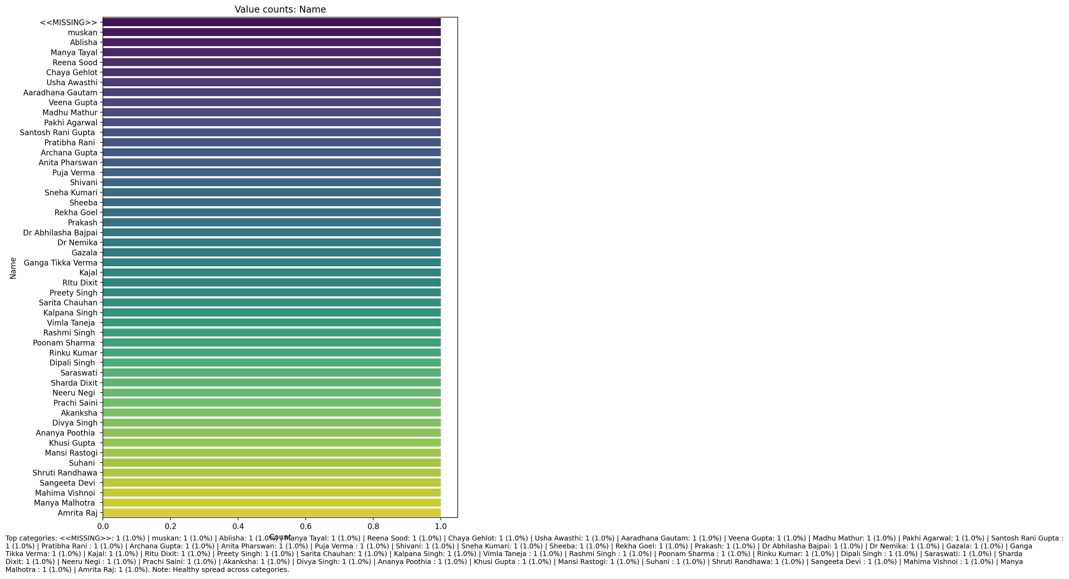

Top categories: <<MISSING>>: 1 (1.0%) | muskan: 1 (1.0%) | Ablisha: 1 (1.0%) | Manya Tayal: 1 (1.0%) | Reena Sood: 1 (1.0%) | Chaya Gehlot: 1 (1.0%) | Usha Awasthi: 1 (1.0%) | Aaradhana Gautam: 1 (1.0%) | Veena Gupta: 1 (1.0%) | Madhu Mathur: 1 (1.0%) | Pakhi Agarwal: 1 (1.0%) | Santosh Rani Gupta : 1 (1.0%) | Pratibha Rani : 1 (1.0%) | Archana Gupta: 1 (1.0%) | Anita Pharswan: 1 (1.0%) | Puja Verma : 1 (1.0%) | Shivani: 1 (1.0%) | Sneha Kumari: 1 (1.0%) | Sheeba: 1 (1.0%) | Rekha Goel: 1 (1.0%) | Prakash: 1 (1.0%) | Dr Abhilasha Bajpai: 1 (1.0%) | Dr Nemika: 1 (1.0%) | Gazala: 1 (1.0%) | Ganga Tikka Verma: 1 (1.0%) | Kajal: 1 (1.0%) | RItu Dixit: 1 (1.0%) | Preety Singh: 1 (1.0%) | Sarita Chauhan: 1 (1.0%) | Kalpana Singh: 1 (1.0%) | Vimla Taneja : 1 (1.0%) | Rashmi Singh : 1 (1.0%) | Poonam Sharma : 1 (1.0%) | Rinku Kumar: 1 (1.0%) | Dipali Singh : 1 (1.0%) | Saraswati: 1 (1.0%) | Sharda Dixit: 1 (1.0%) | Neeru Negi : 1 (1.0%) | Prachi Saini: 1 (1.0%) | Akanksha: 1 (1.0%) | Divya Singh: 1 (1.0%) | Ananya Poothia : 1 (1.0%) | Khusi Gupta : 1 (1.0%) | Mansi Rastogi: 1 (1.0%) | Suhani : 1 (1.0%) | Shruti Randhawa: 1 (1.0%) | Sangeeta Devi : 1 (1.0%) | Mahima Vishnoi : 1 (1.0%) | Manya Malhotra : 1 (1.0%) | Amrita Raj: 1 (1.0%)

## Age (IN YEARS)

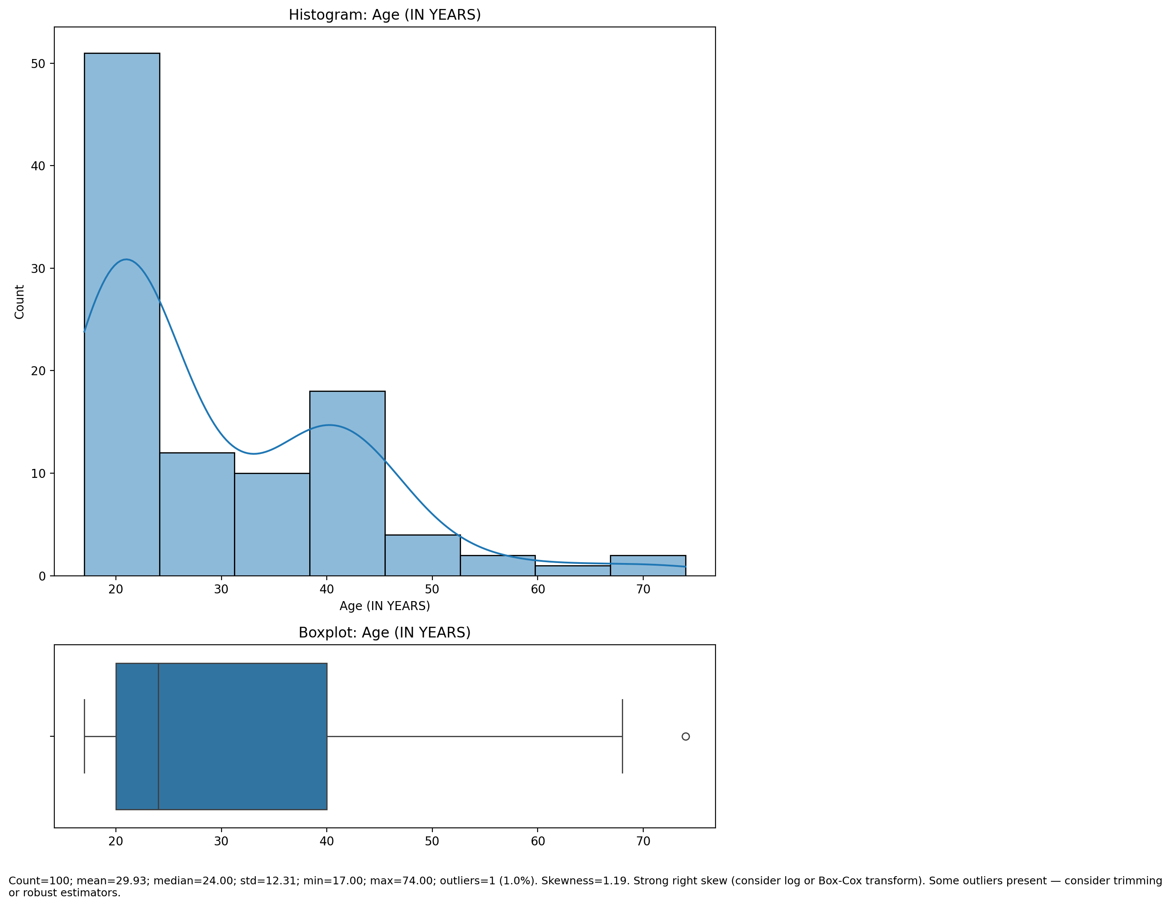

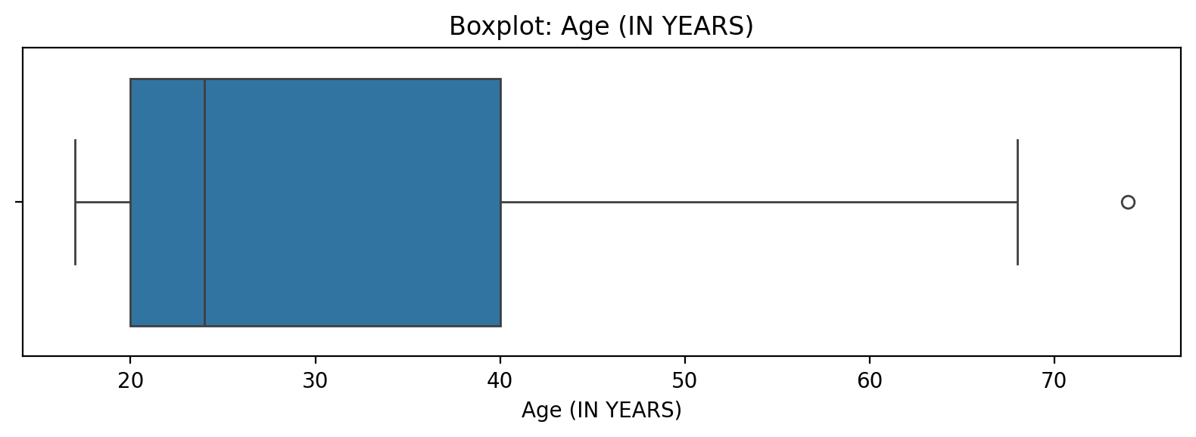

Count=100; mean=29.93; median=24.00; std=12.31; min=17.00; max=74.00; outliers=1 (1.0%). Skewness=1.19.

## Marital Status

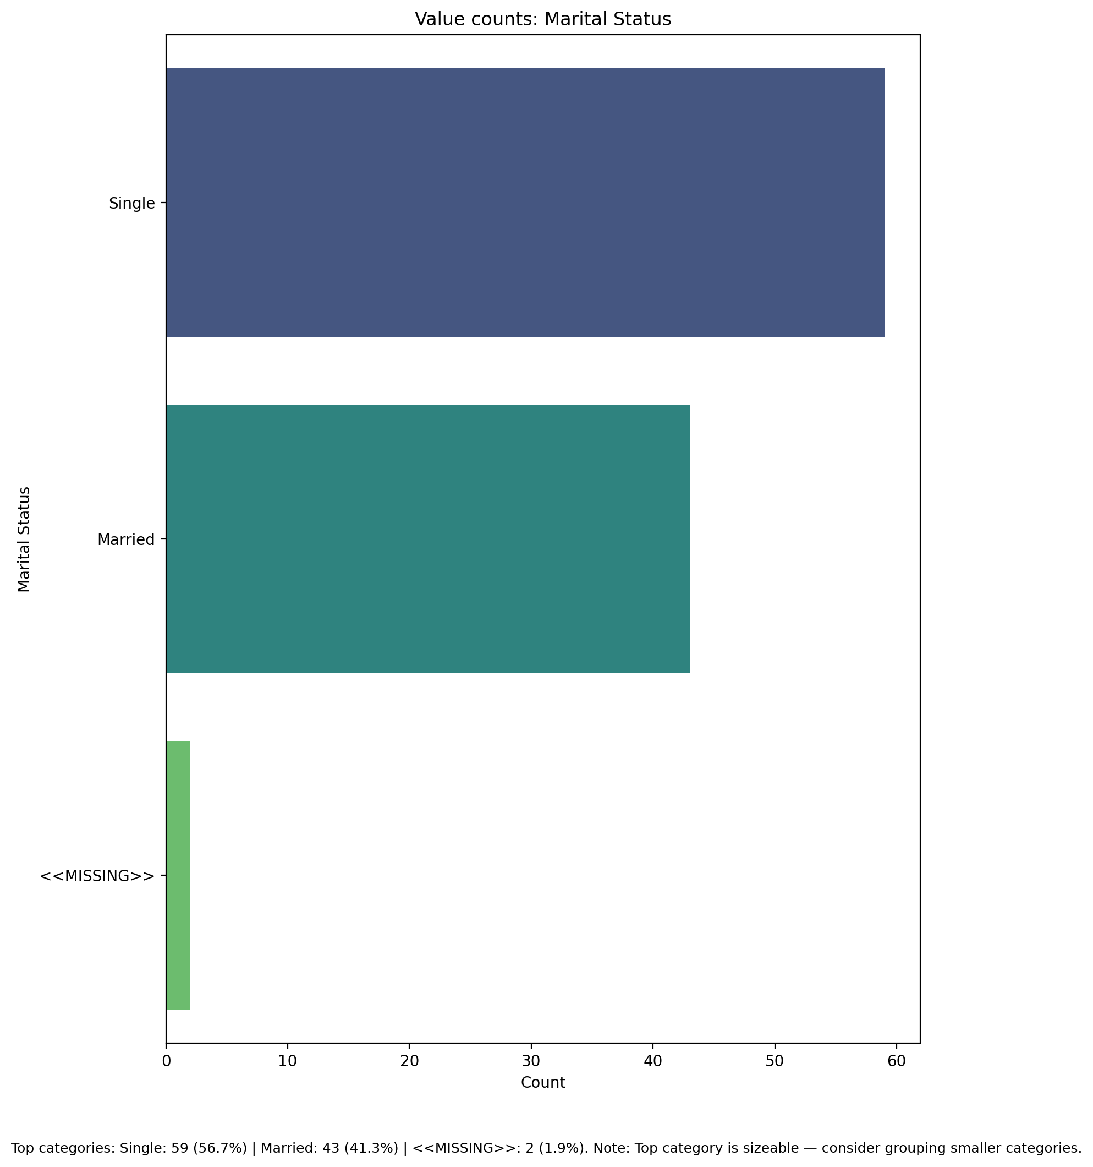

Top categories: Single: 59 (56.7%) | Married: 43 (41.3%) | <<MISSING>>: 2 (1.9%)

## Highest level of education completed

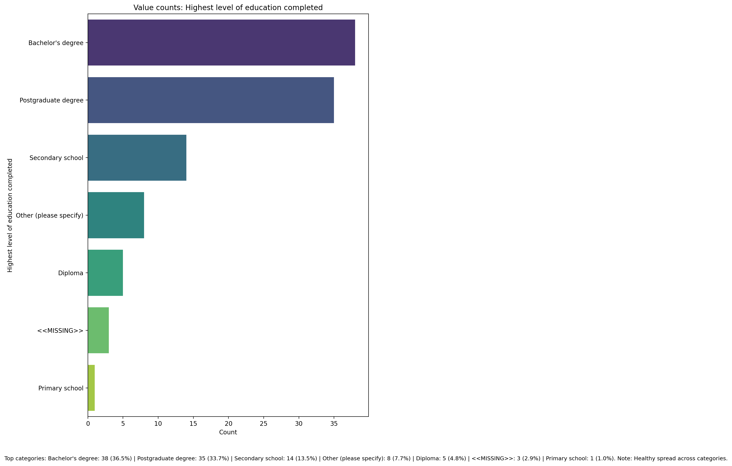

Top categories: Bachelor's degree: 38 (36.5%) | Postgraduate degree: 35 (33.7%) | Secondary school: 14 (13.5%) | Other (please specify): 8 (7.7%) | Diploma: 5 (4.8%) | <<MISSING>>: 3 (2.9%) | Primary school: 1 (1.0%)

## Current Employment Status

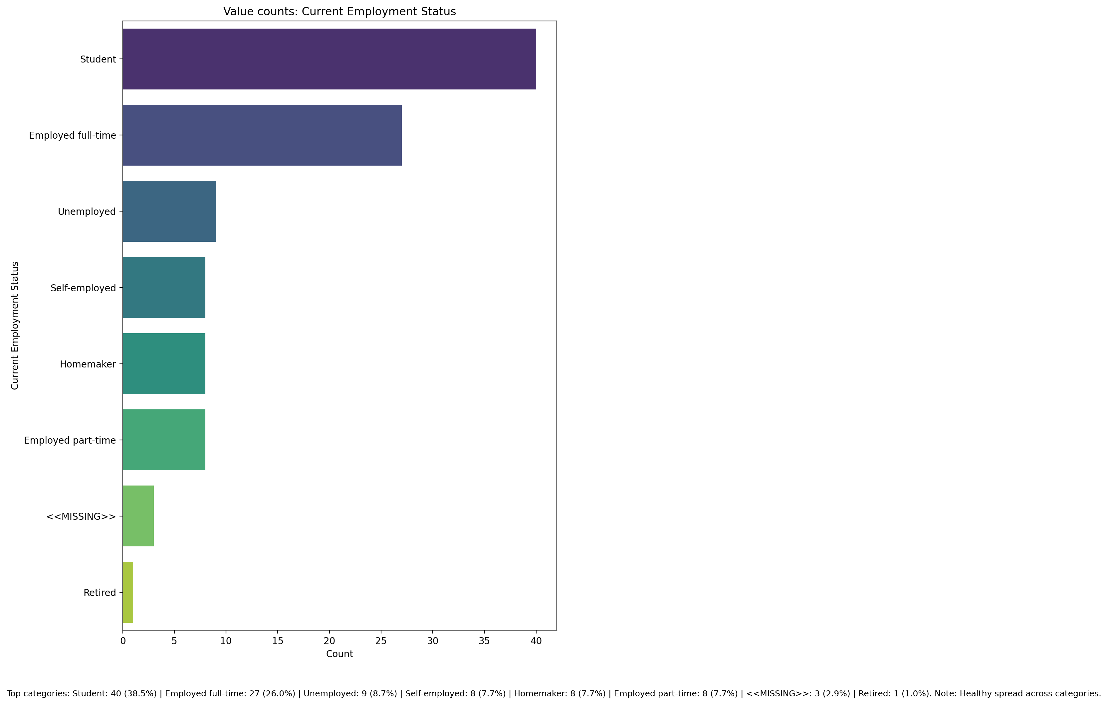

Top categories: Student: 40 (38.5%) | Employed full-time: 27 (26.0%) | Unemployed: 9 (8.7%) | Self-employed: 8 (7.7%) | Homemaker: 8 (7.7%) | Employed part-time: 8 (7.7%) | <<MISSING>>: 3 (2.9%) | Retired: 1 (1.0%)

## Number of children

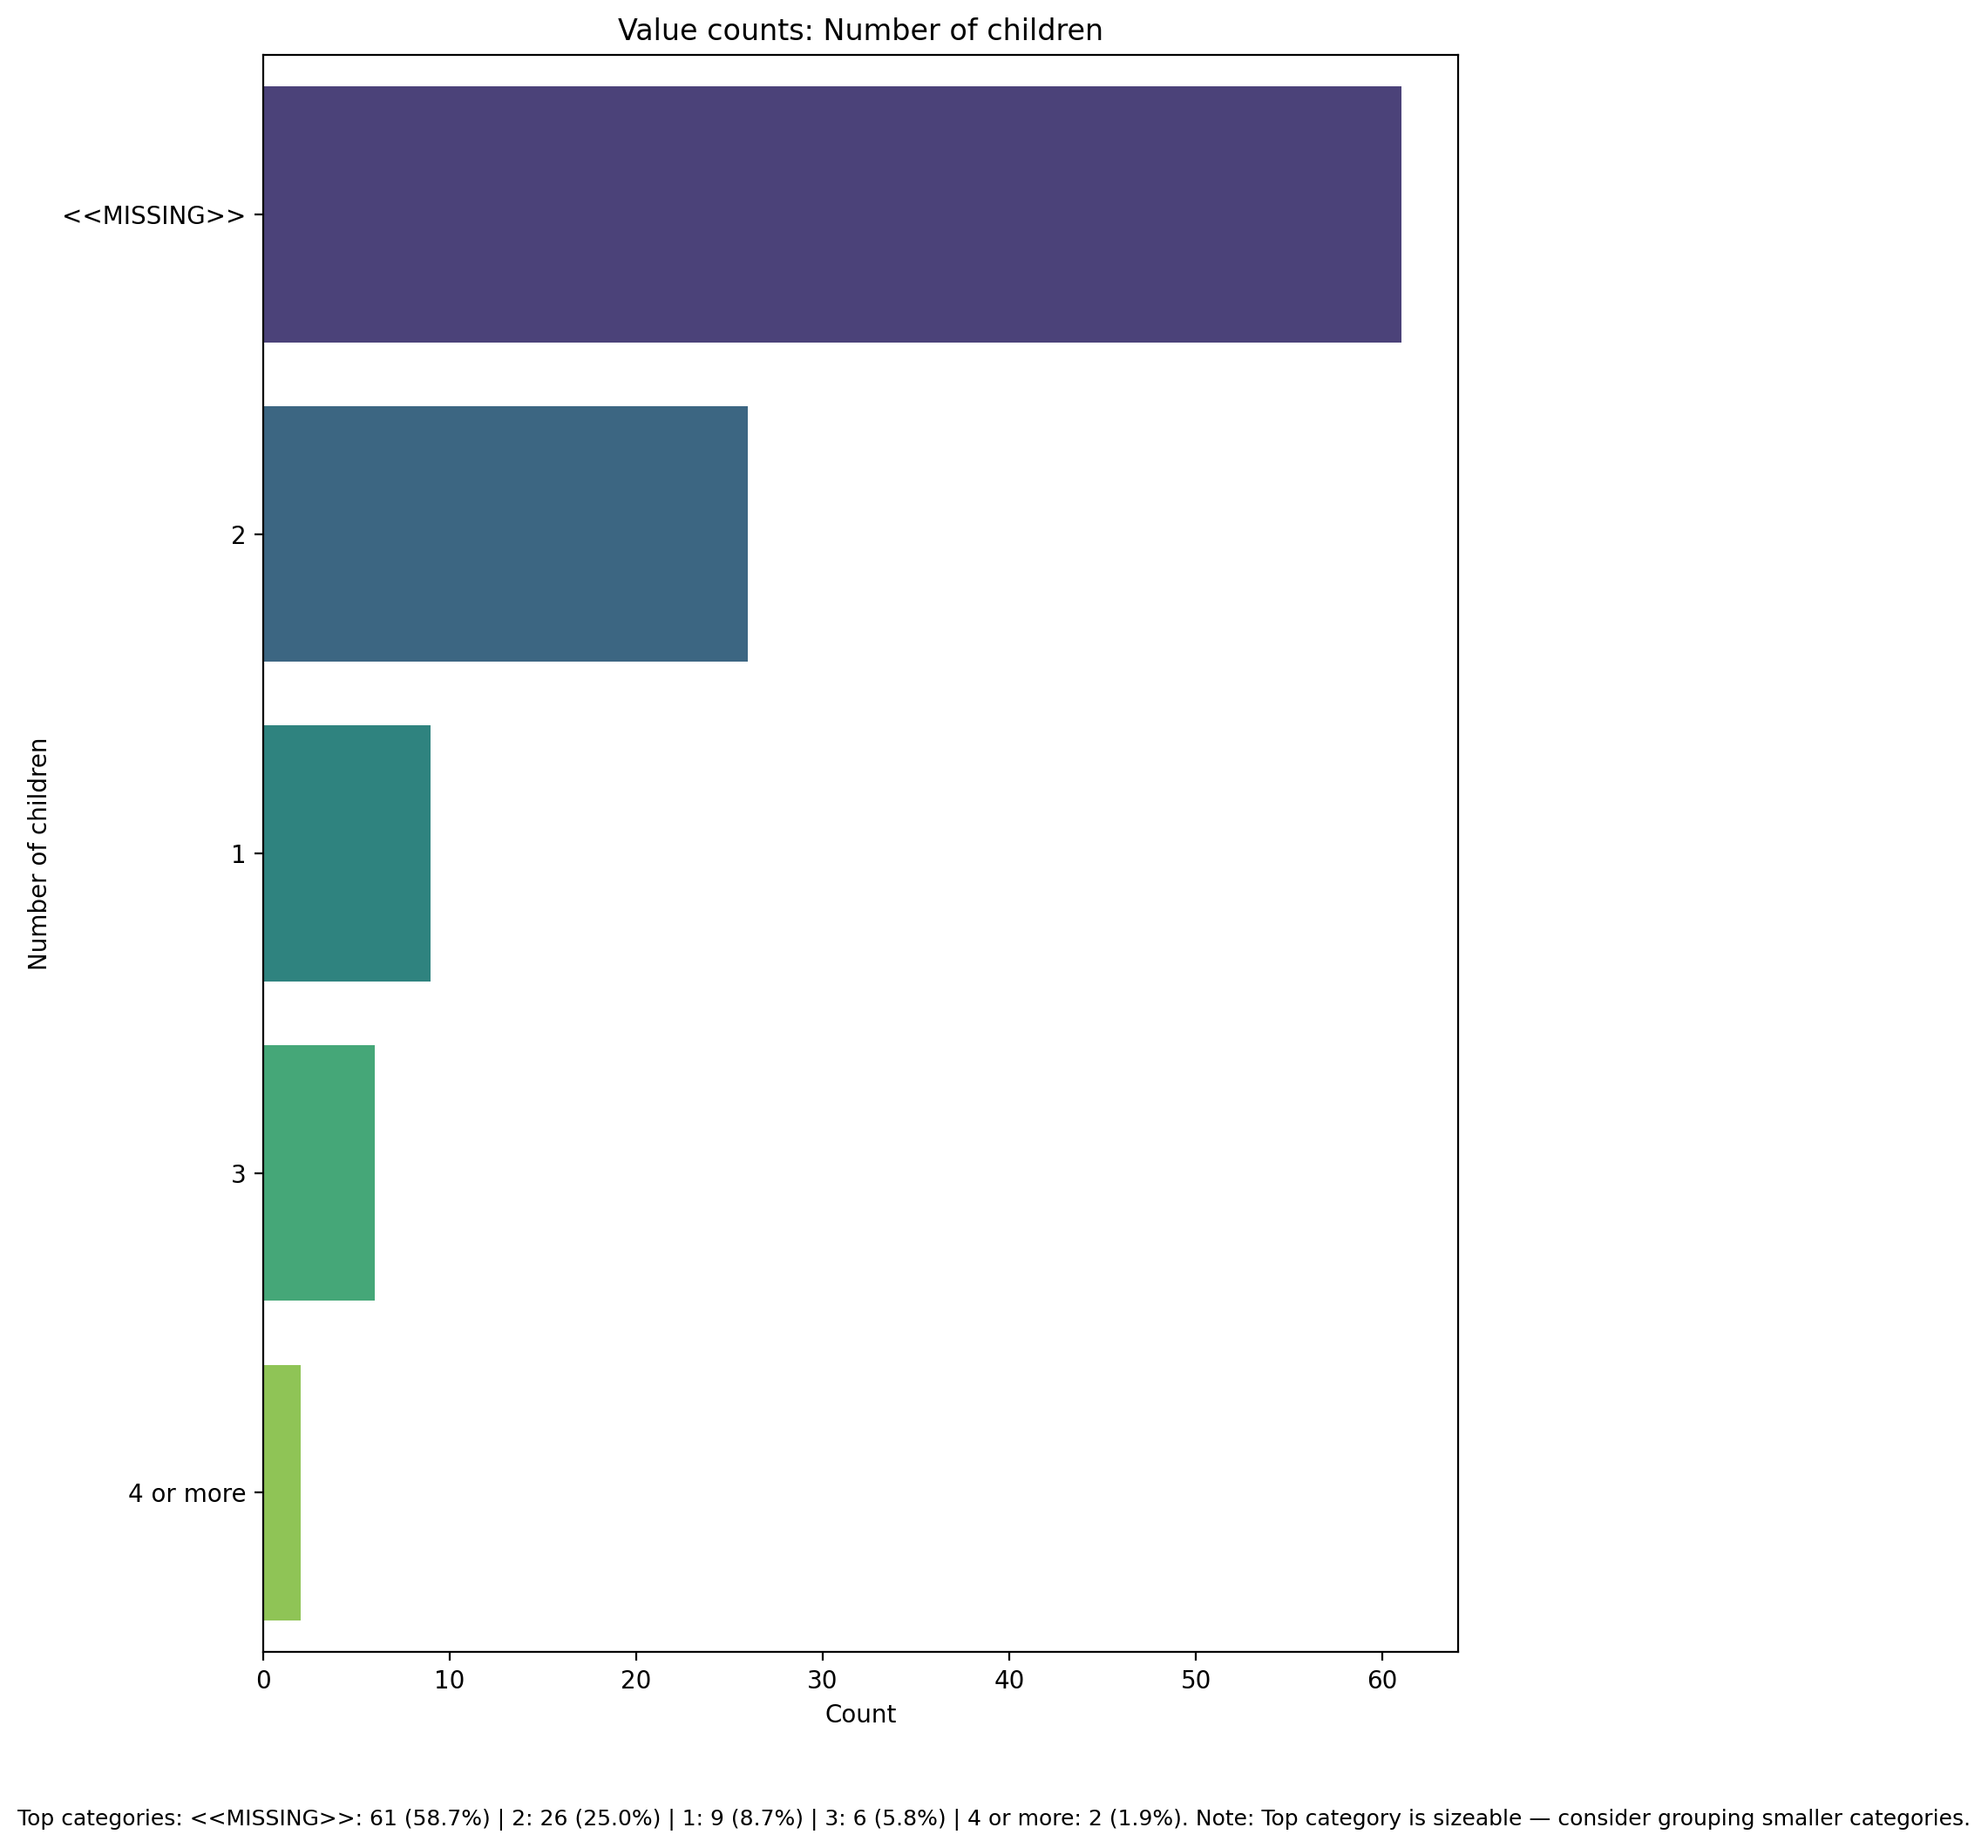

Top categories: <<MISSING>>: 61 (58.7%) | 2: 26 (25.0%) | 1: 9 (8.7%) | 3: 6 (5.8%) | 4 or more: 2 (1.9%)

## Type of family structure

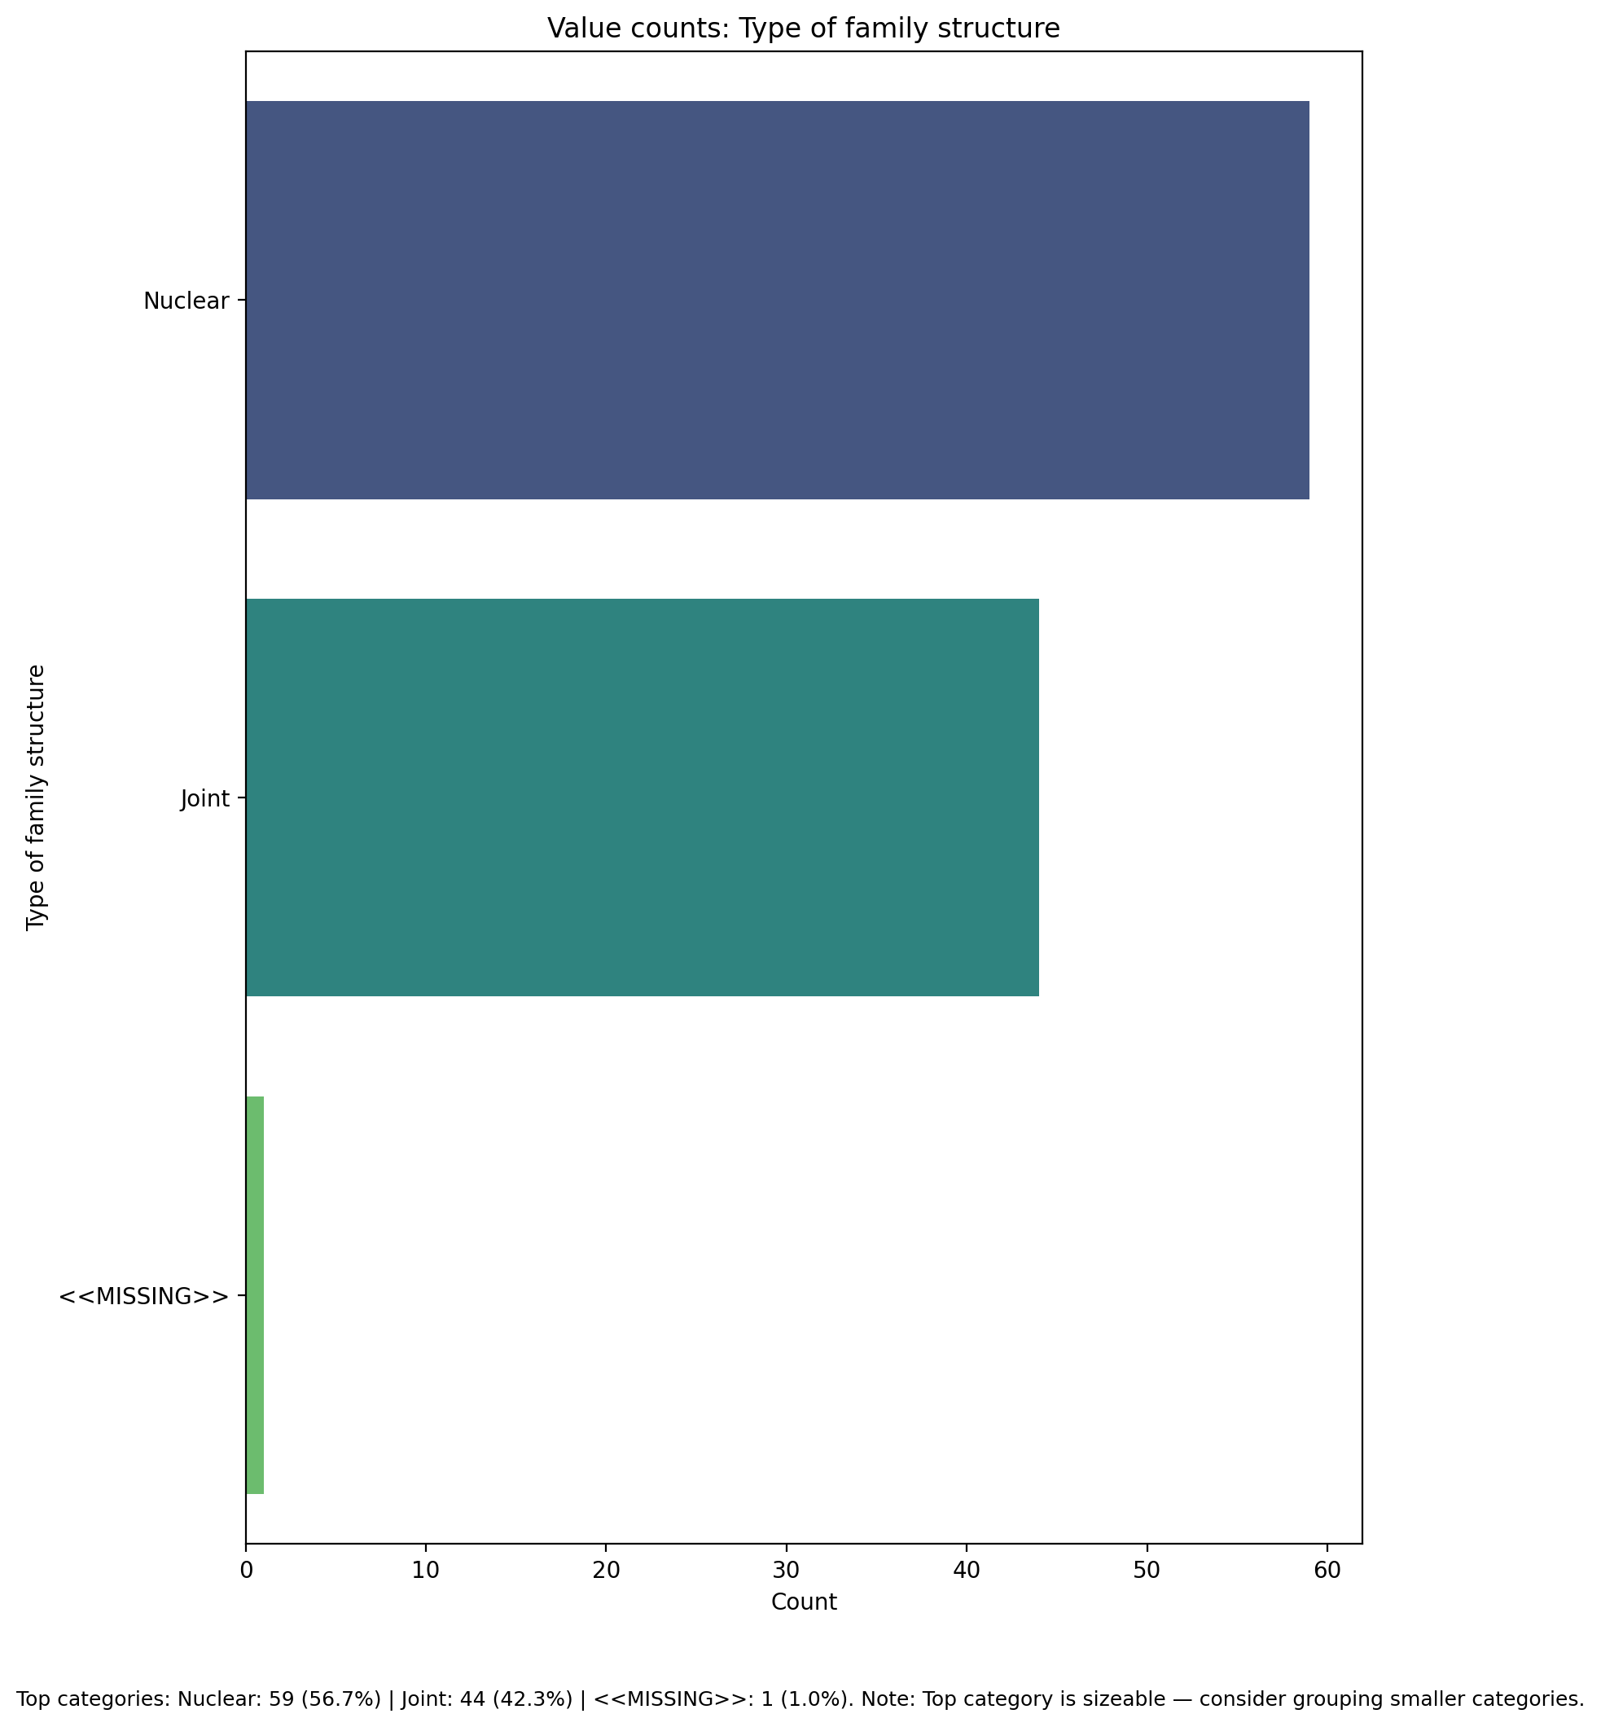

Top categories: Nuclear: 59 (56.7%) | Joint: 44 (42.3%) | <<MISSING>>: 1 (1.0%)

## Monthly household income

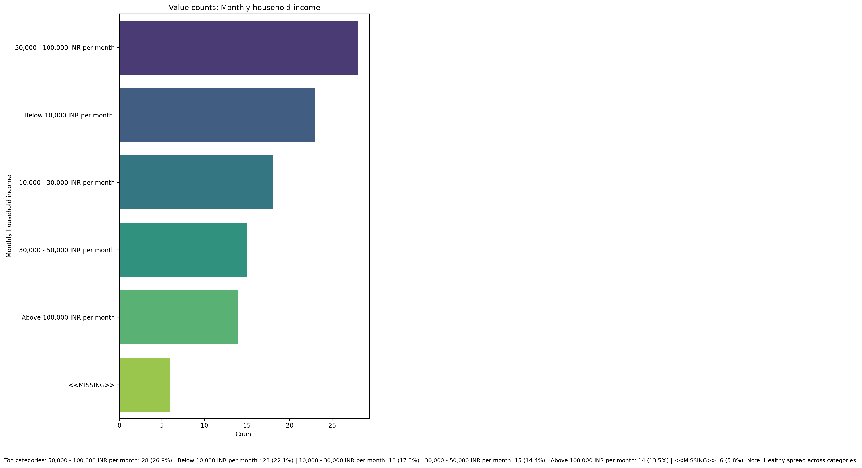

Top categories: 50,000 - 100,000 INR per month: 28 (26.9%) | Below 10,000 INR per month : 23 (22.1%) | 10,000 - 30,000 INR per month: 18 (17.3%) | 30,000 - 50,000 INR per month: 15 (14.4%) | Above 100,000 INR per month: 14 (13.5%) | <<MISSING>>: 6 (5.8%)

## Access to healthcare services

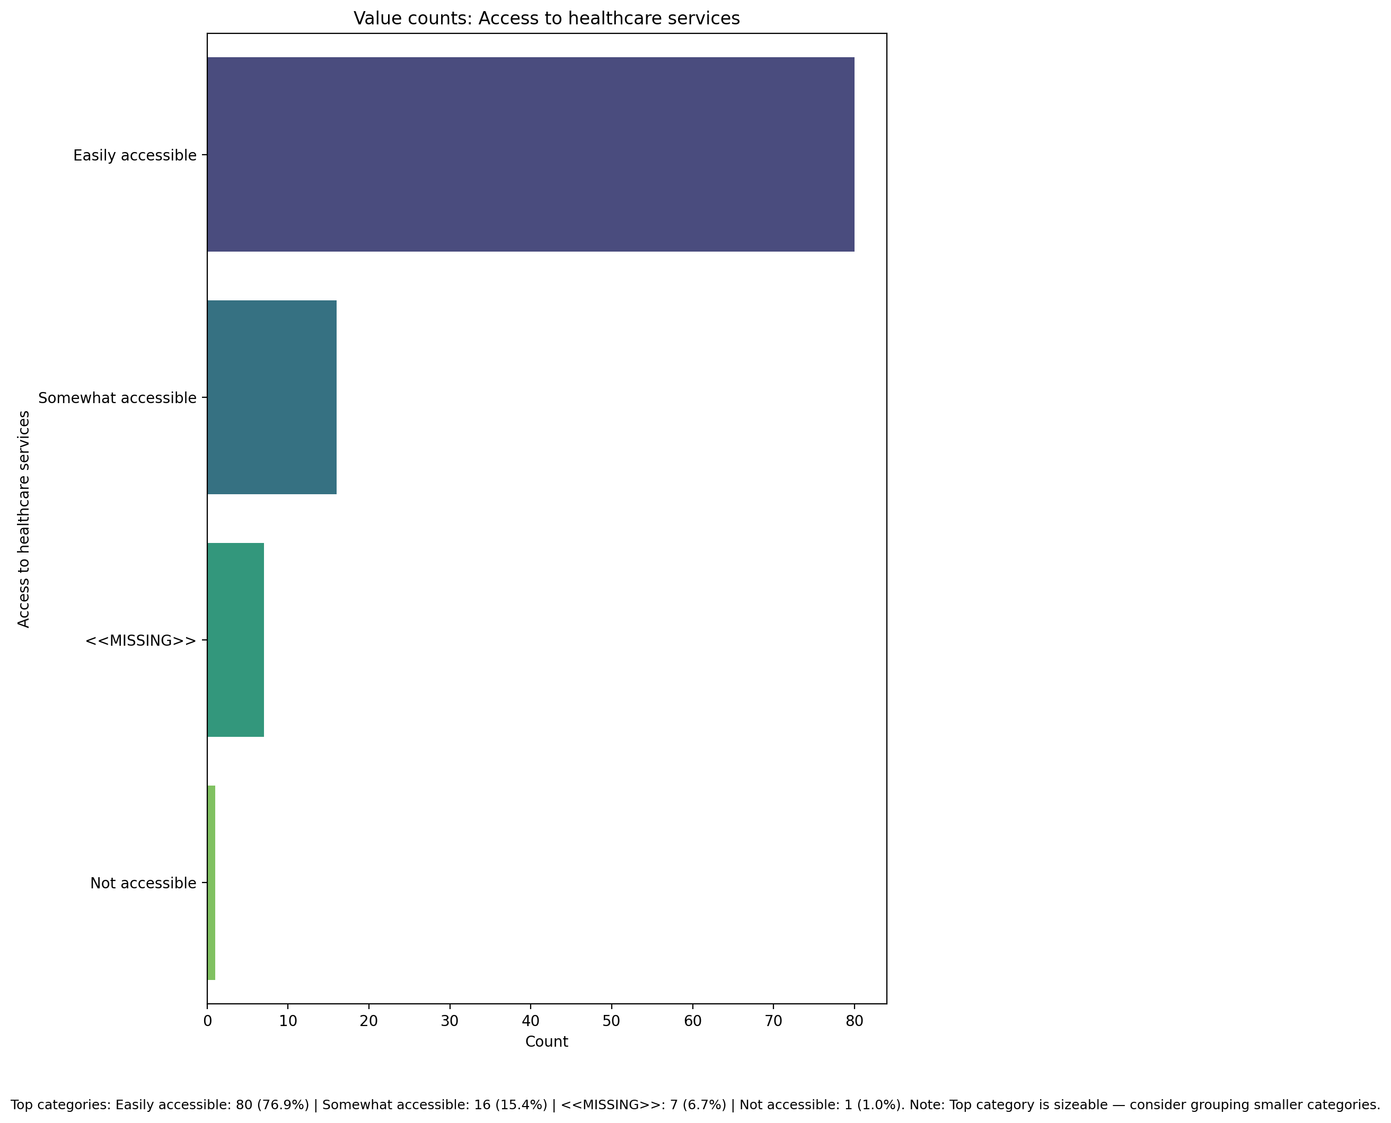

Top categories: Easily accessible: 80 (76.9%) | Somewhat accessible: 16 (15.4%) | <<MISSING>>: 7 (6.7%) | Not accessible: 1 (1.0%)

## Overall health status

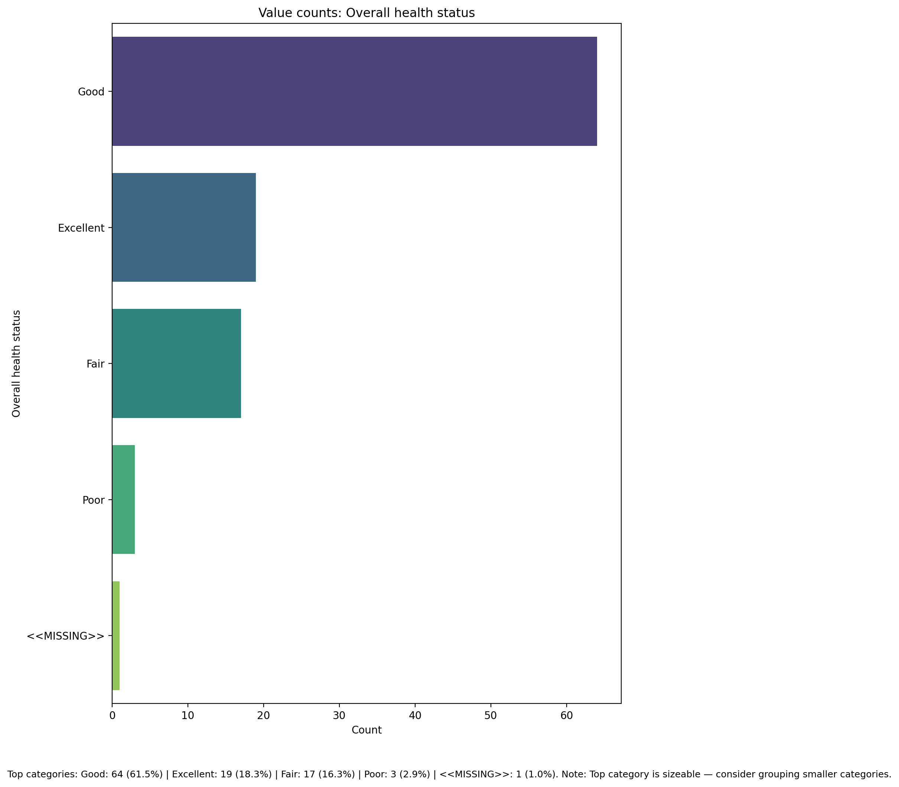

Top categories: Good: 64 (61.5%) | Excellent: 19 (18.3%) | Fair: 17 (16.3%) | Poor: 3 (2.9%) | <<MISSING>>: 1 (1.0%)

## Are you covered by health insurance?

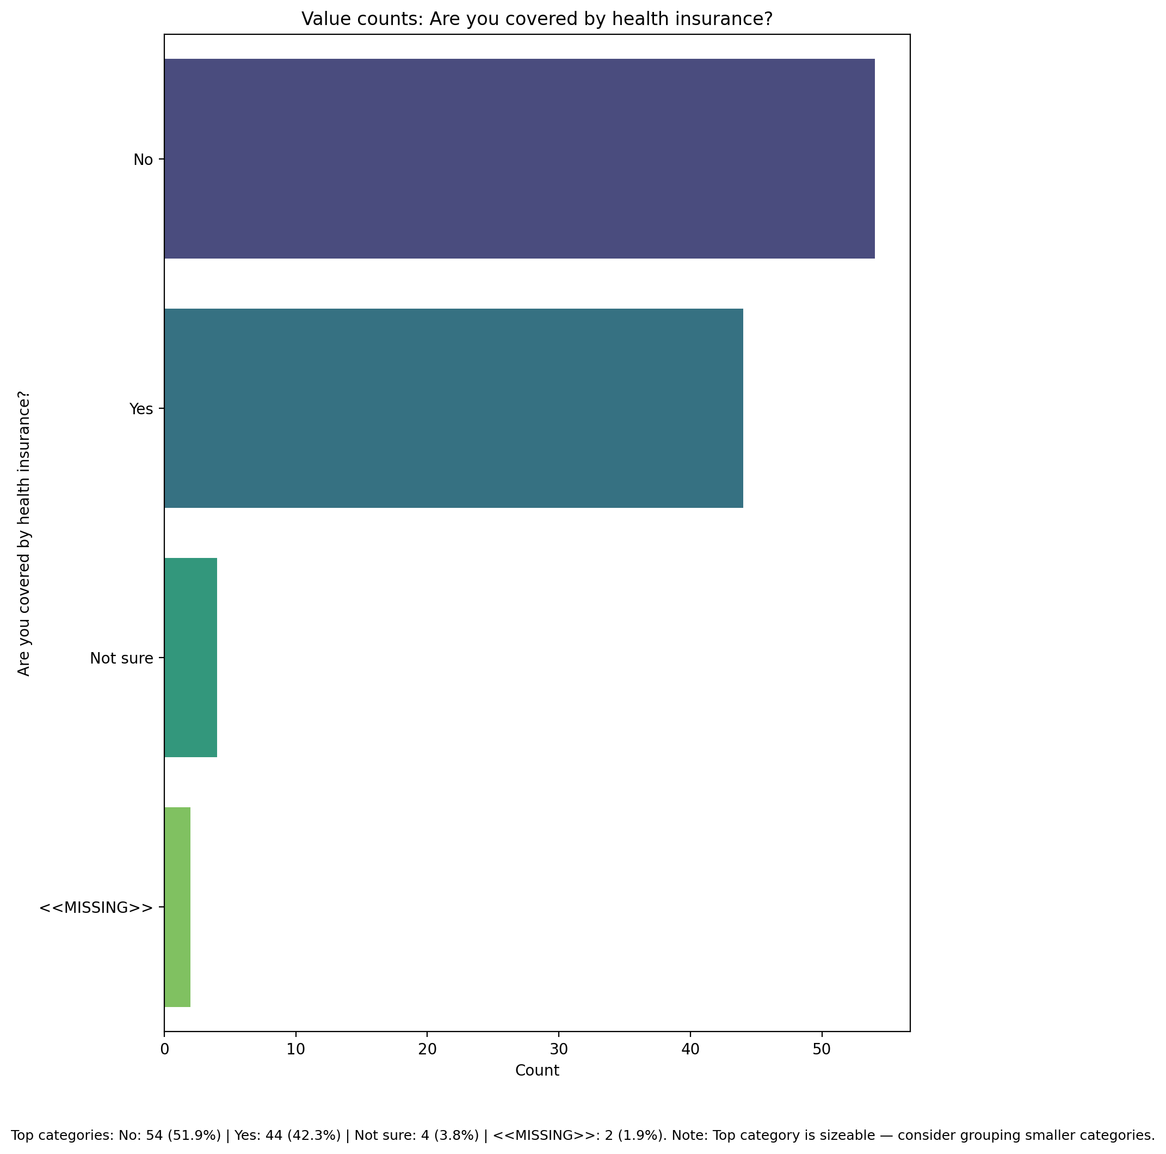

Top categories: No: 54 (51.9%) | Yes: 44 (42.3%) | Not sure: 4 (3.8%) | <<MISSING>>: 2 (1.9%)

## Participation in community or social activities

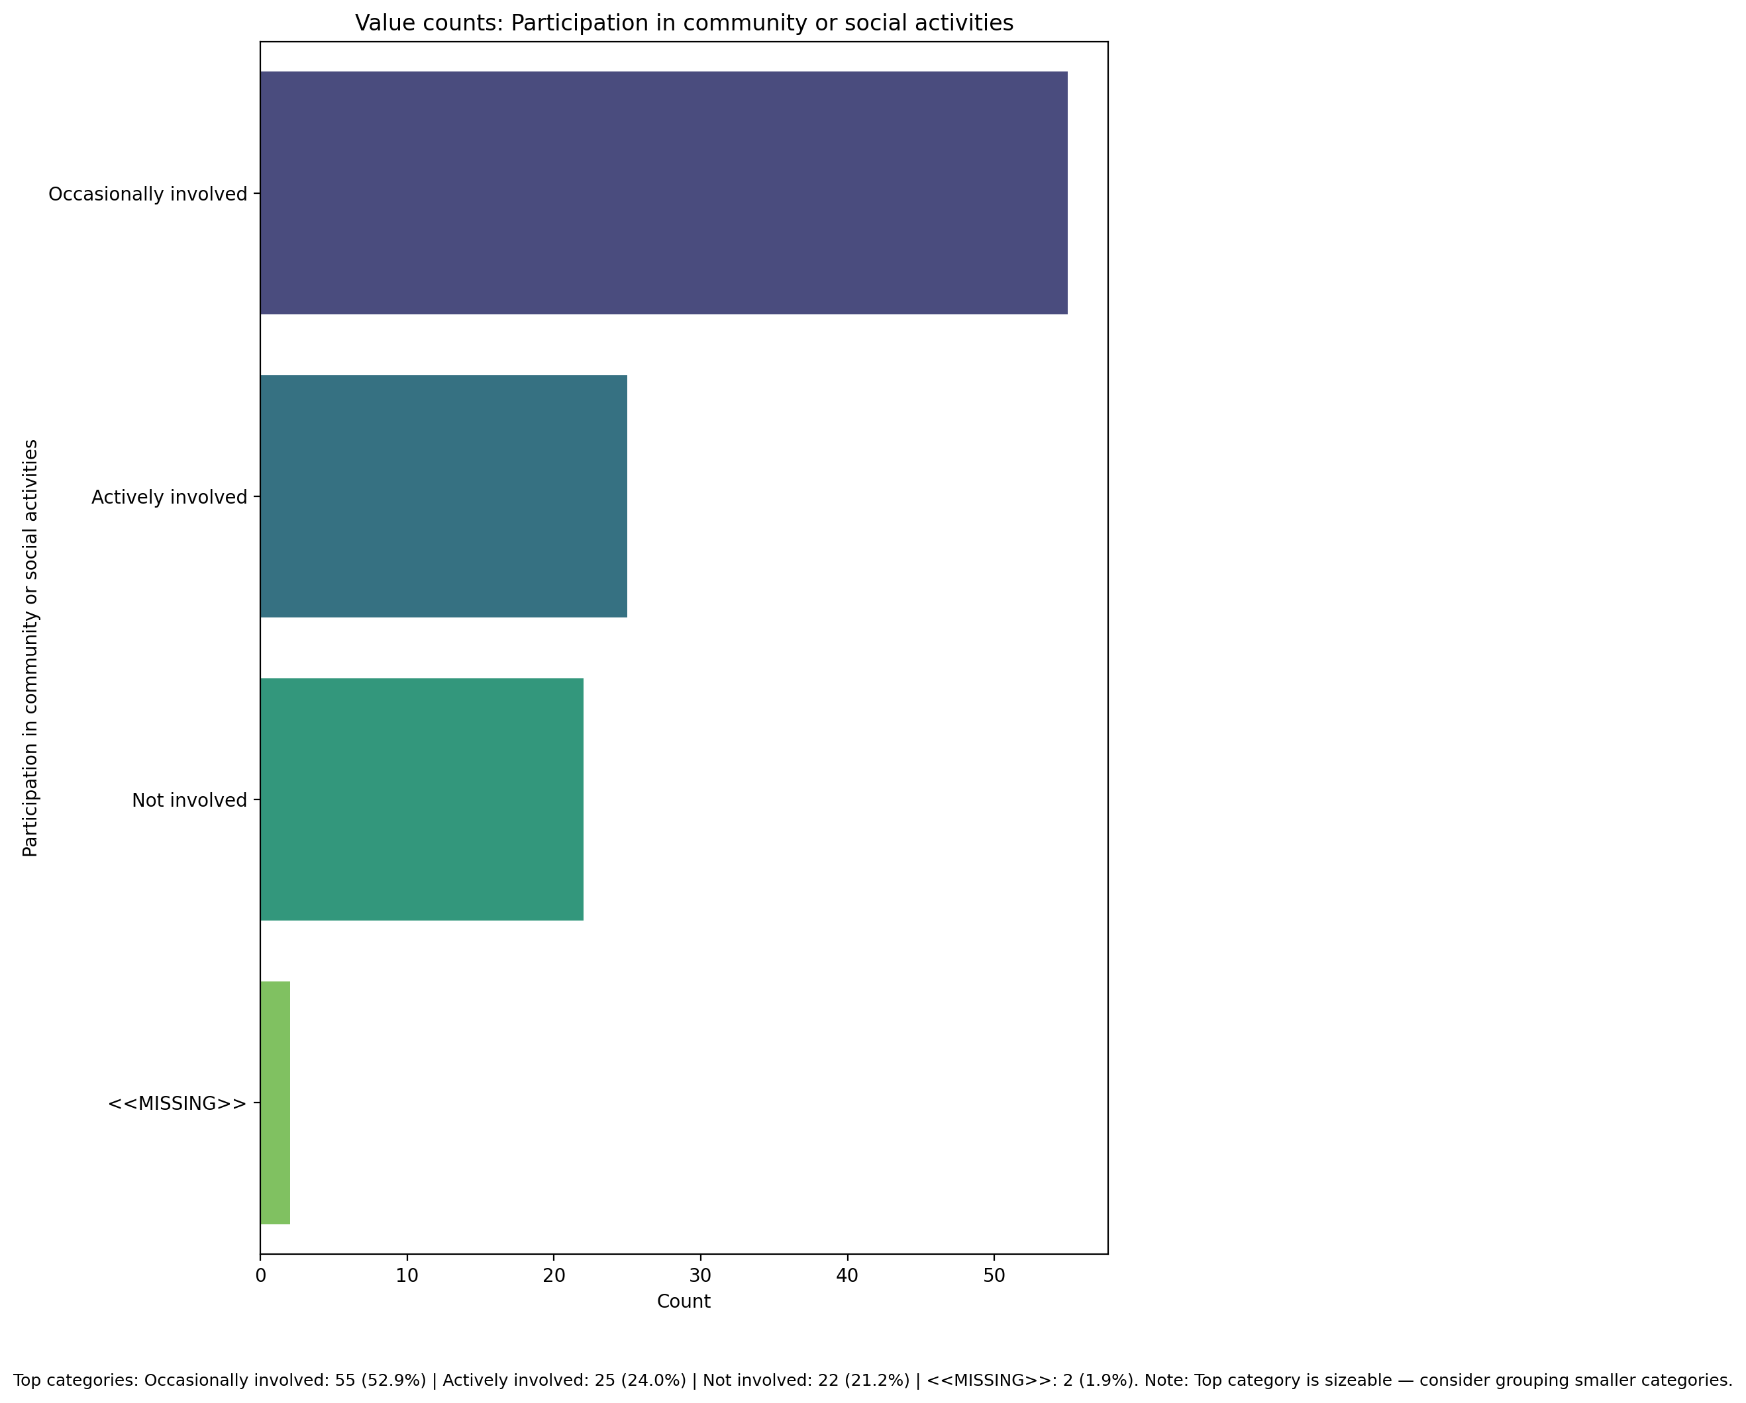

Top categories: Occasionally involved: 55 (52.9%) | Actively involved: 25 (24.0%) | Not involved: 22 (21.2%) | <<MISSING>>: 2 (1.9%)

## Functional Impairment - Raw Score

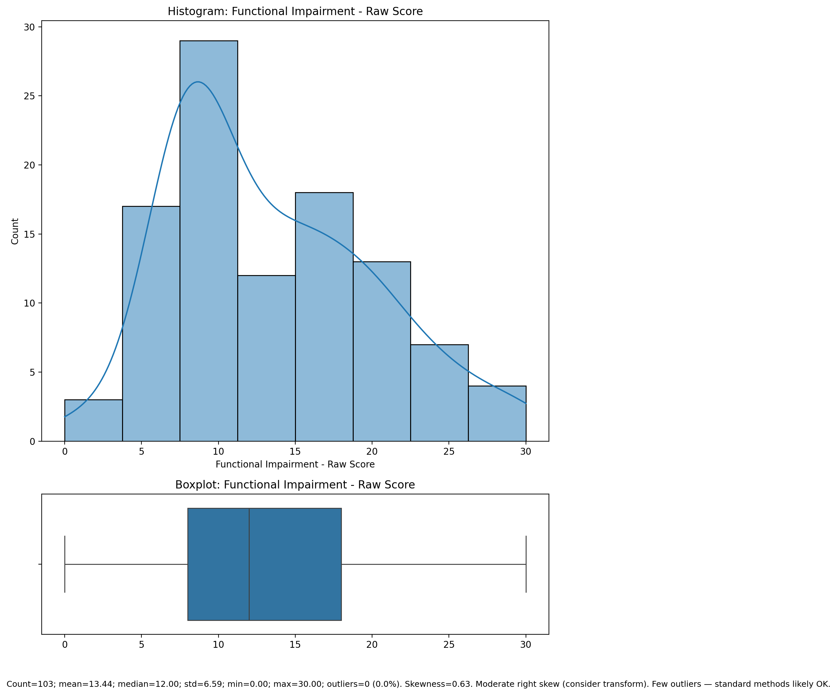

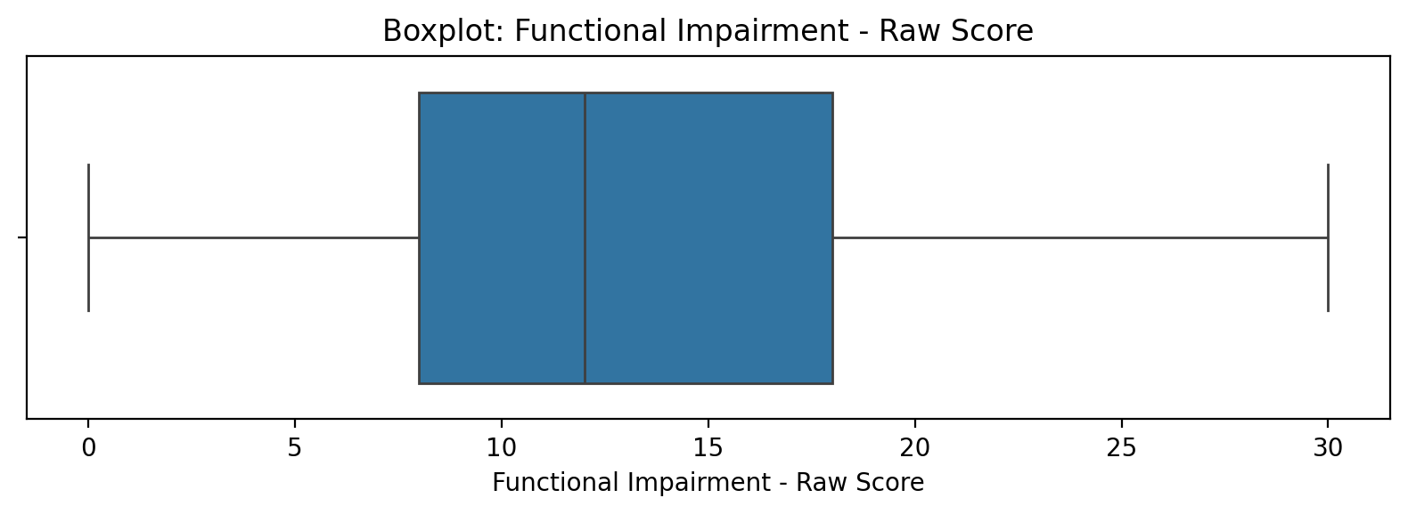

Count=103; mean=13.44; median=12.00; std=6.59; min=0.00; max=30.00; outliers=0 (0.0%). Skewness=0.63.

## Withdrawl - Raw Score

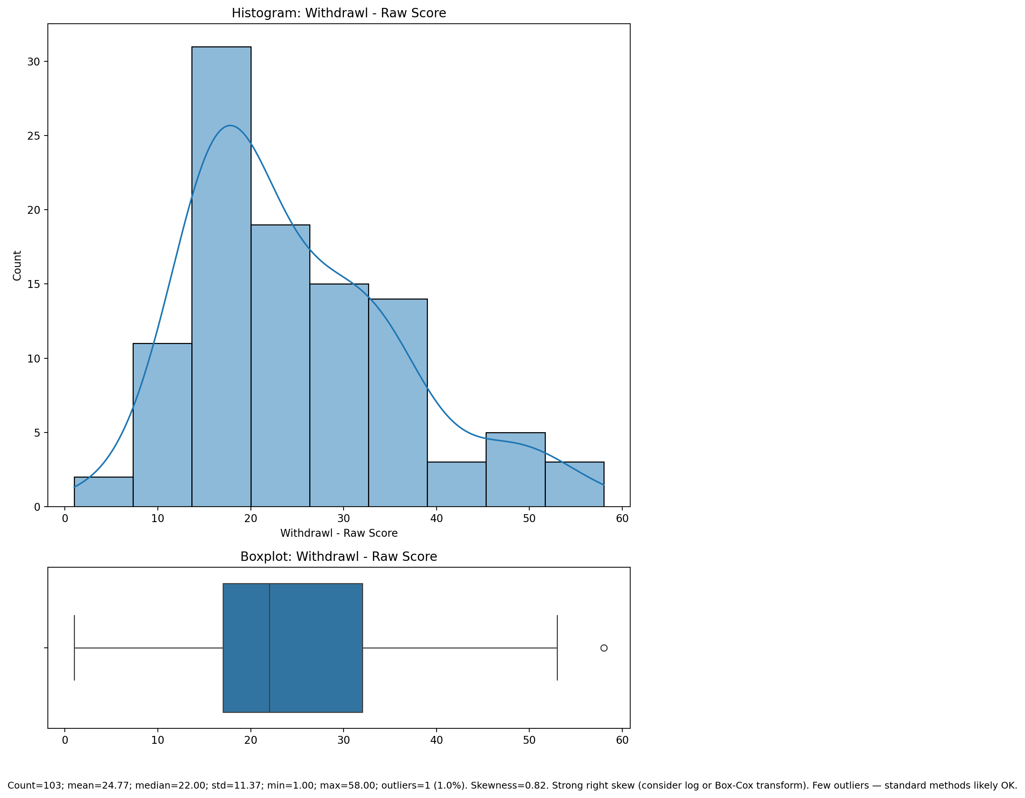

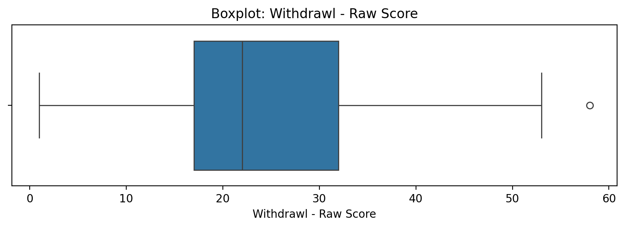

Count=103; mean=24.77; median=22.00; std=11.37; min=1.00; max=58.00; outliers=1 (1.0%). Skewness=0.82.

## Occupational & Relationship Consequences - Raw Score

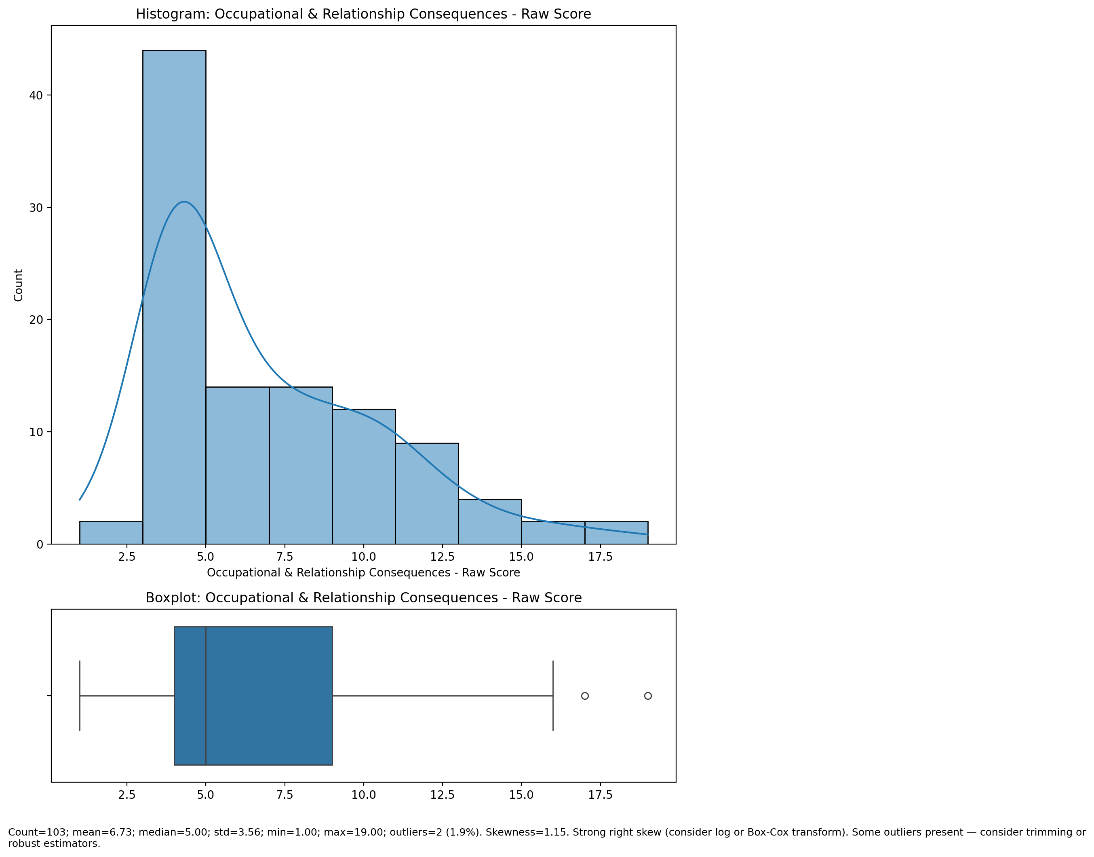

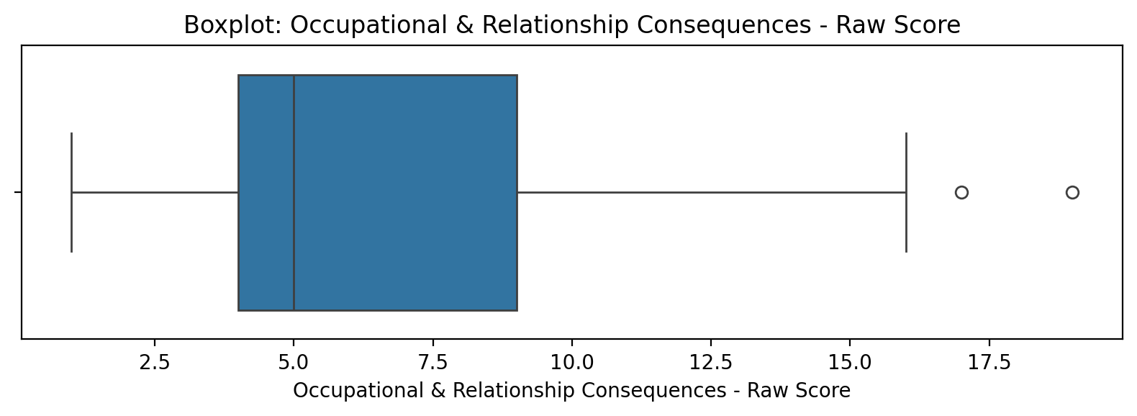

Count=103; mean=6.73; median=5.00; std=3.56; min=1.00; max=19.00; outliers=2 (1.9%). Skewness=1.15.

## Compulsive Behaviour - Raw Score

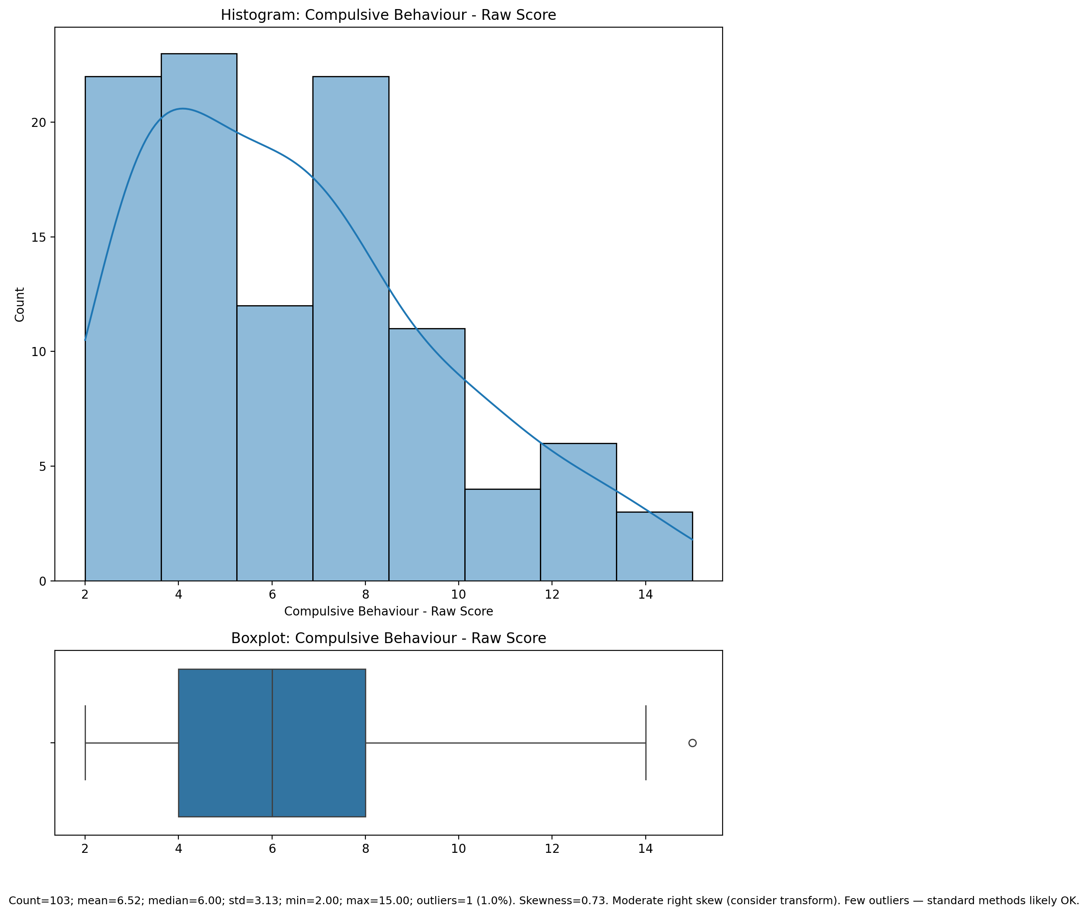

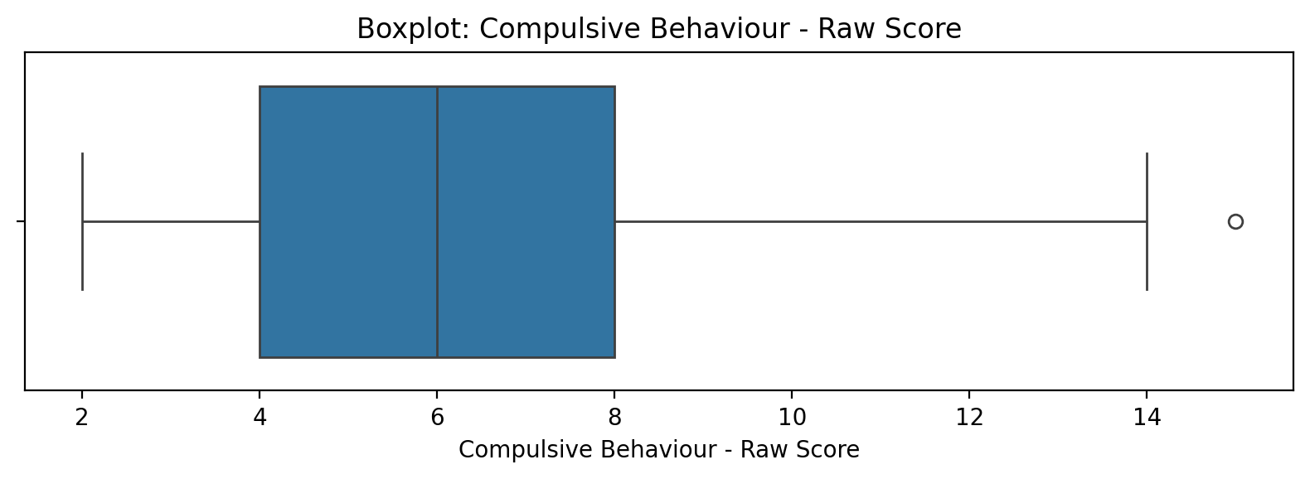

Count=103; mean=6.52; median=6.00; std=3.13; min=2.00; max=15.00; outliers=1 (1.0%). Skewness=0.73.

## Obsession with Internet - Raw Score

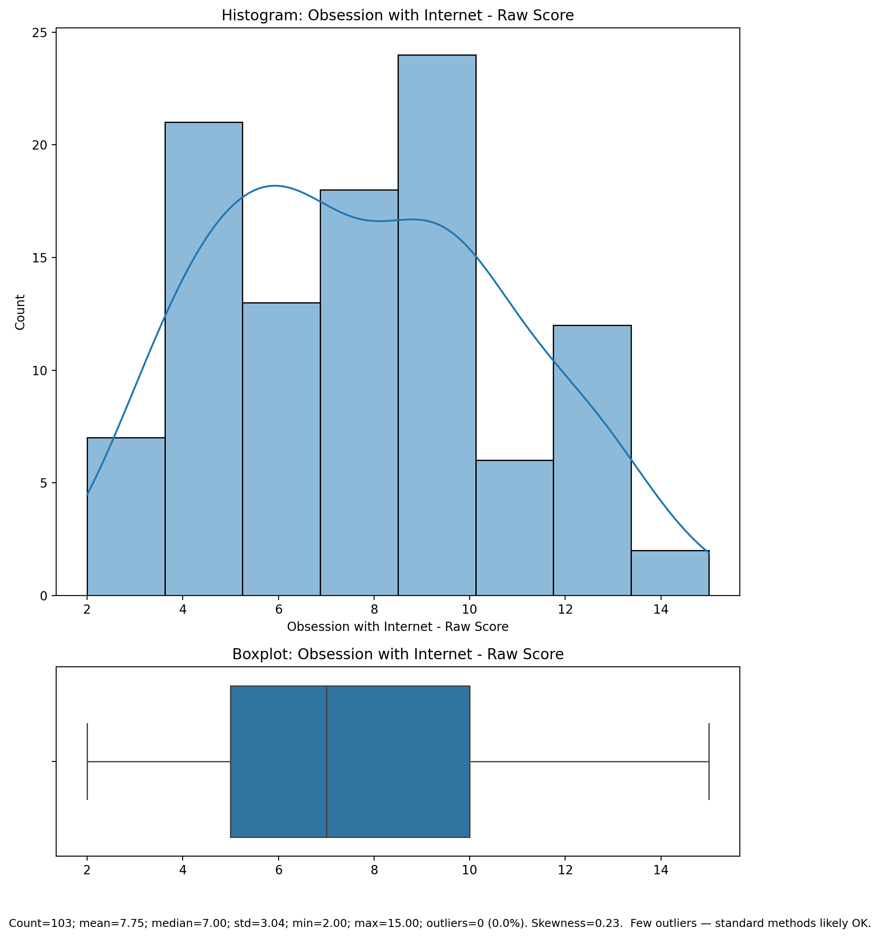

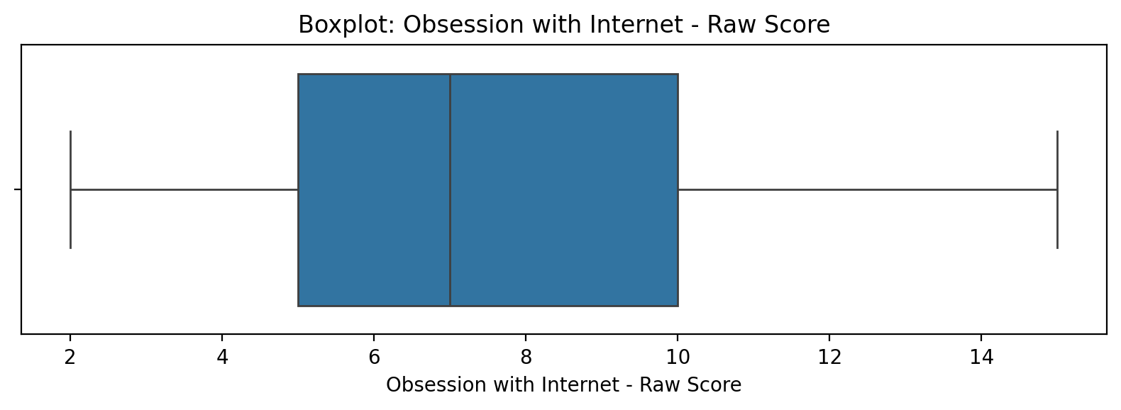

Count=103; mean=7.75; median=7.00; std=3.04; min=2.00; max=15.00; outliers=0 (0.0%). Skewness=0.23.

## Internet as a Source of Recreation - Raw Score

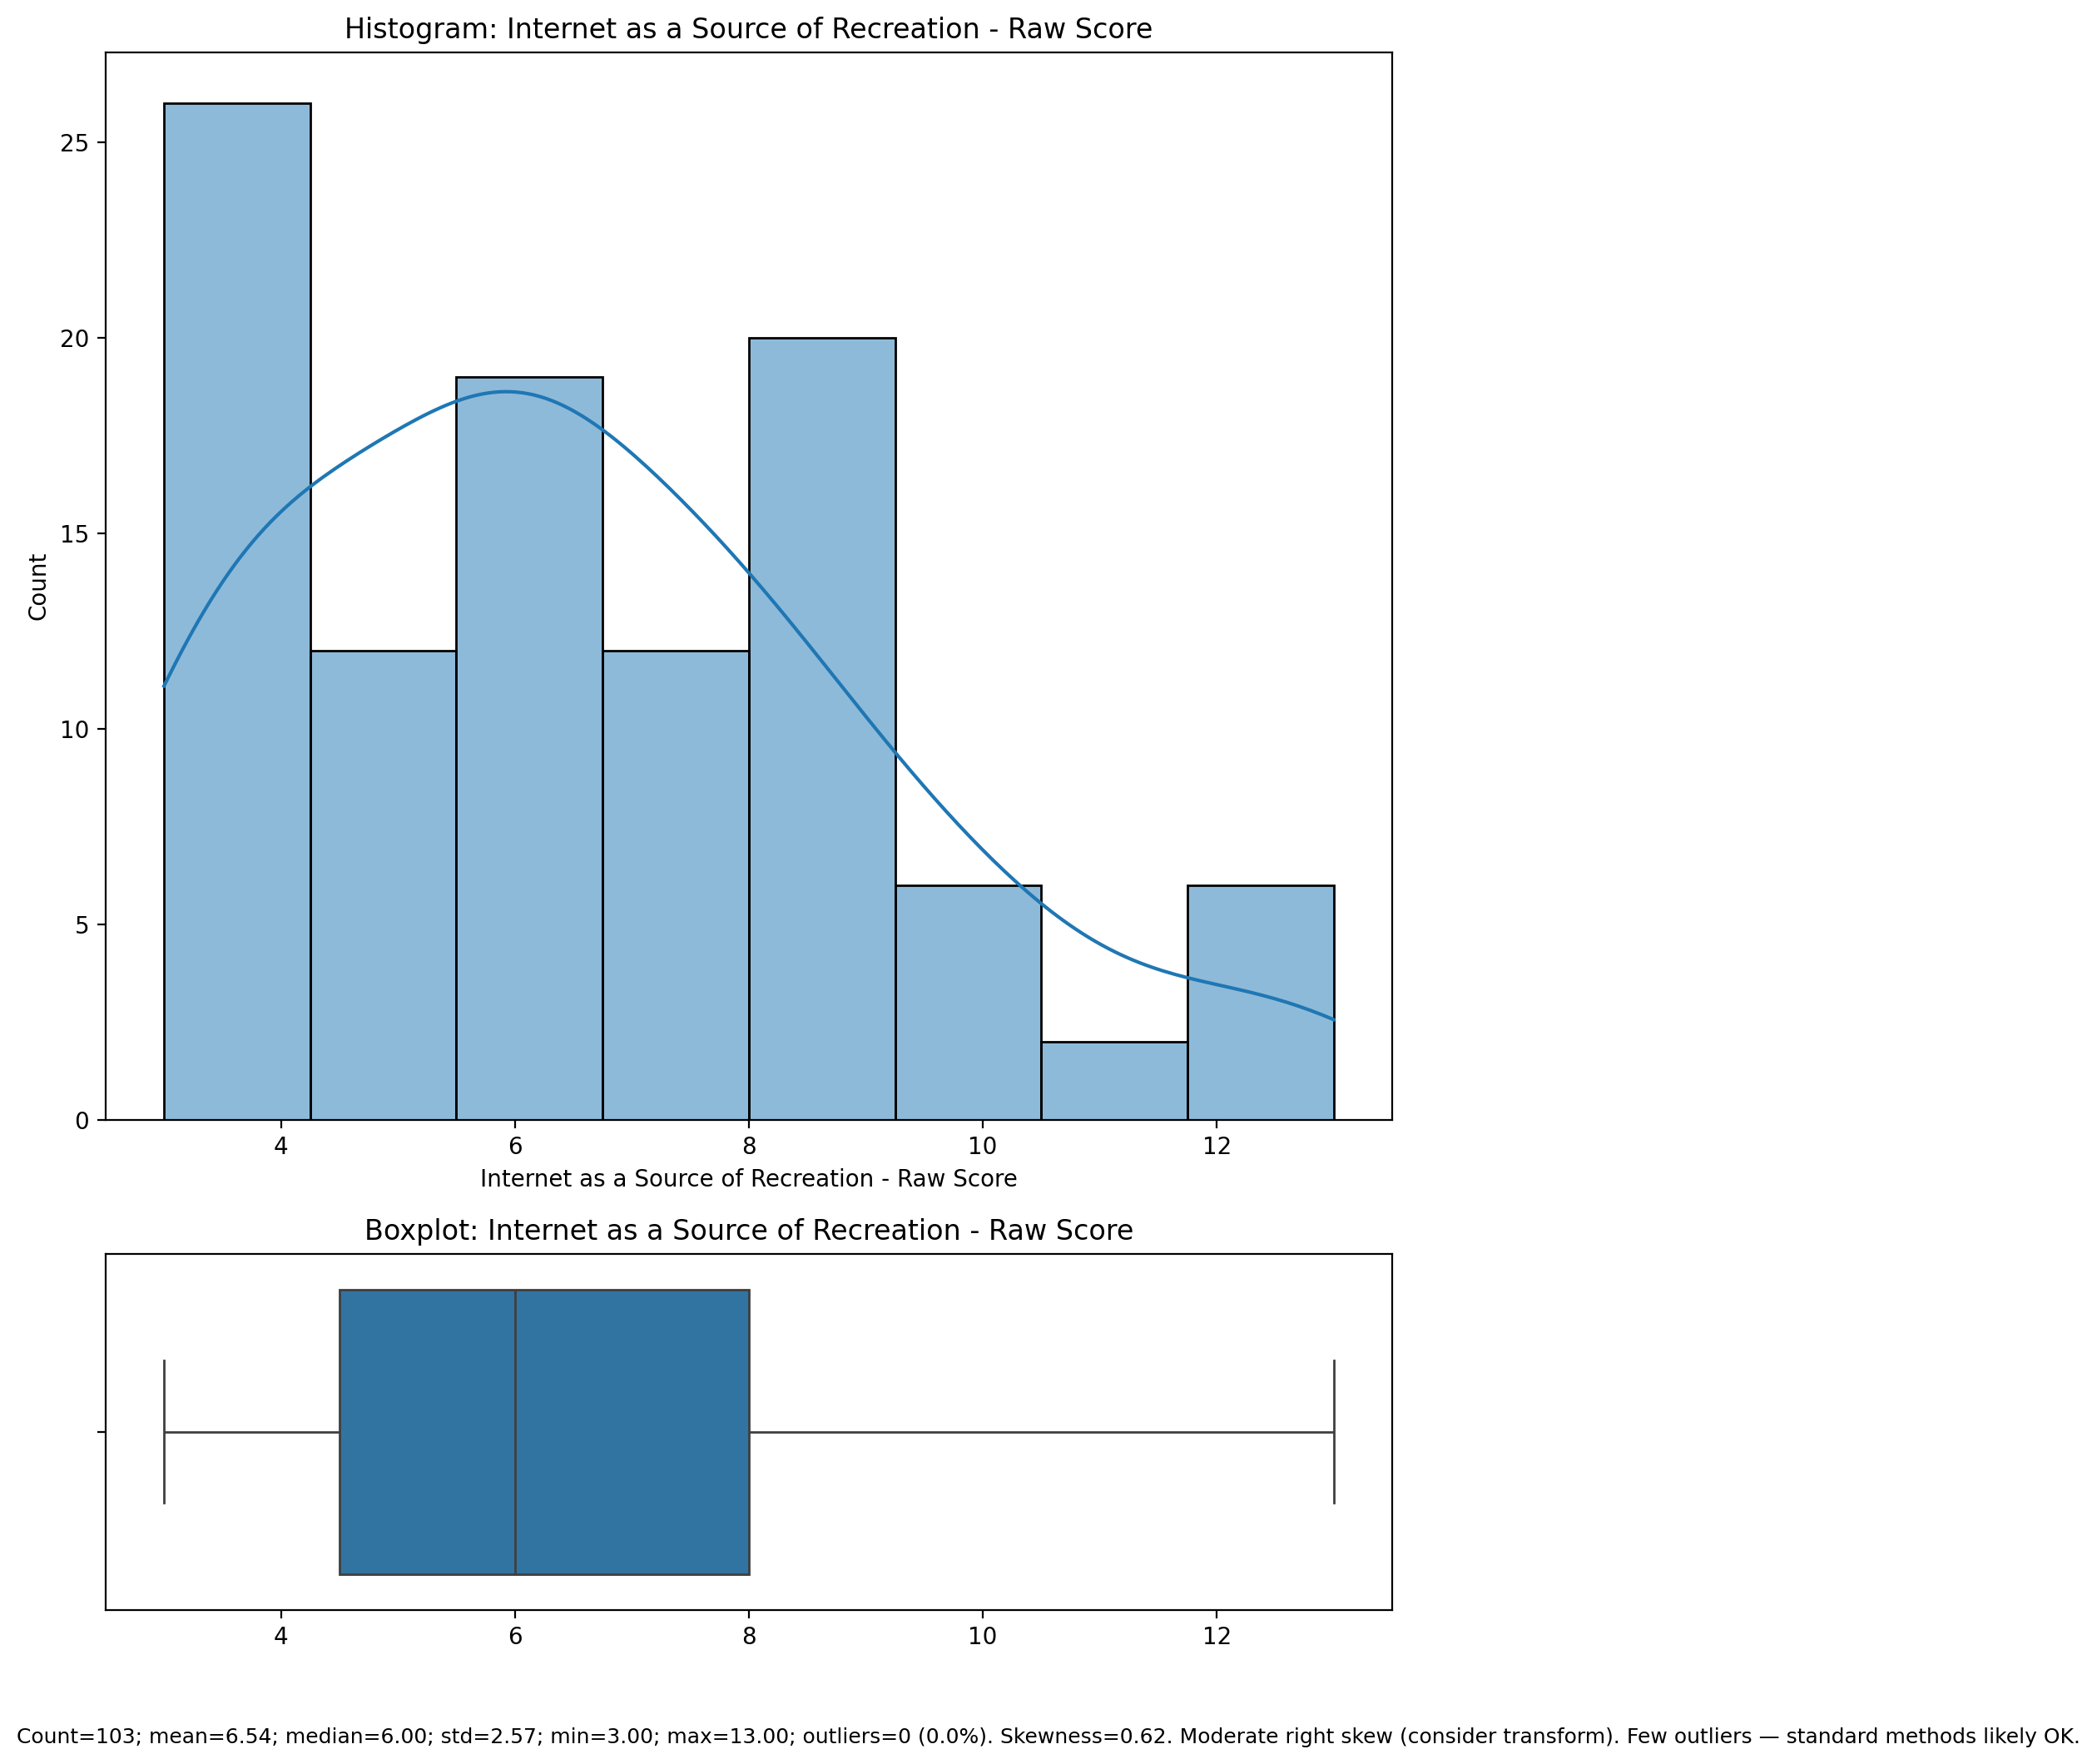

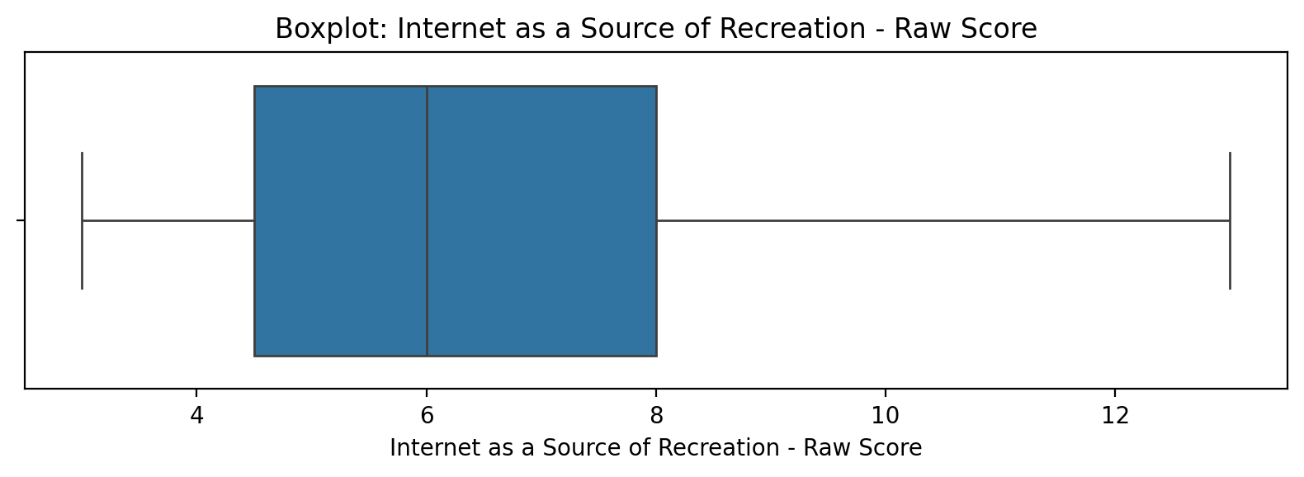

Count=103; mean=6.54; median=6.00; std=2.57; min=3.00; max=13.00; outliers=0 (0.0%). Skewness=0.62.

## Enhanced Socialization - Raw Score

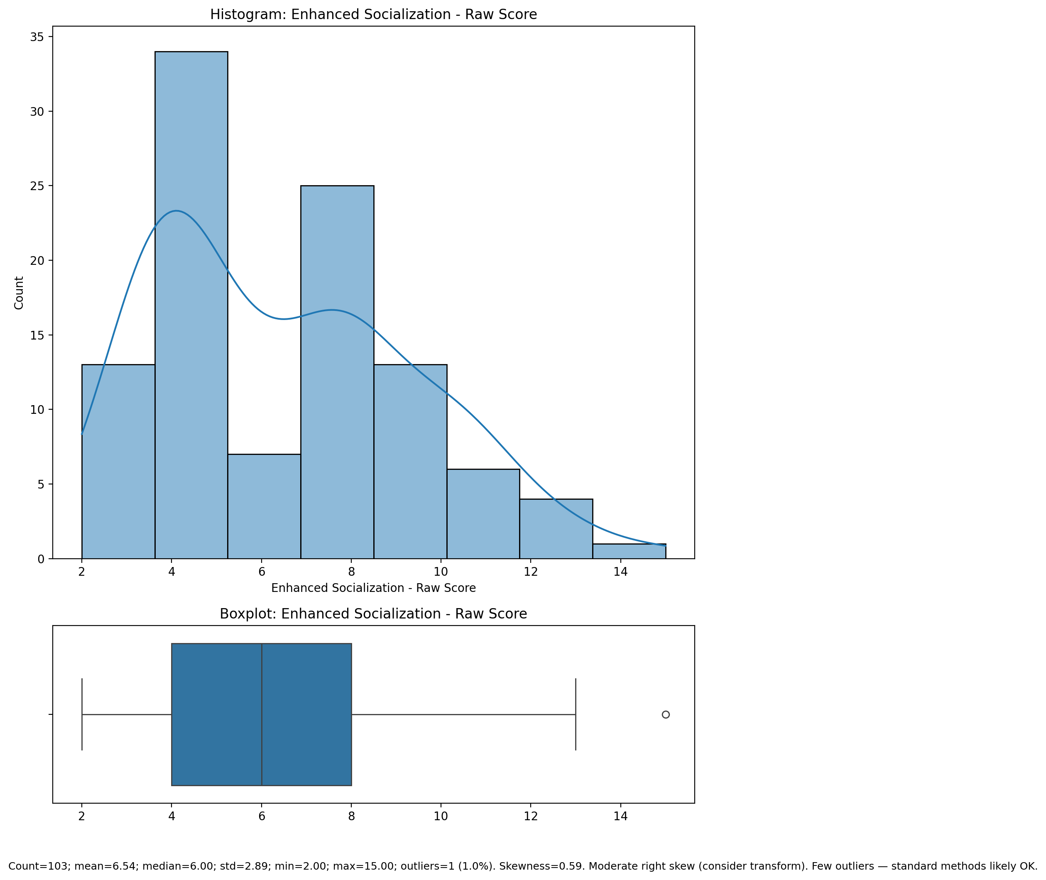

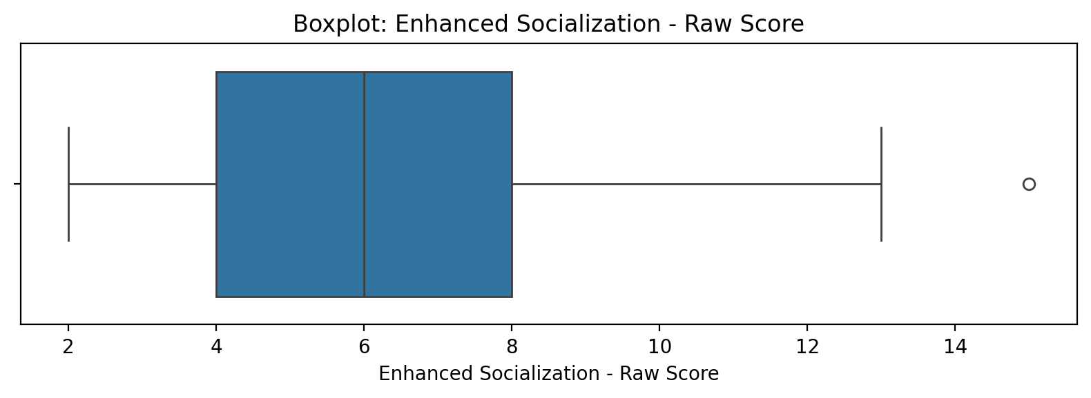

Count=103; mean=6.54; median=6.00; std=2.89; min=2.00; max=15.00; outliers=1 (1.0%). Skewness=0.59.

## Perceived Control of Internet Use - Raw Score

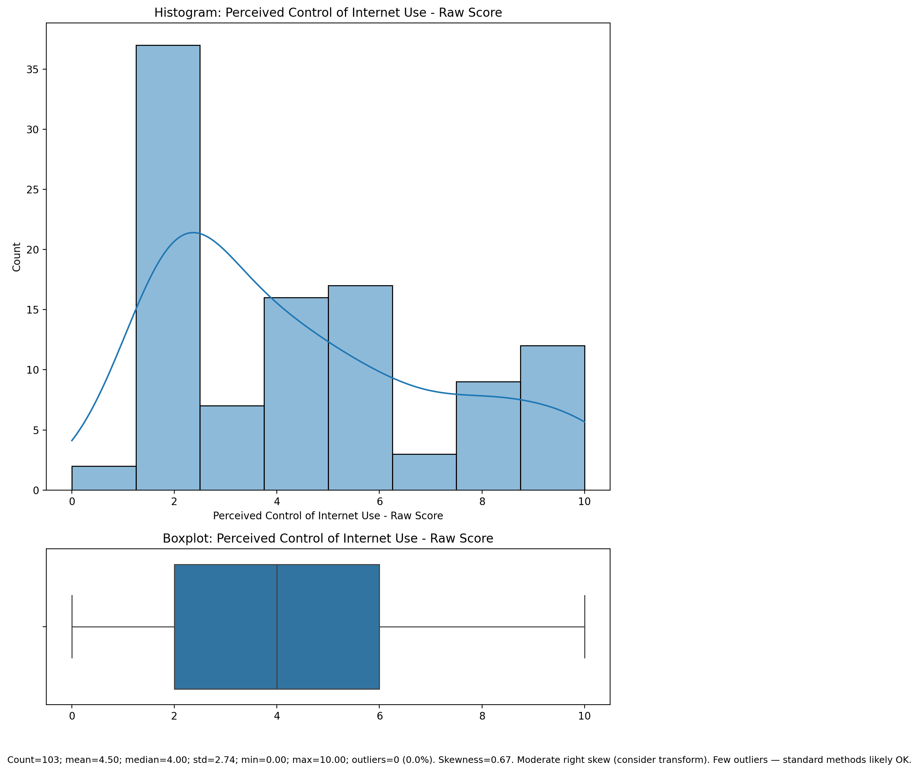

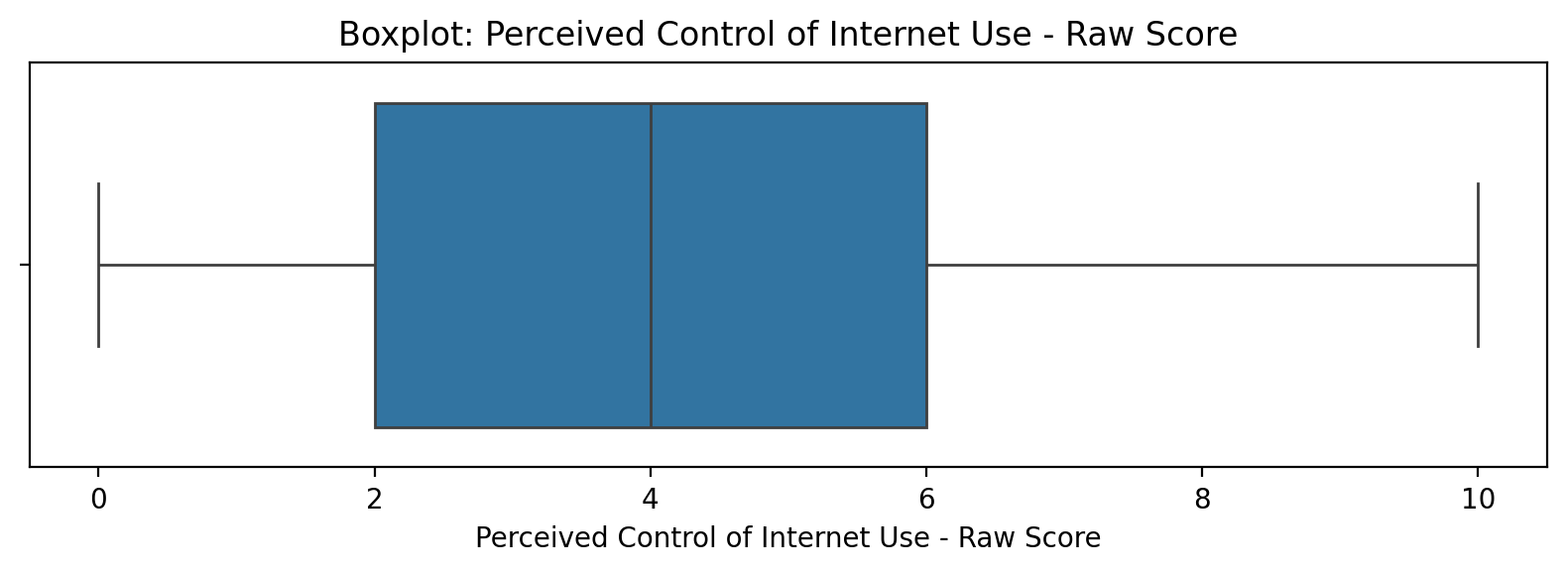

Count=103; mean=4.50; median=4.00; std=2.74; min=0.00; max=10.00; outliers=0 (0.0%). Skewness=0.67.

## Functional Impairment - Weighted Score

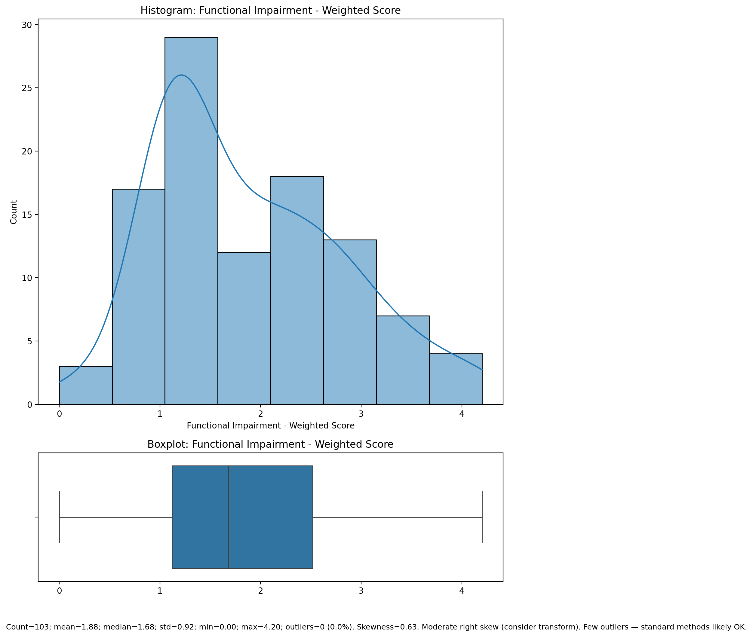

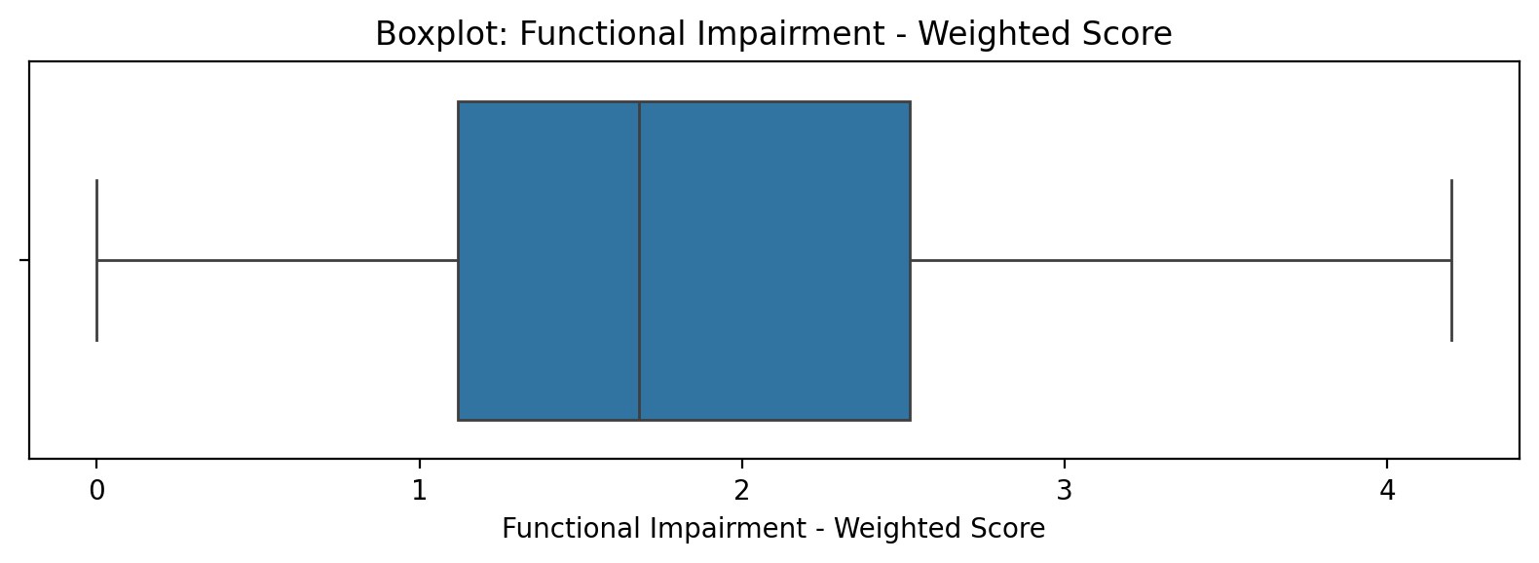

Count=103; mean=1.88; median=1.68; std=0.92; min=0.00; max=4.20; outliers=0 (0.0%). Skewness=0.63.

## Withdrawl - Weighted Score

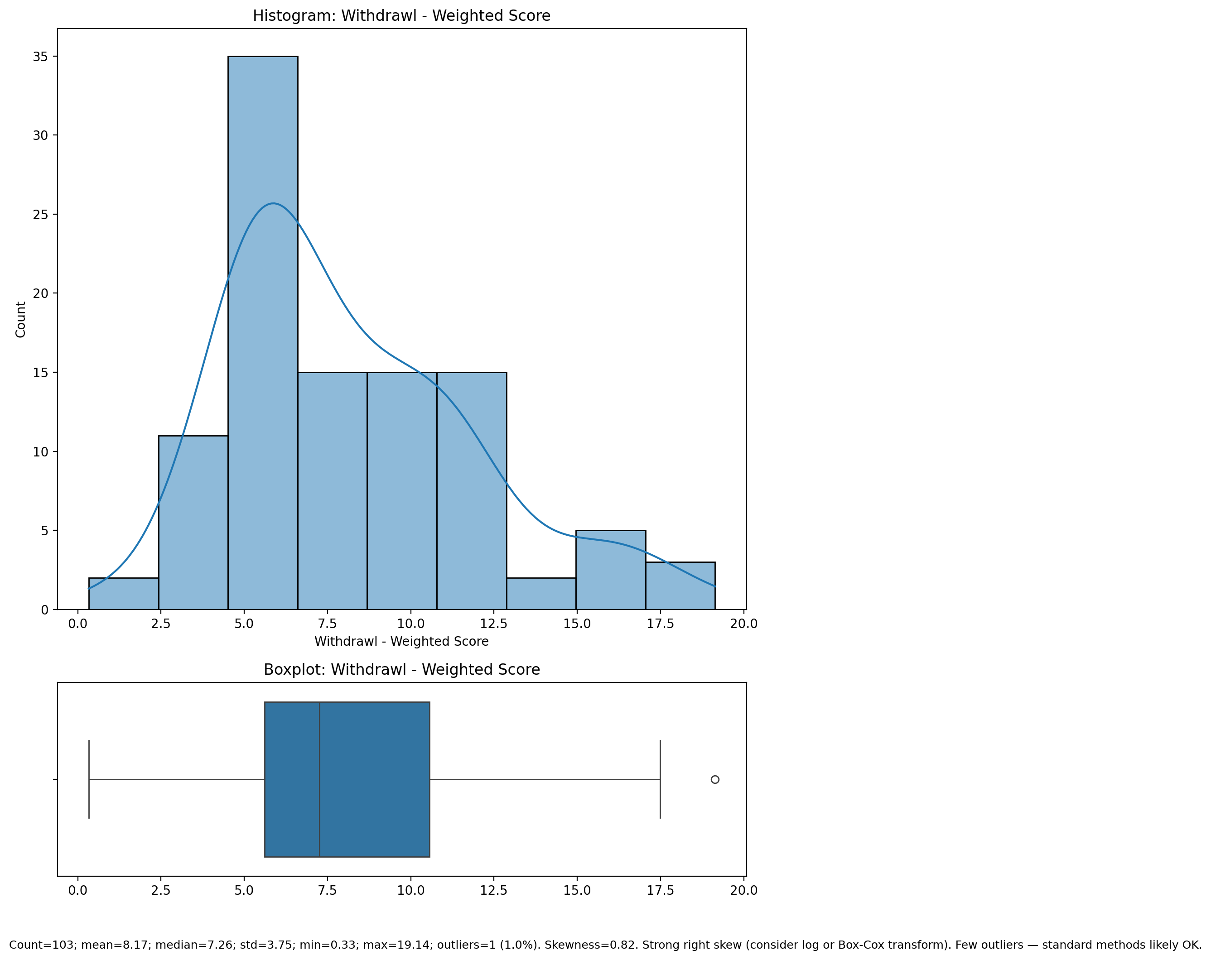

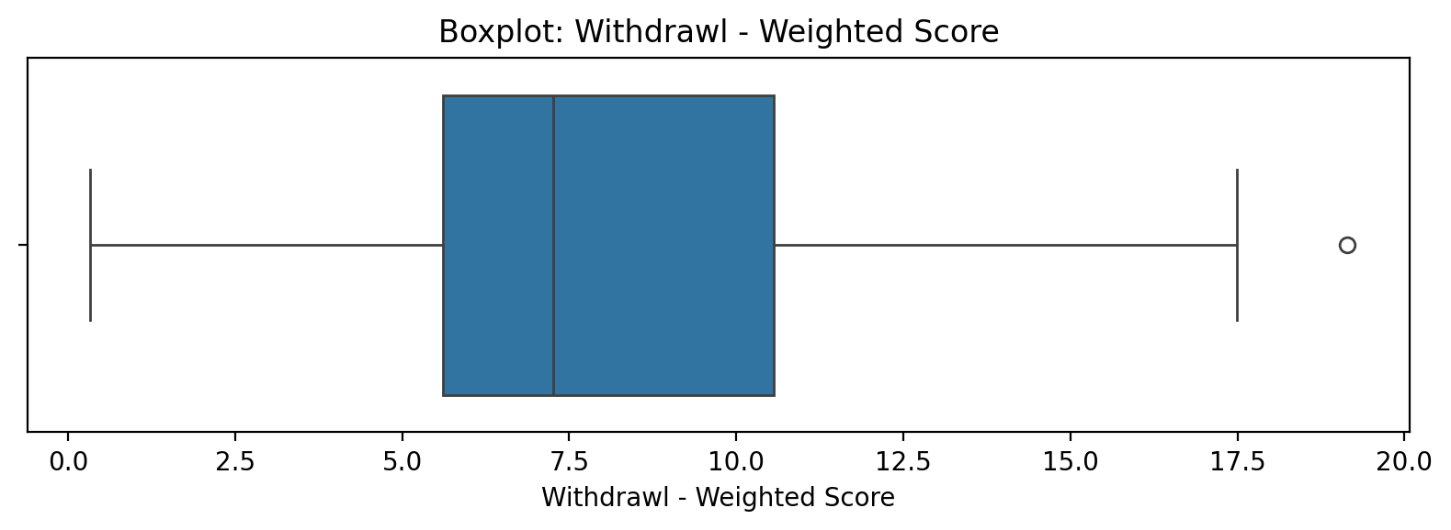

Count=103; mean=8.17; median=7.26; std=3.75; min=0.33; max=19.14; outliers=1 (1.0%). Skewness=0.82.

## Occupational & Relationship Consequences - Weighted Score

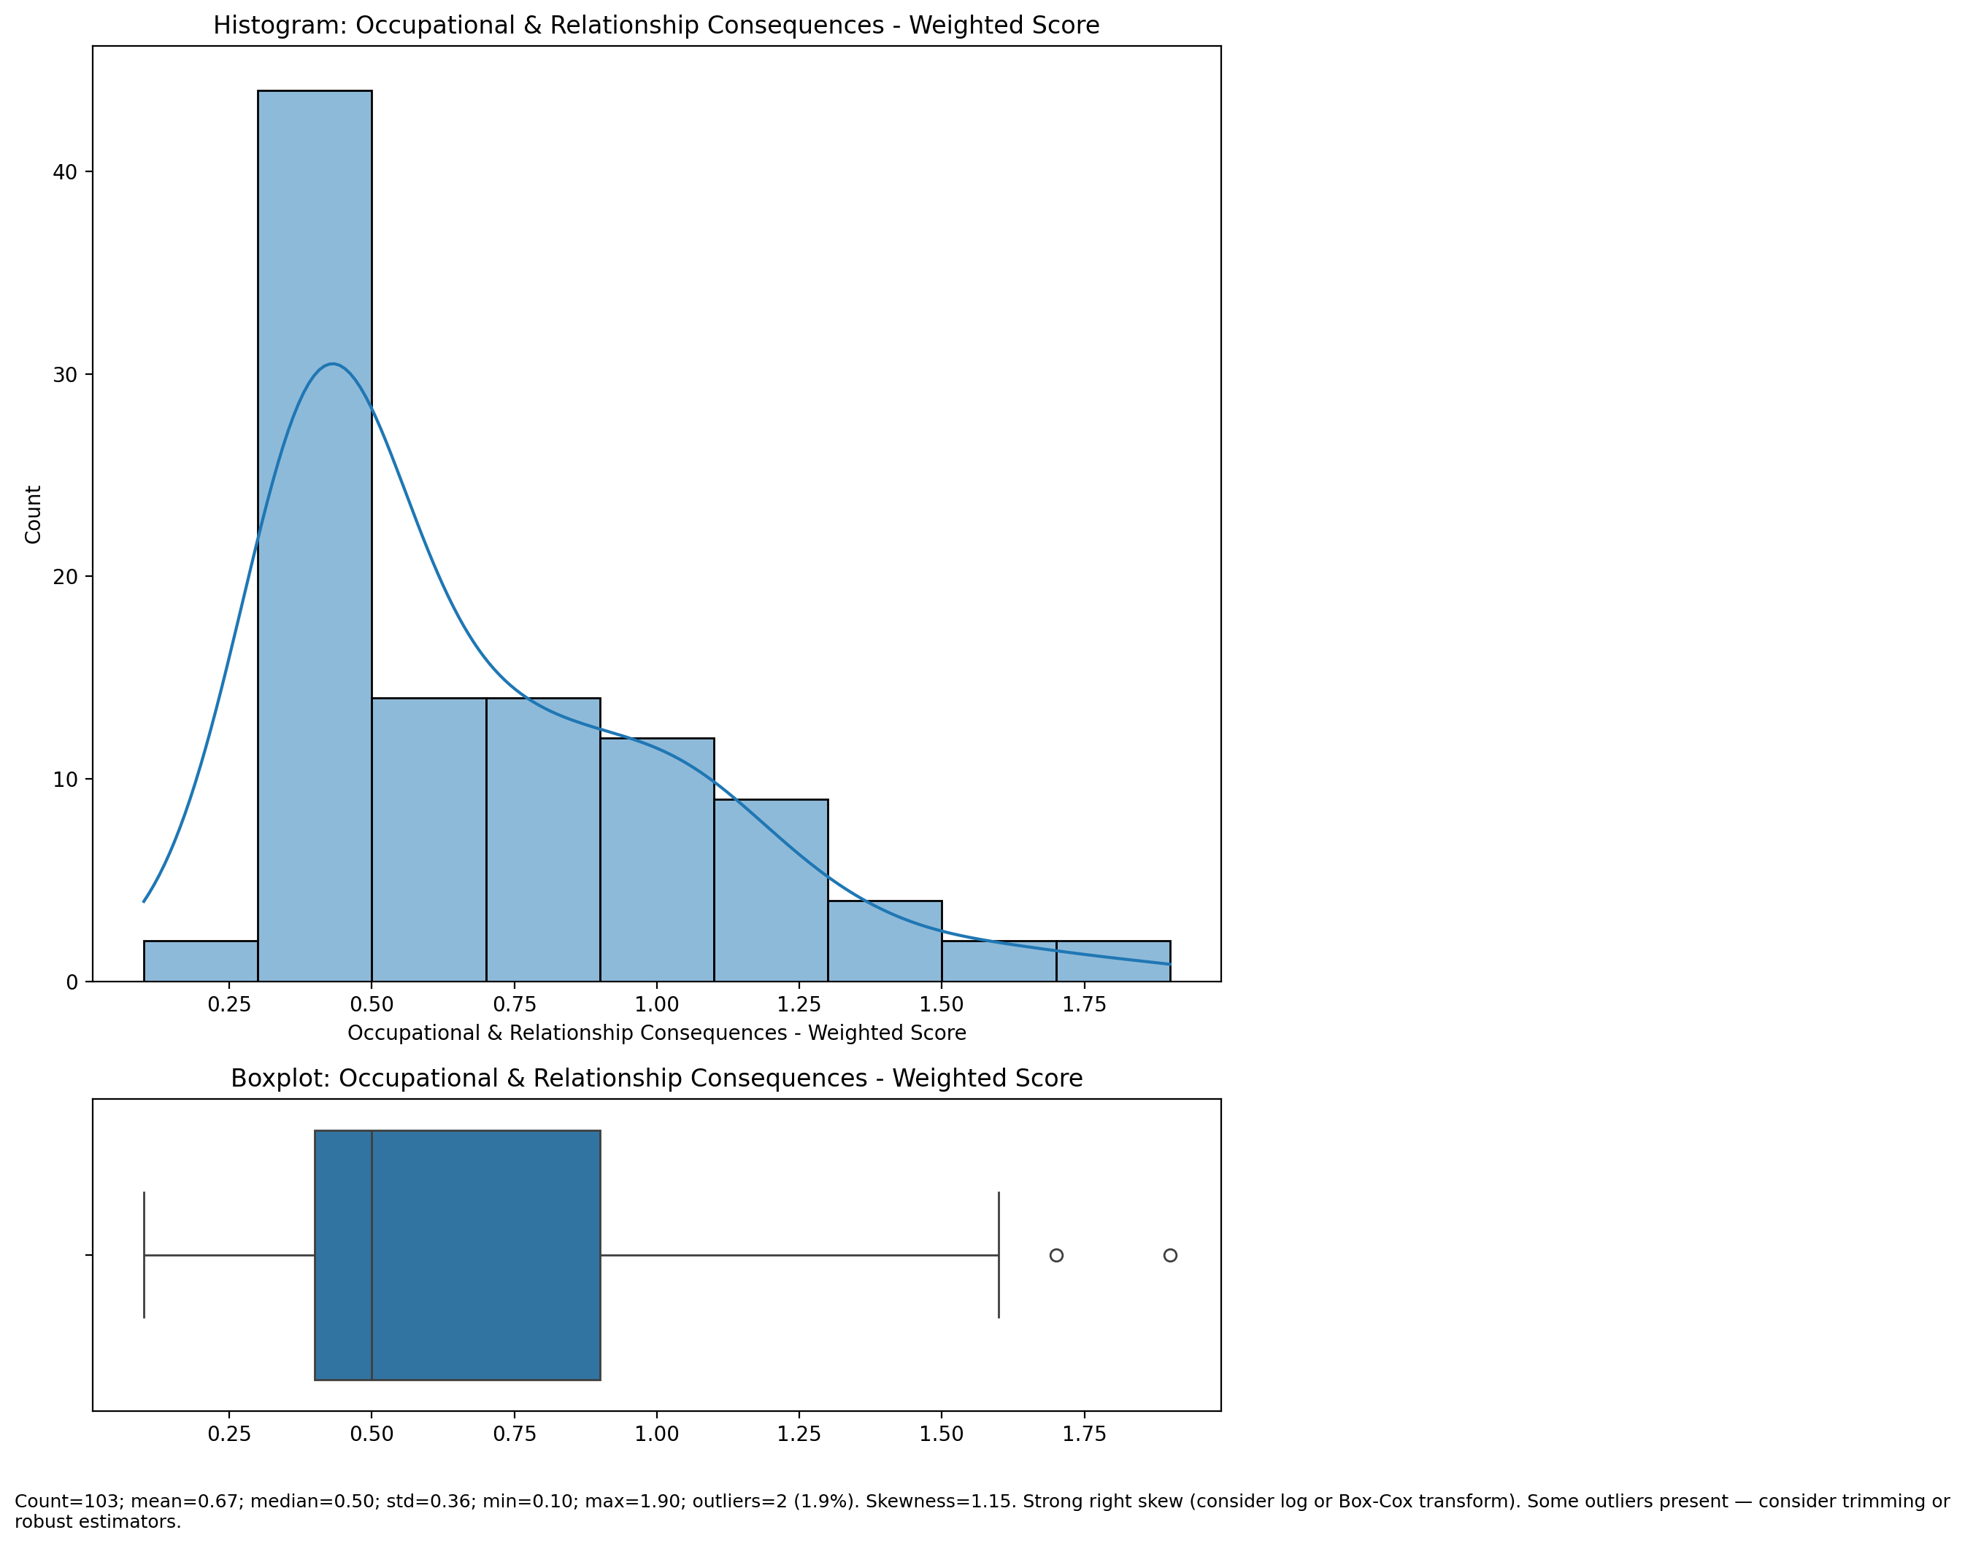

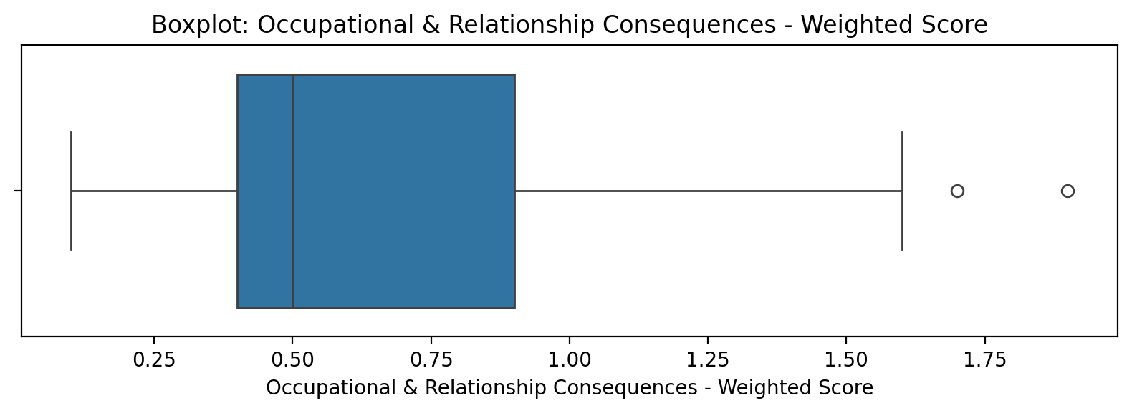

Count=103; mean=0.67; median=0.50; std=0.36; min=0.10; max=1.90; outliers=2 (1.9%). Skewness=1.15.

## Compulsive Behaviour - Weighted Score

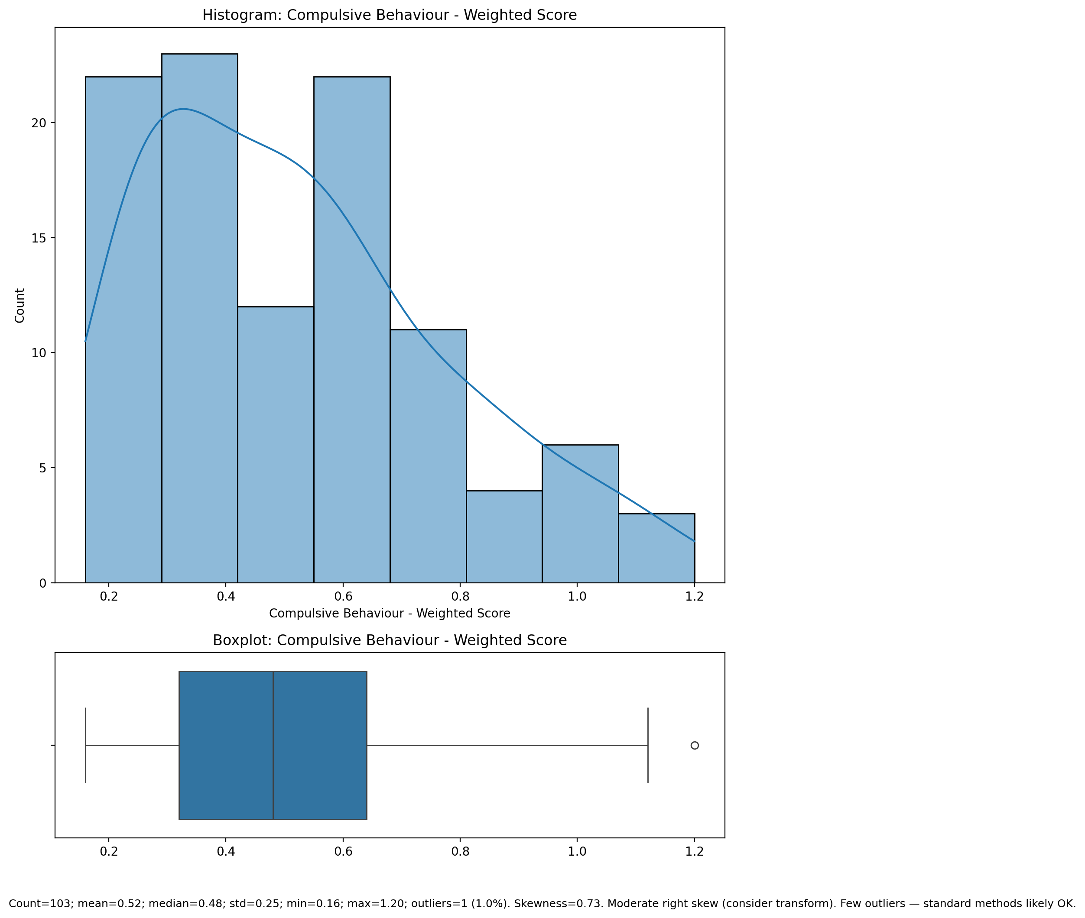

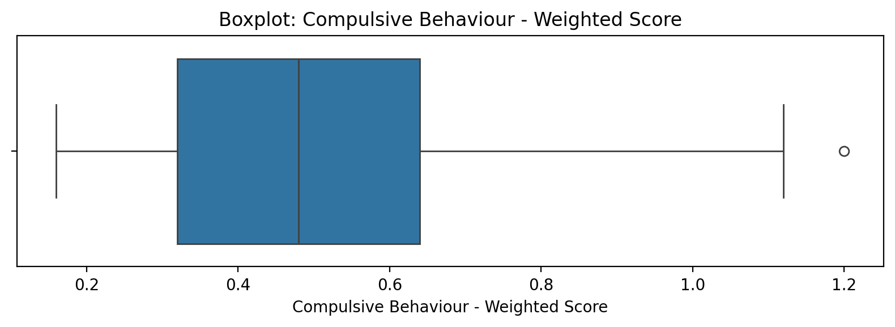

Count=103; mean=0.52; median=0.48; std=0.25; min=0.16; max=1.20; outliers=1 (1.0%). Skewness=0.73.

## Obsession with Internet - Weighted Score

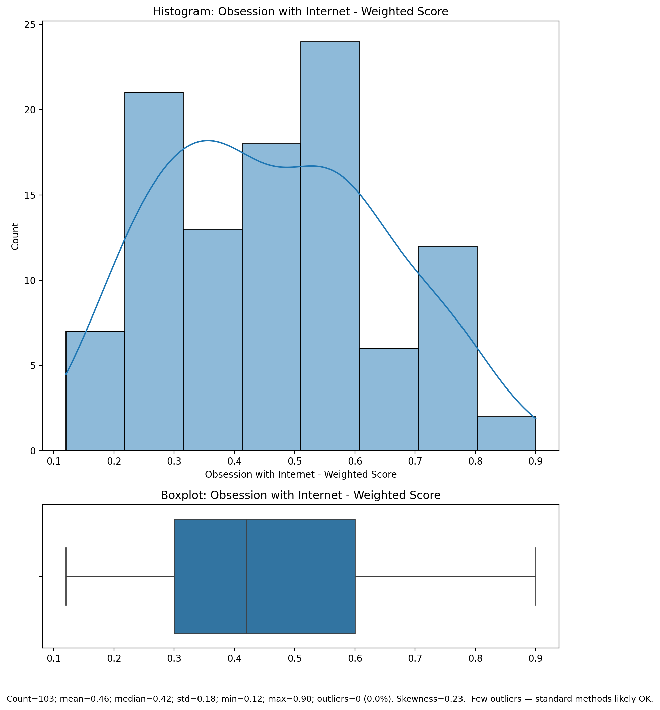

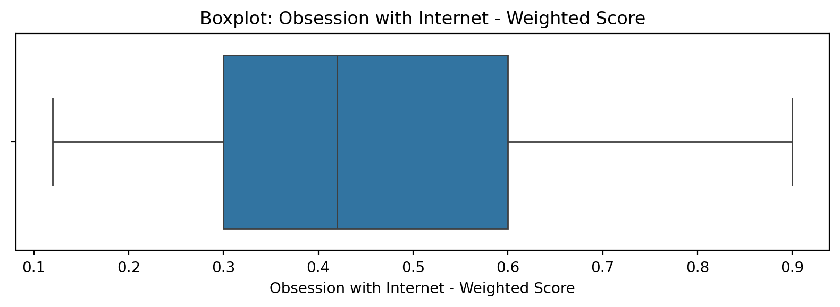

Count=103; mean=0.46; median=0.42; std=0.18; min=0.12; max=0.90; outliers=0 (0.0%). Skewness=0.23.

## Internet as a Source of Recreation - Weighted Score

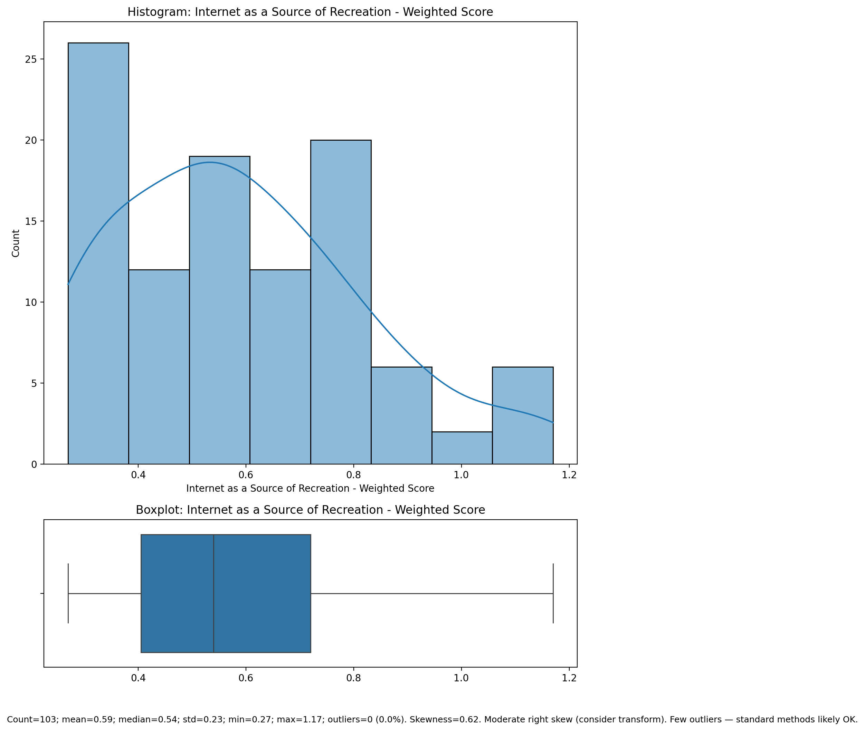

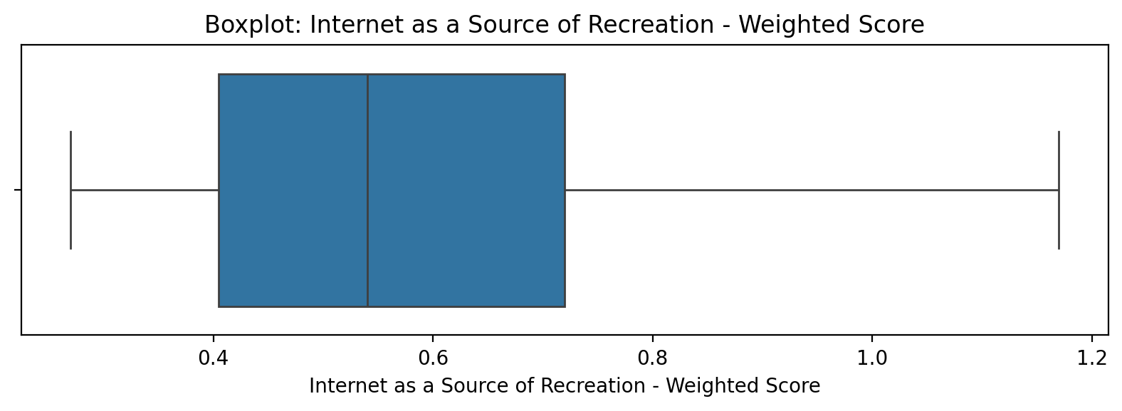

Count=103; mean=0.59; median=0.54; std=0.23; min=0.27; max=1.17; outliers=0 (0.0%). Skewness=0.62.

## Enhanced Socialization - Weighted Score

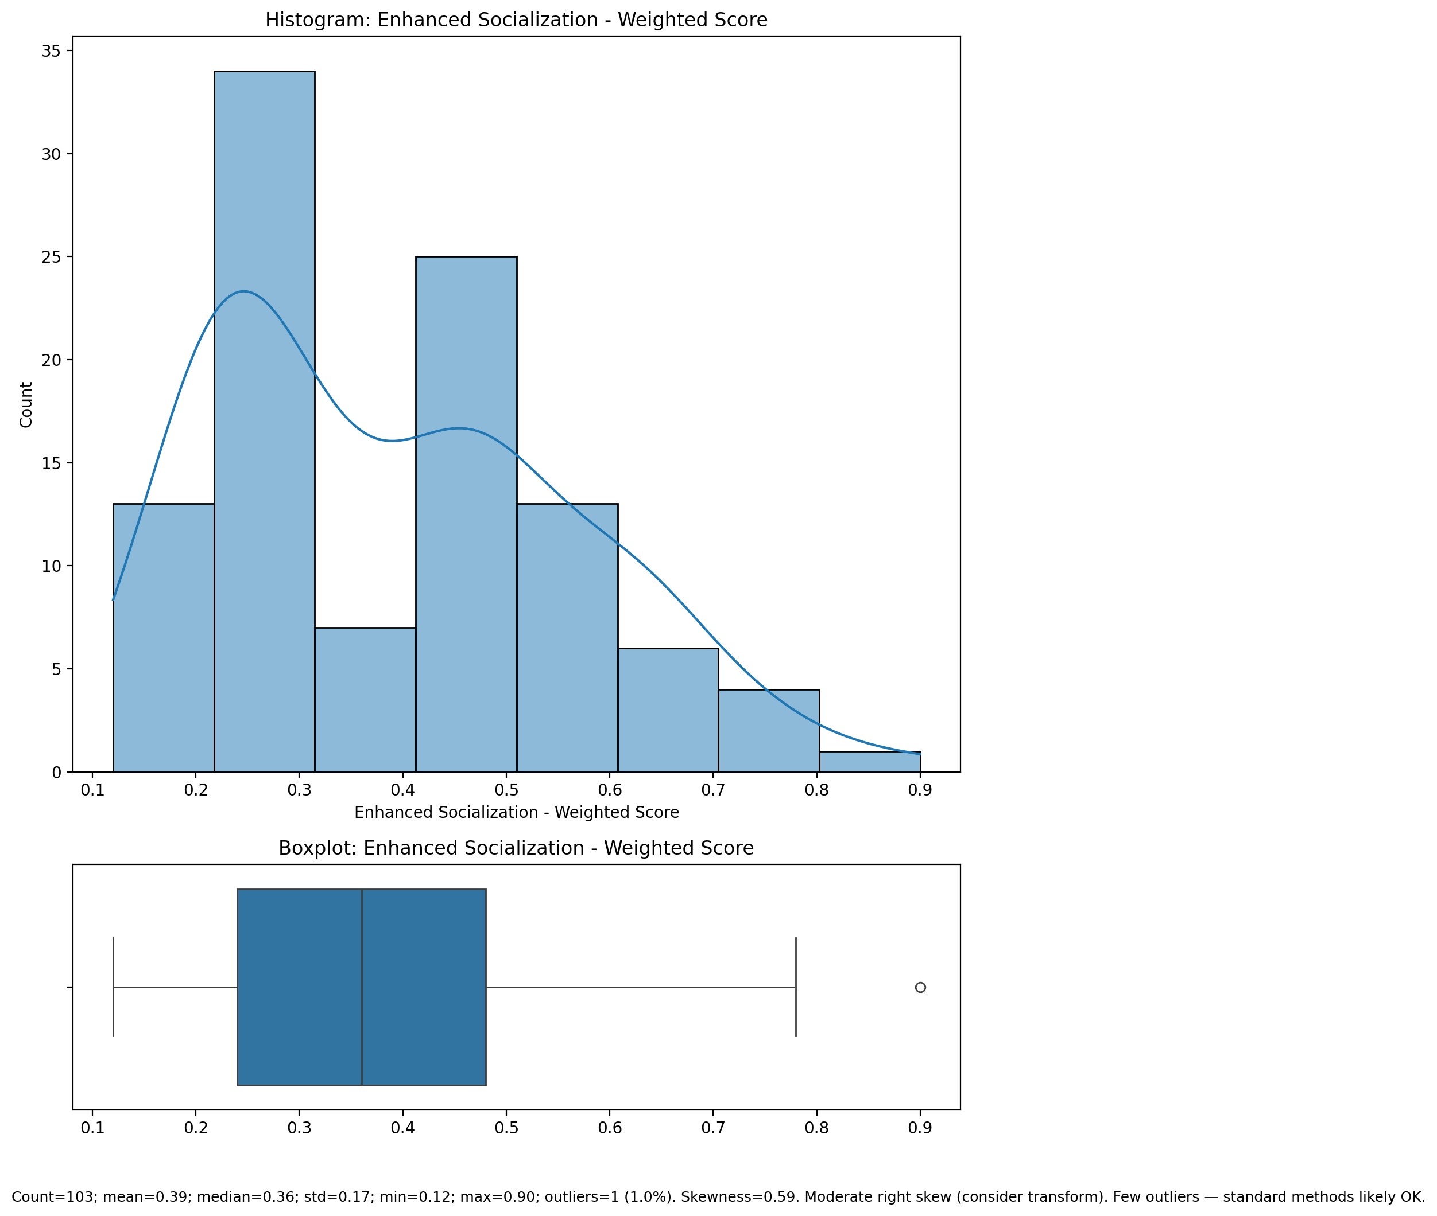

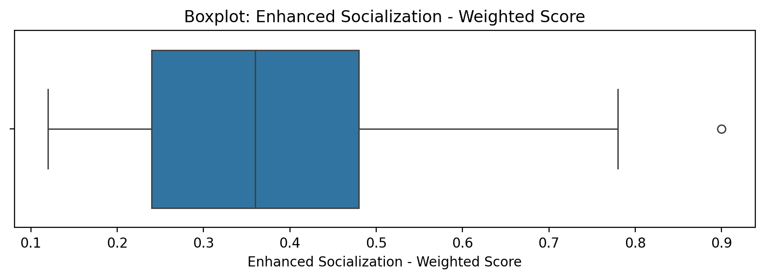

Count=103; mean=0.39; median=0.36; std=0.17; min=0.12; max=0.90; outliers=1 (1.0%). Skewness=0.59.

## Perceived Control of Internet Use - Weighted Score

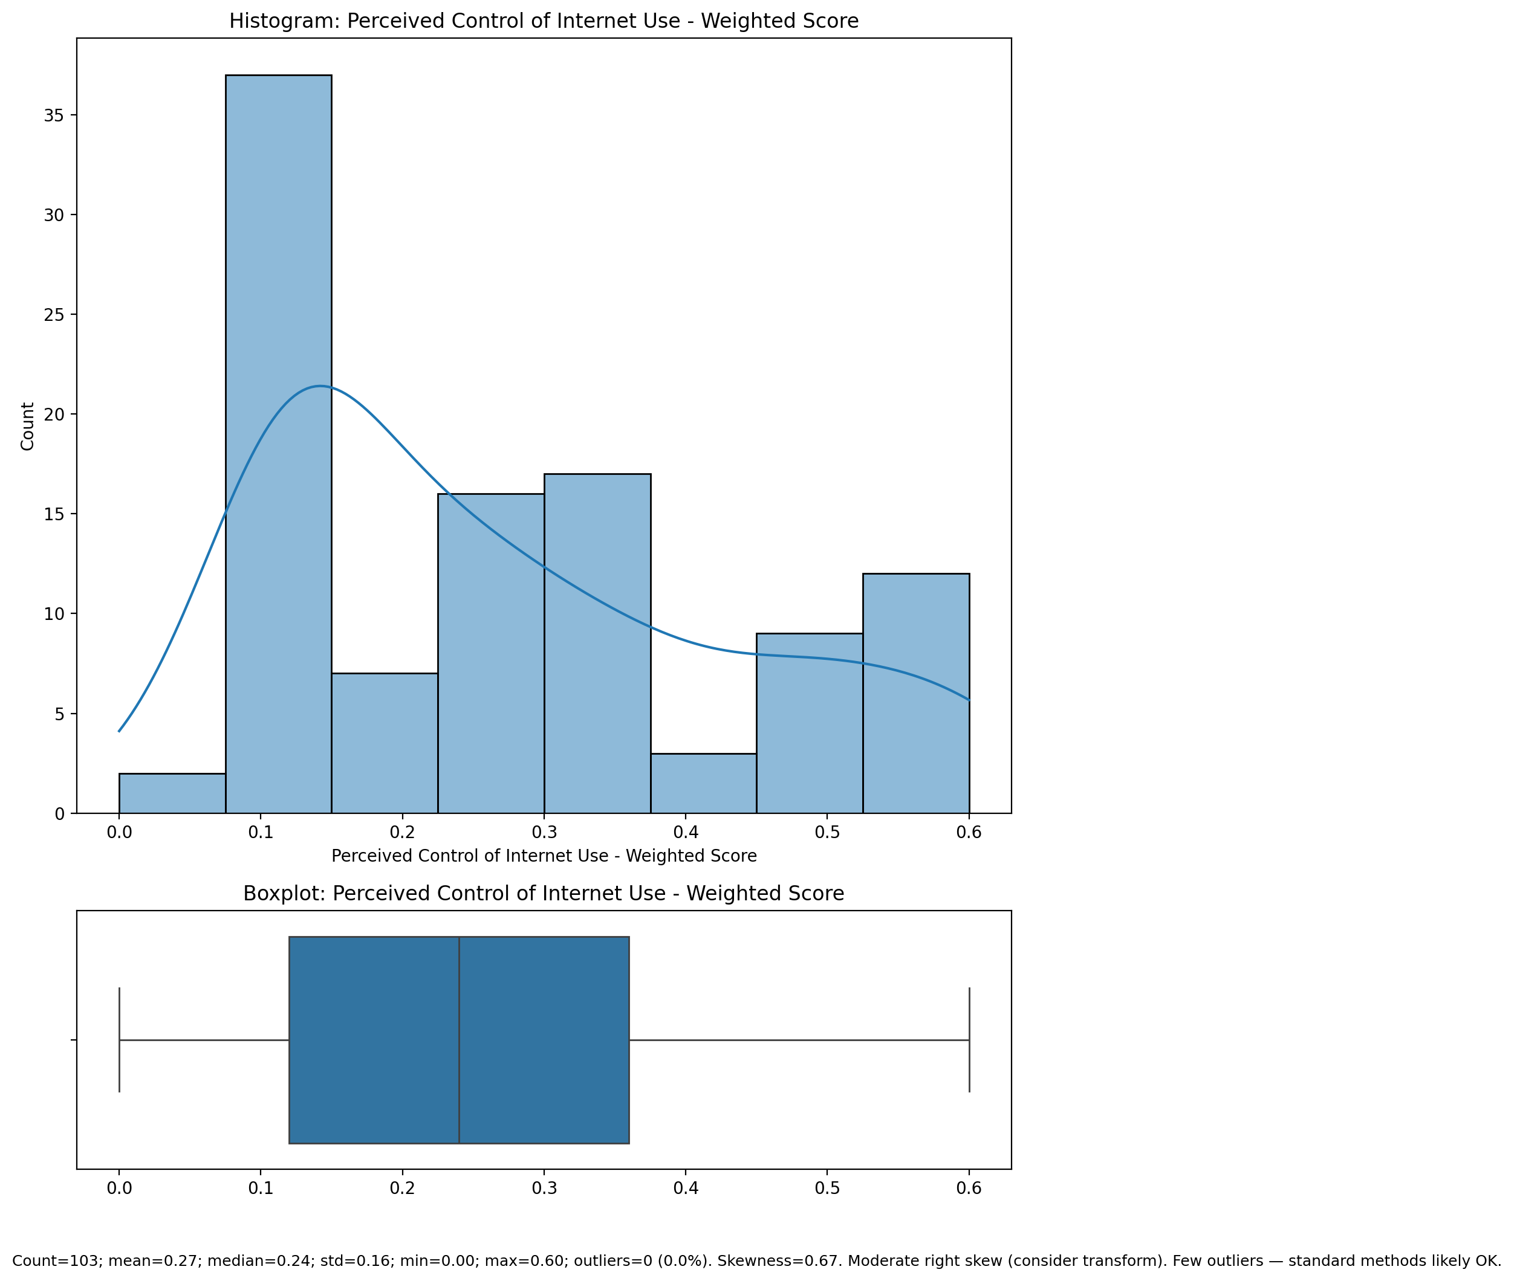

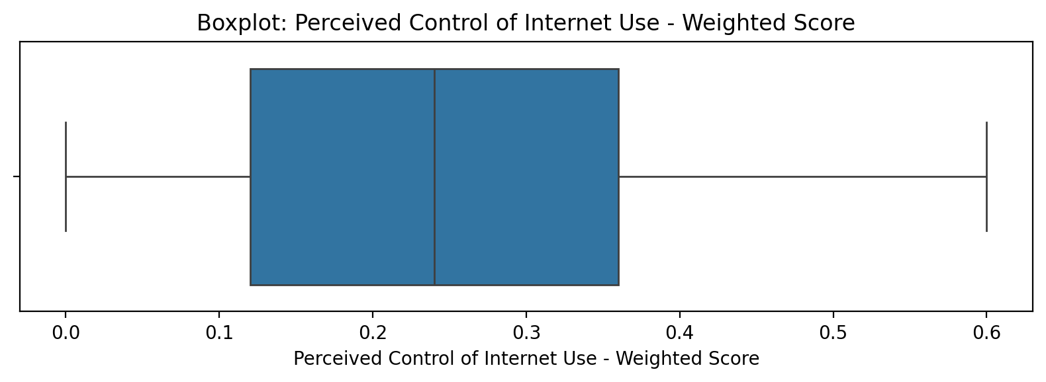

Count=103; mean=0.27; median=0.24; std=0.16; min=0.00; max=0.60; outliers=0 (0.0%). Skewness=0.67.

## Internet Usage Total Score (Weighted)

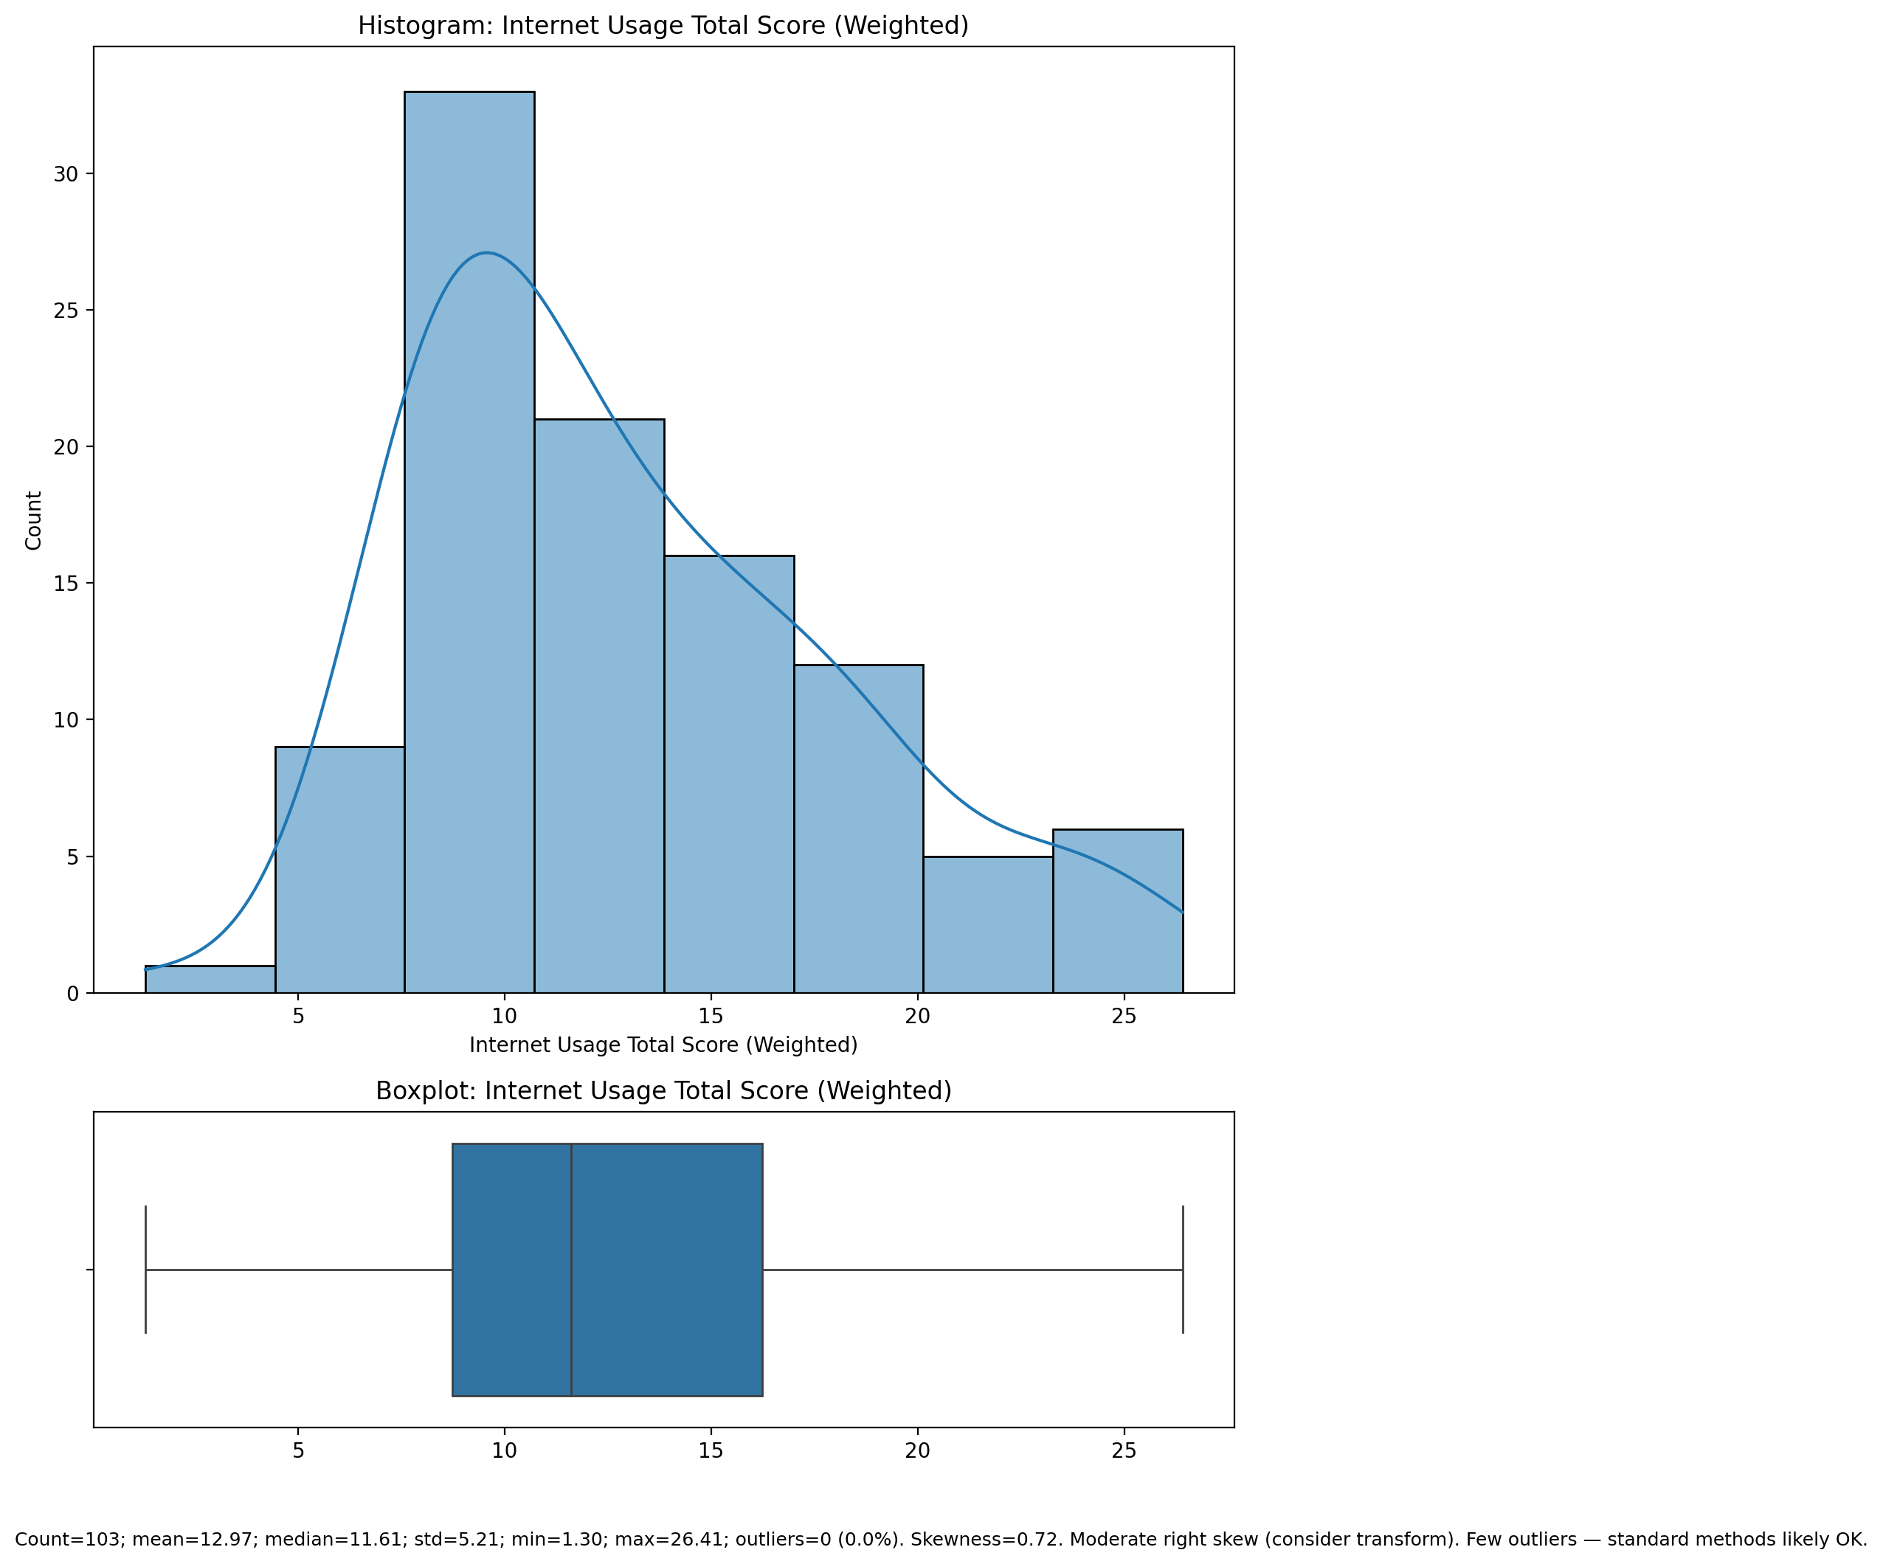

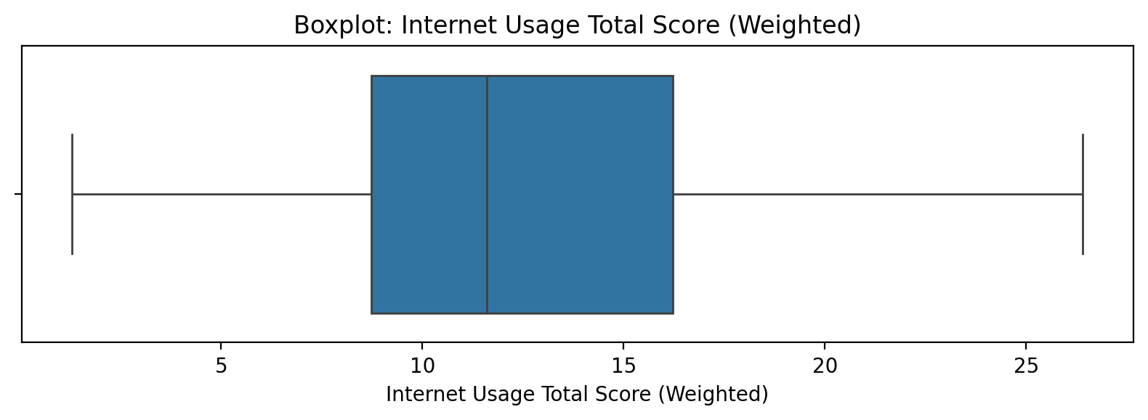

Count=103; mean=12.97; median=11.61; std=5.21; min=1.30; max=26.41; outliers=0 (0.0%). Skewness=0.72.

## Functional Impairment - Category

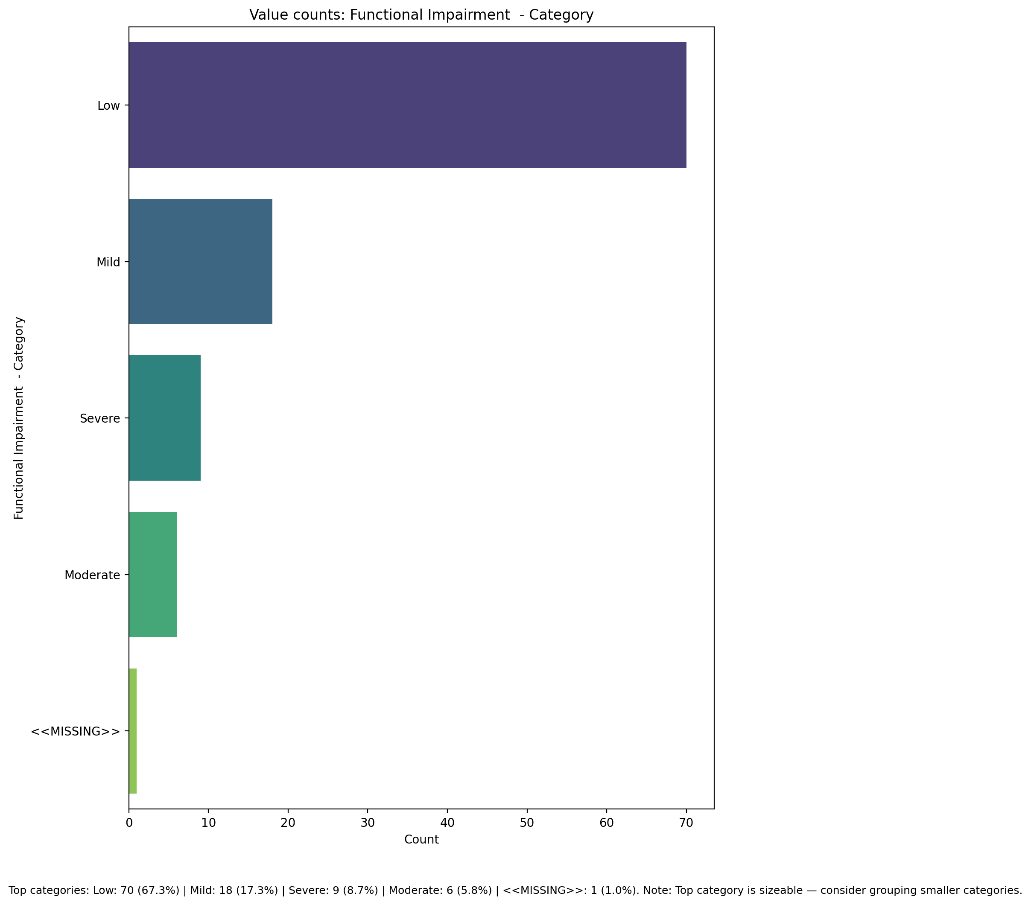

Top categories: Low: 70 (67.3%) | Mild: 18 (17.3%) | Severe: 9 (8.7%) | Moderate: 6 (5.8%) | <<MISSING>>: 1 (1.0%)

## Withdrawl – Category

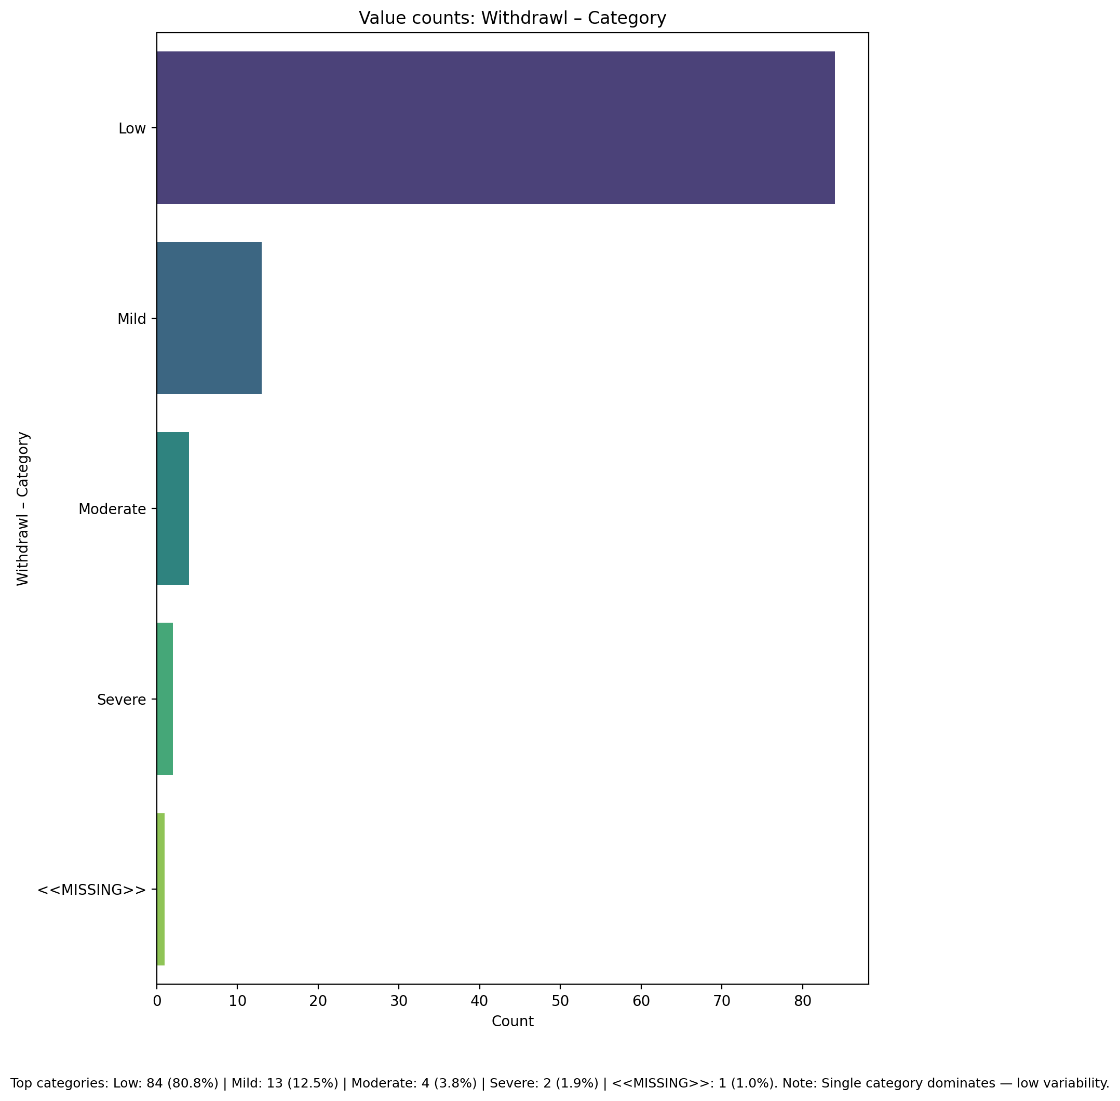

Top categories: Low: 84 (80.8%) | Mild: 13 (12.5%) | Moderate: 4 (3.8%) | Severe: 2 (1.9%) | <<MISSING>>: 1 (1.0%)

## Occupational & Relationship Consequences – Category

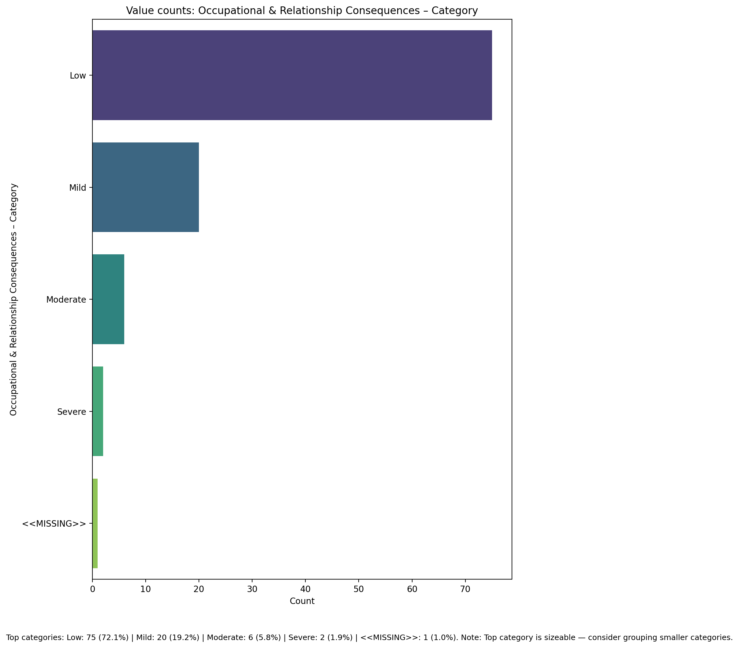

Top categories: Low: 75 (72.1%) | Mild: 20 (19.2%) | Moderate: 6 (5.8%) | Severe: 2 (1.9%) | <<MISSING>>: 1 (1.0%)

## Compulsive Behaviour – Category

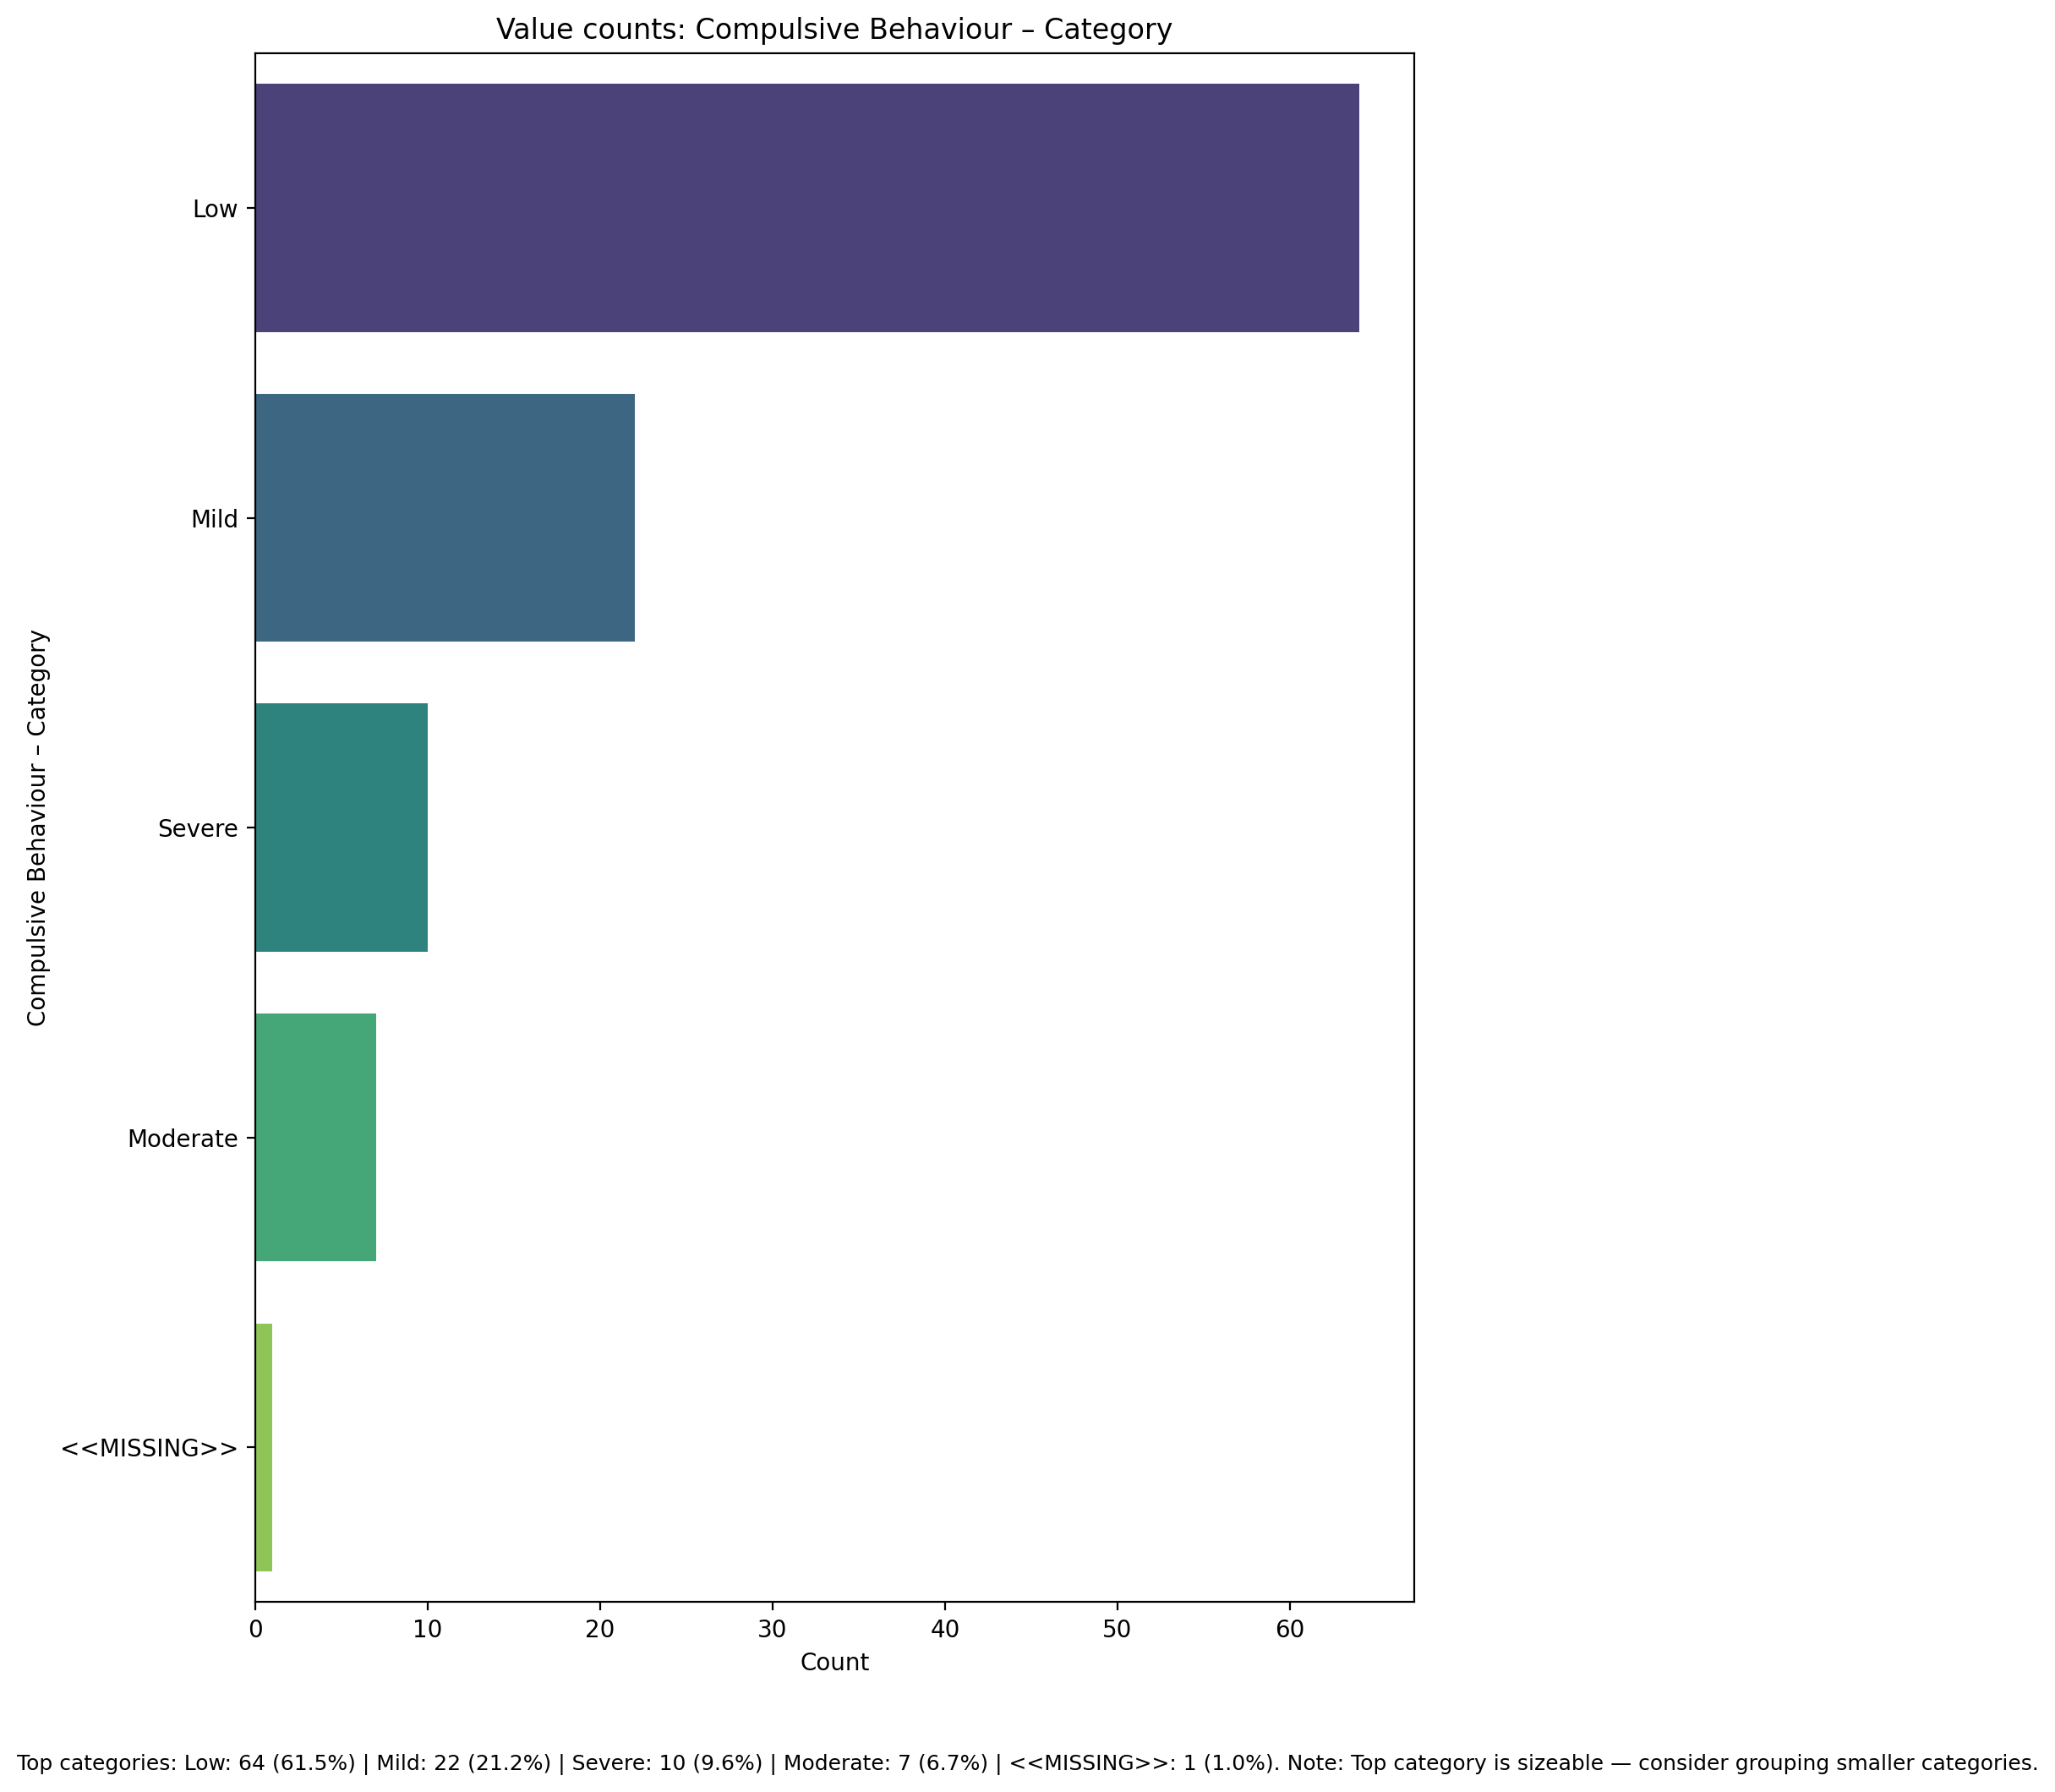

Top categories: Low: 64 (61.5%) | Mild: 22 (21.2%) | Severe: 10 (9.6%) | Moderate: 7 (6.7%) | <<MISSING>>: 1 (1.0%)

## Obsession with Internet – Category

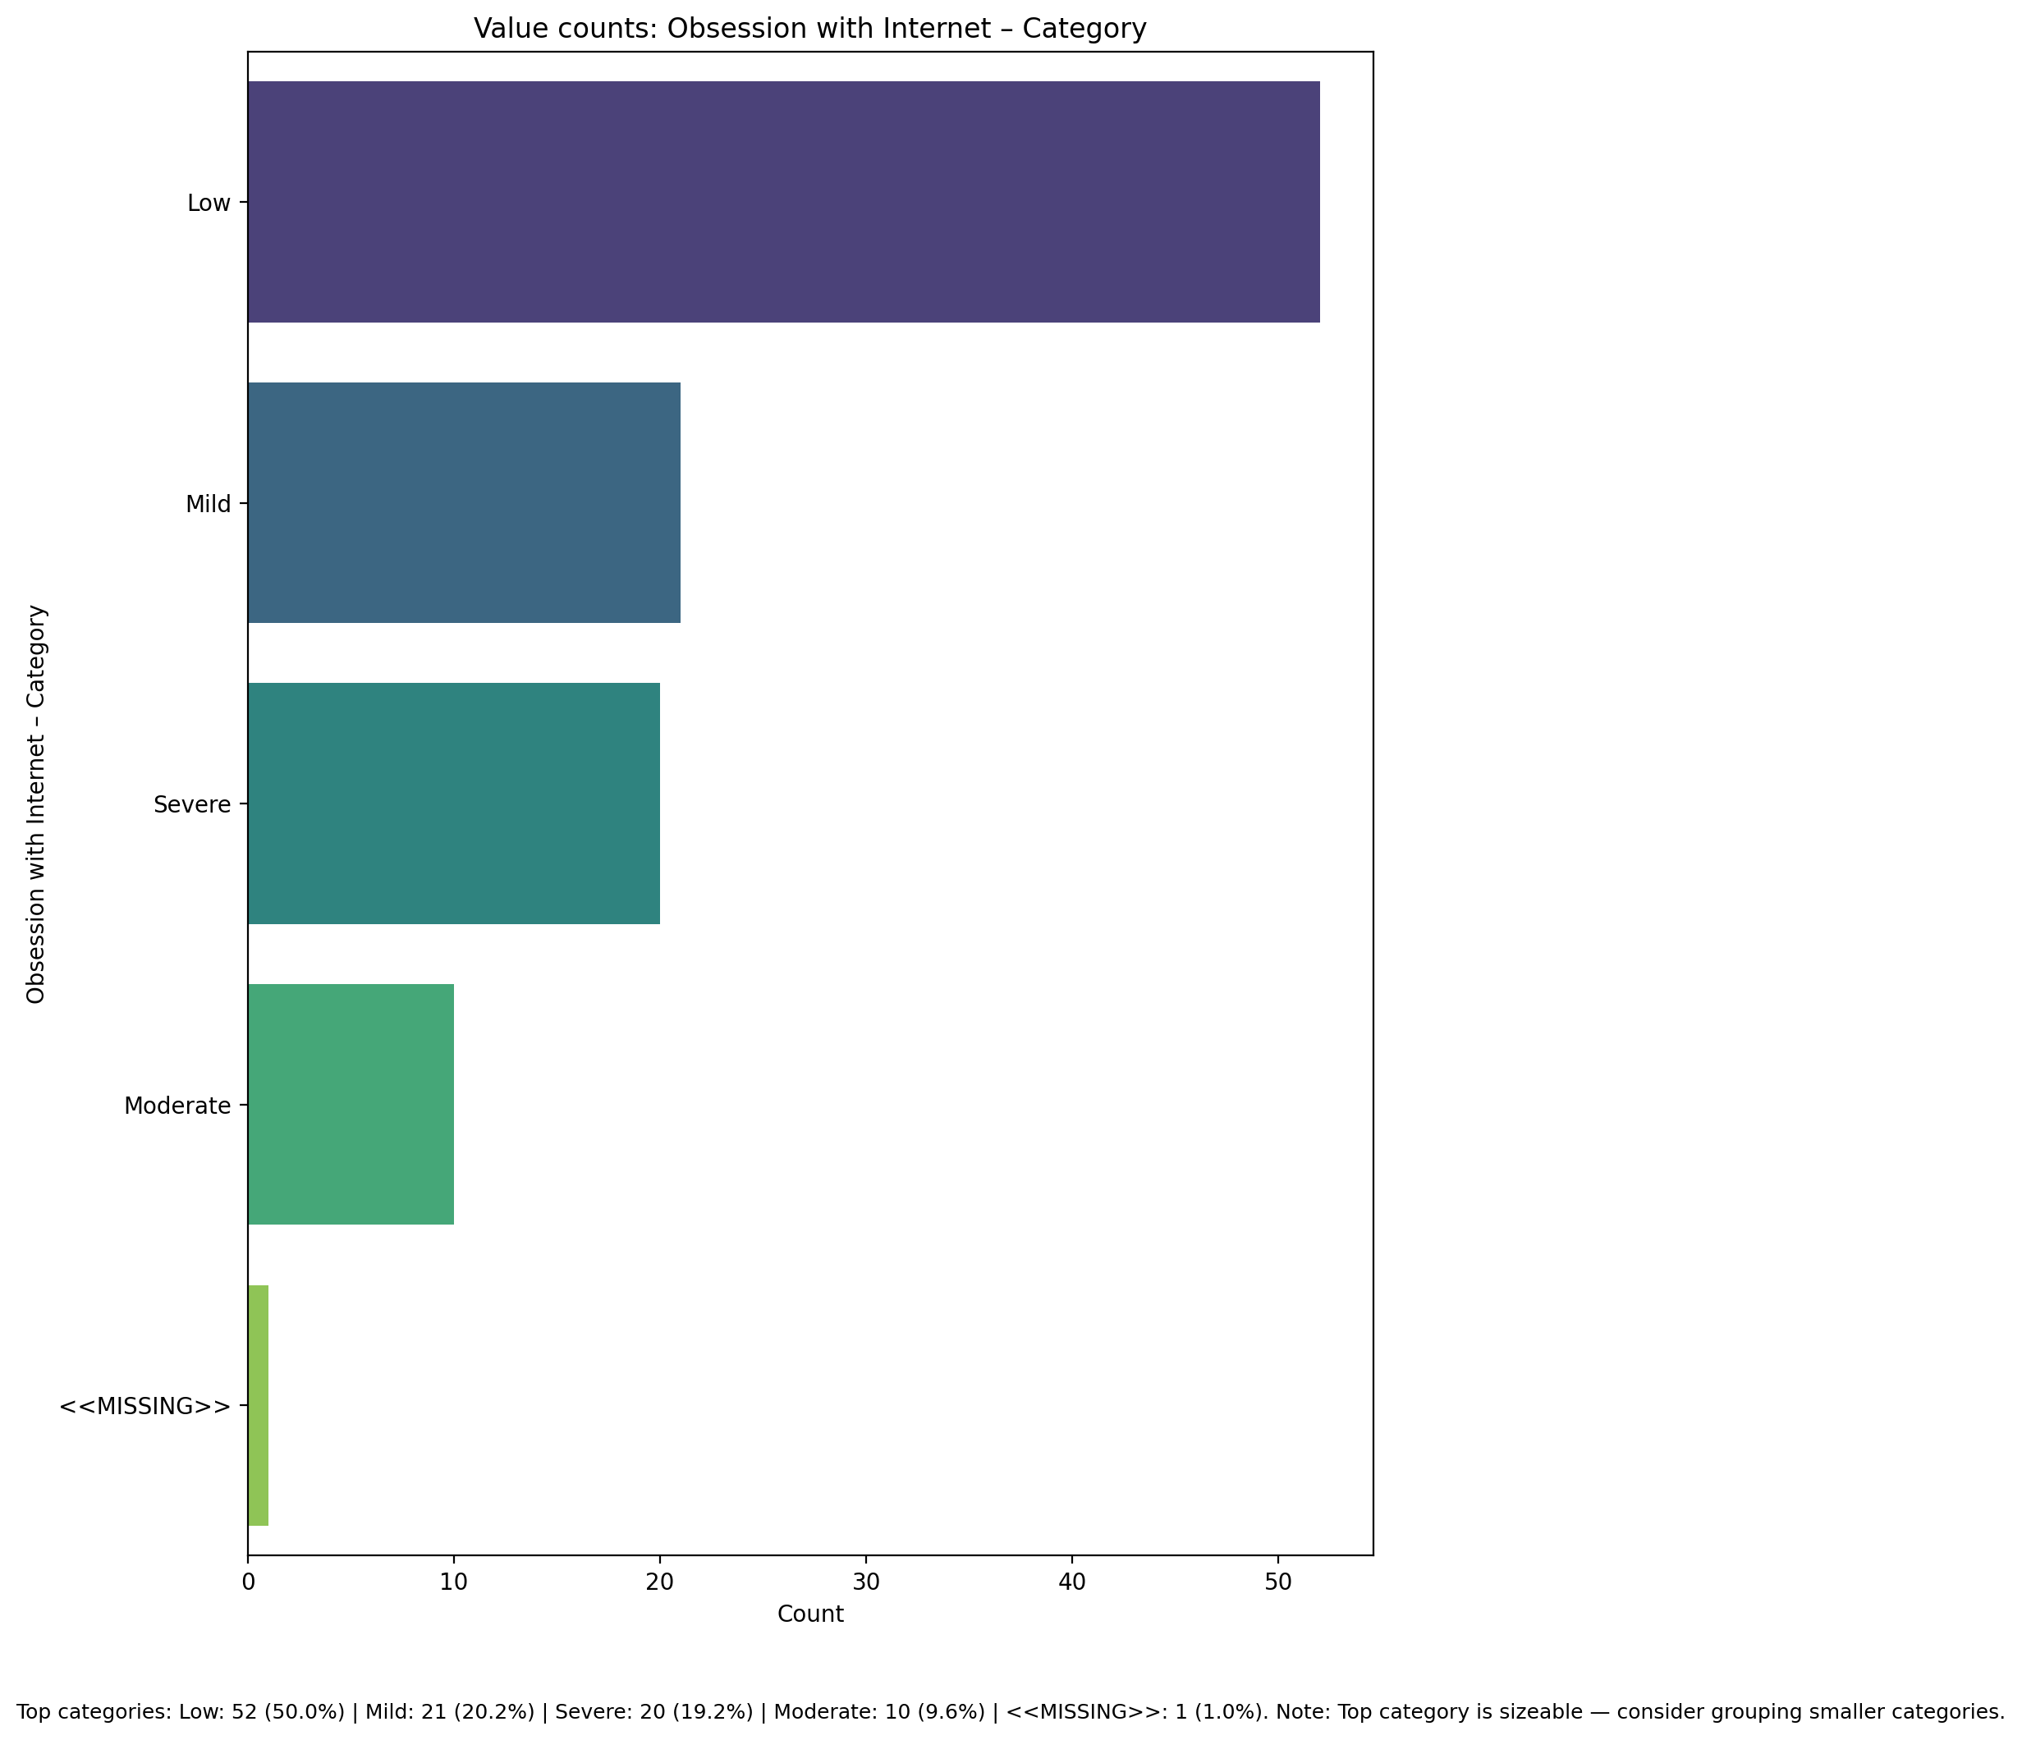

Top categories: Low: 52 (50.0%) | Mild: 21 (20.2%) | Severe: 20 (19.2%) | Moderate: 10 (9.6%) | <<MISSING>>: 1 (1.0%)

## Internet as a Source of Recreation – Category

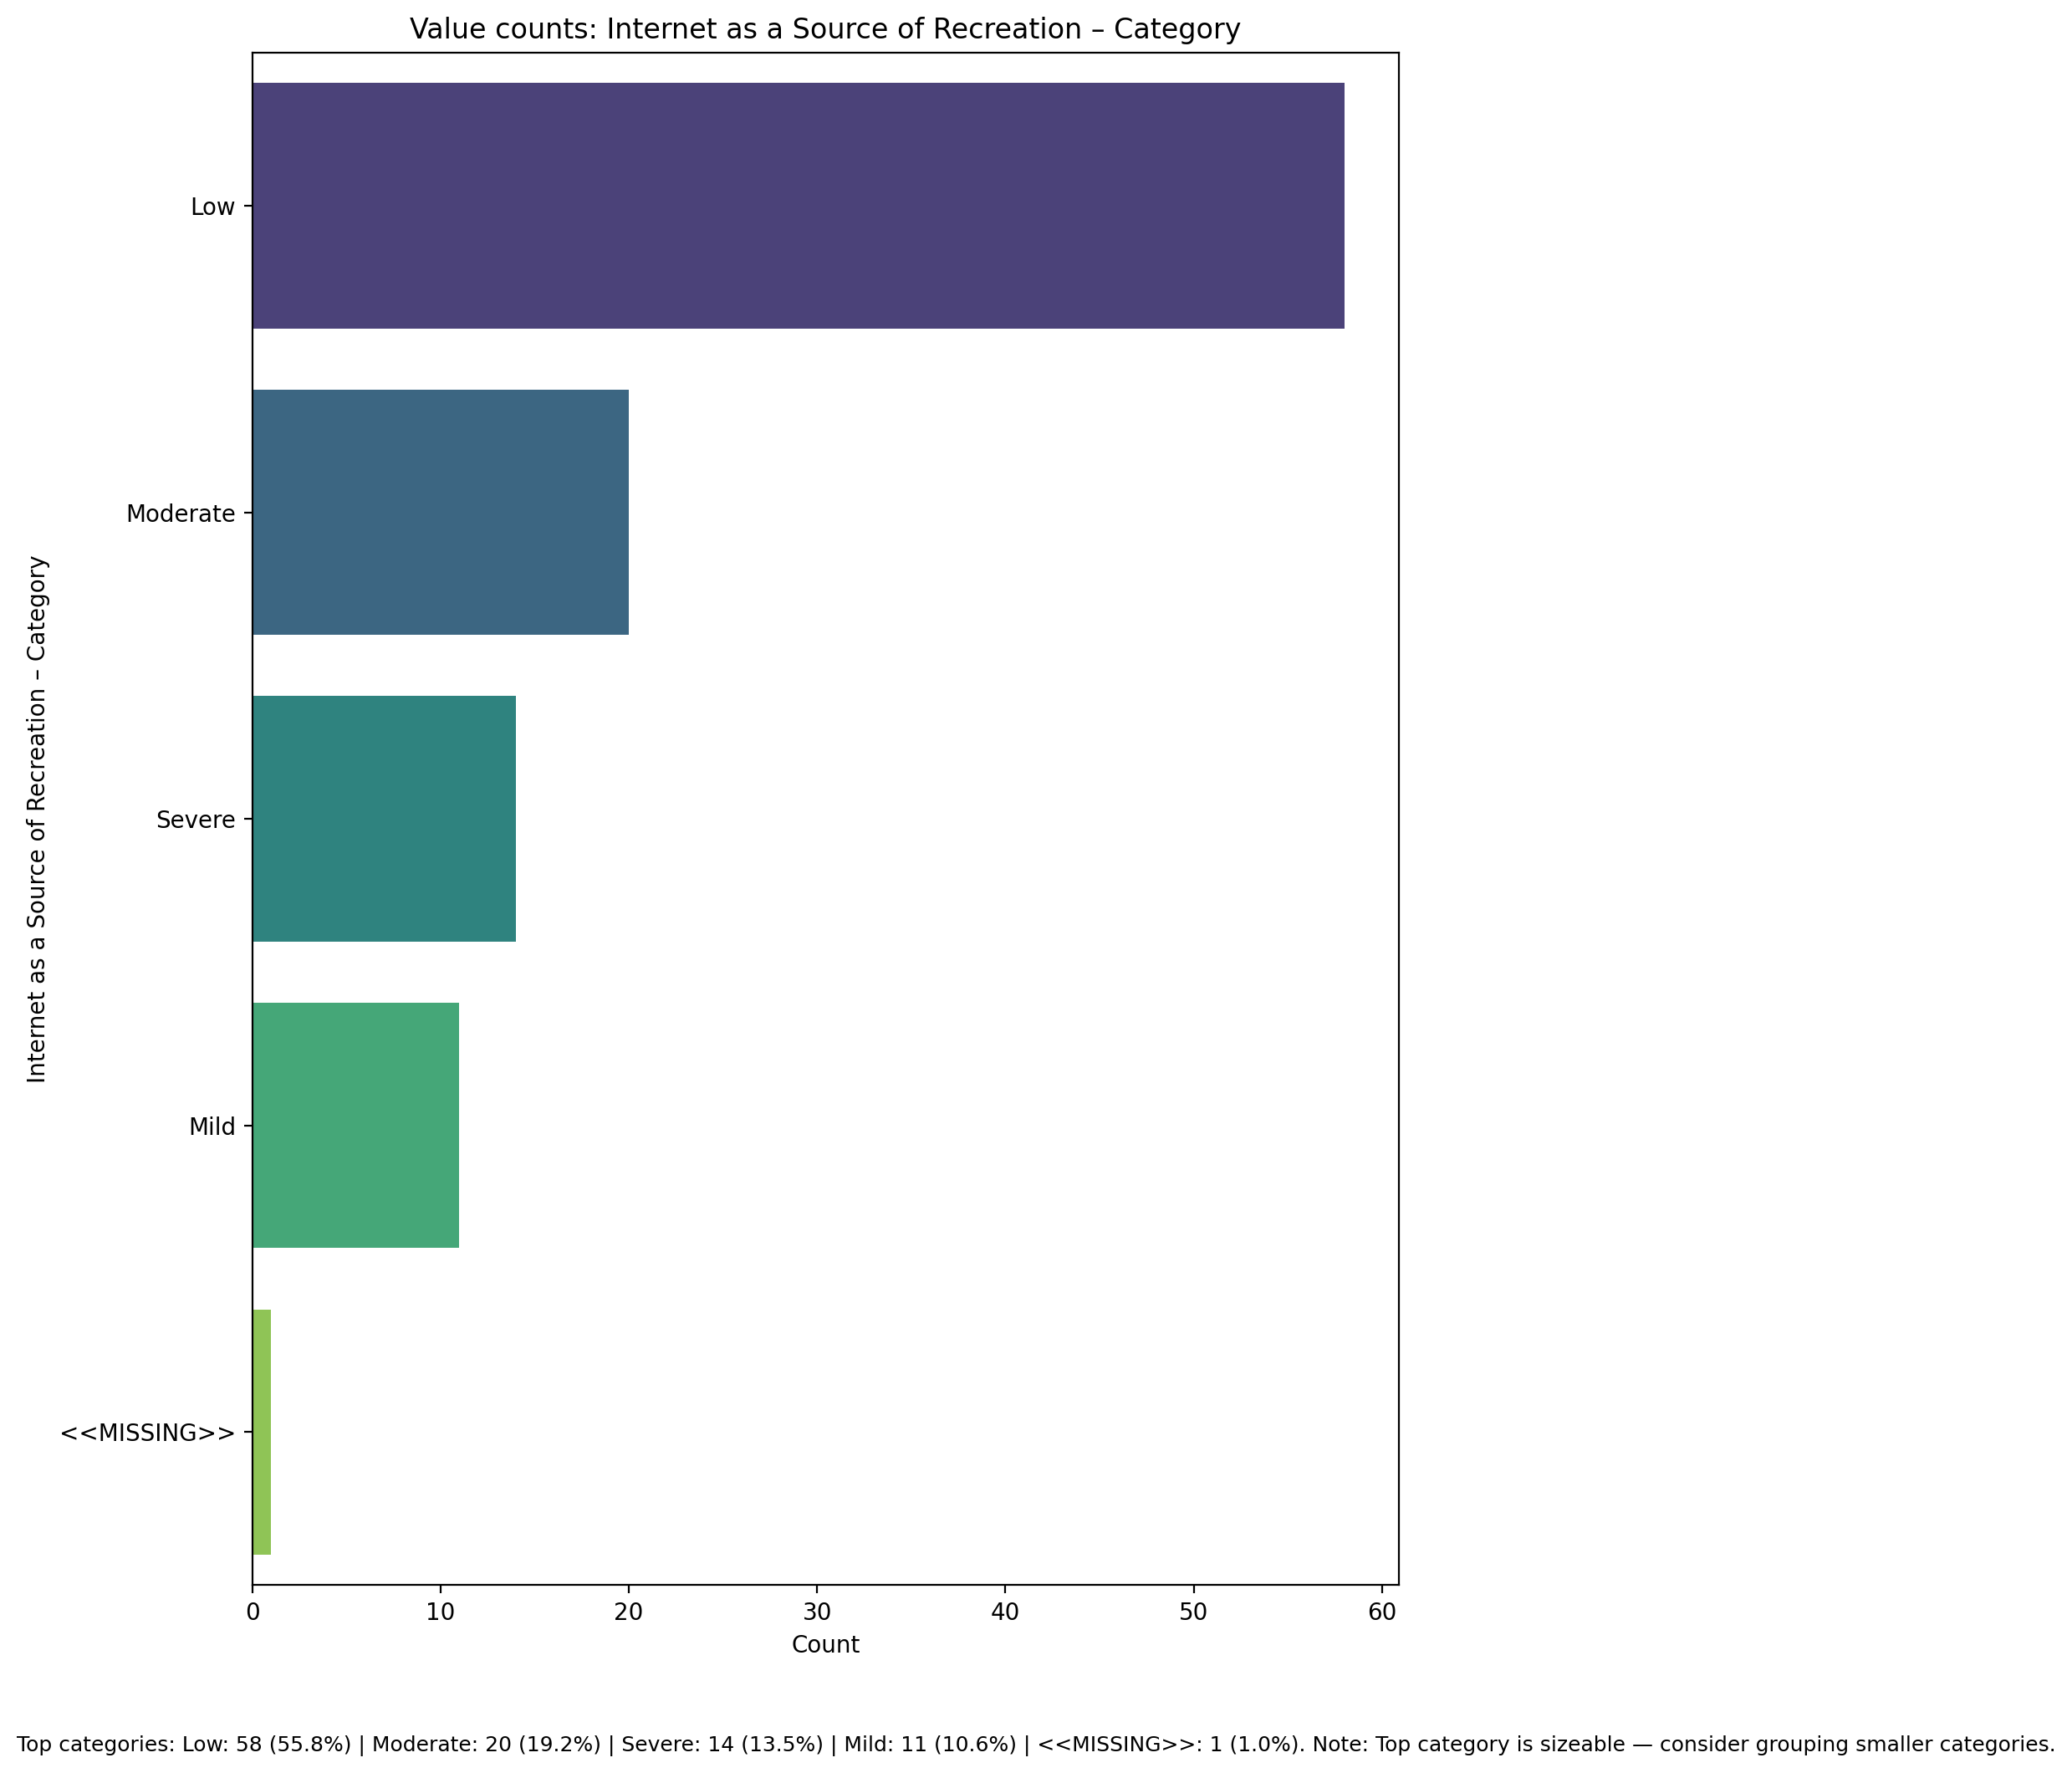

Top categories: Low: 58 (55.8%) | Moderate: 20 (19.2%) | Severe: 14 (13.5%) | Mild: 11 (10.6%) | <<MISSING>>: 1 (1.0%)

## Enhanced Socialization - Category

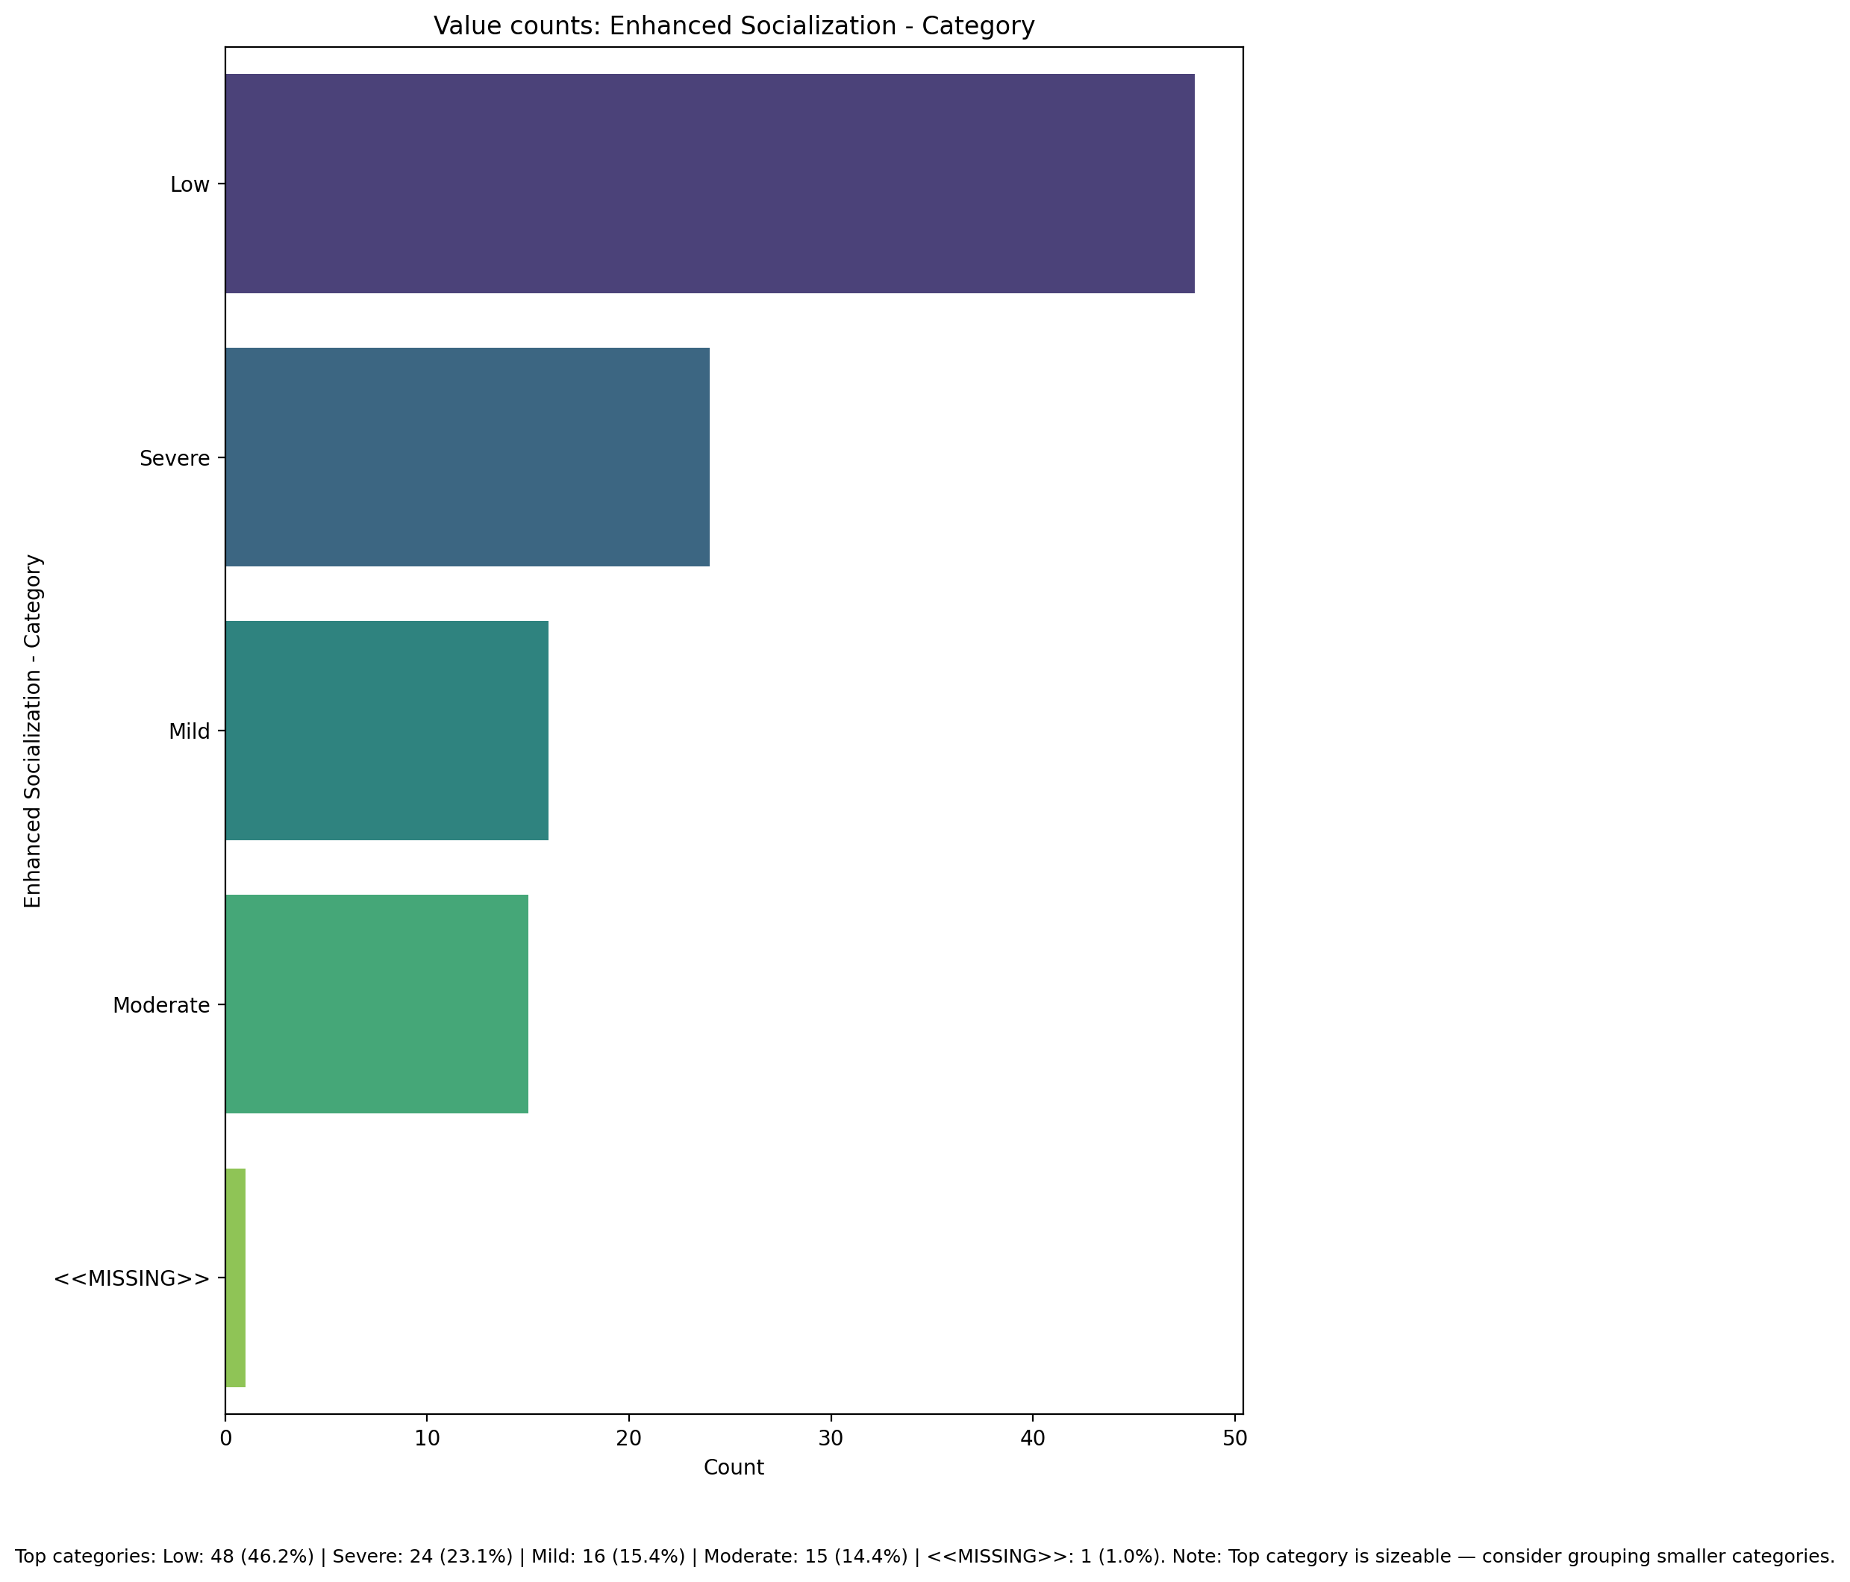

Top categories: Low: 48 (46.2%) | Severe: 24 (23.1%) | Mild: 16 (15.4%) | Moderate: 15 (14.4%) | <<MISSING>>: 1 (1.0%)

## Perceived Control of Internet Use - Category

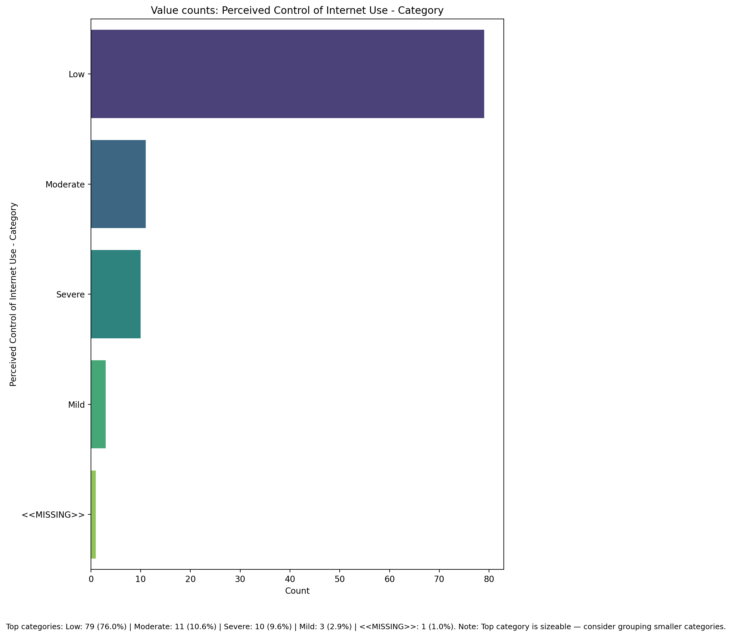

Top categories: Low: 79 (76.0%) | Moderate: 11 (10.6%) | Severe: 10 (9.6%) | Mild: 3 (2.9%) | <<MISSING>>: 1 (1.0%)

## Internet Usage Total Categoty

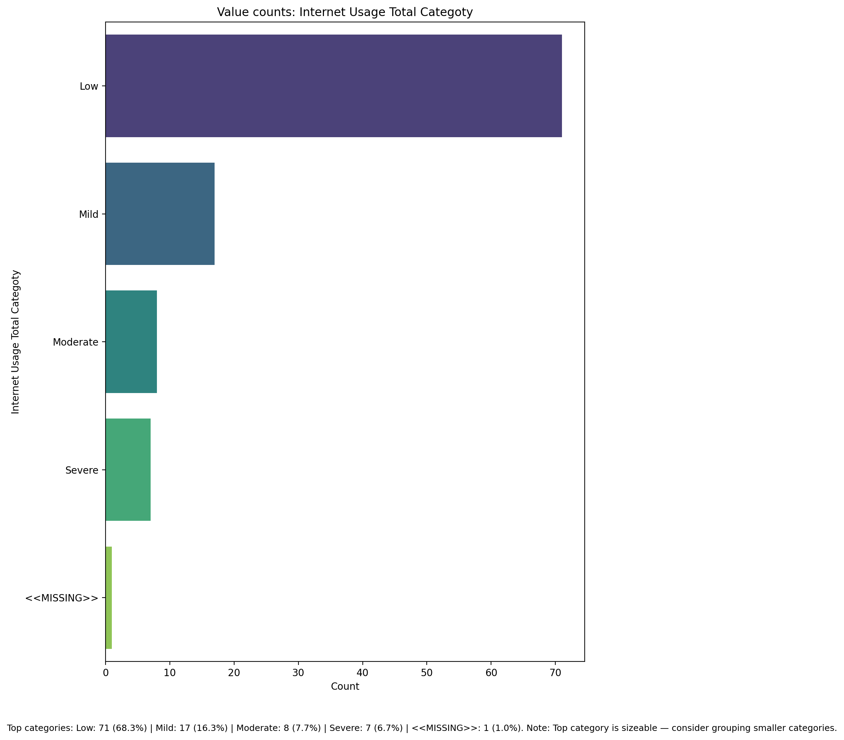

Top categories: Low: 71 (68.3%) | Mild: 17 (16.3%) | Moderate: 8 (7.7%) | Severe: 7 (6.7%) | <<MISSING>>: 1 (1.0%)

## Emotional Support - Raw Score

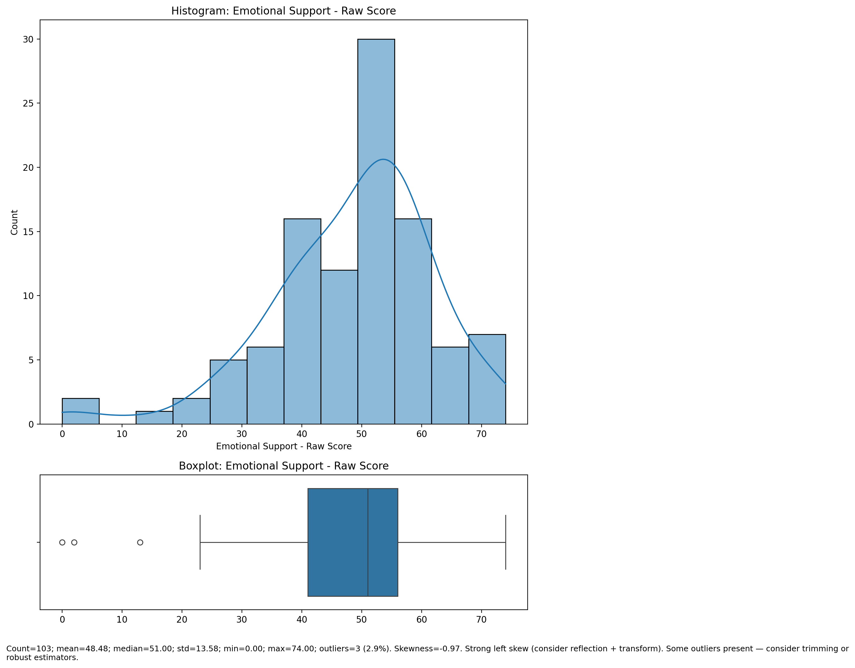

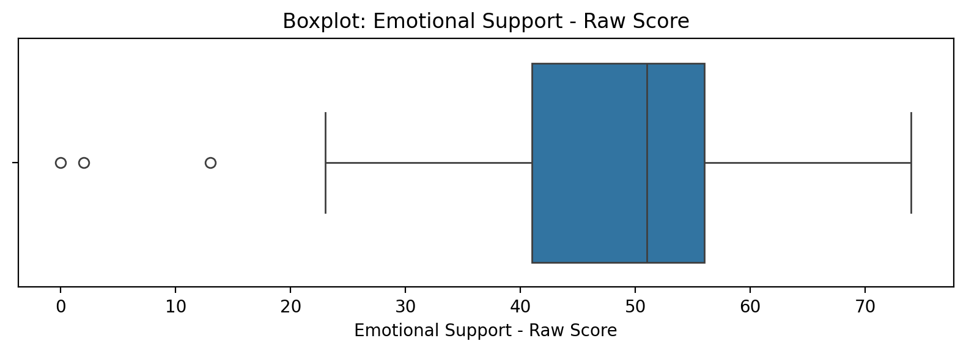

Count=103; mean=48.48; median=51.00; std=13.58; min=0.00; max=74.00; outliers=3 (2.9%). Skewness=-0.97.

## Informational Support - Raw Score

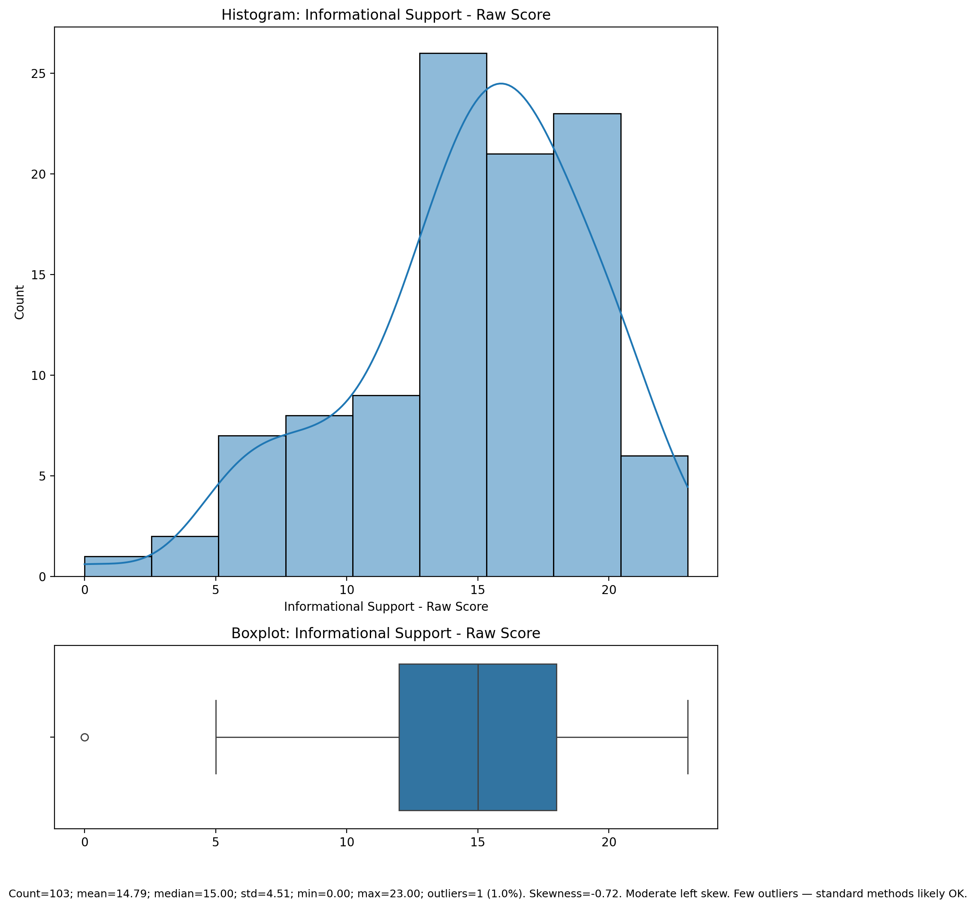

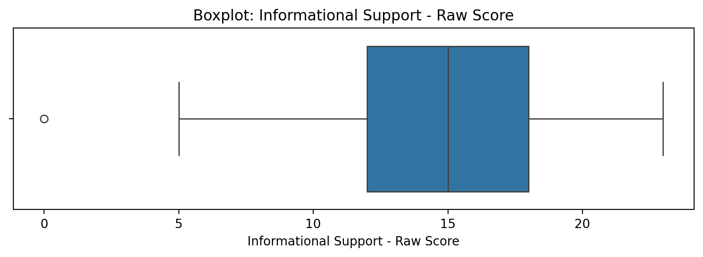

Count=103; mean=14.79; median=15.00; std=4.51; min=0.00; max=23.00; outliers=1 (1.0%). Skewness=-0.72.

## Instrumental Support - Raw Score

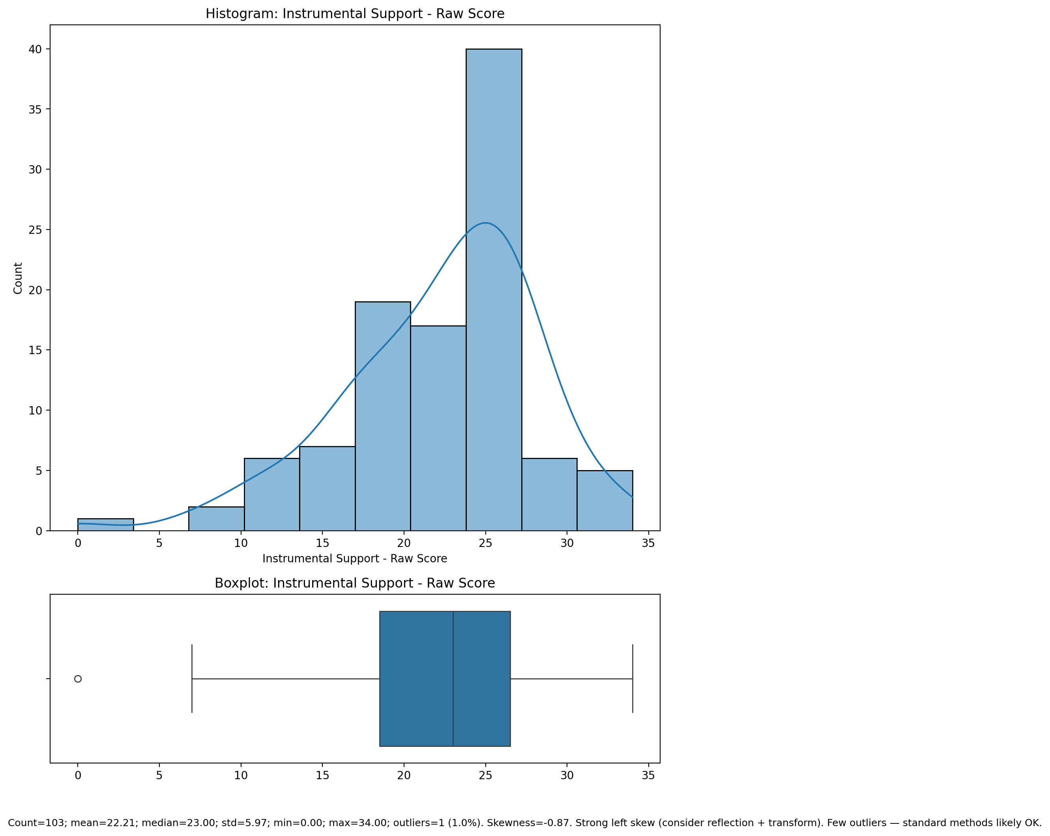

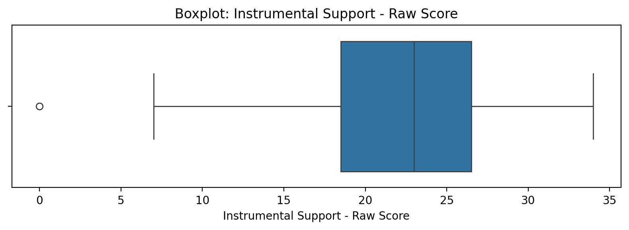

Count=103; mean=22.21; median=23.00; std=5.97; min=0.00; max=34.00; outliers=1 (1.0%). Skewness=-0.87.

## Perceived Social Support Total Raw Score

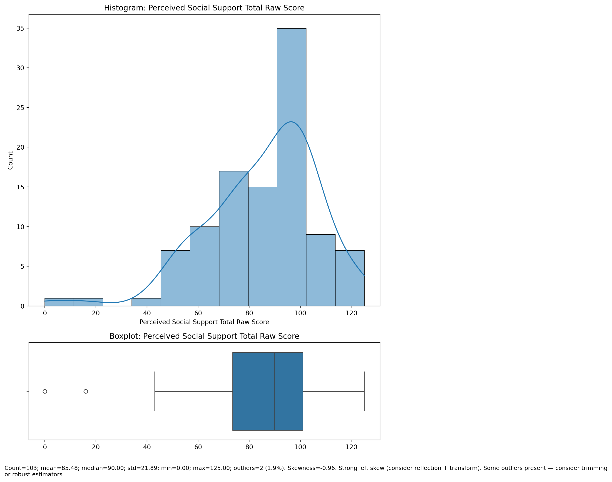

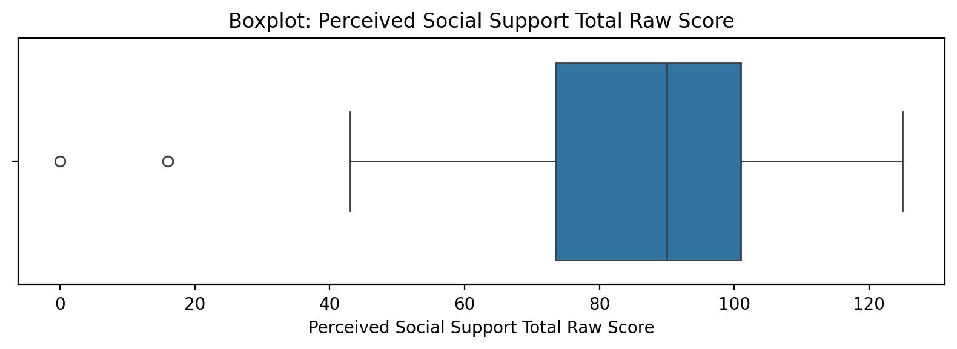

Count=103; mean=85.48; median=90.00; std=21.89; min=0.00; max=125.00; outliers=2 (1.9%). Skewness=-0.96.

## Emotional Support - T Score

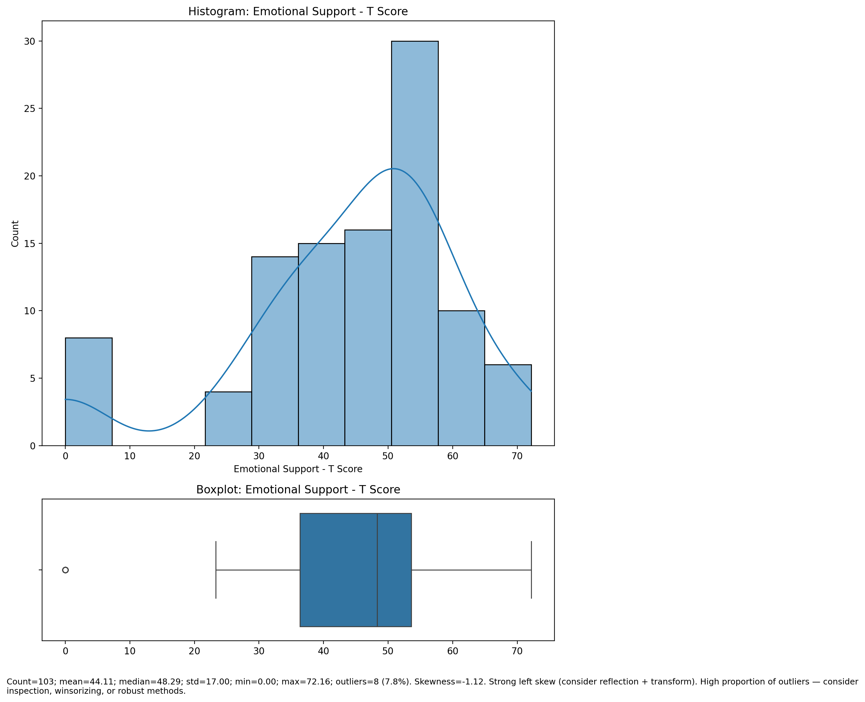

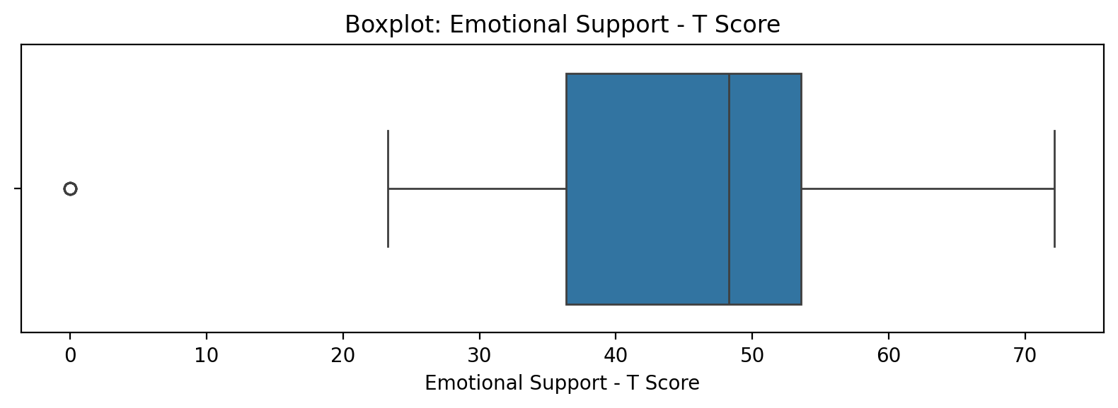

Count=103; mean=44.11; median=48.29; std=17.00; min=0.00; max=72.16; outliers=8 (7.8%). Skewness=-1.12.

## Informational Support - T Score

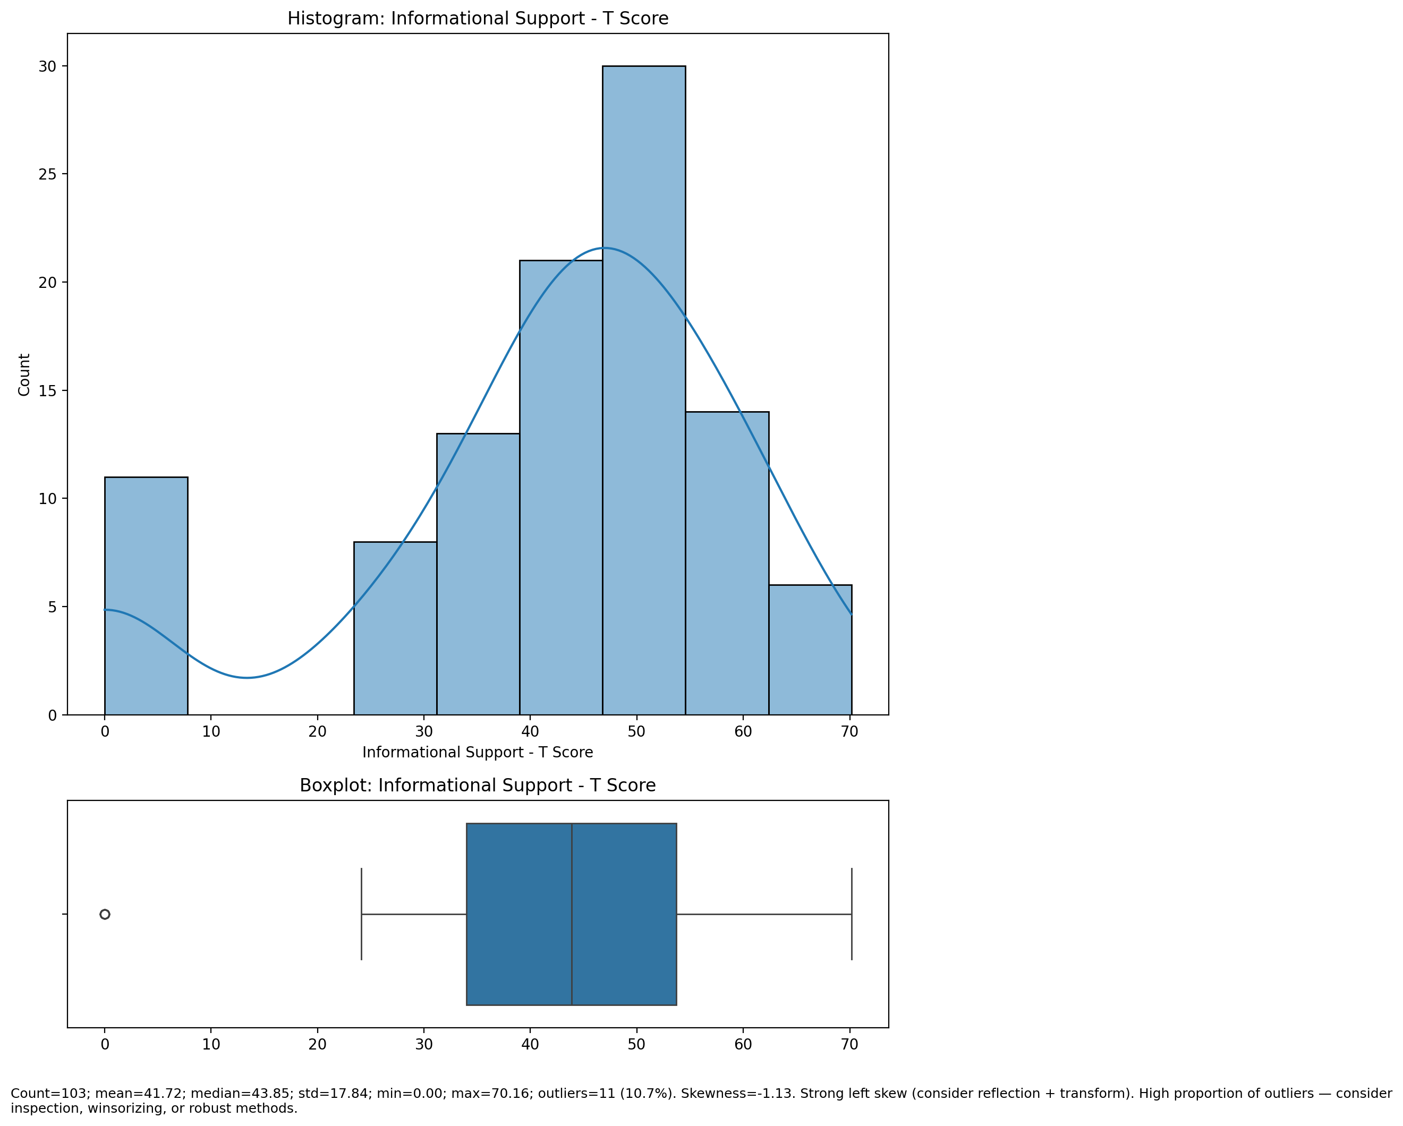

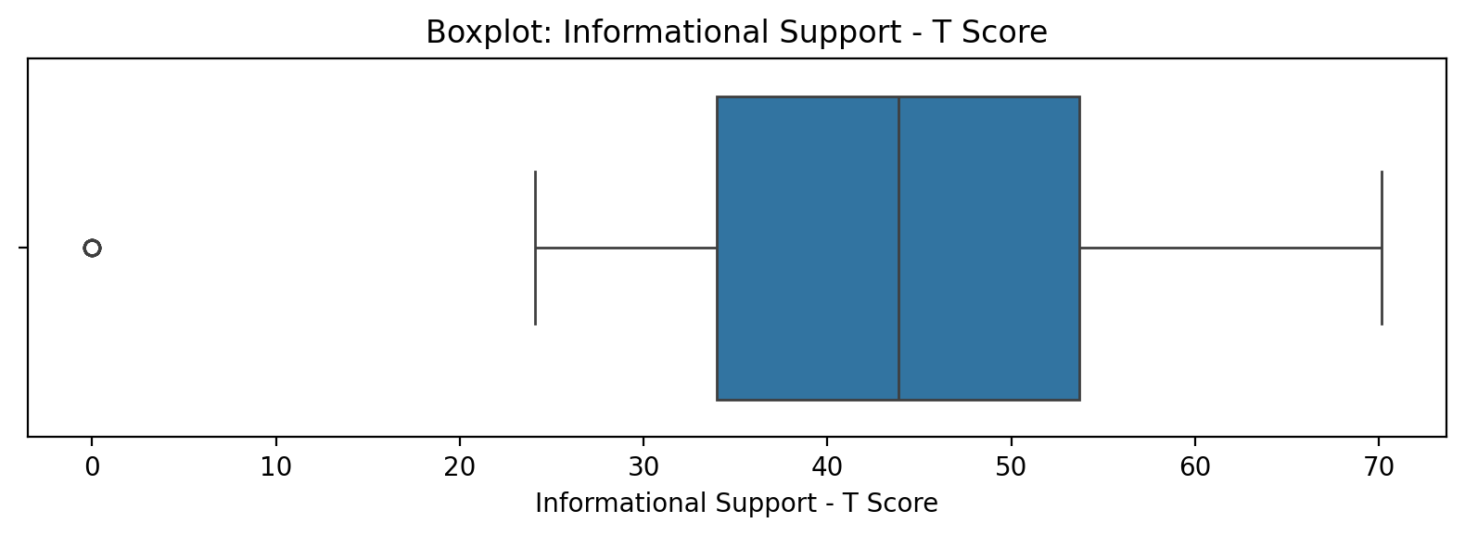

Count=103; mean=41.72; median=43.85; std=17.84; min=0.00; max=70.16; outliers=11 (10.7%). Skewness=-1.13.

## Instrumental Support - T Score

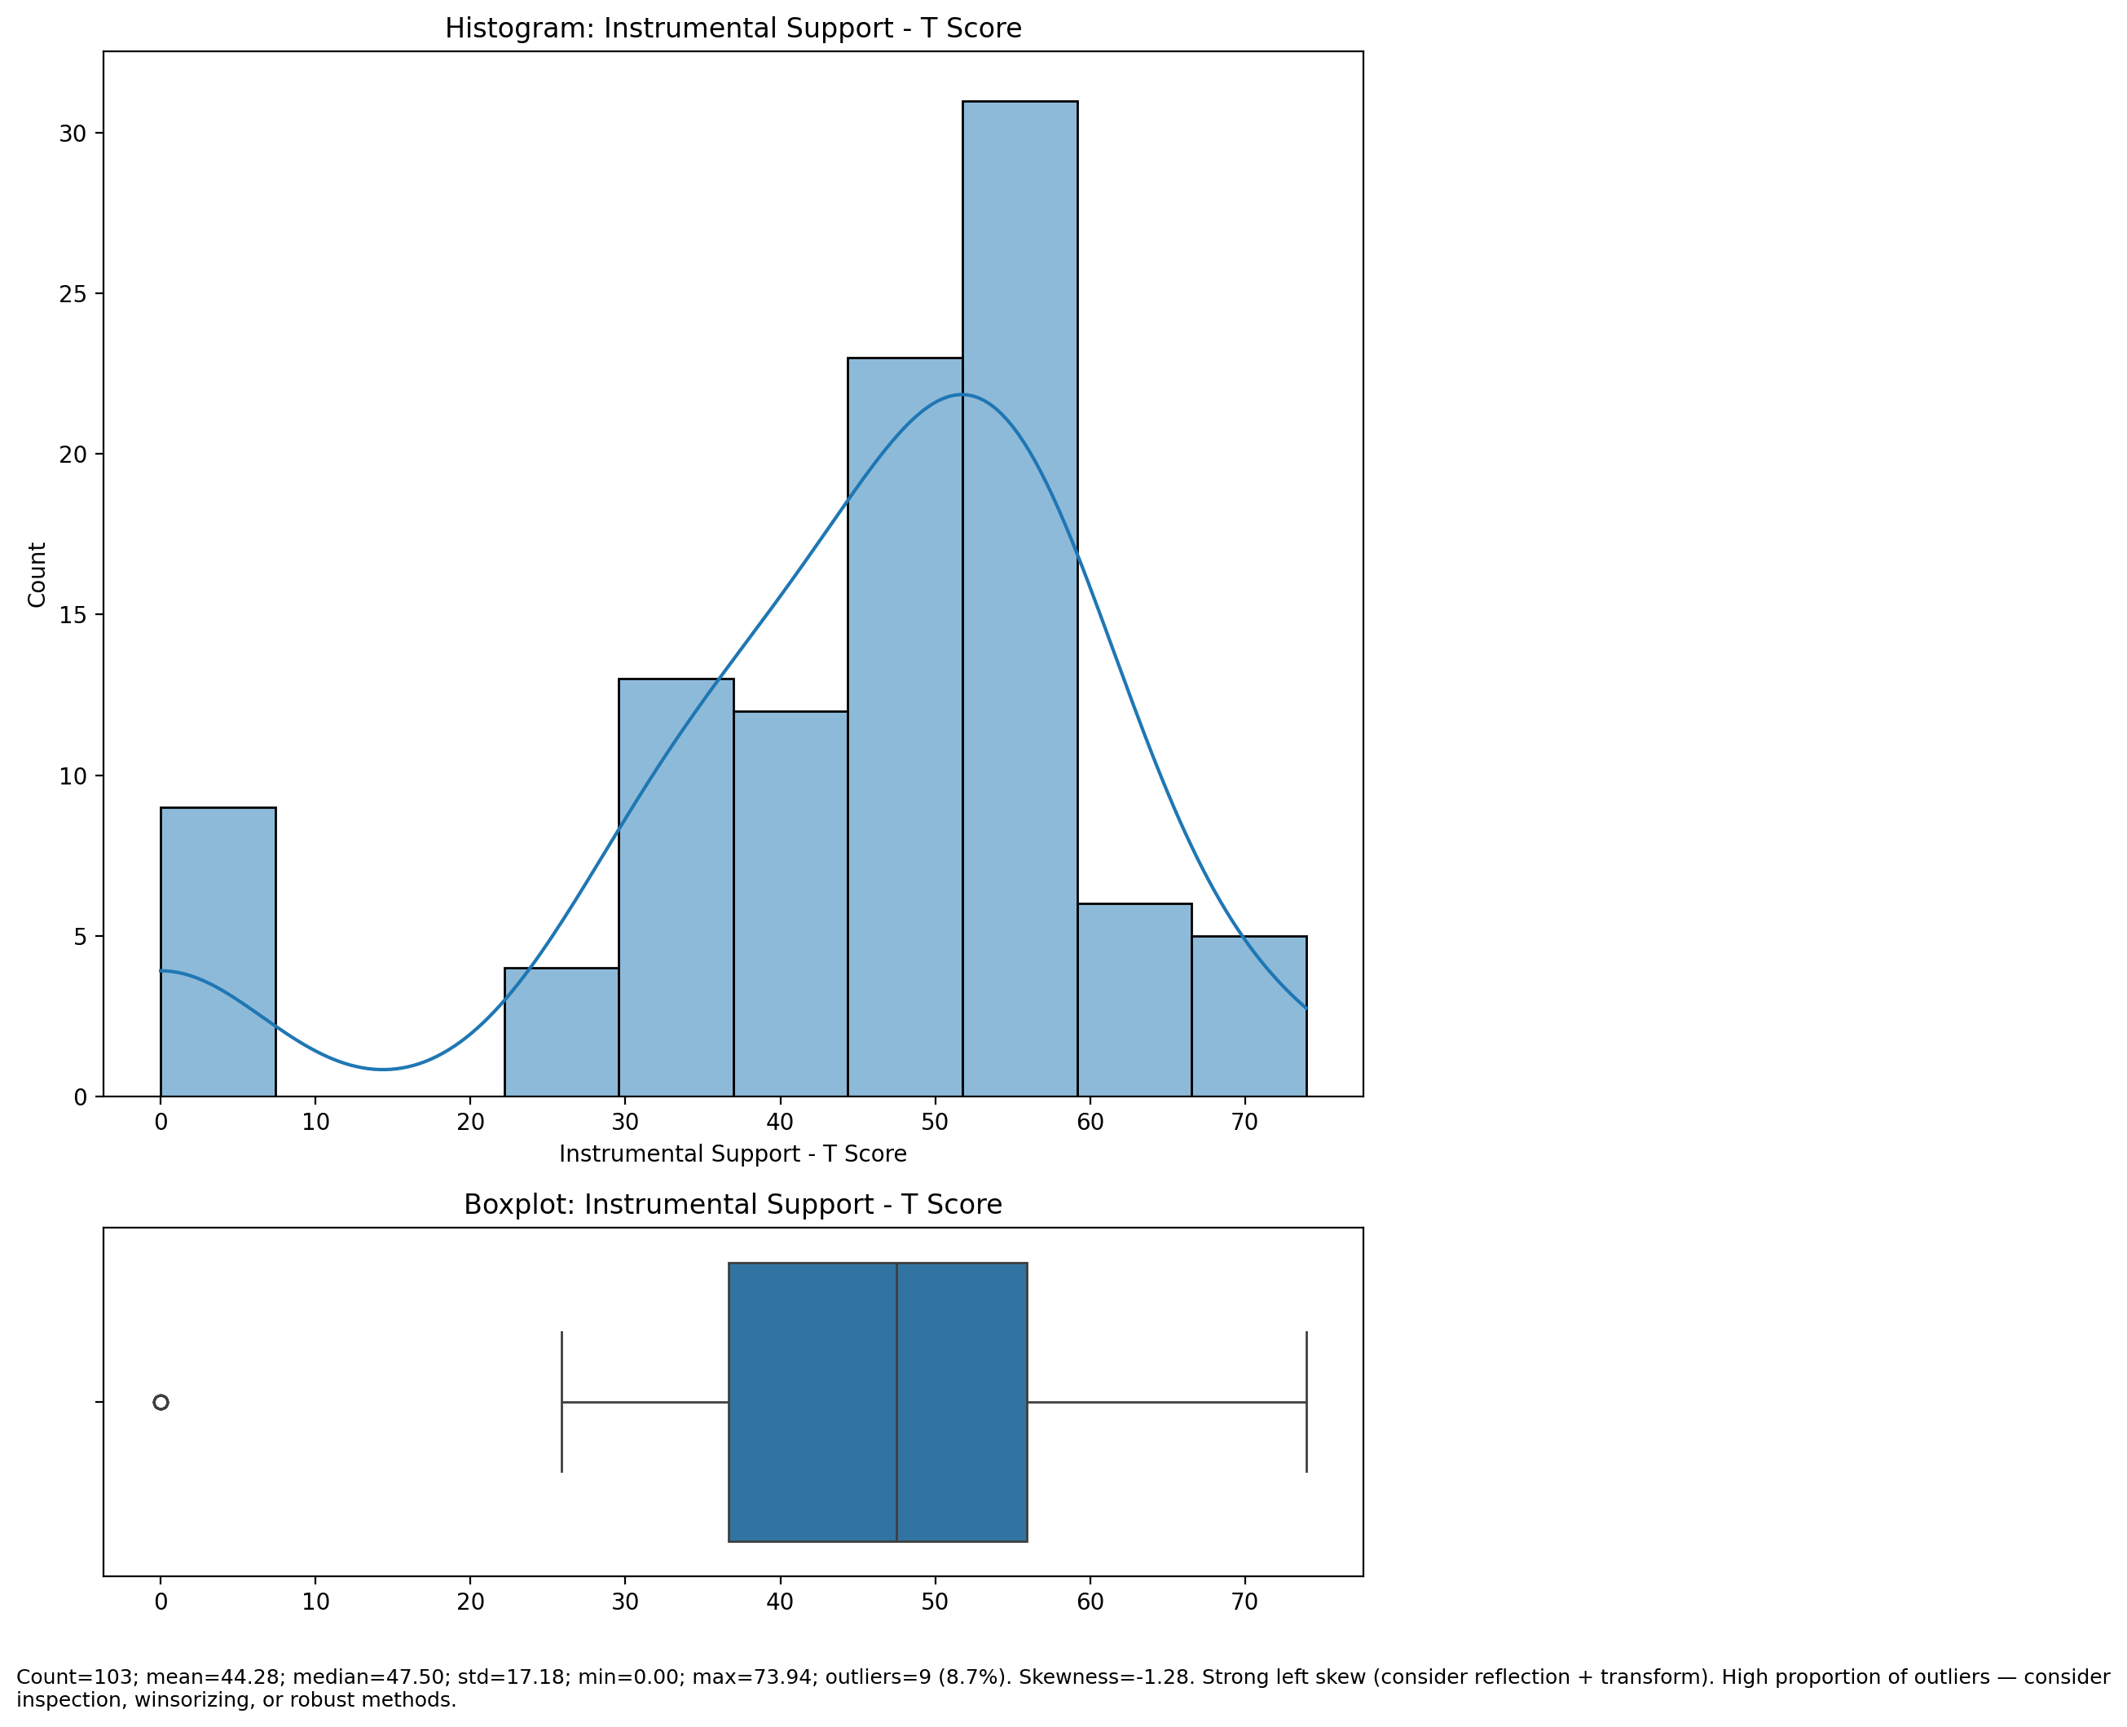

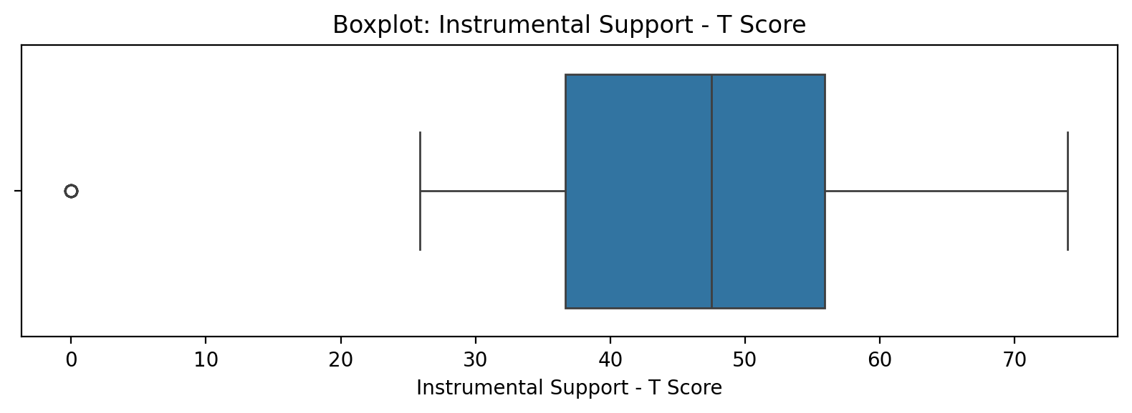

Count=103; mean=44.28; median=47.50; std=17.18; min=0.00; max=73.94; outliers=9 (8.7%). Skewness=-1.28.

## Perceived Social Support Total T Score

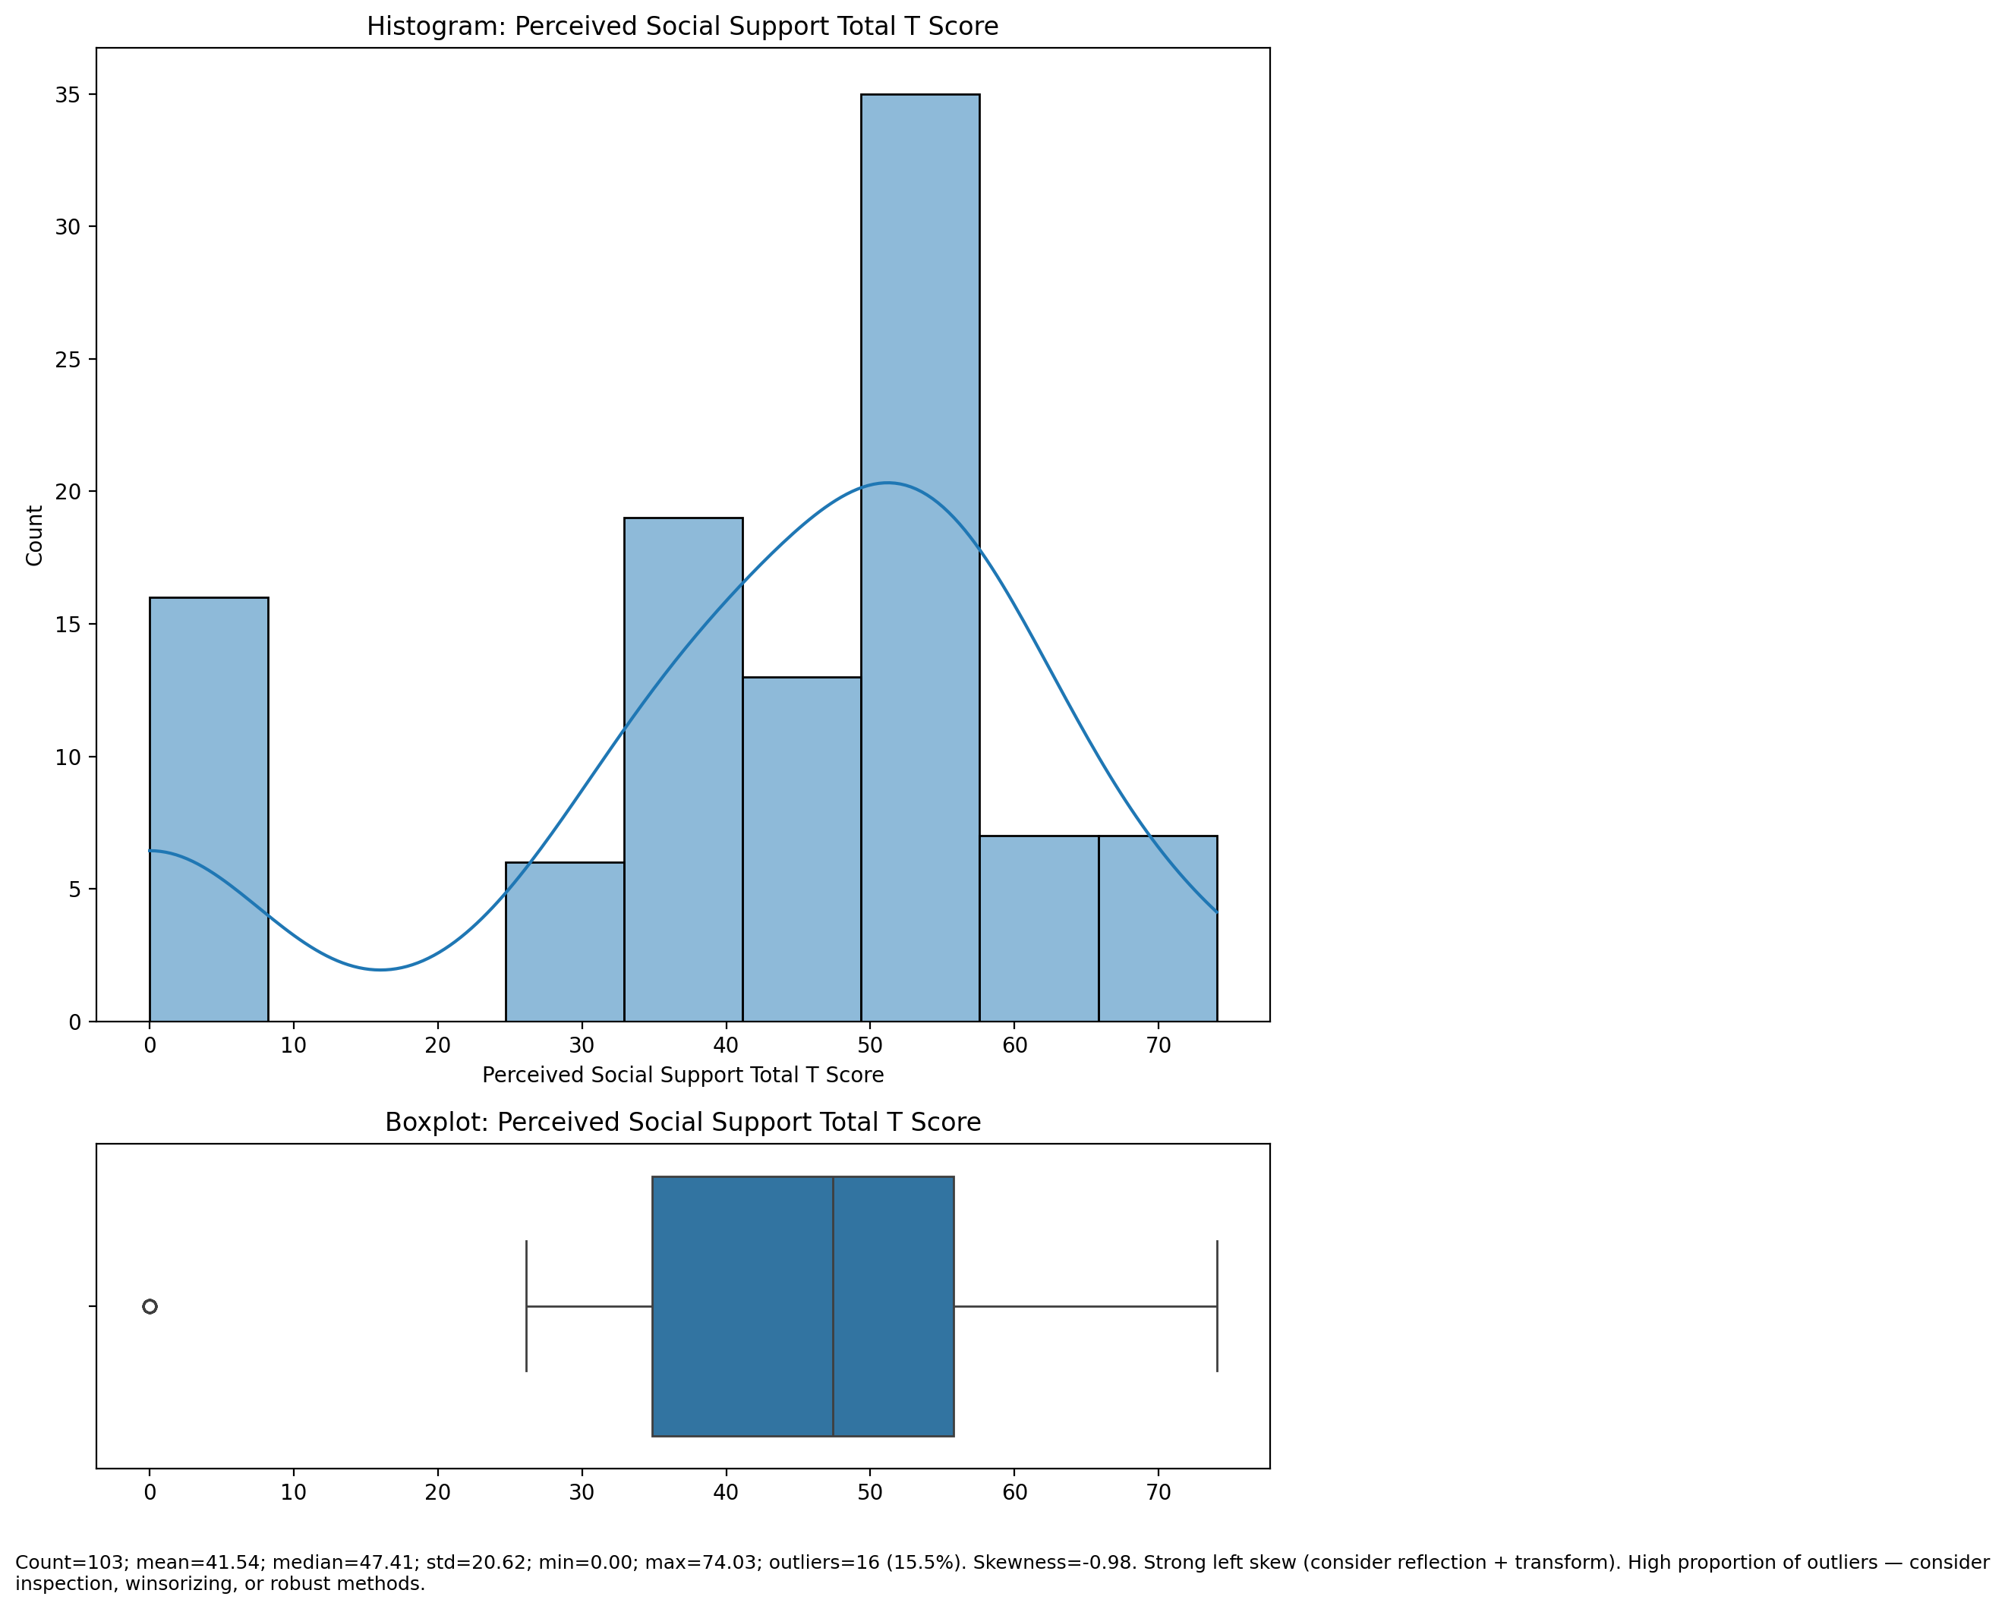

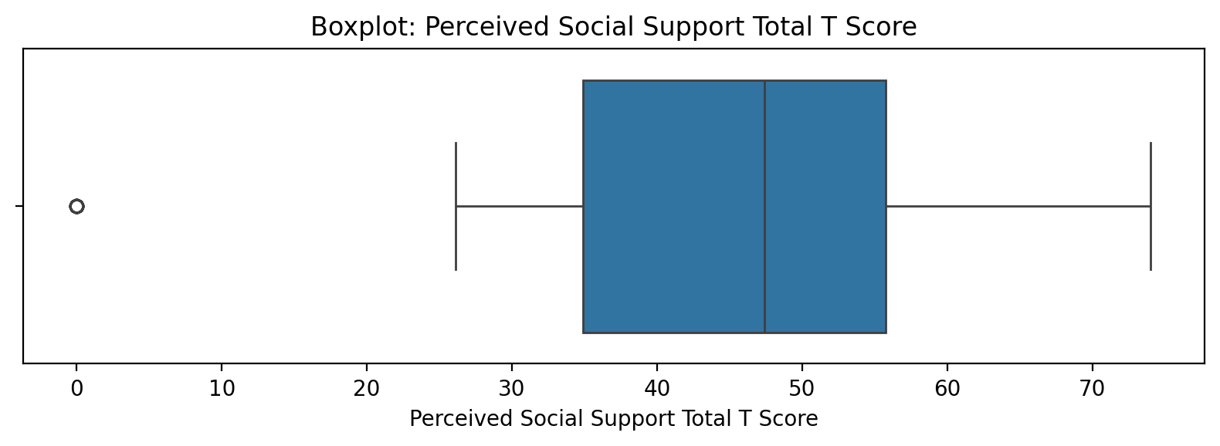

Count=103; mean=41.54; median=47.41; std=20.62; min=0.00; max=74.03; outliers=16 (15.5%). Skewness=-0.98.

## Emotional Support - Rank

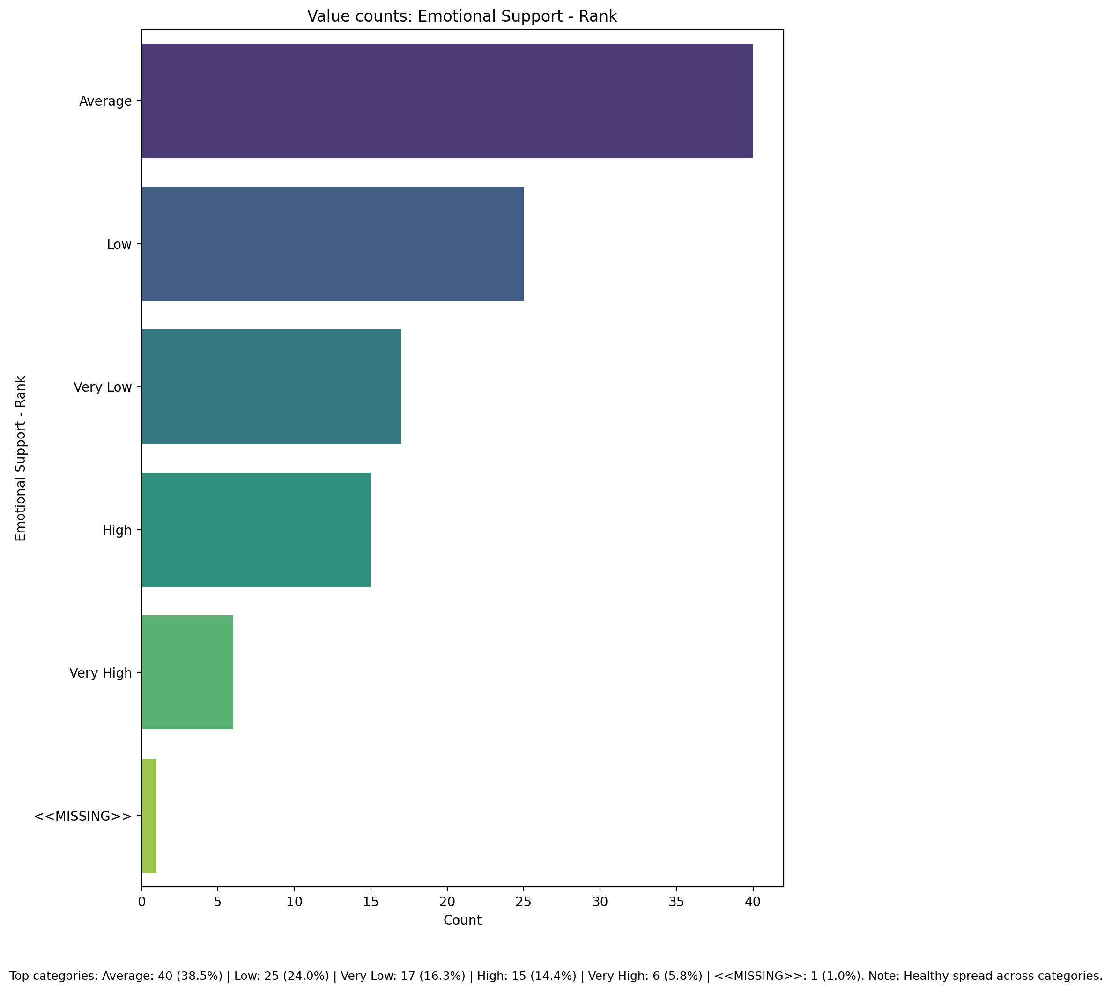

Top categories: Average: 40 (38.5%) | Low: 25 (24.0%) | Very Low: 17 (16.3%) | High: 15 (14.4%) | Very High: 6 (5.8%) | <<MISSING>>: 1 (1.0%)

## Informational Support - Rank

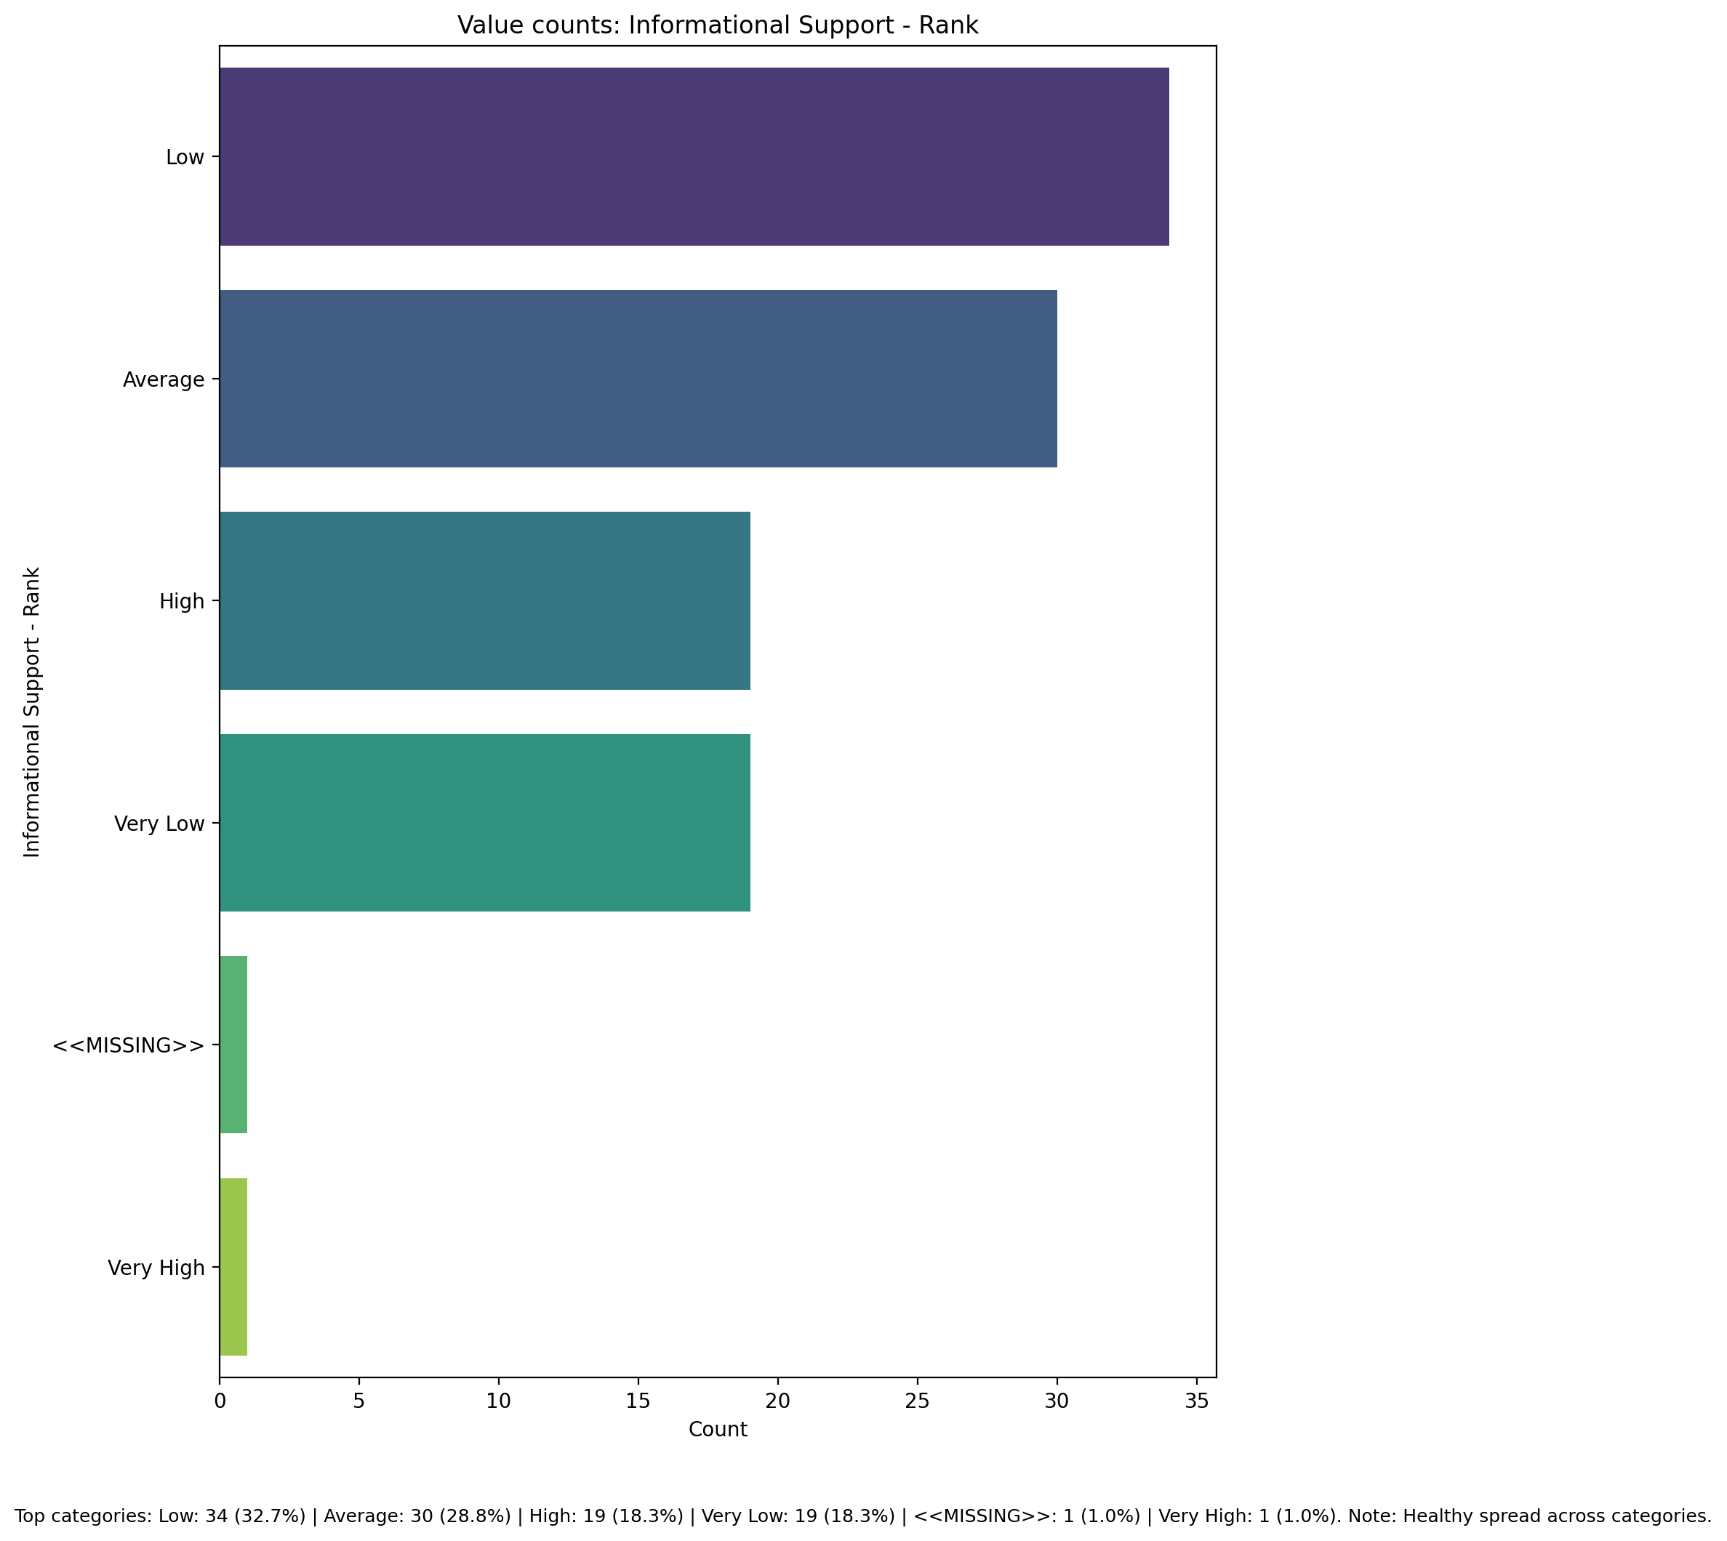

Top categories: Low: 34 (32.7%) | Average: 30 (28.8%) | High: 19 (18.3%) | Very Low: 19 (18.3%) | <<MISSING>>: 1 (1.0%) | Very High: 1 (1.0%)

## Instrumental Support - Rank

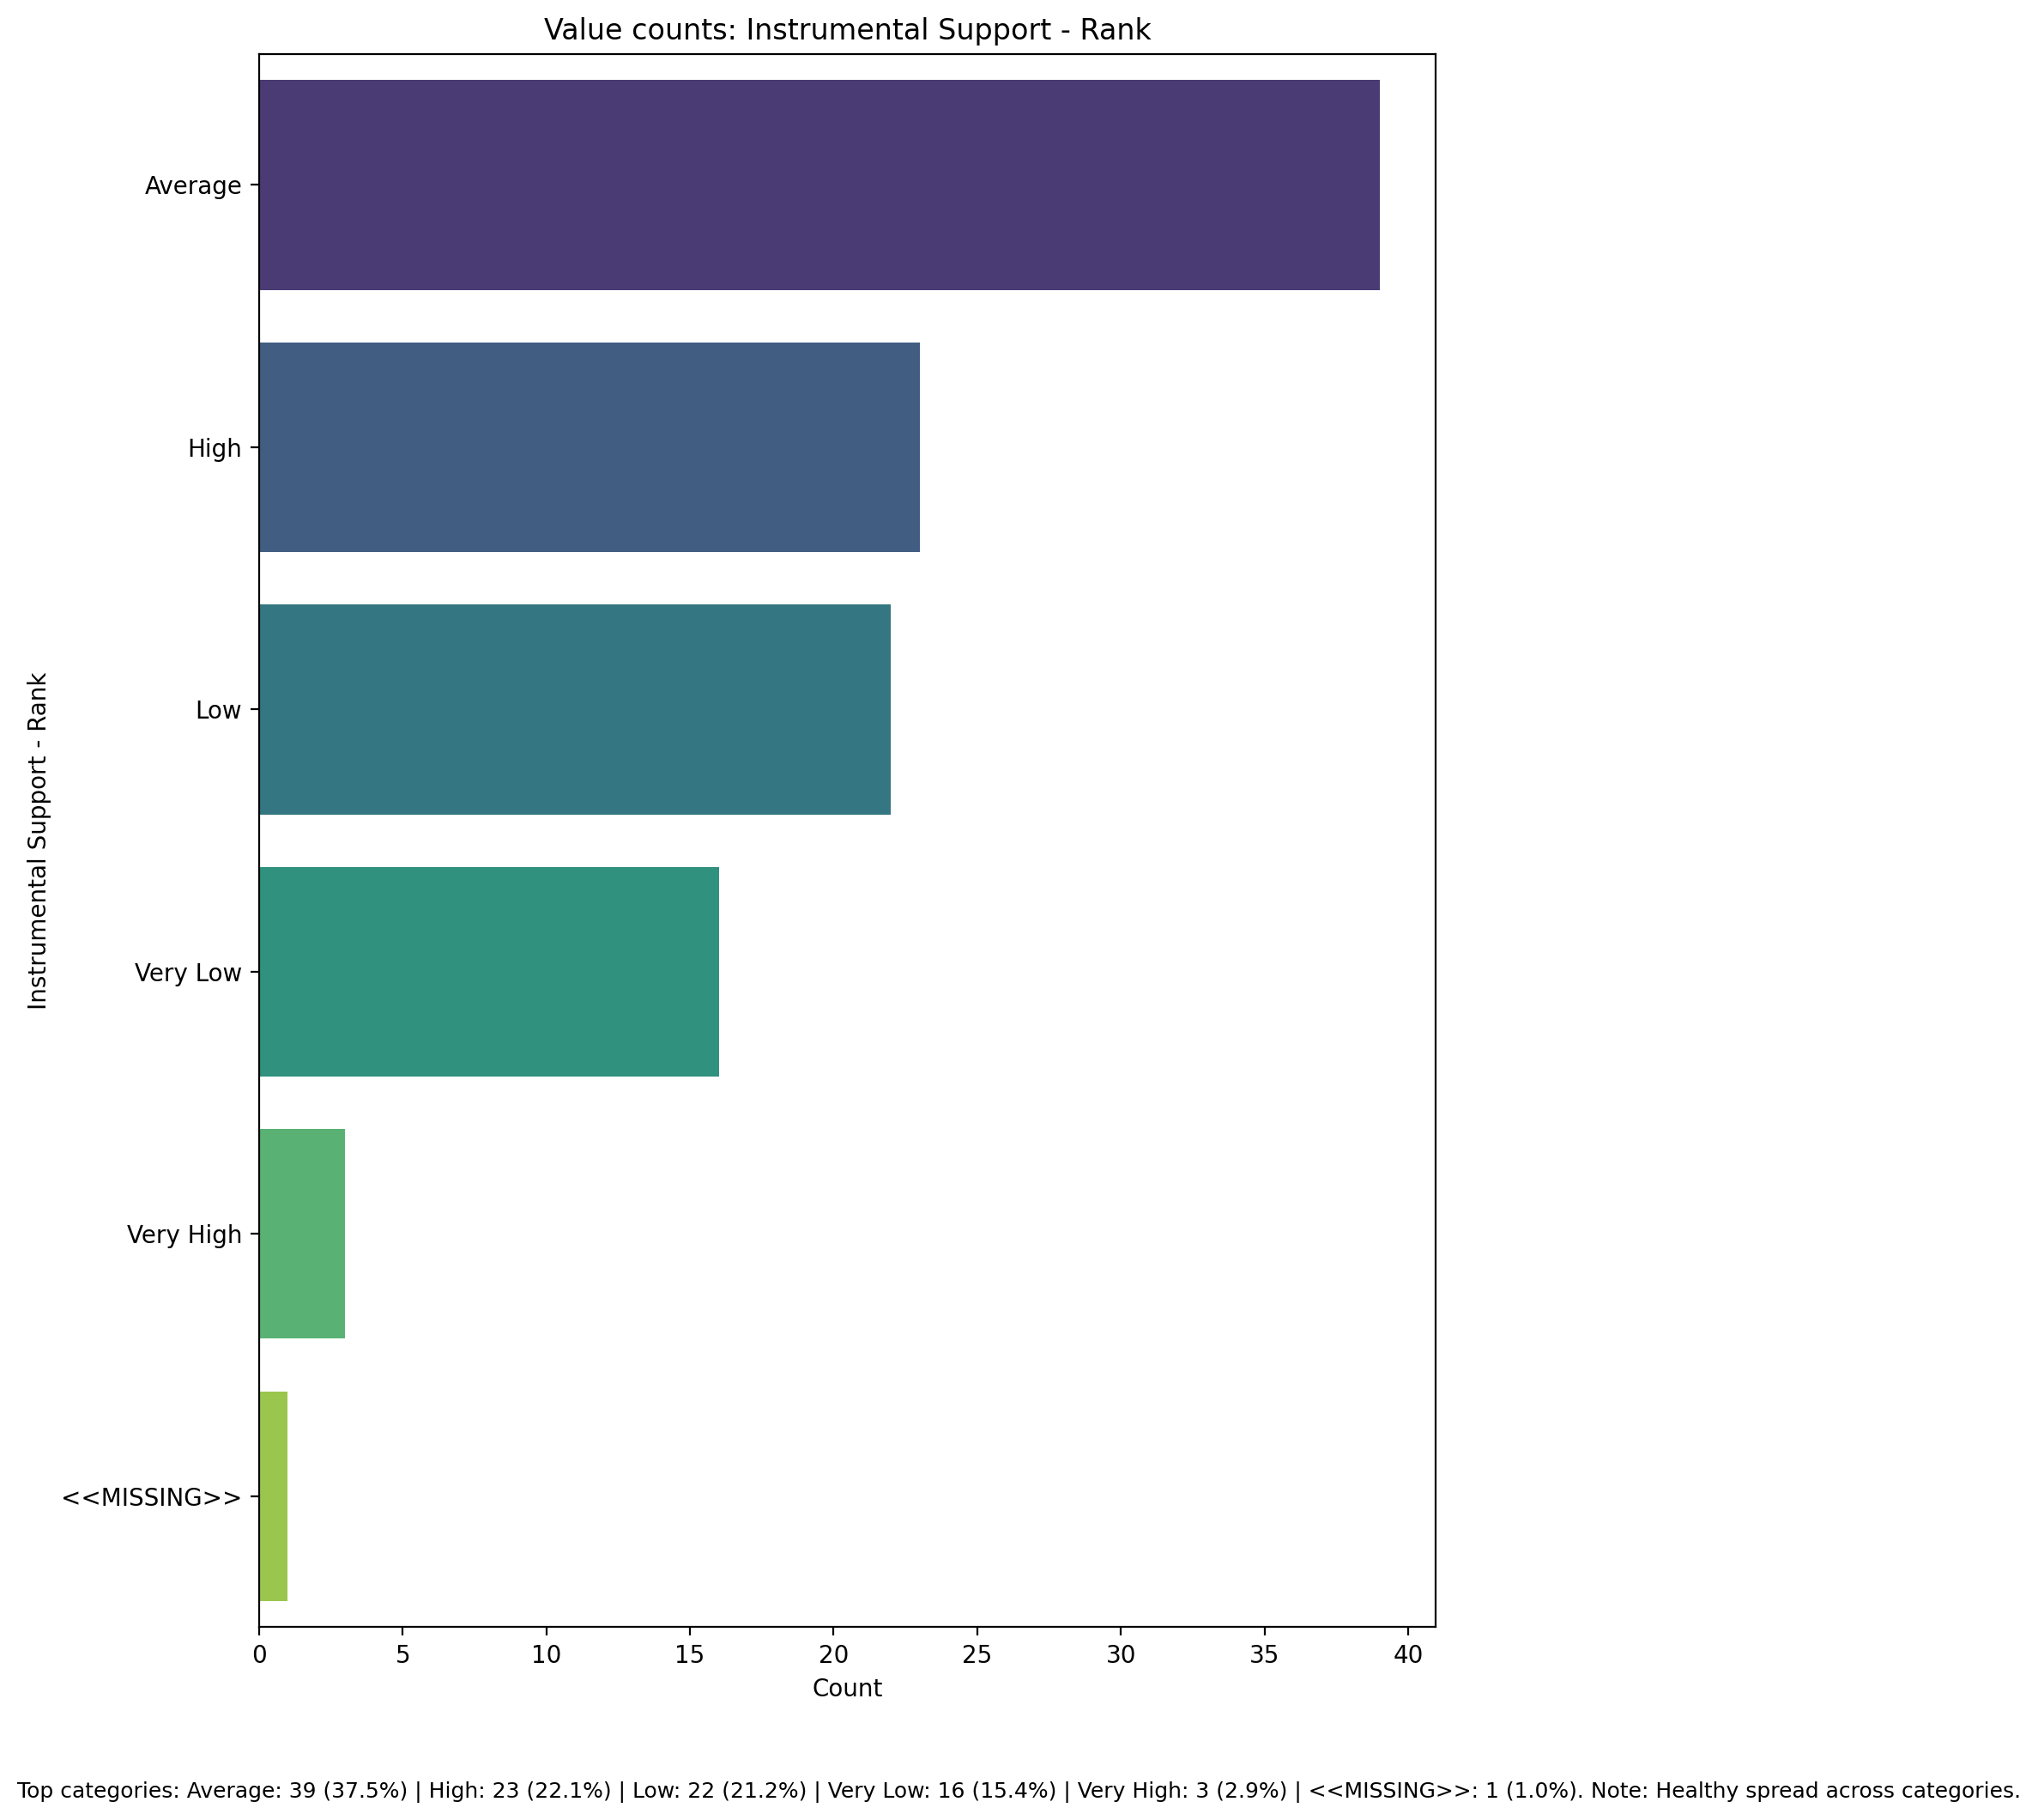

Top categories: Average: 39 (37.5%) | High: 23 (22.1%) | Low: 22 (21.2%) | Very Low: 16 (15.4%) | Very High: 3 (2.9%) | <<MISSING>>: 1 (1.0%)

## Perceived Social Support TOTAL - Rank

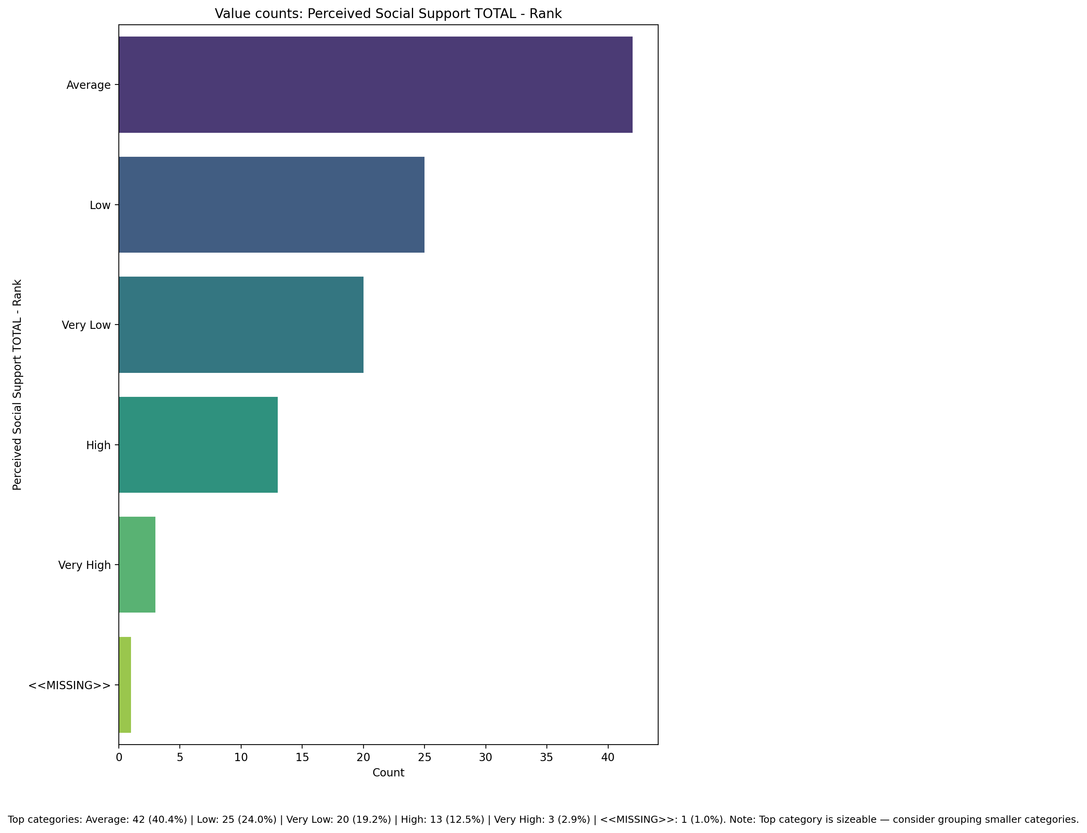

Top categories: Average: 42 (40.4%) | Low: 25 (24.0%) | Very Low: 20 (19.2%) | High: 13 (12.5%) | Very High: 3 (2.9%) | <<MISSING>>: 1 (1.0%)

## Power Self Concept - Real Self Concept Score

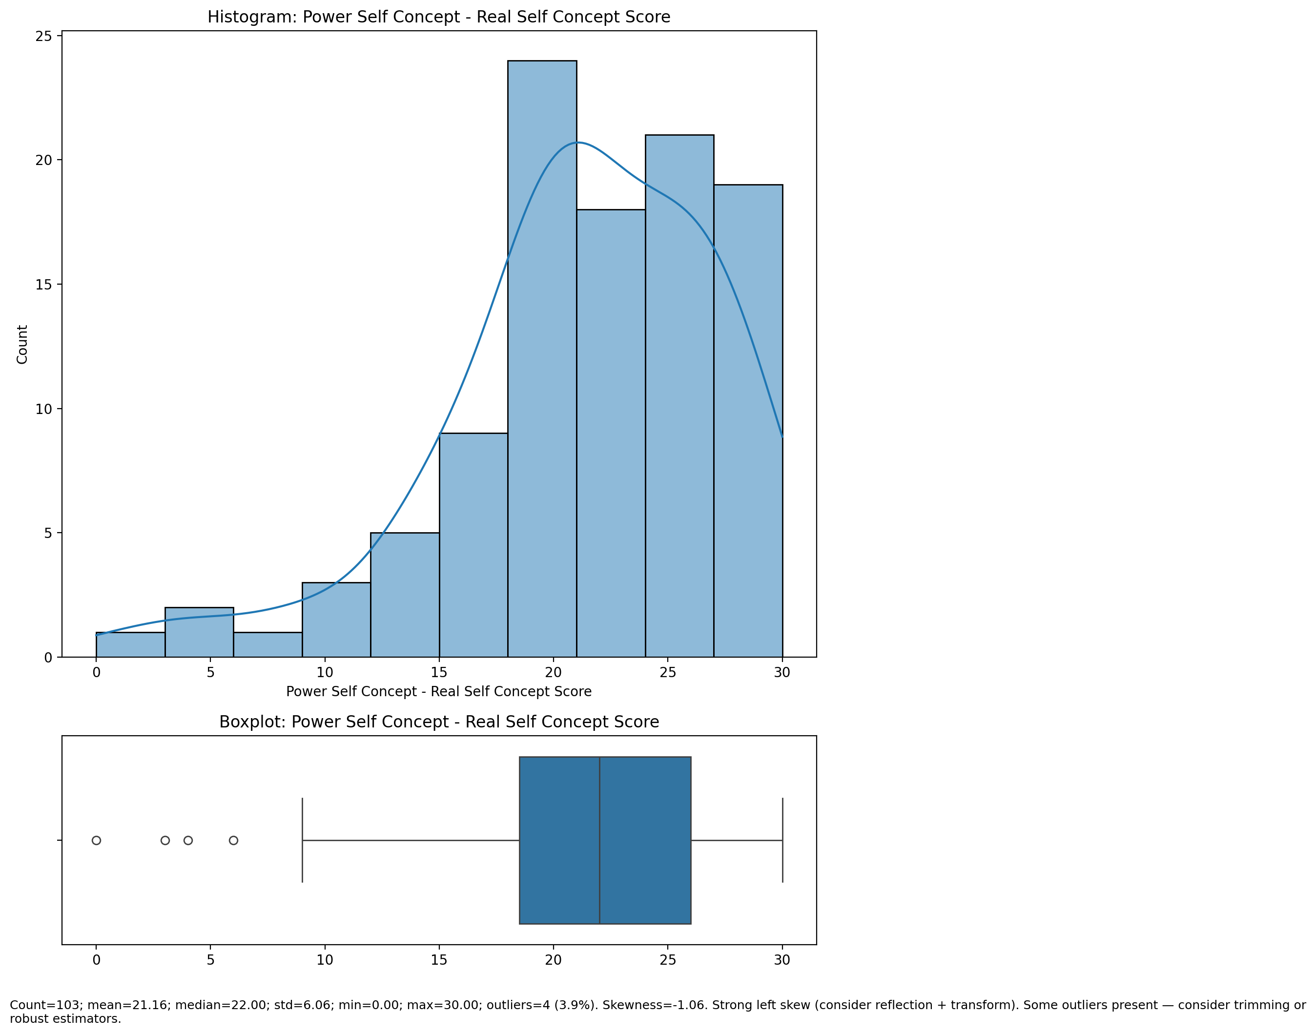

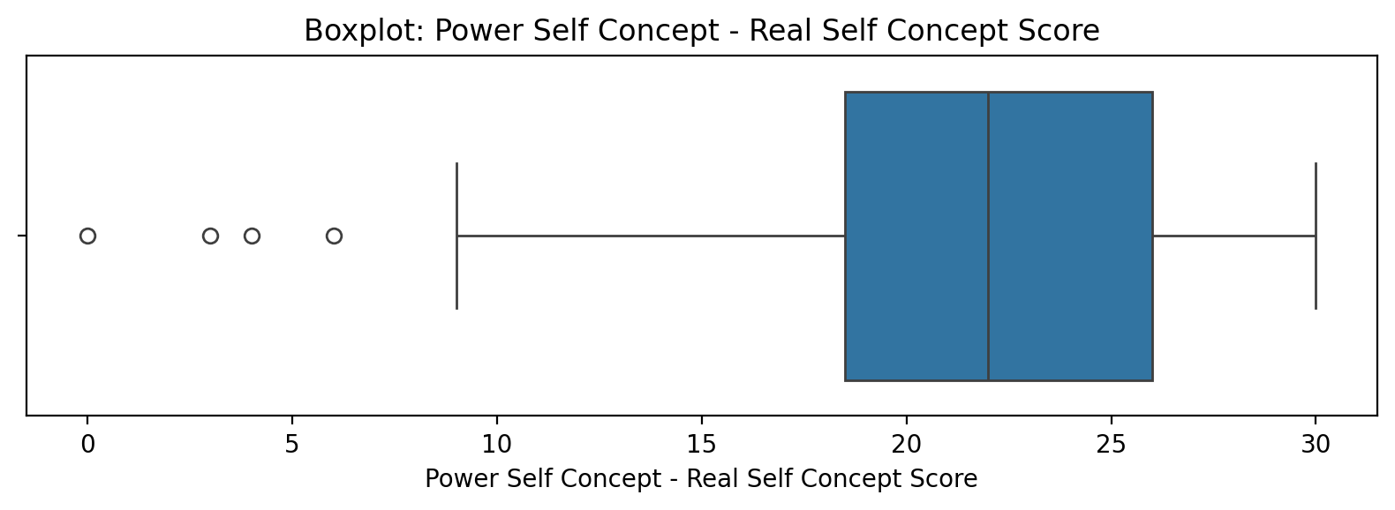

Count=103; mean=21.16; median=22.00; std=6.06; min=0.00; max=30.00; outliers=4 (3.9%). Skewness=-1.06.

## Power Self Concept - Ideal Self Concept score

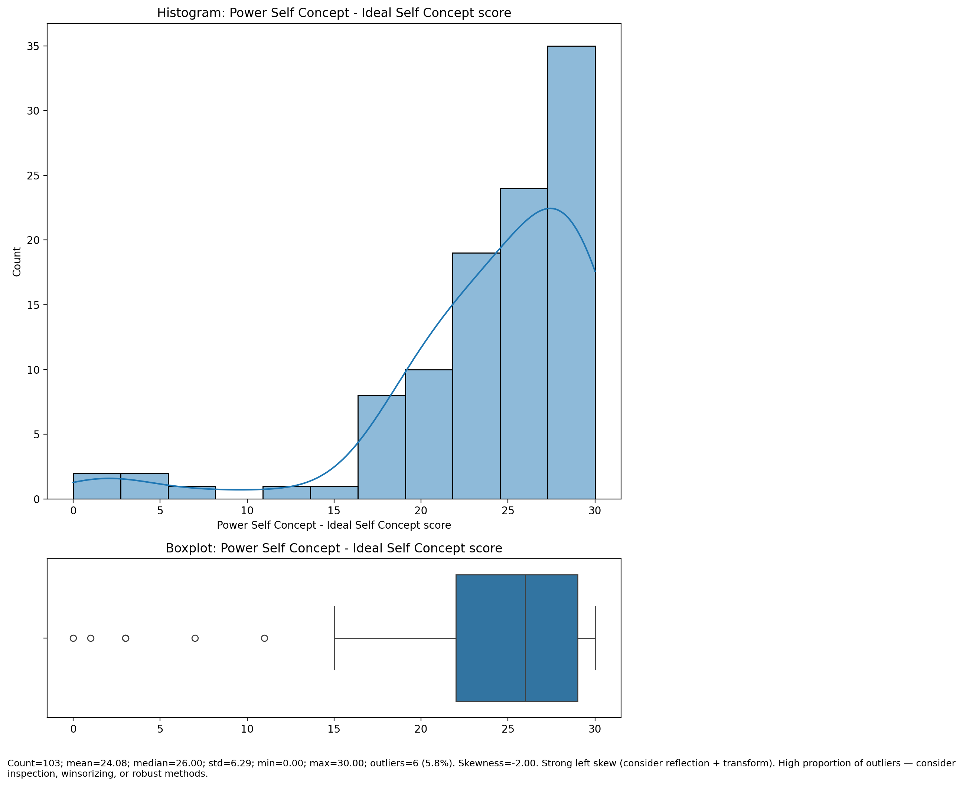

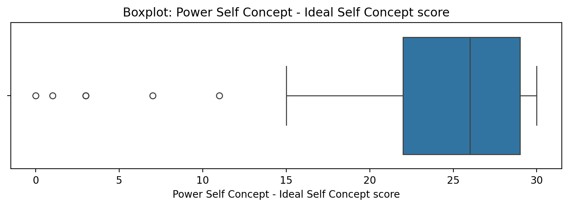

Count=103; mean=24.08; median=26.00; std=6.29; min=0.00; max=30.00; outliers=6 (5.8%). Skewness=-2.00.

## Power Self Concept – Social Self Concept Score

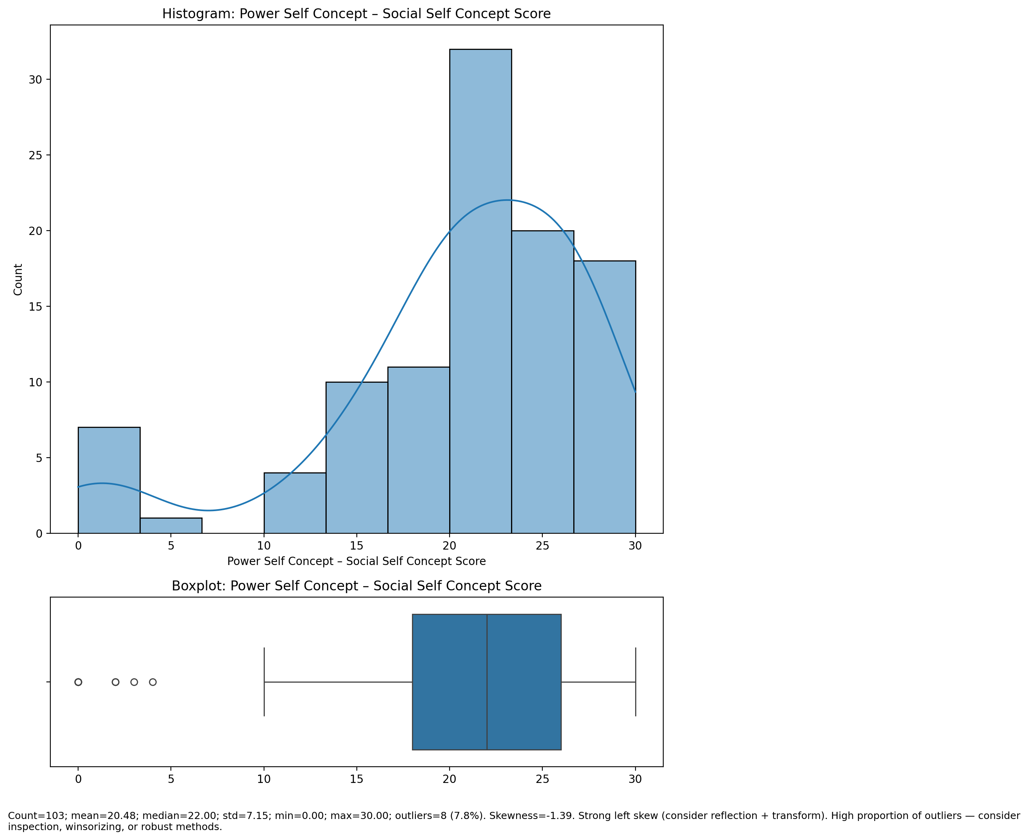

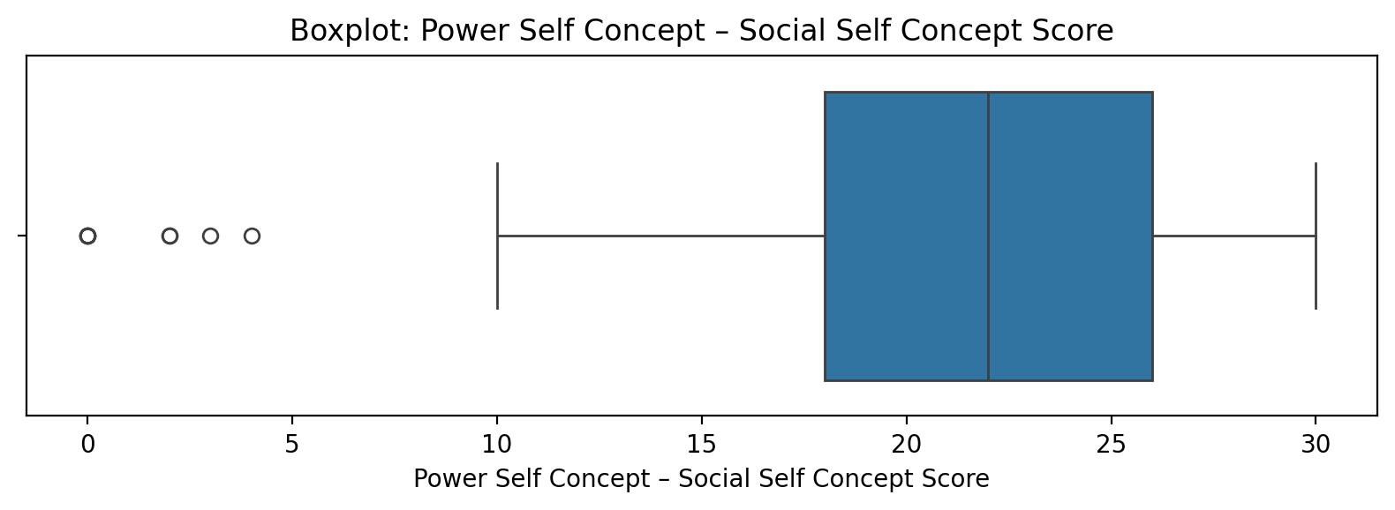

Count=103; mean=20.48; median=22.00; std=7.15; min=0.00; max=30.00; outliers=8 (7.8%). Skewness=-1.39.

## Social Self Concept - Real Self Concept Score

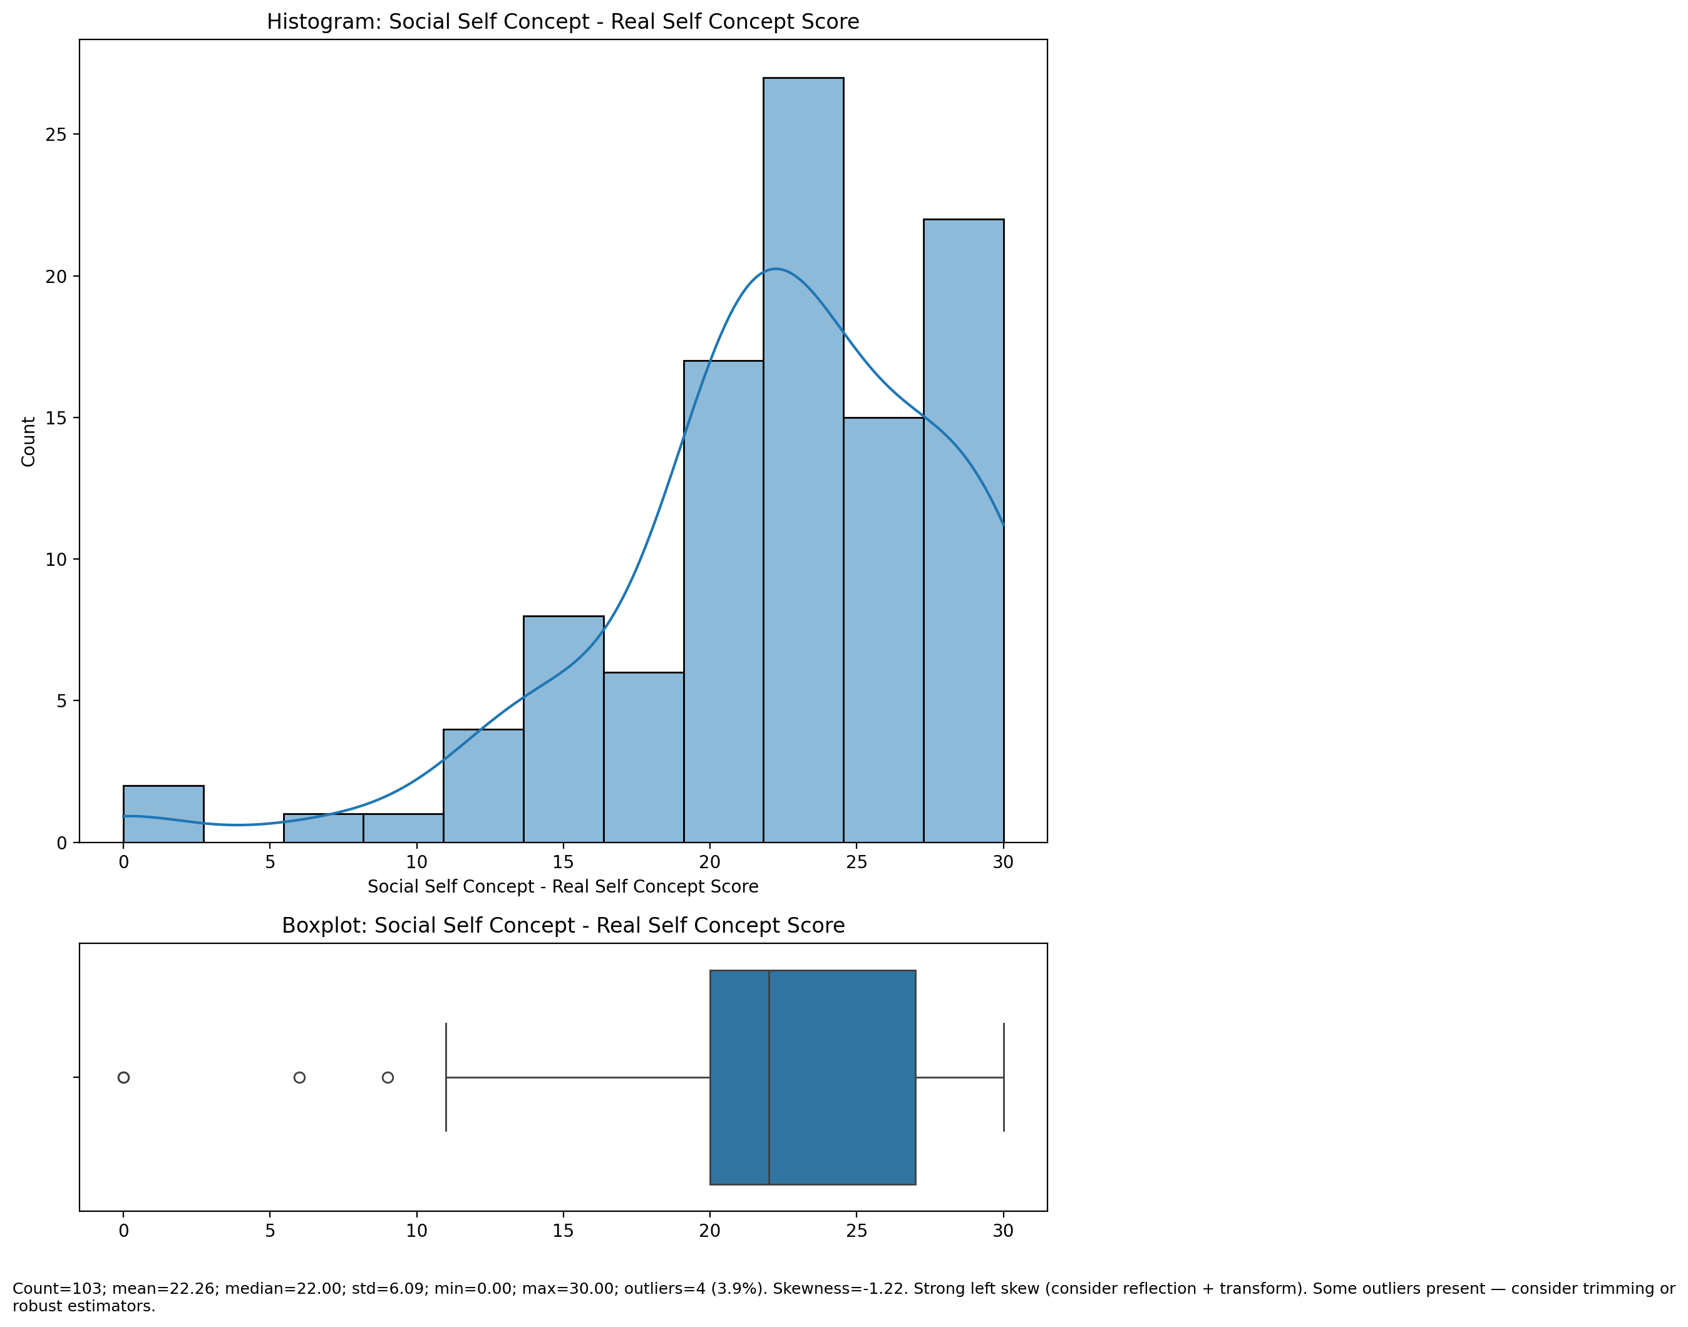

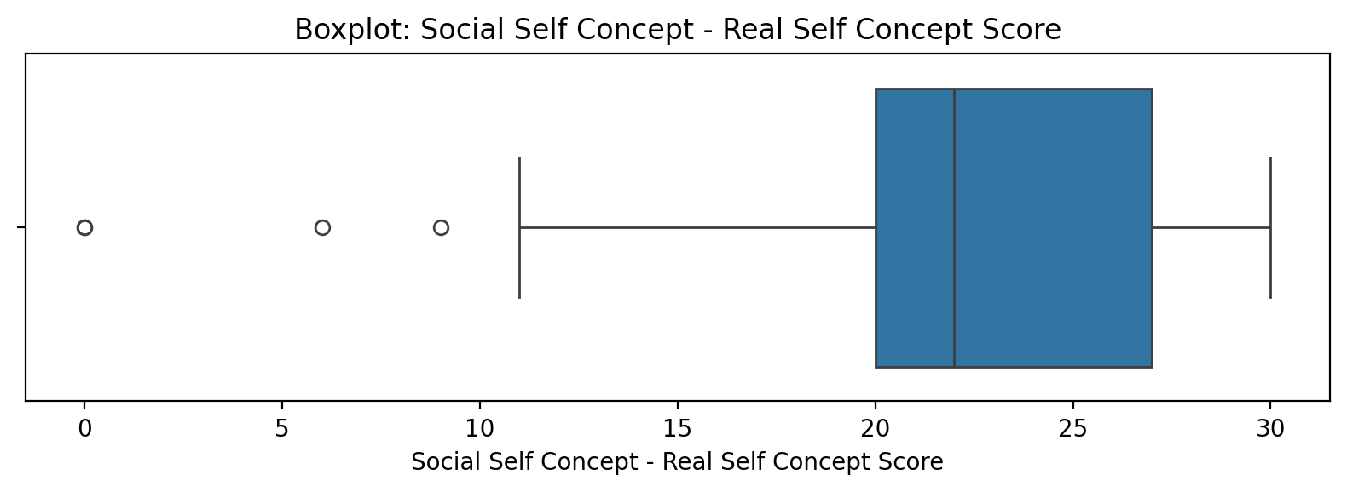

Count=103; mean=22.26; median=22.00; std=6.09; min=0.00; max=30.00; outliers=4 (3.9%). Skewness=-1.22.

## Social Self Concept – Ideal Self Concept Score

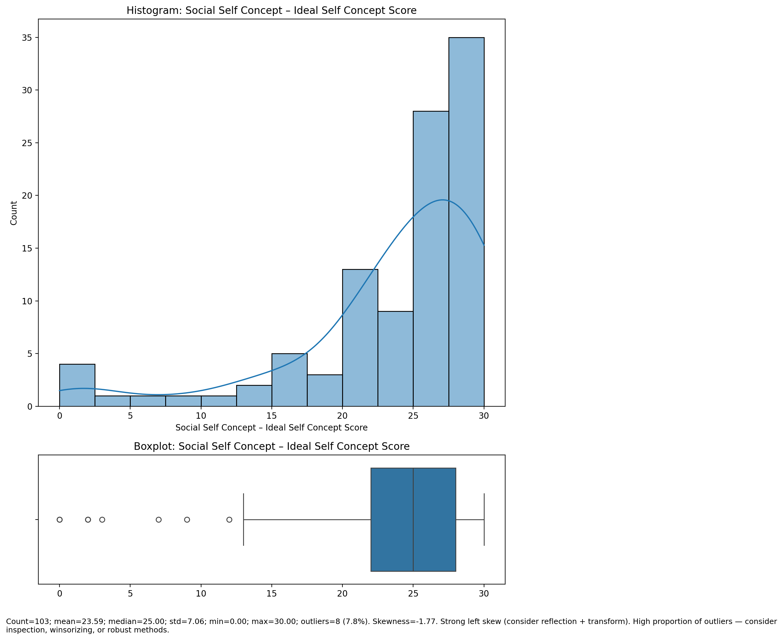

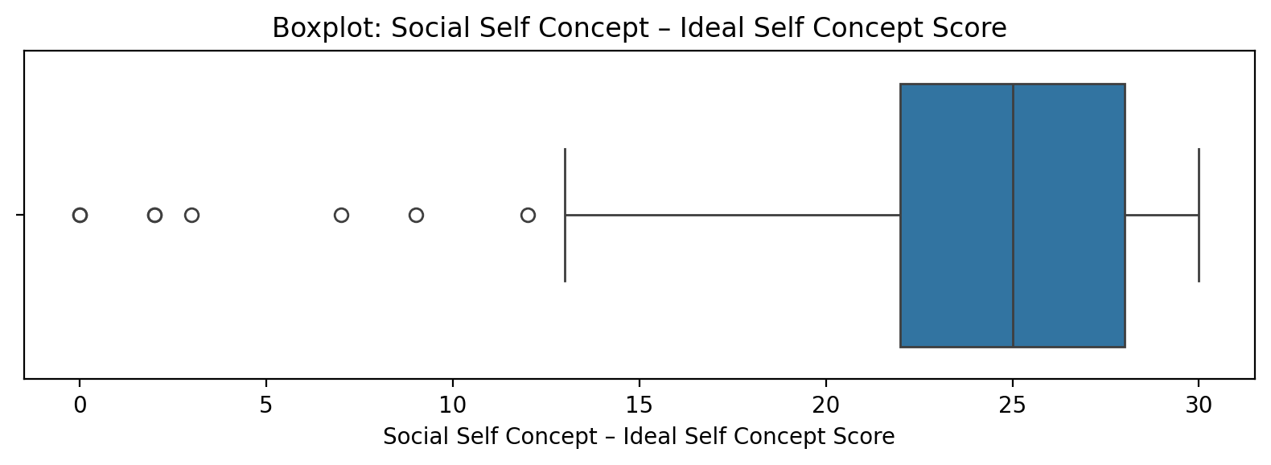

Count=103; mean=23.59; median=25.00; std=7.06; min=0.00; max=30.00; outliers=8 (7.8%). Skewness=-1.77.

## Social Self Concept – Social Self Concept Score

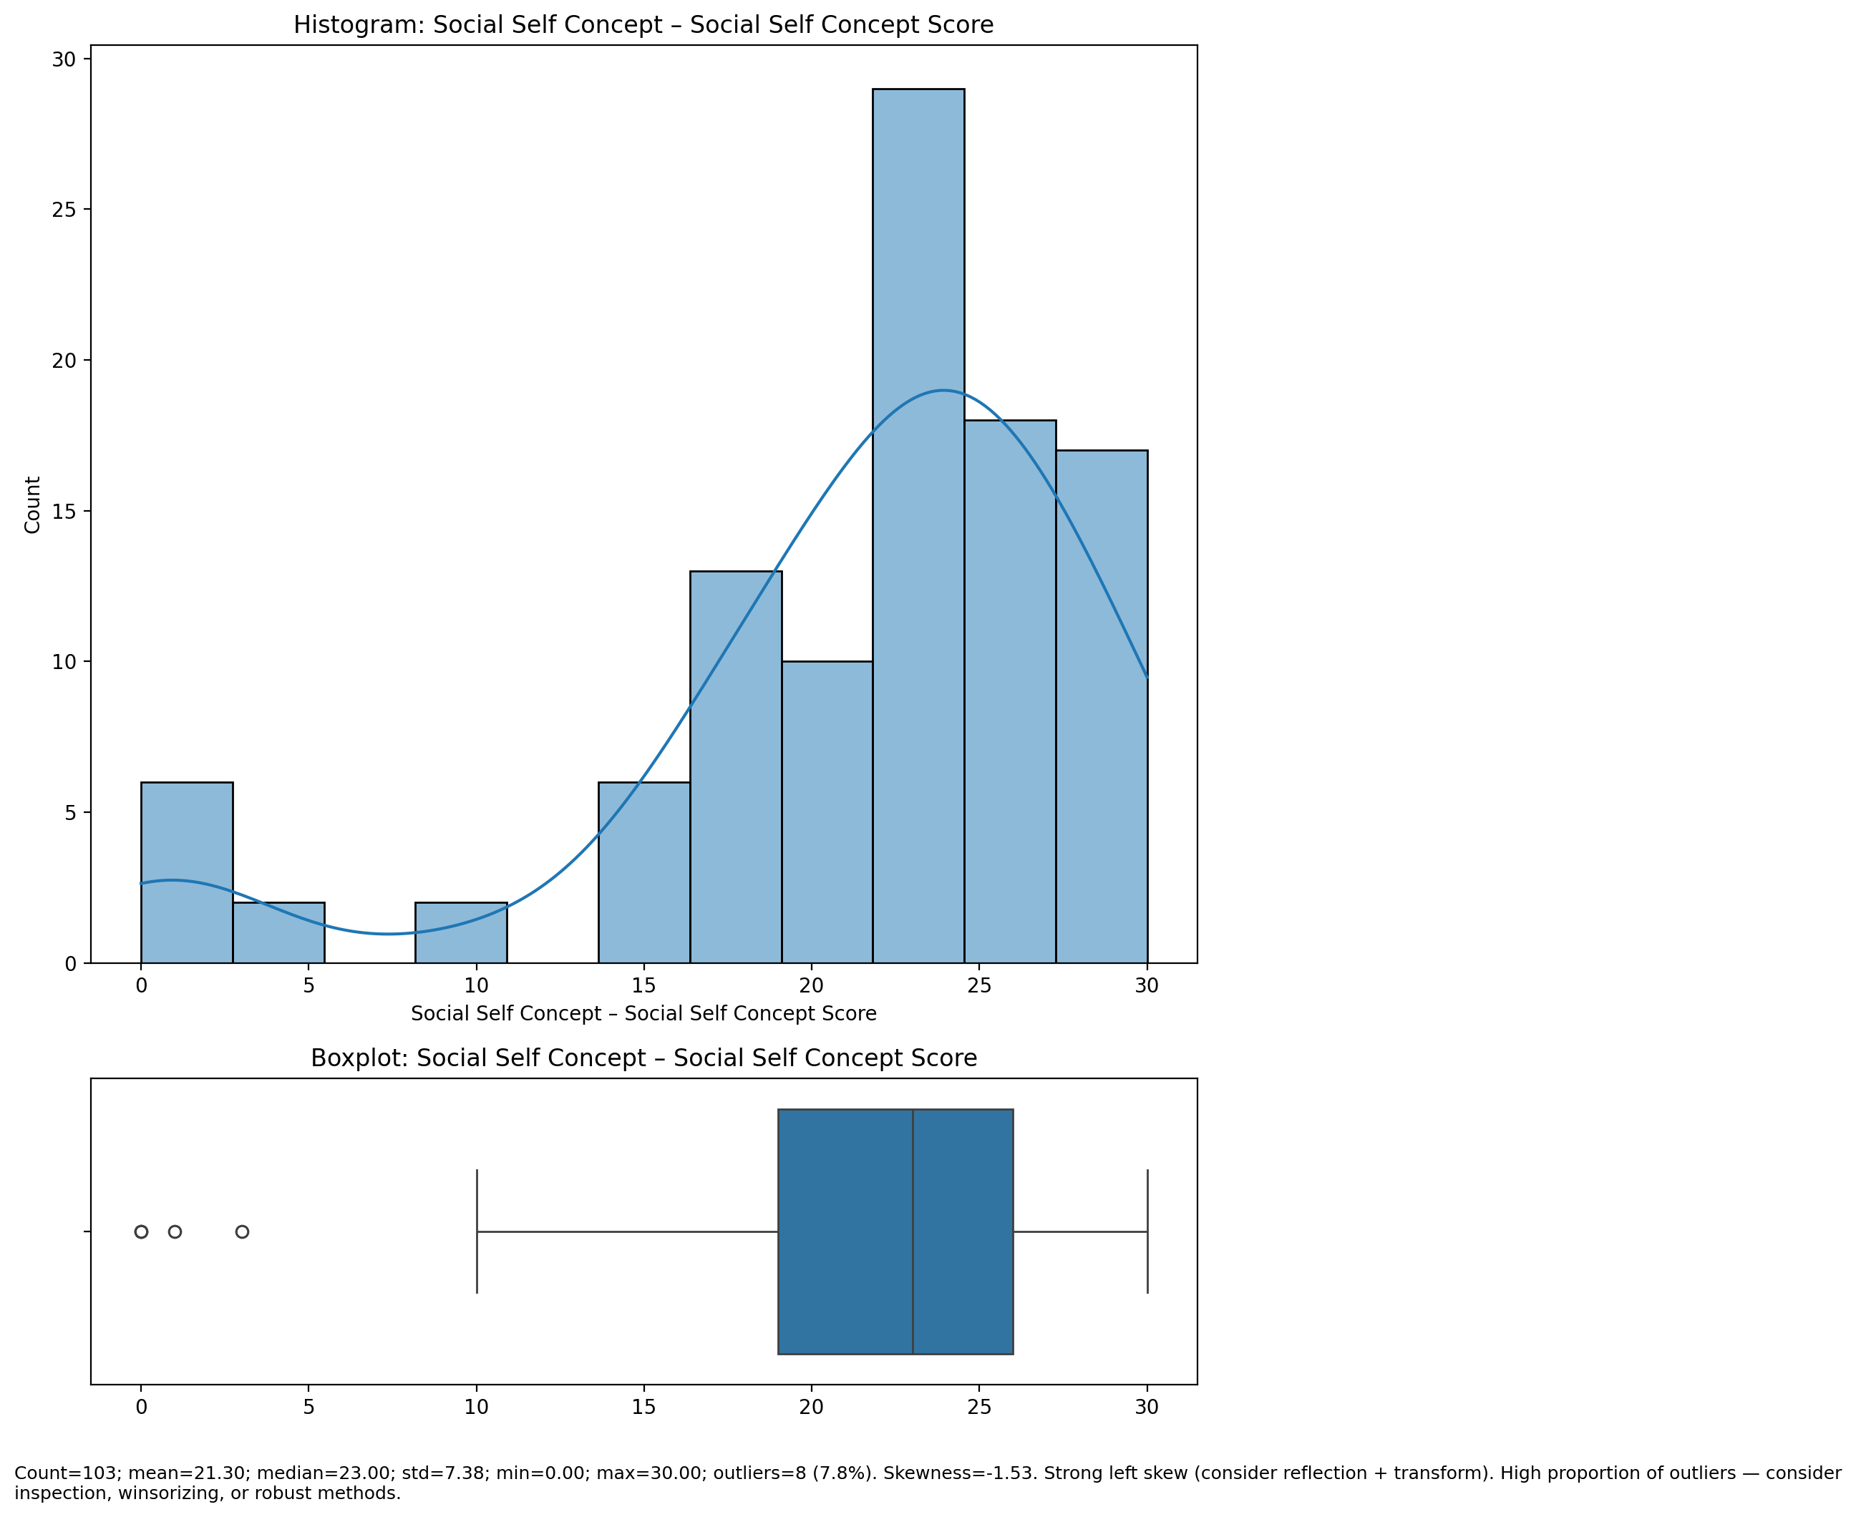

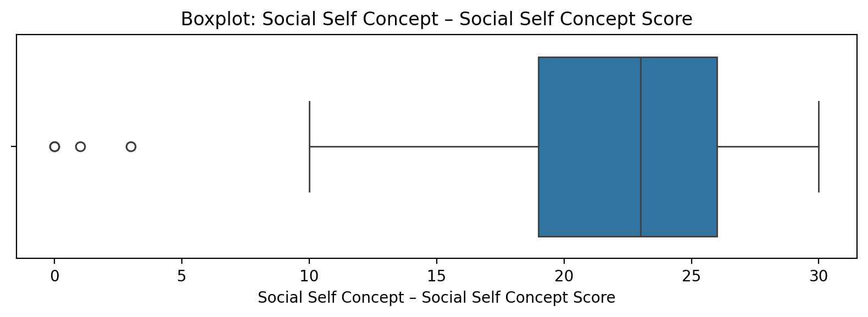

Count=103; mean=21.30; median=23.00; std=7.38; min=0.00; max=30.00; outliers=8 (7.8%). Skewness=-1.53.

## Ability Self Concept - Real Self Concept Score

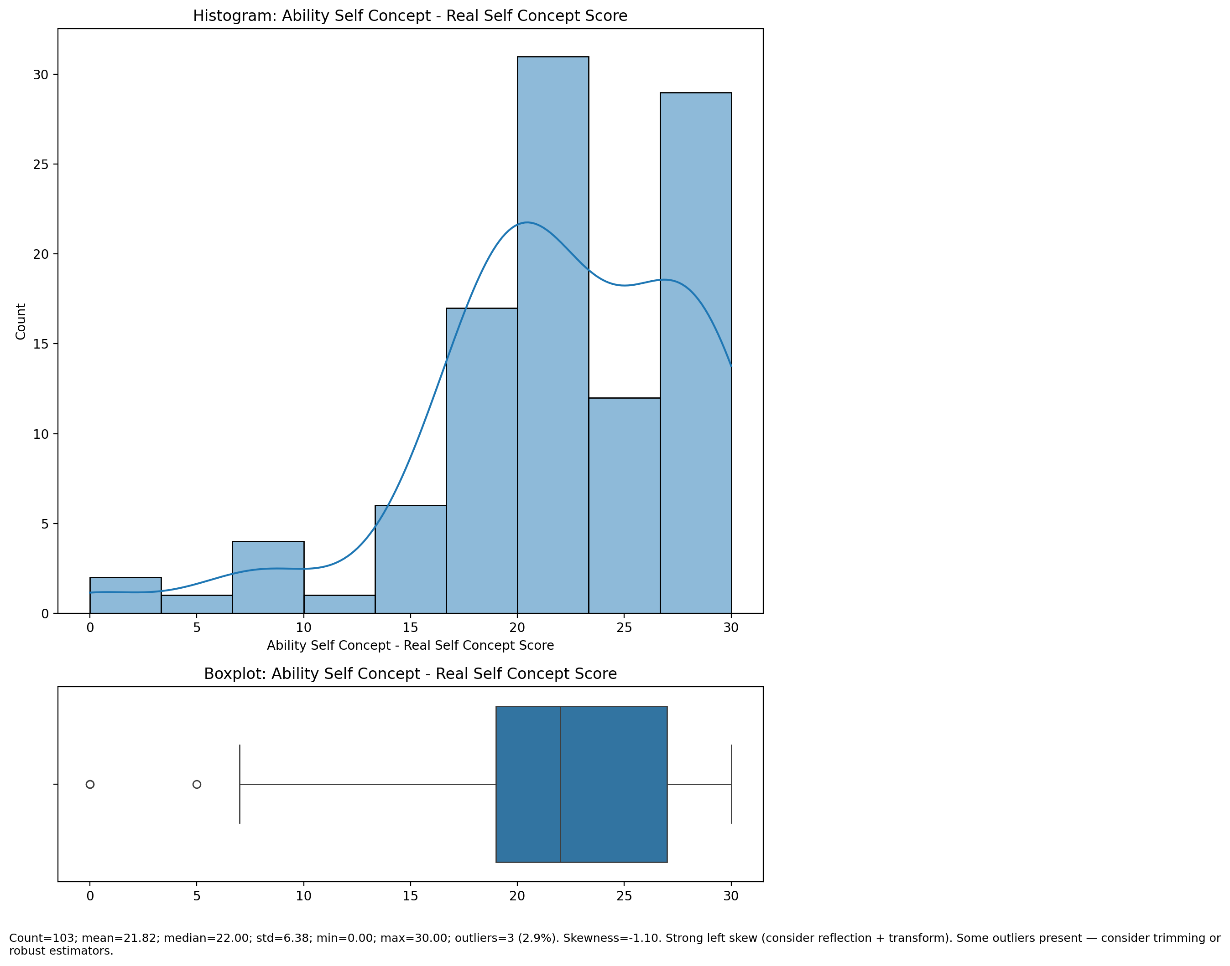

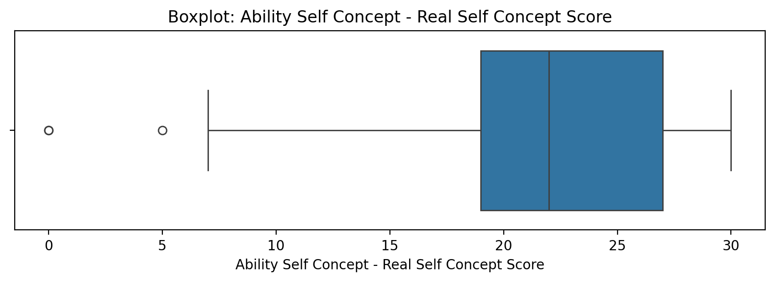

Count=103; mean=21.82; median=22.00; std=6.38; min=0.00; max=30.00; outliers=3 (2.9%). Skewness=-1.10.

## Ability Self Concept - Ideal Self Concept Score

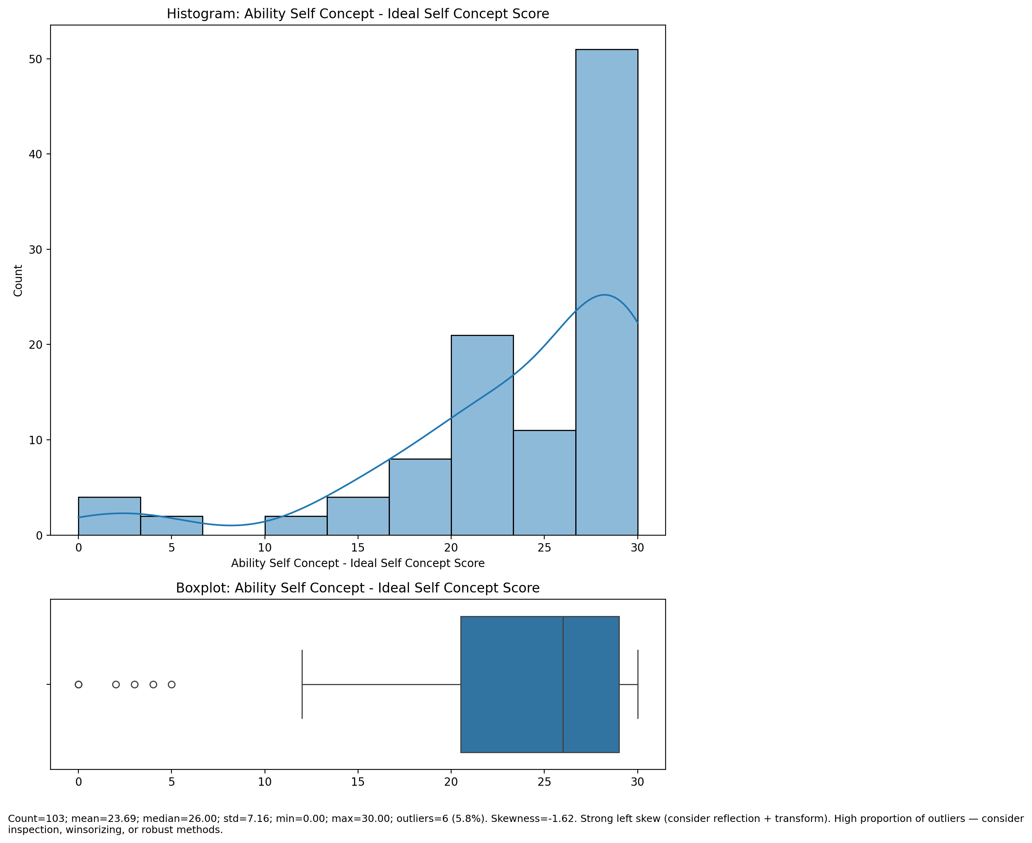

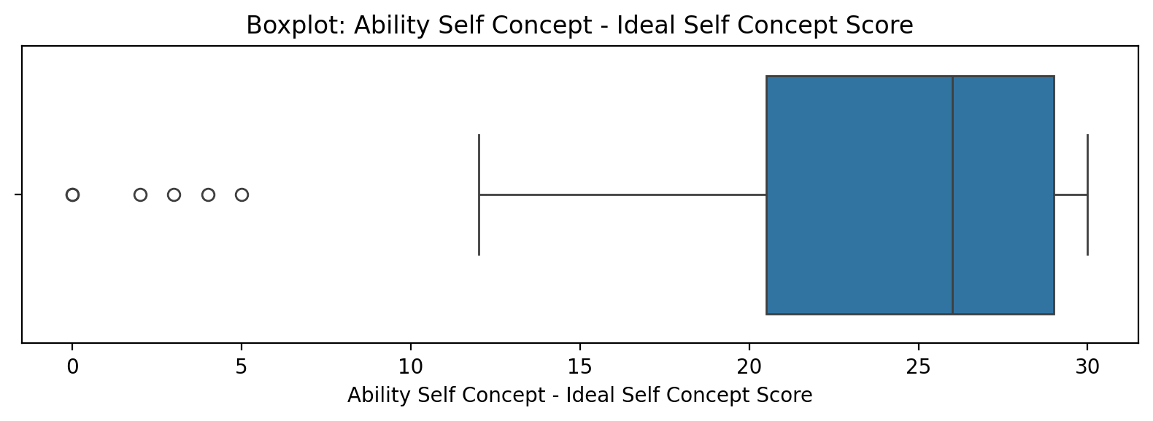

Count=103; mean=23.69; median=26.00; std=7.16; min=0.00; max=30.00; outliers=6 (5.8%). Skewness=-1.62.

## Ability Self Concept – Social Self Concept Score

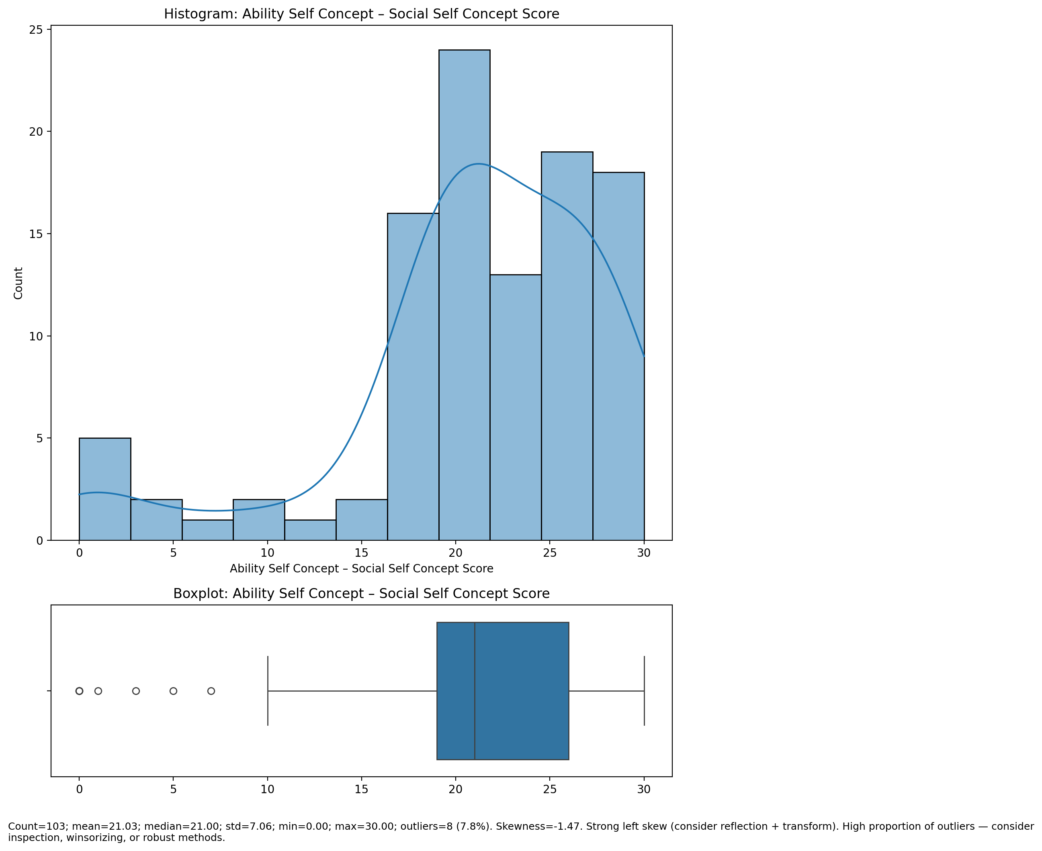

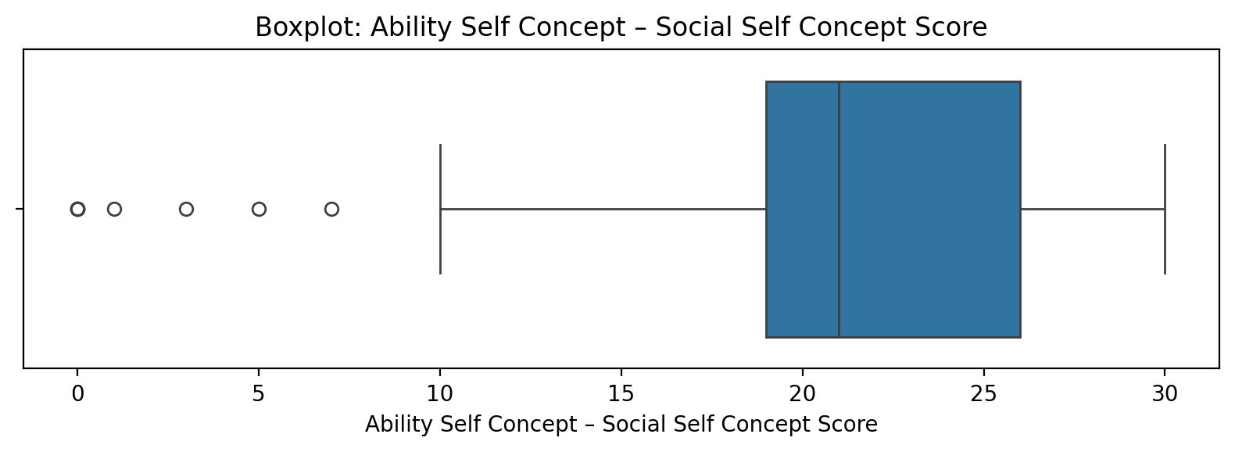

Count=103; mean=21.03; median=21.00; std=7.06; min=0.00; max=30.00; outliers=8 (7.8%). Skewness=-1.47.

## Physical Self Concept - Real Self Concept Score

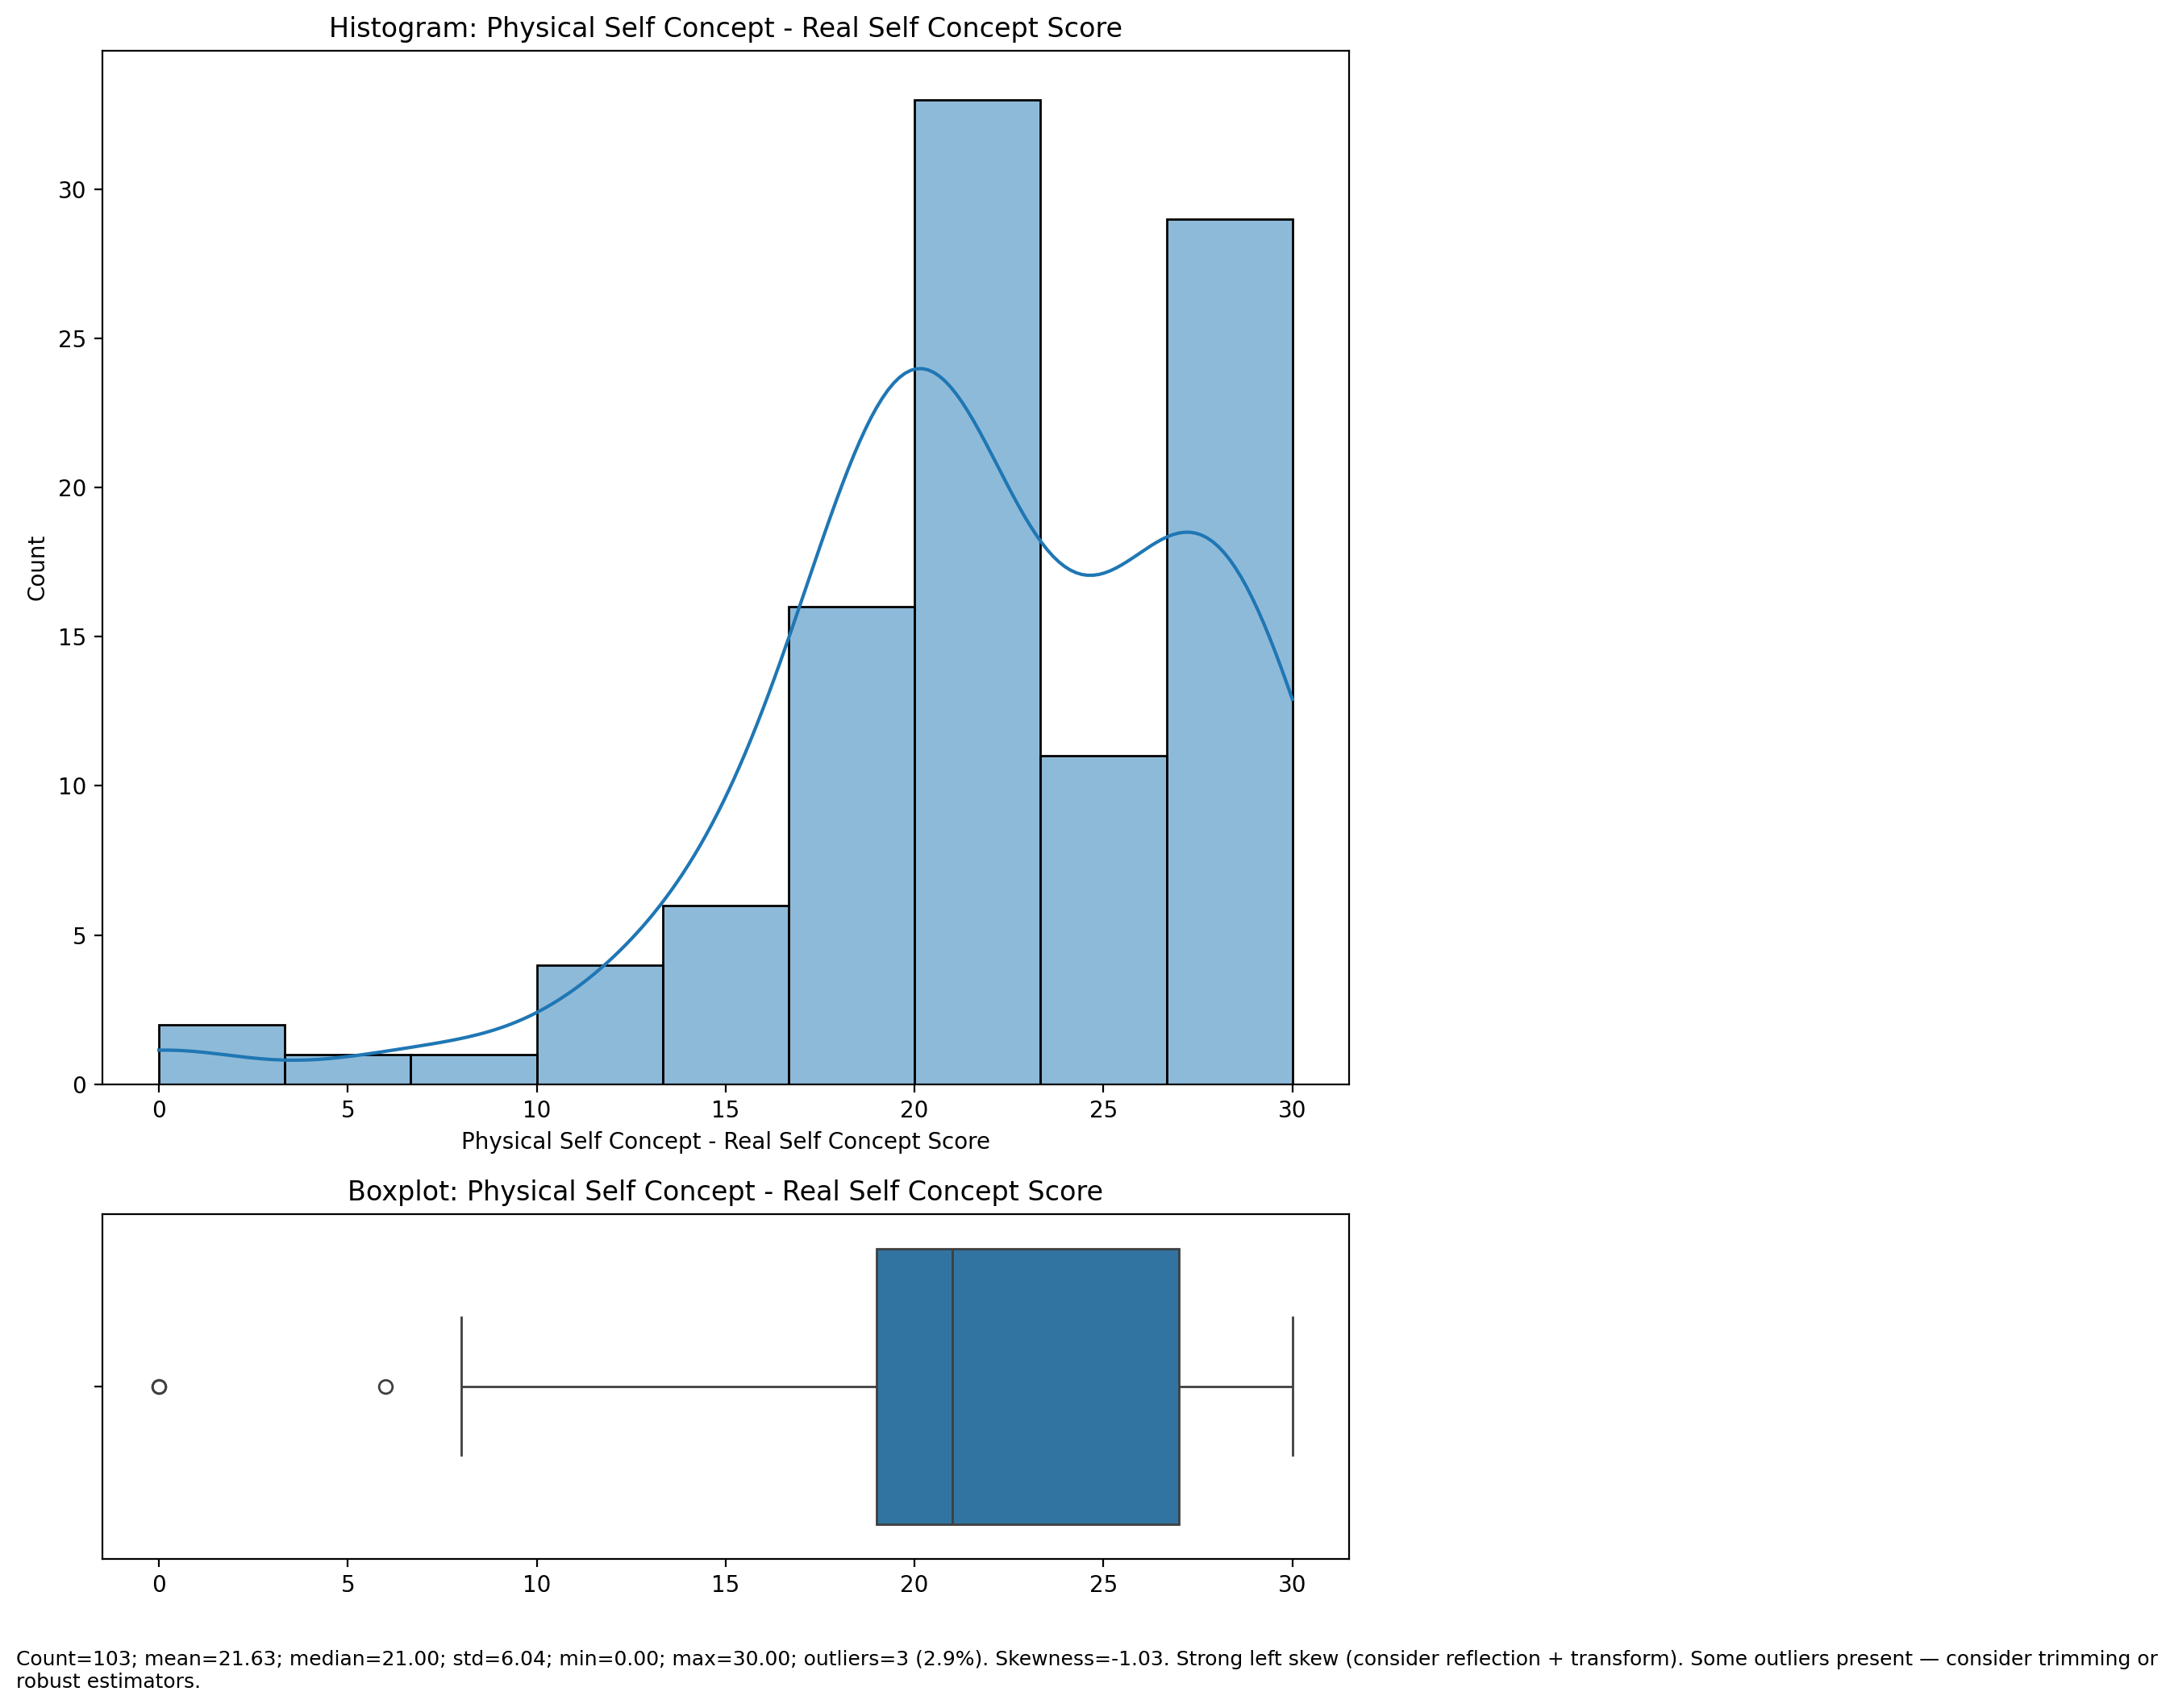

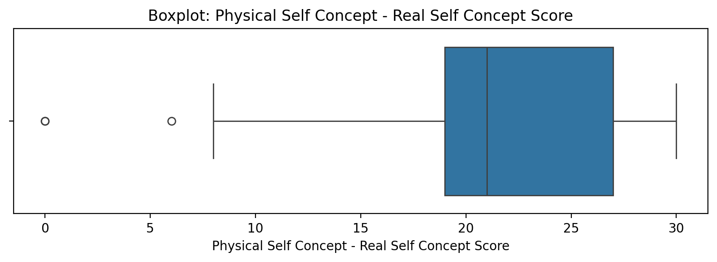

Count=103; mean=21.63; median=21.00; std=6.04; min=0.00; max=30.00; outliers=3 (2.9%). Skewness=-1.03.

## Physical Self Concept – Ideal Self Concept Score

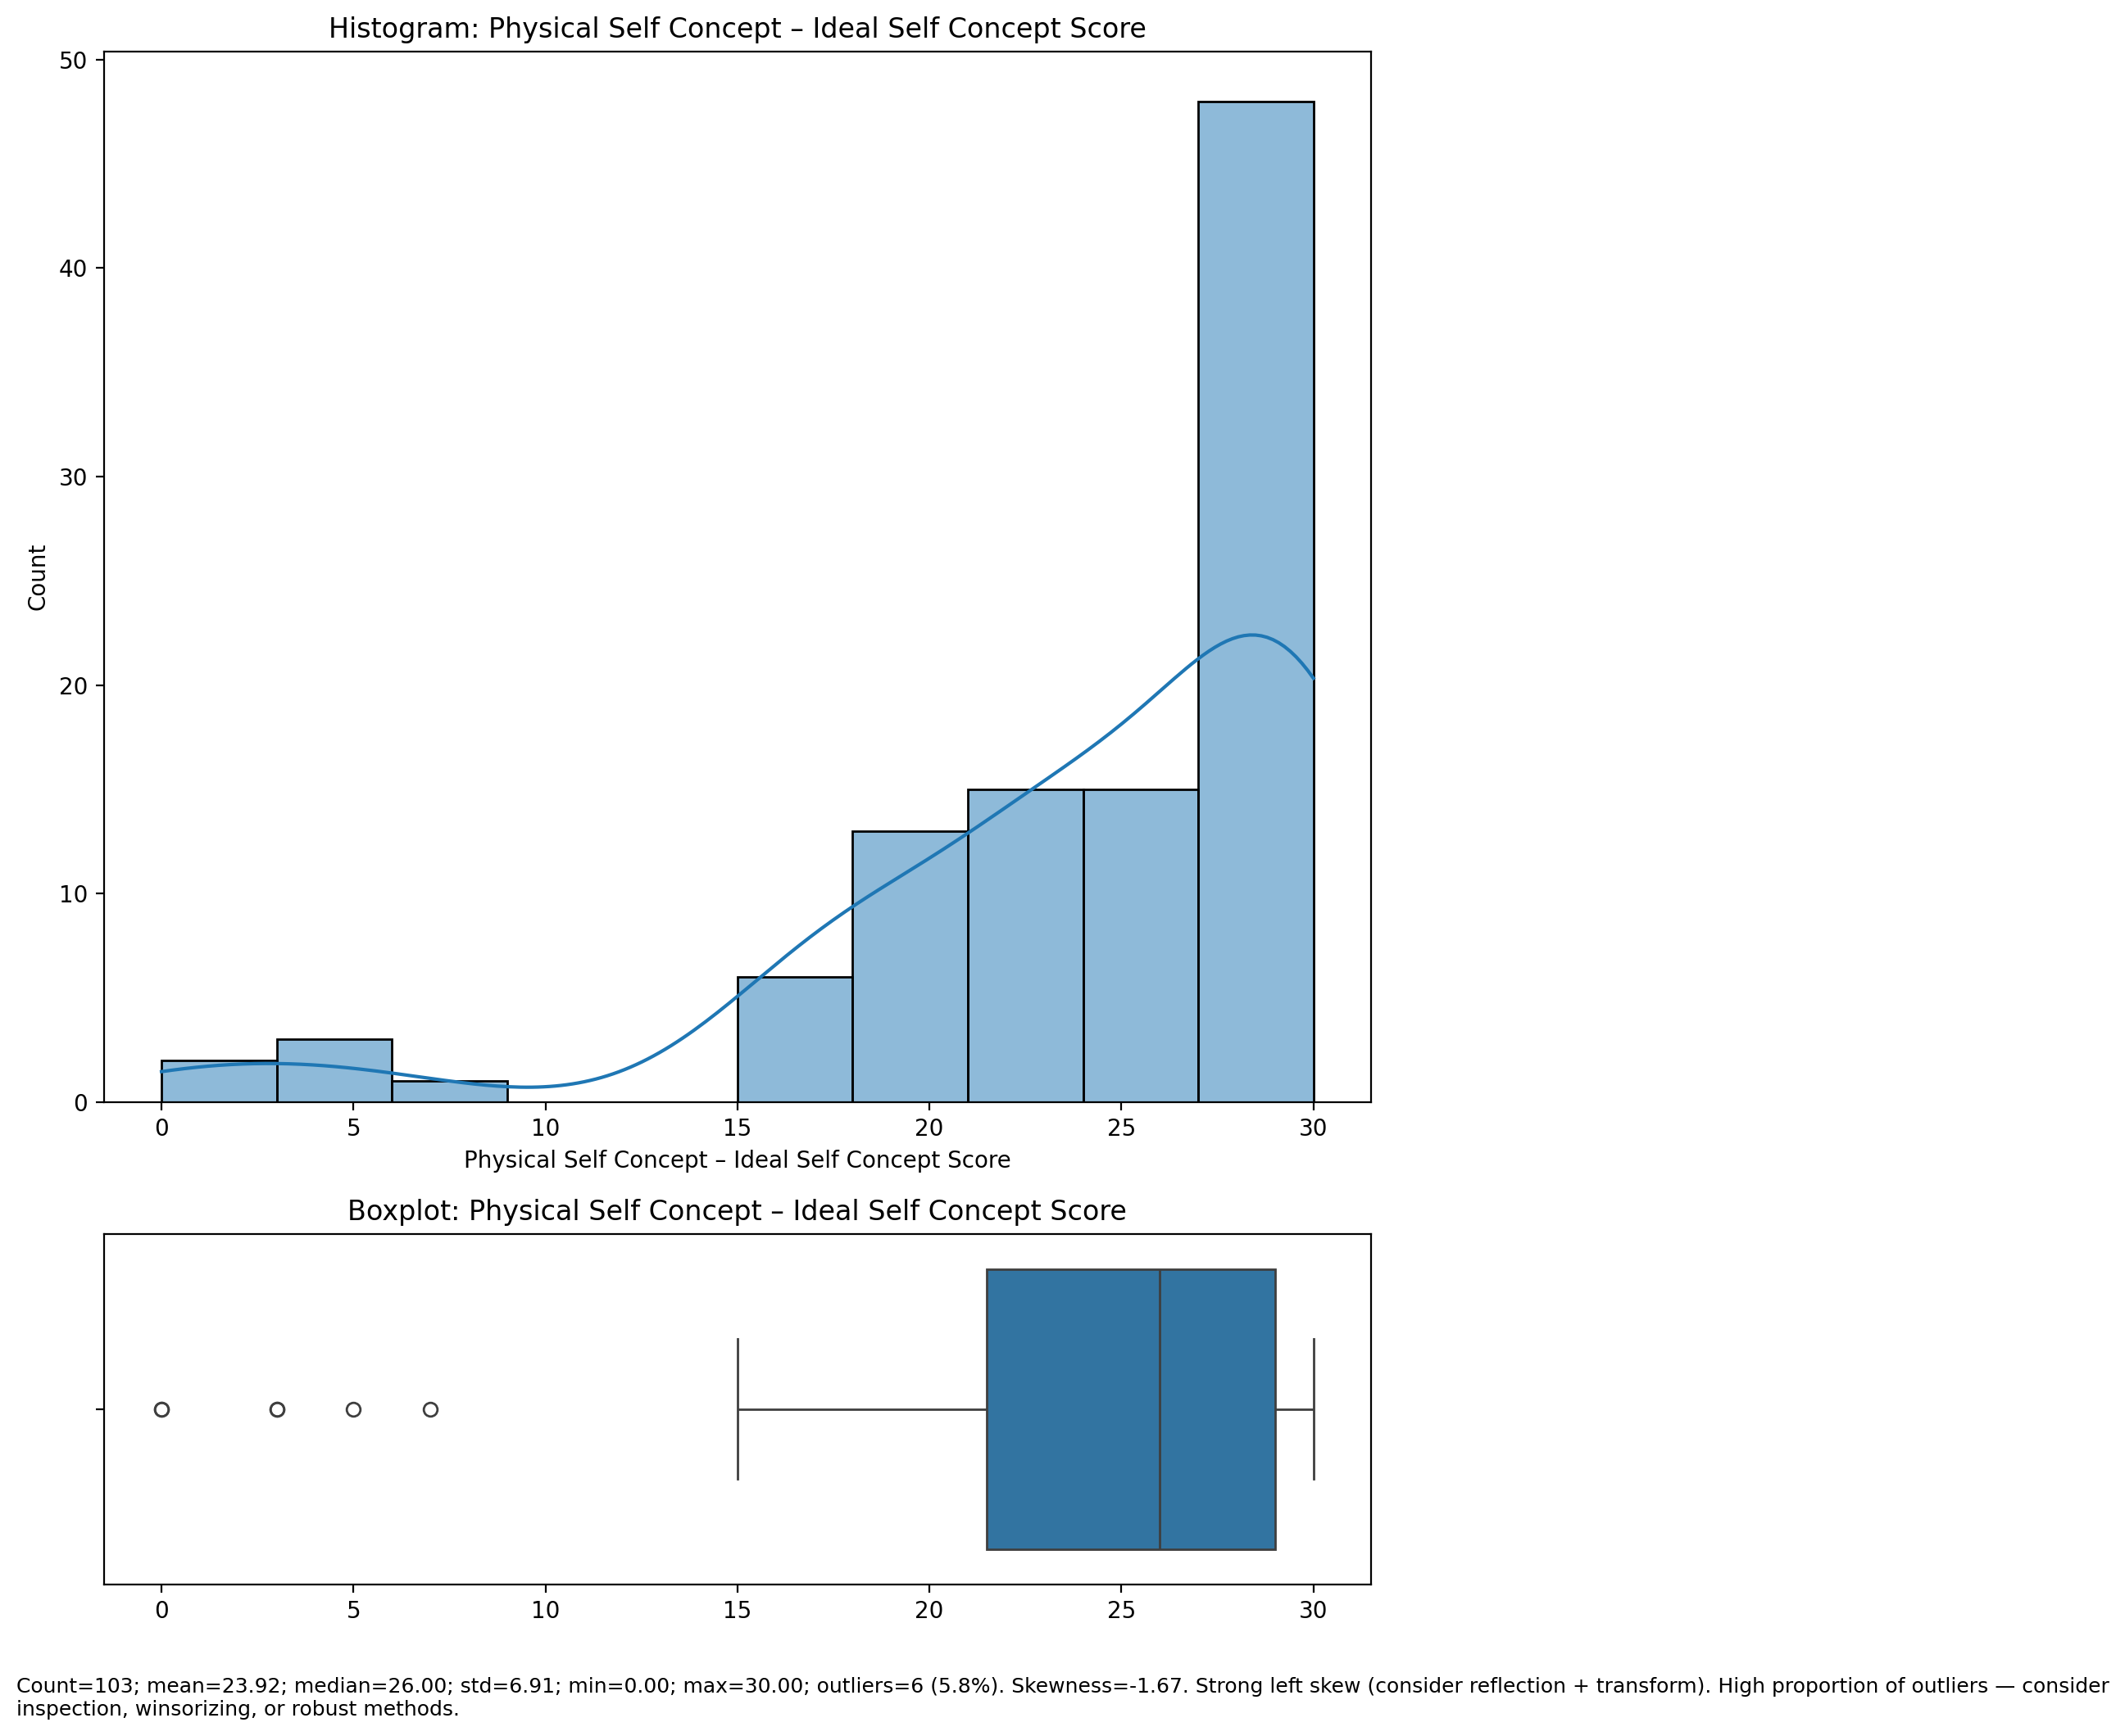

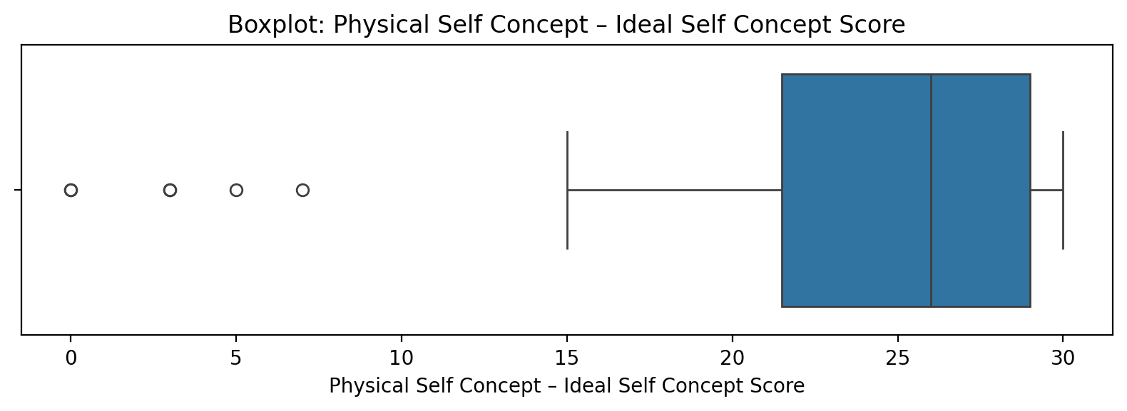

Count=103; mean=23.92; median=26.00; std=6.91; min=0.00; max=30.00; outliers=6 (5.8%). Skewness=-1.67.

## Physical Self Concept – Social Self Concept Score

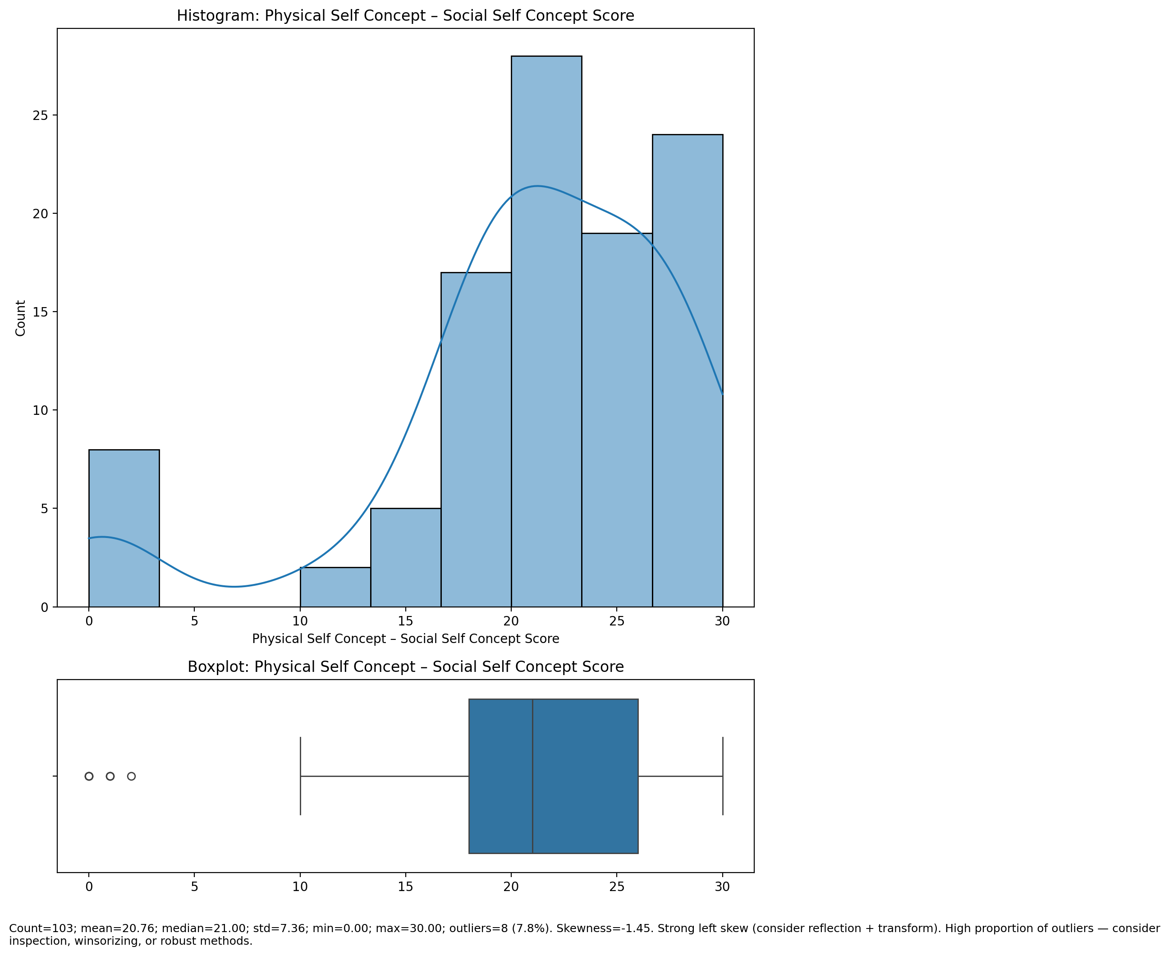

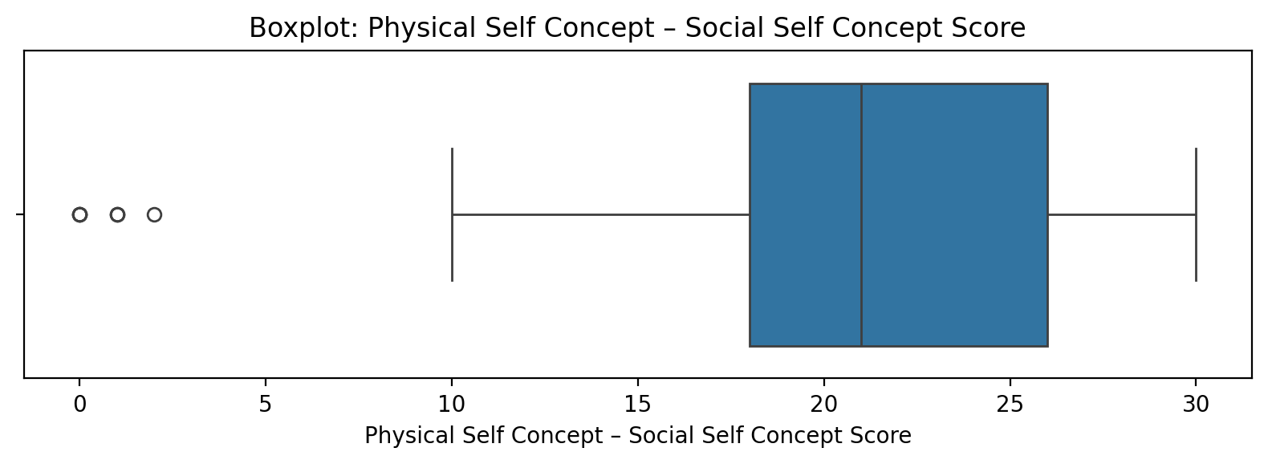

Count=103; mean=20.76; median=21.00; std=7.36; min=0.00; max=30.00; outliers=8 (7.8%). Skewness=-1.45.

## Psychological Self Concept - Real Self Concept Score

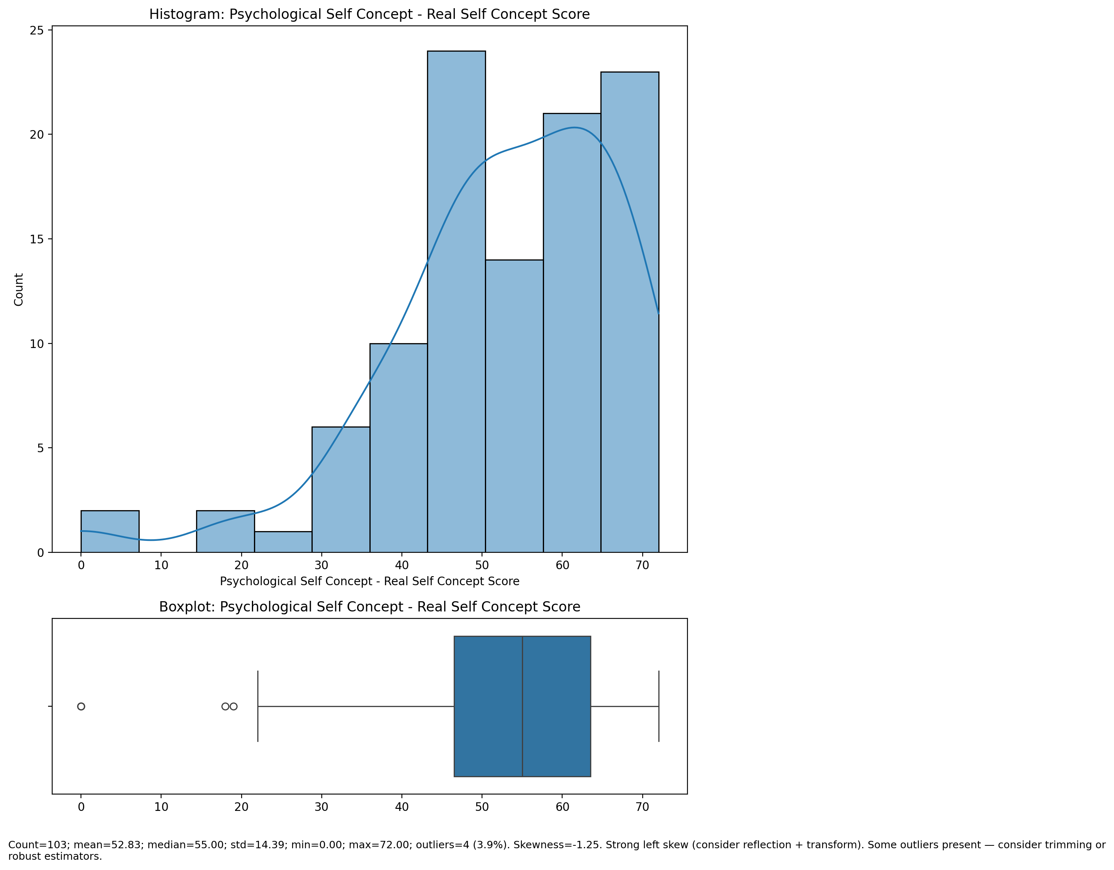

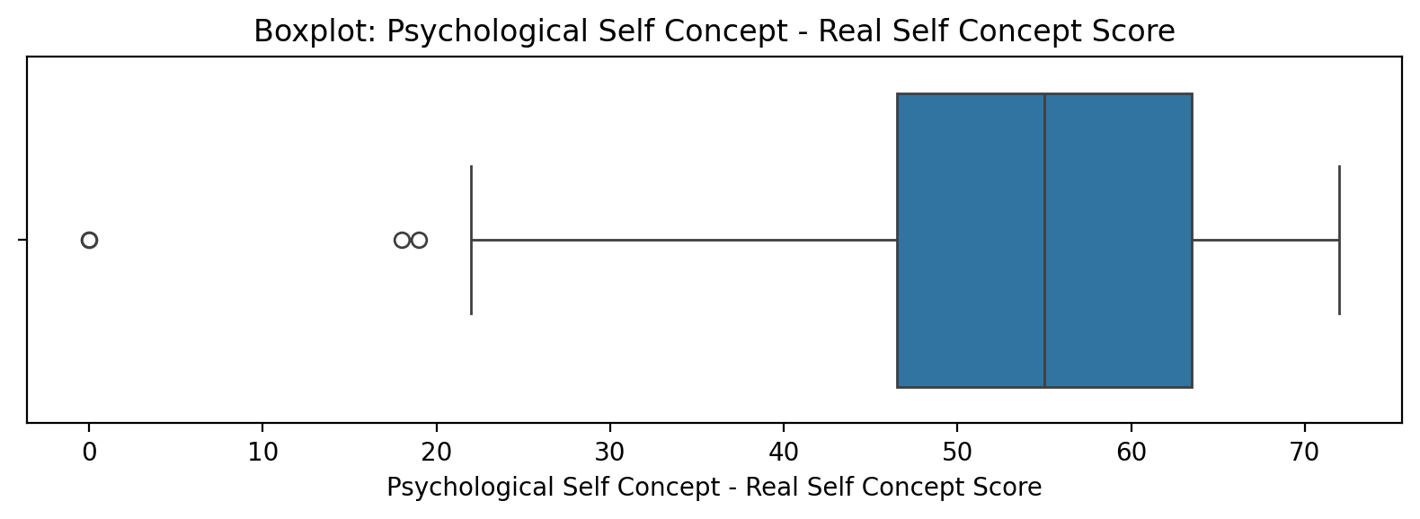

Count=103; mean=52.83; median=55.00; std=14.39; min=0.00; max=72.00; outliers=4 (3.9%). Skewness=-1.25.

## Psychological Self Concept – Ideal Self Concept Score

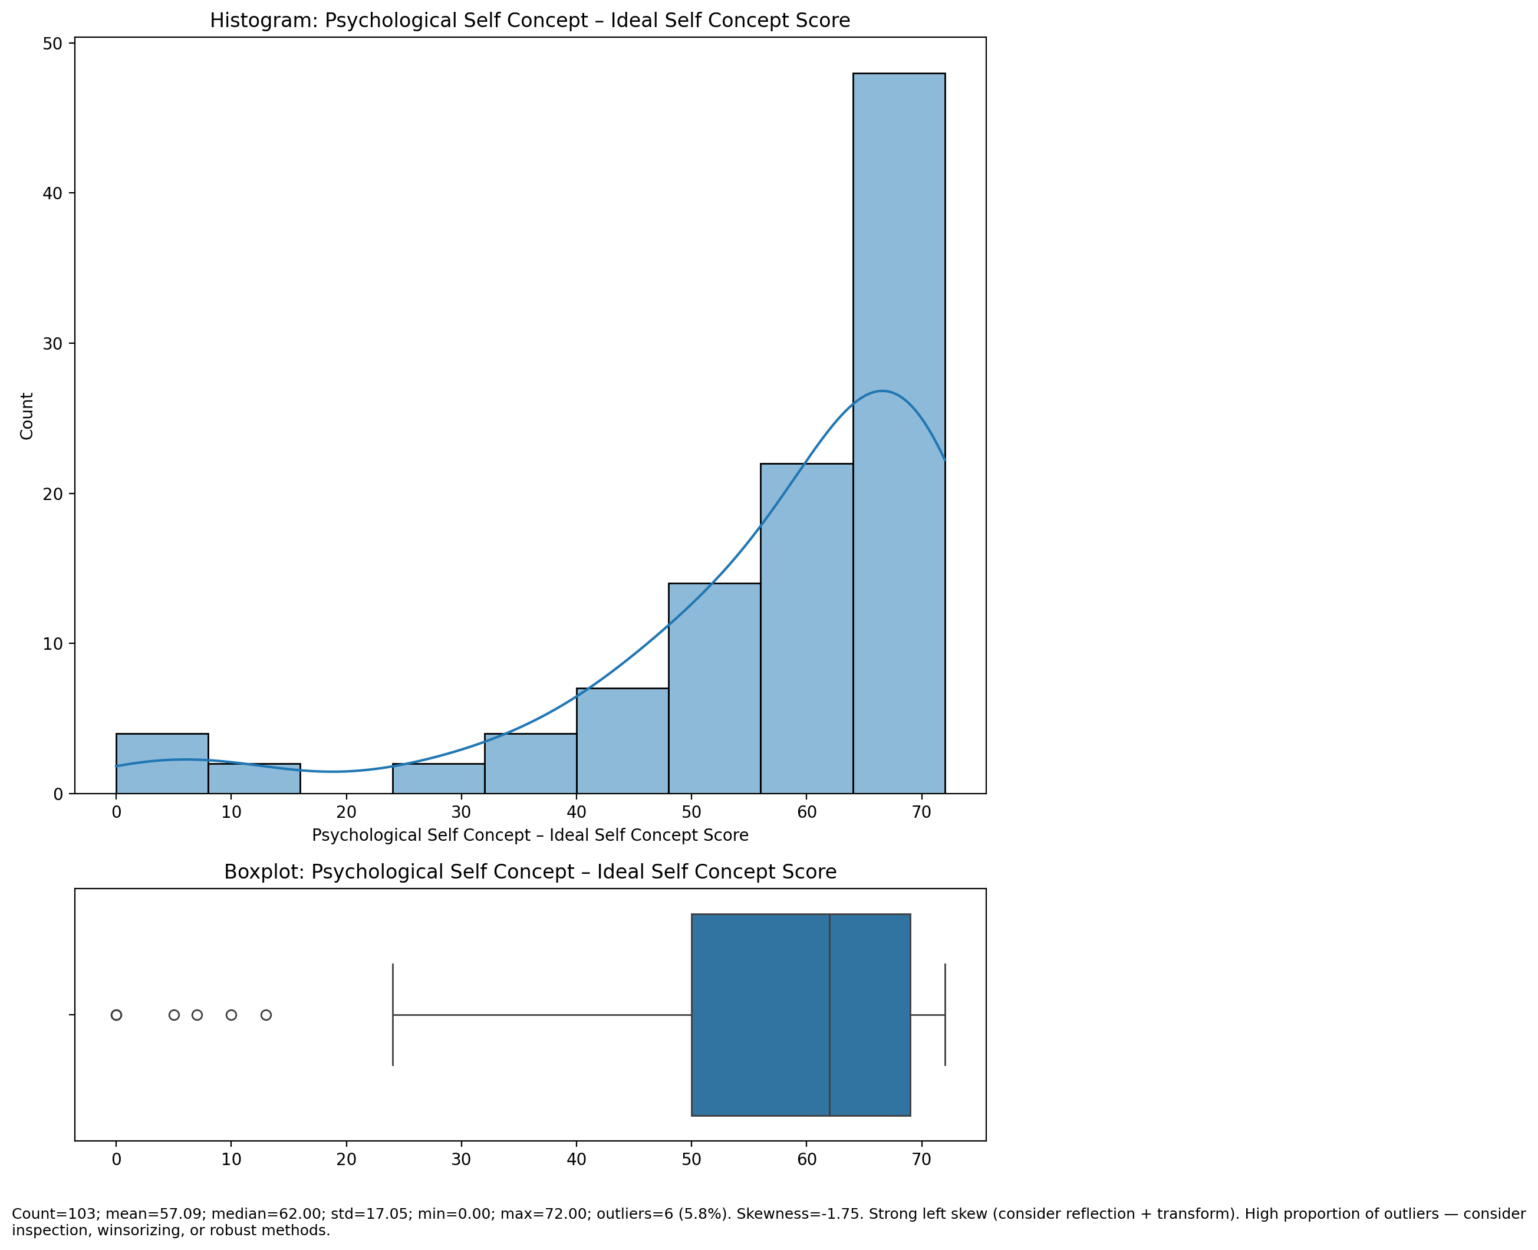

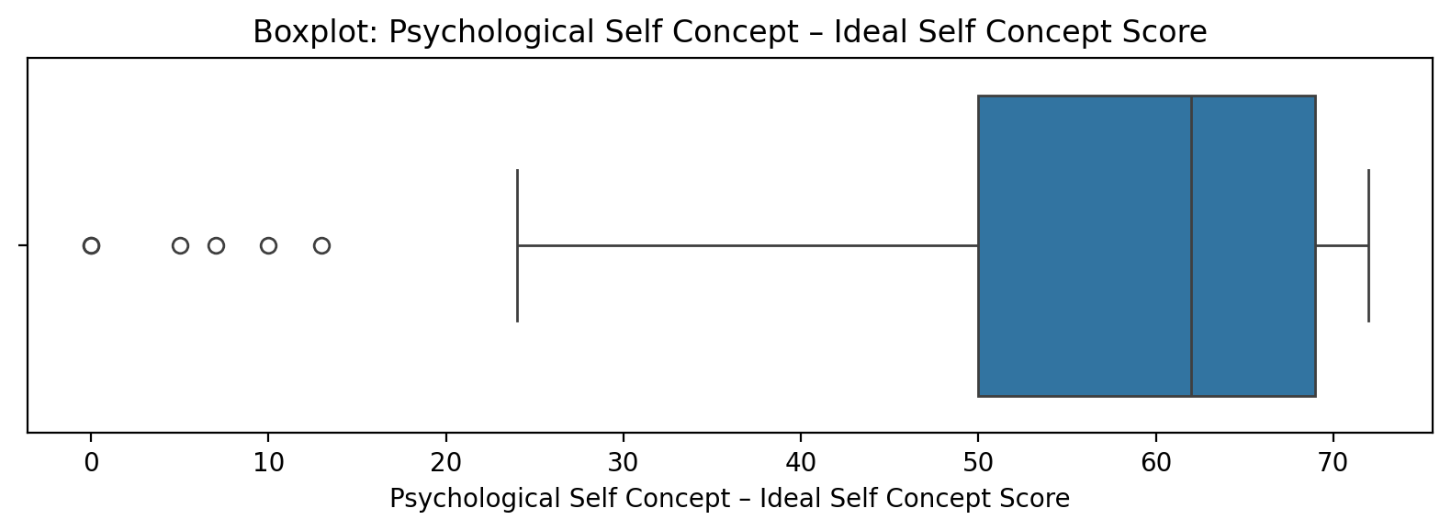

Count=103; mean=57.09; median=62.00; std=17.05; min=0.00; max=72.00; outliers=6 (5.8%). Skewness=-1.75.

## Psychological Self Concept – Social Self Concept Score

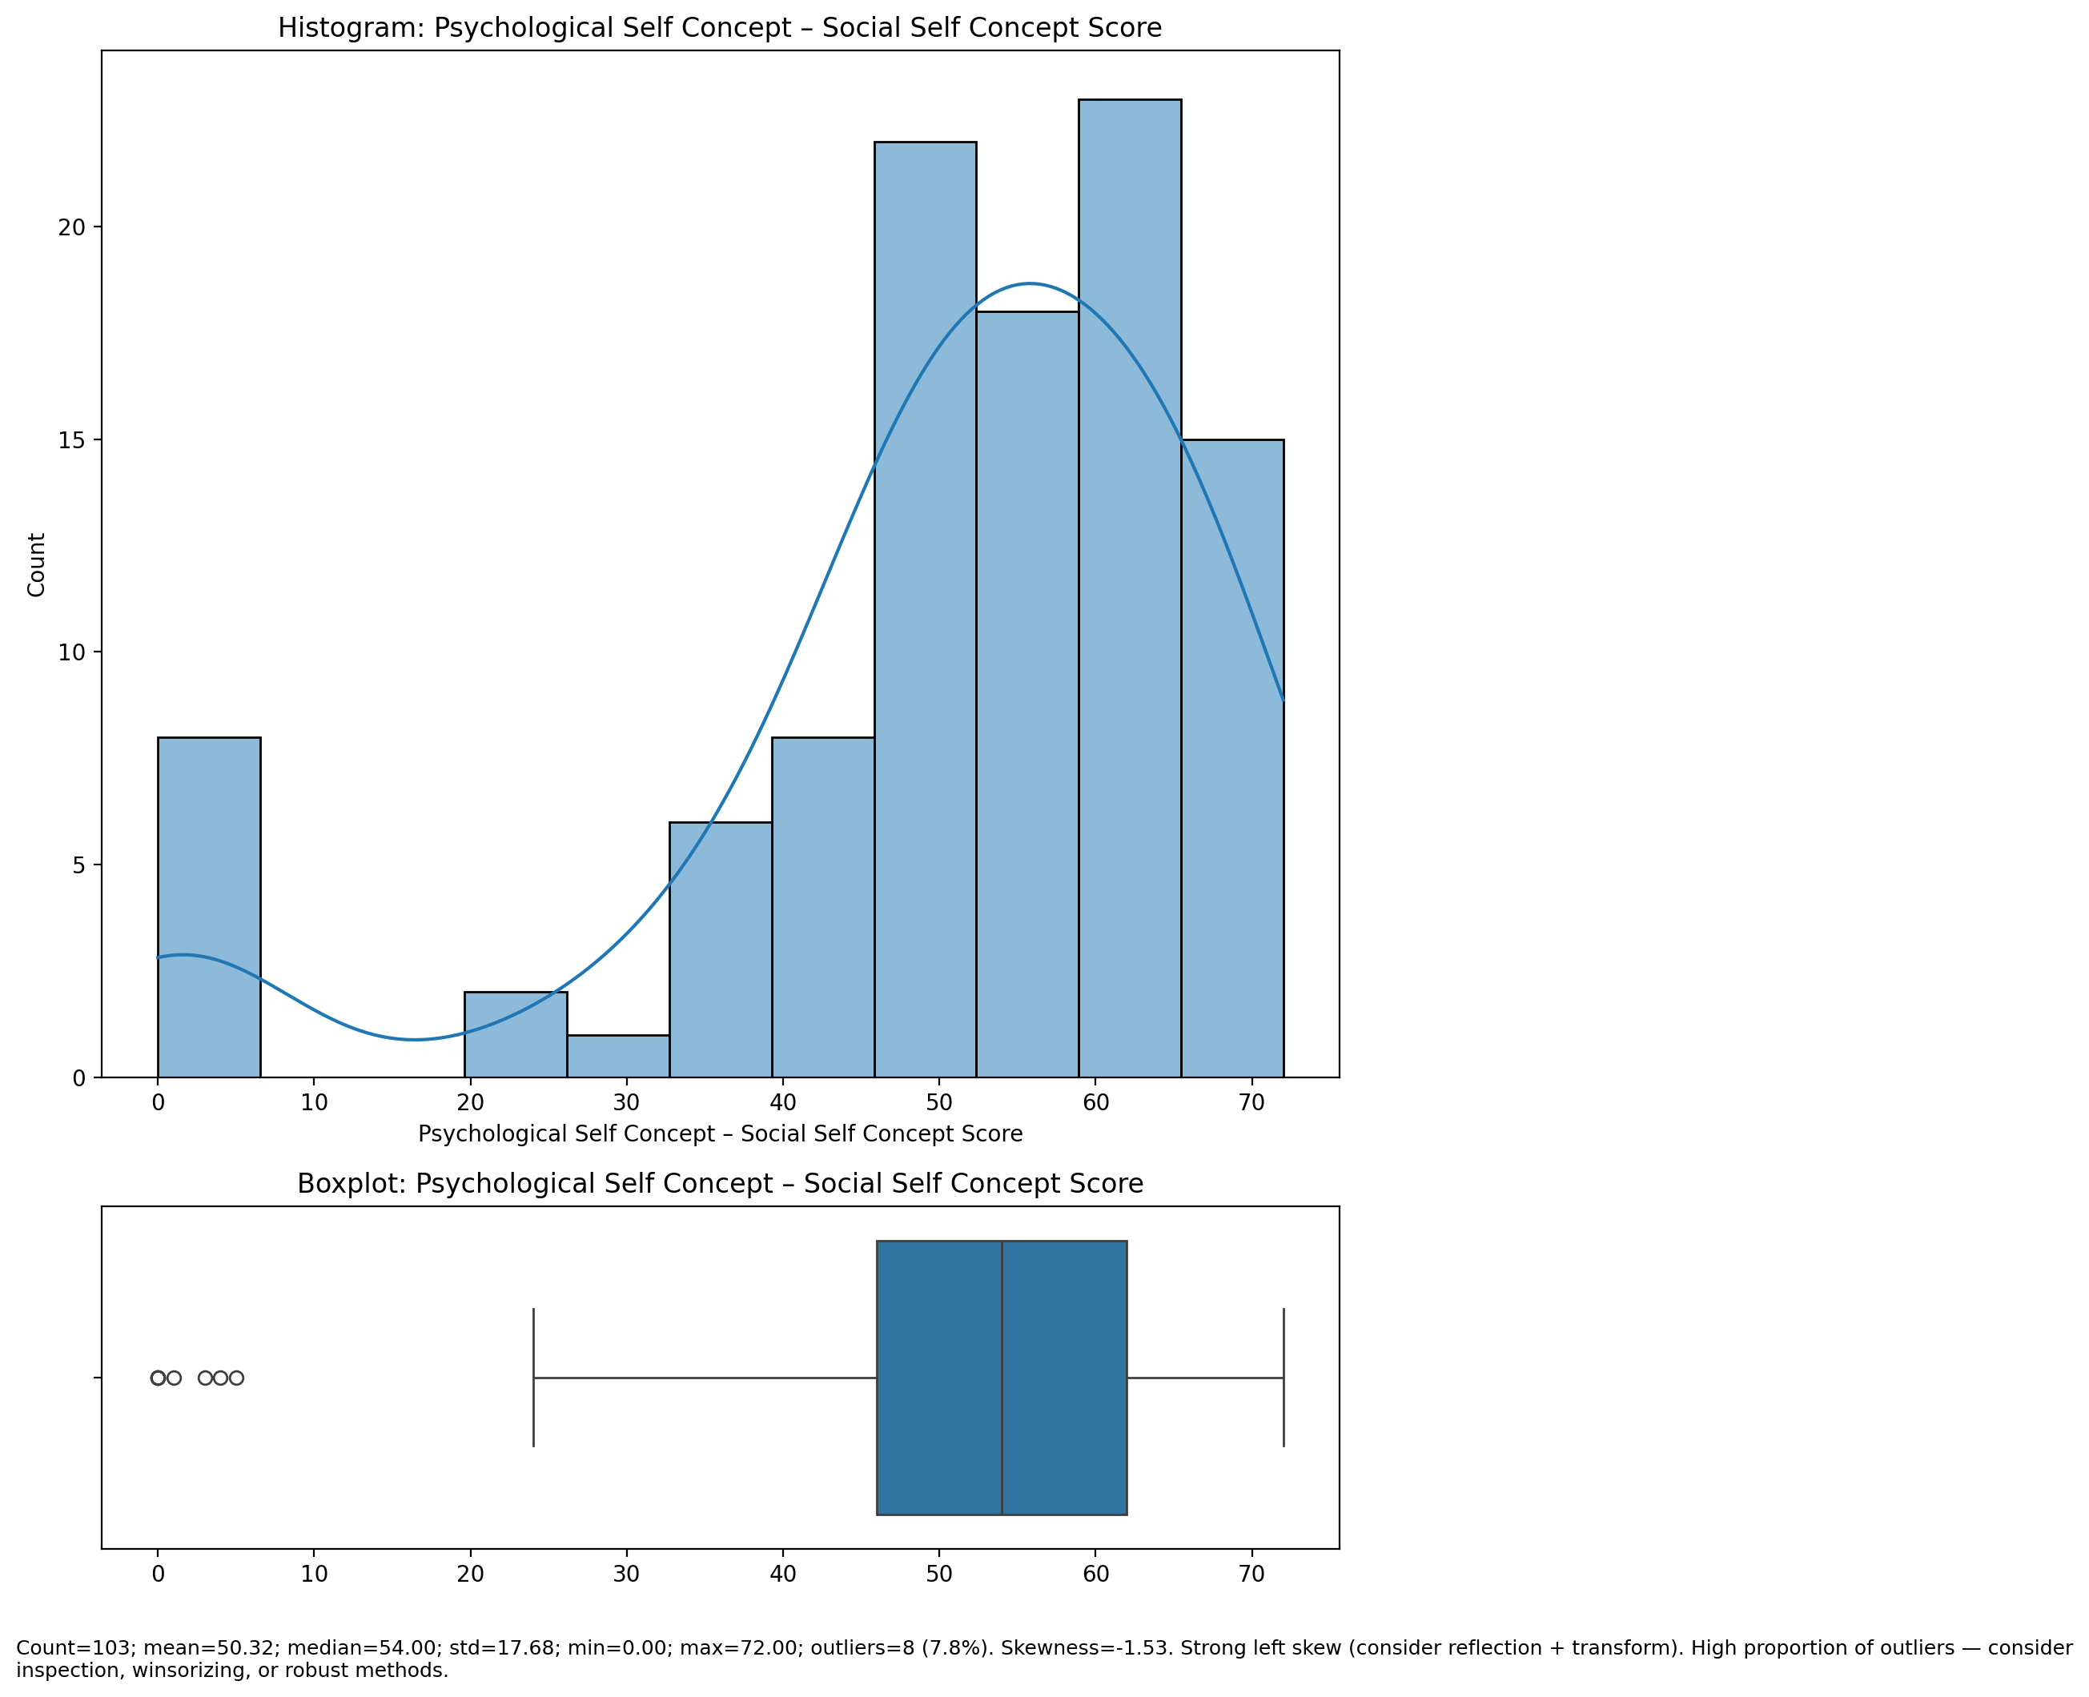

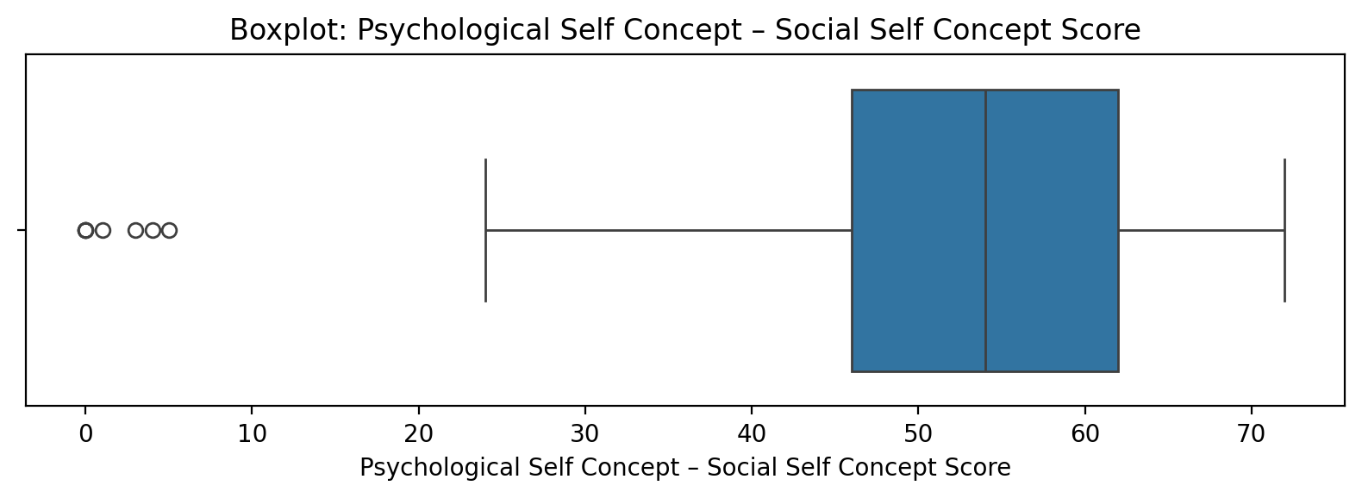

Count=103; mean=50.32; median=54.00; std=17.68; min=0.00; max=72.00; outliers=8 (7.8%). Skewness=-1.53.

## Real Self Concept Total Score

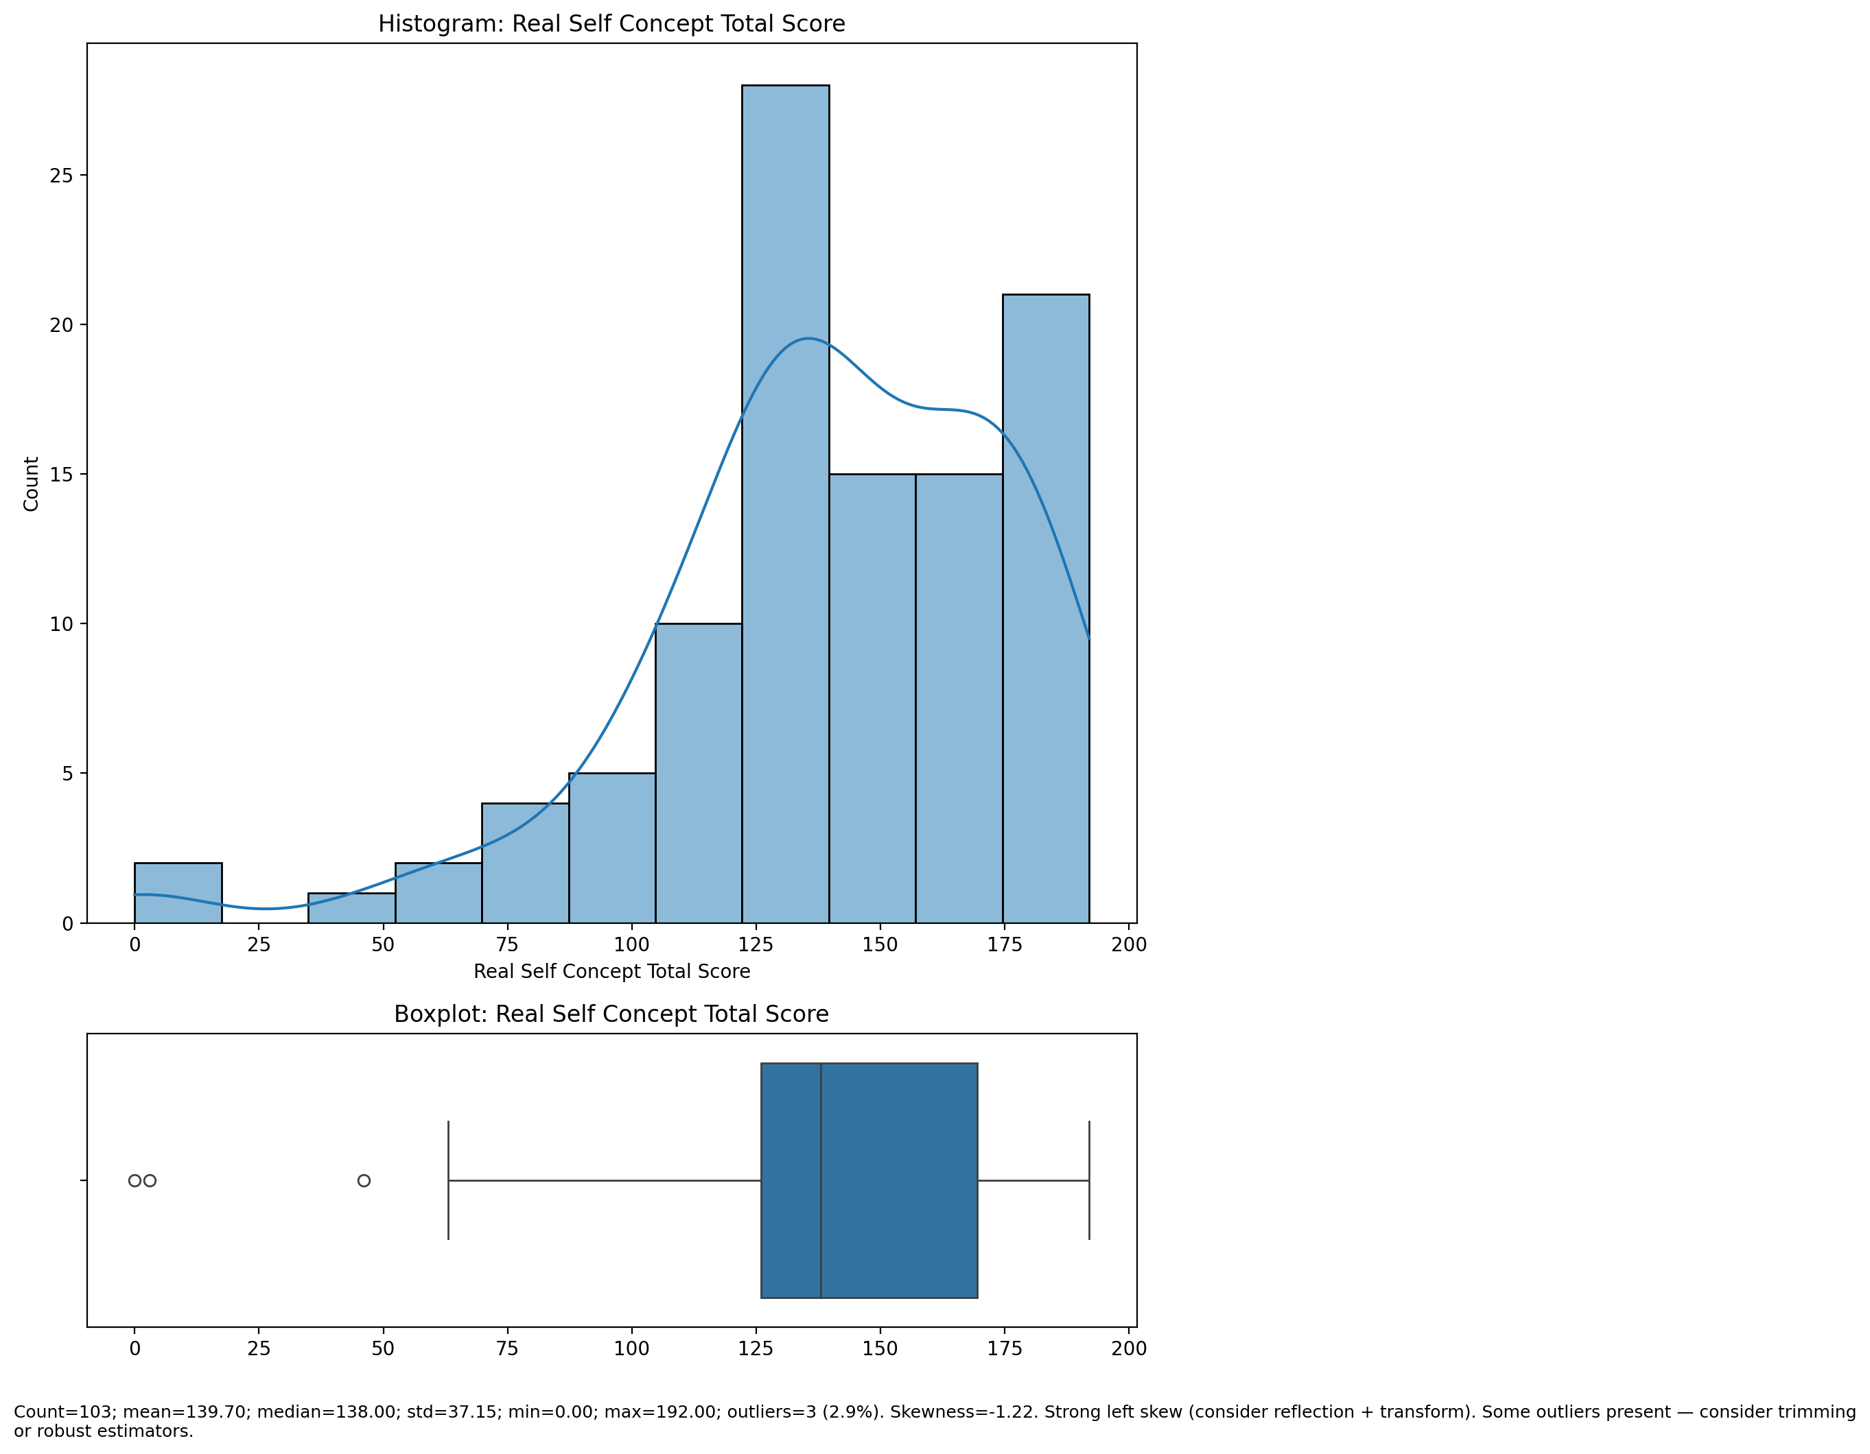

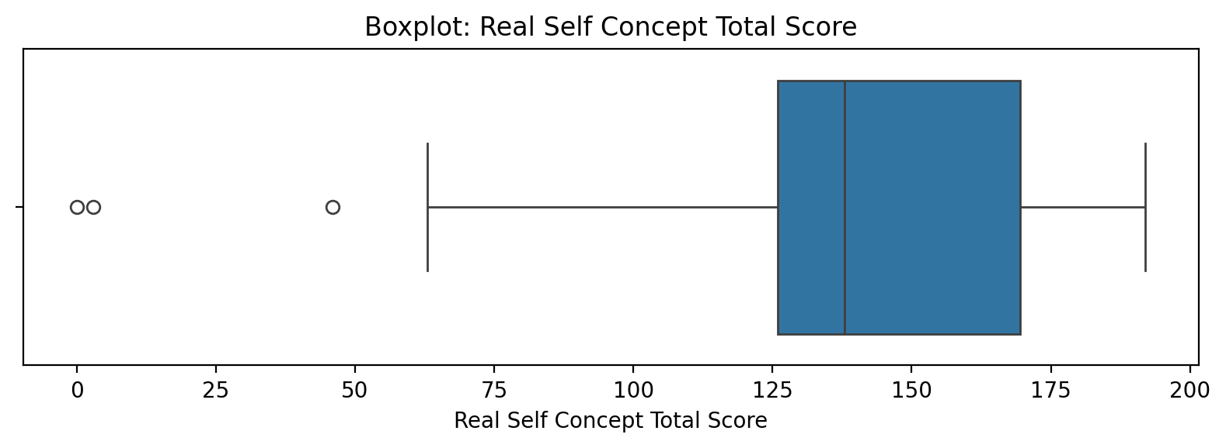

Count=103; mean=139.70; median=138.00; std=37.15; min=0.00; max=192.00; outliers=3 (2.9%). Skewness=-1.22.

## Ideal Self Concept Total Score

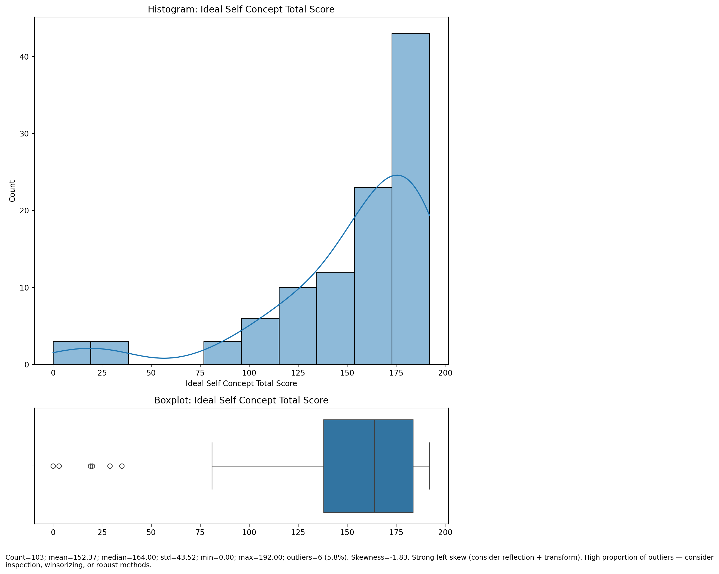

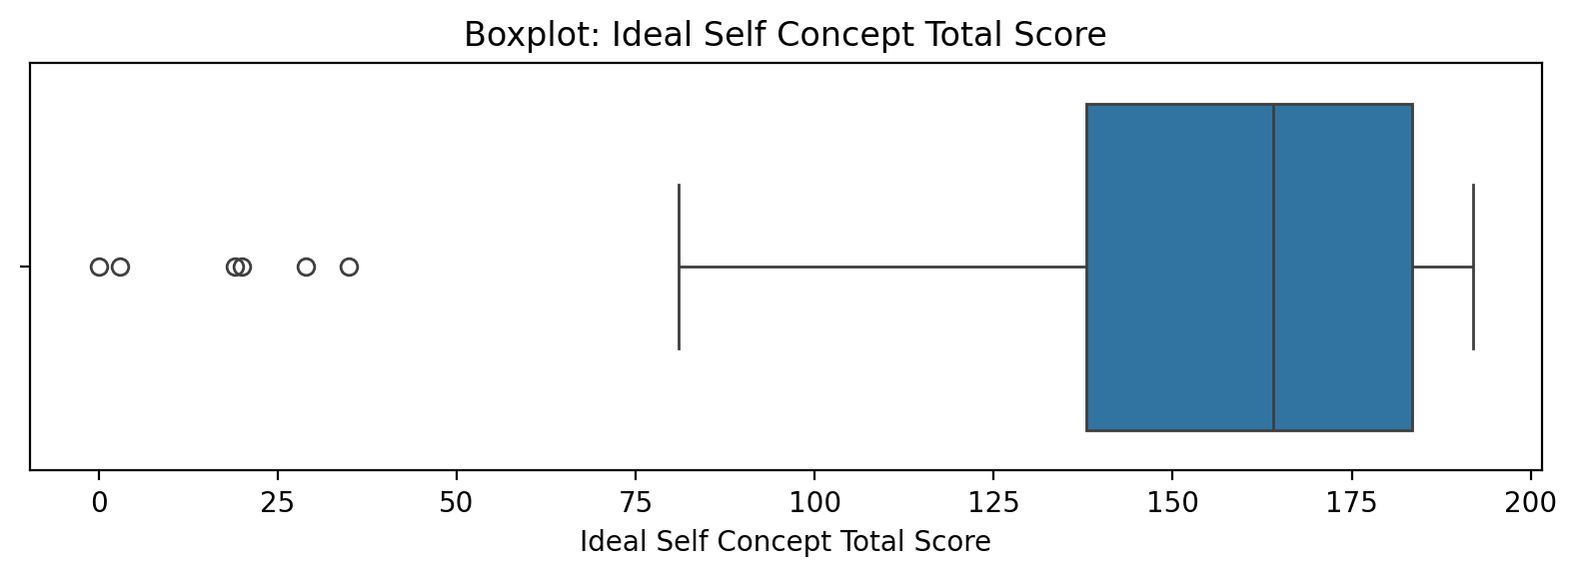

Count=103; mean=152.37; median=164.00; std=43.52; min=0.00; max=192.00; outliers=6 (5.8%). Skewness=-1.83.

## Social Self Concept Total Score

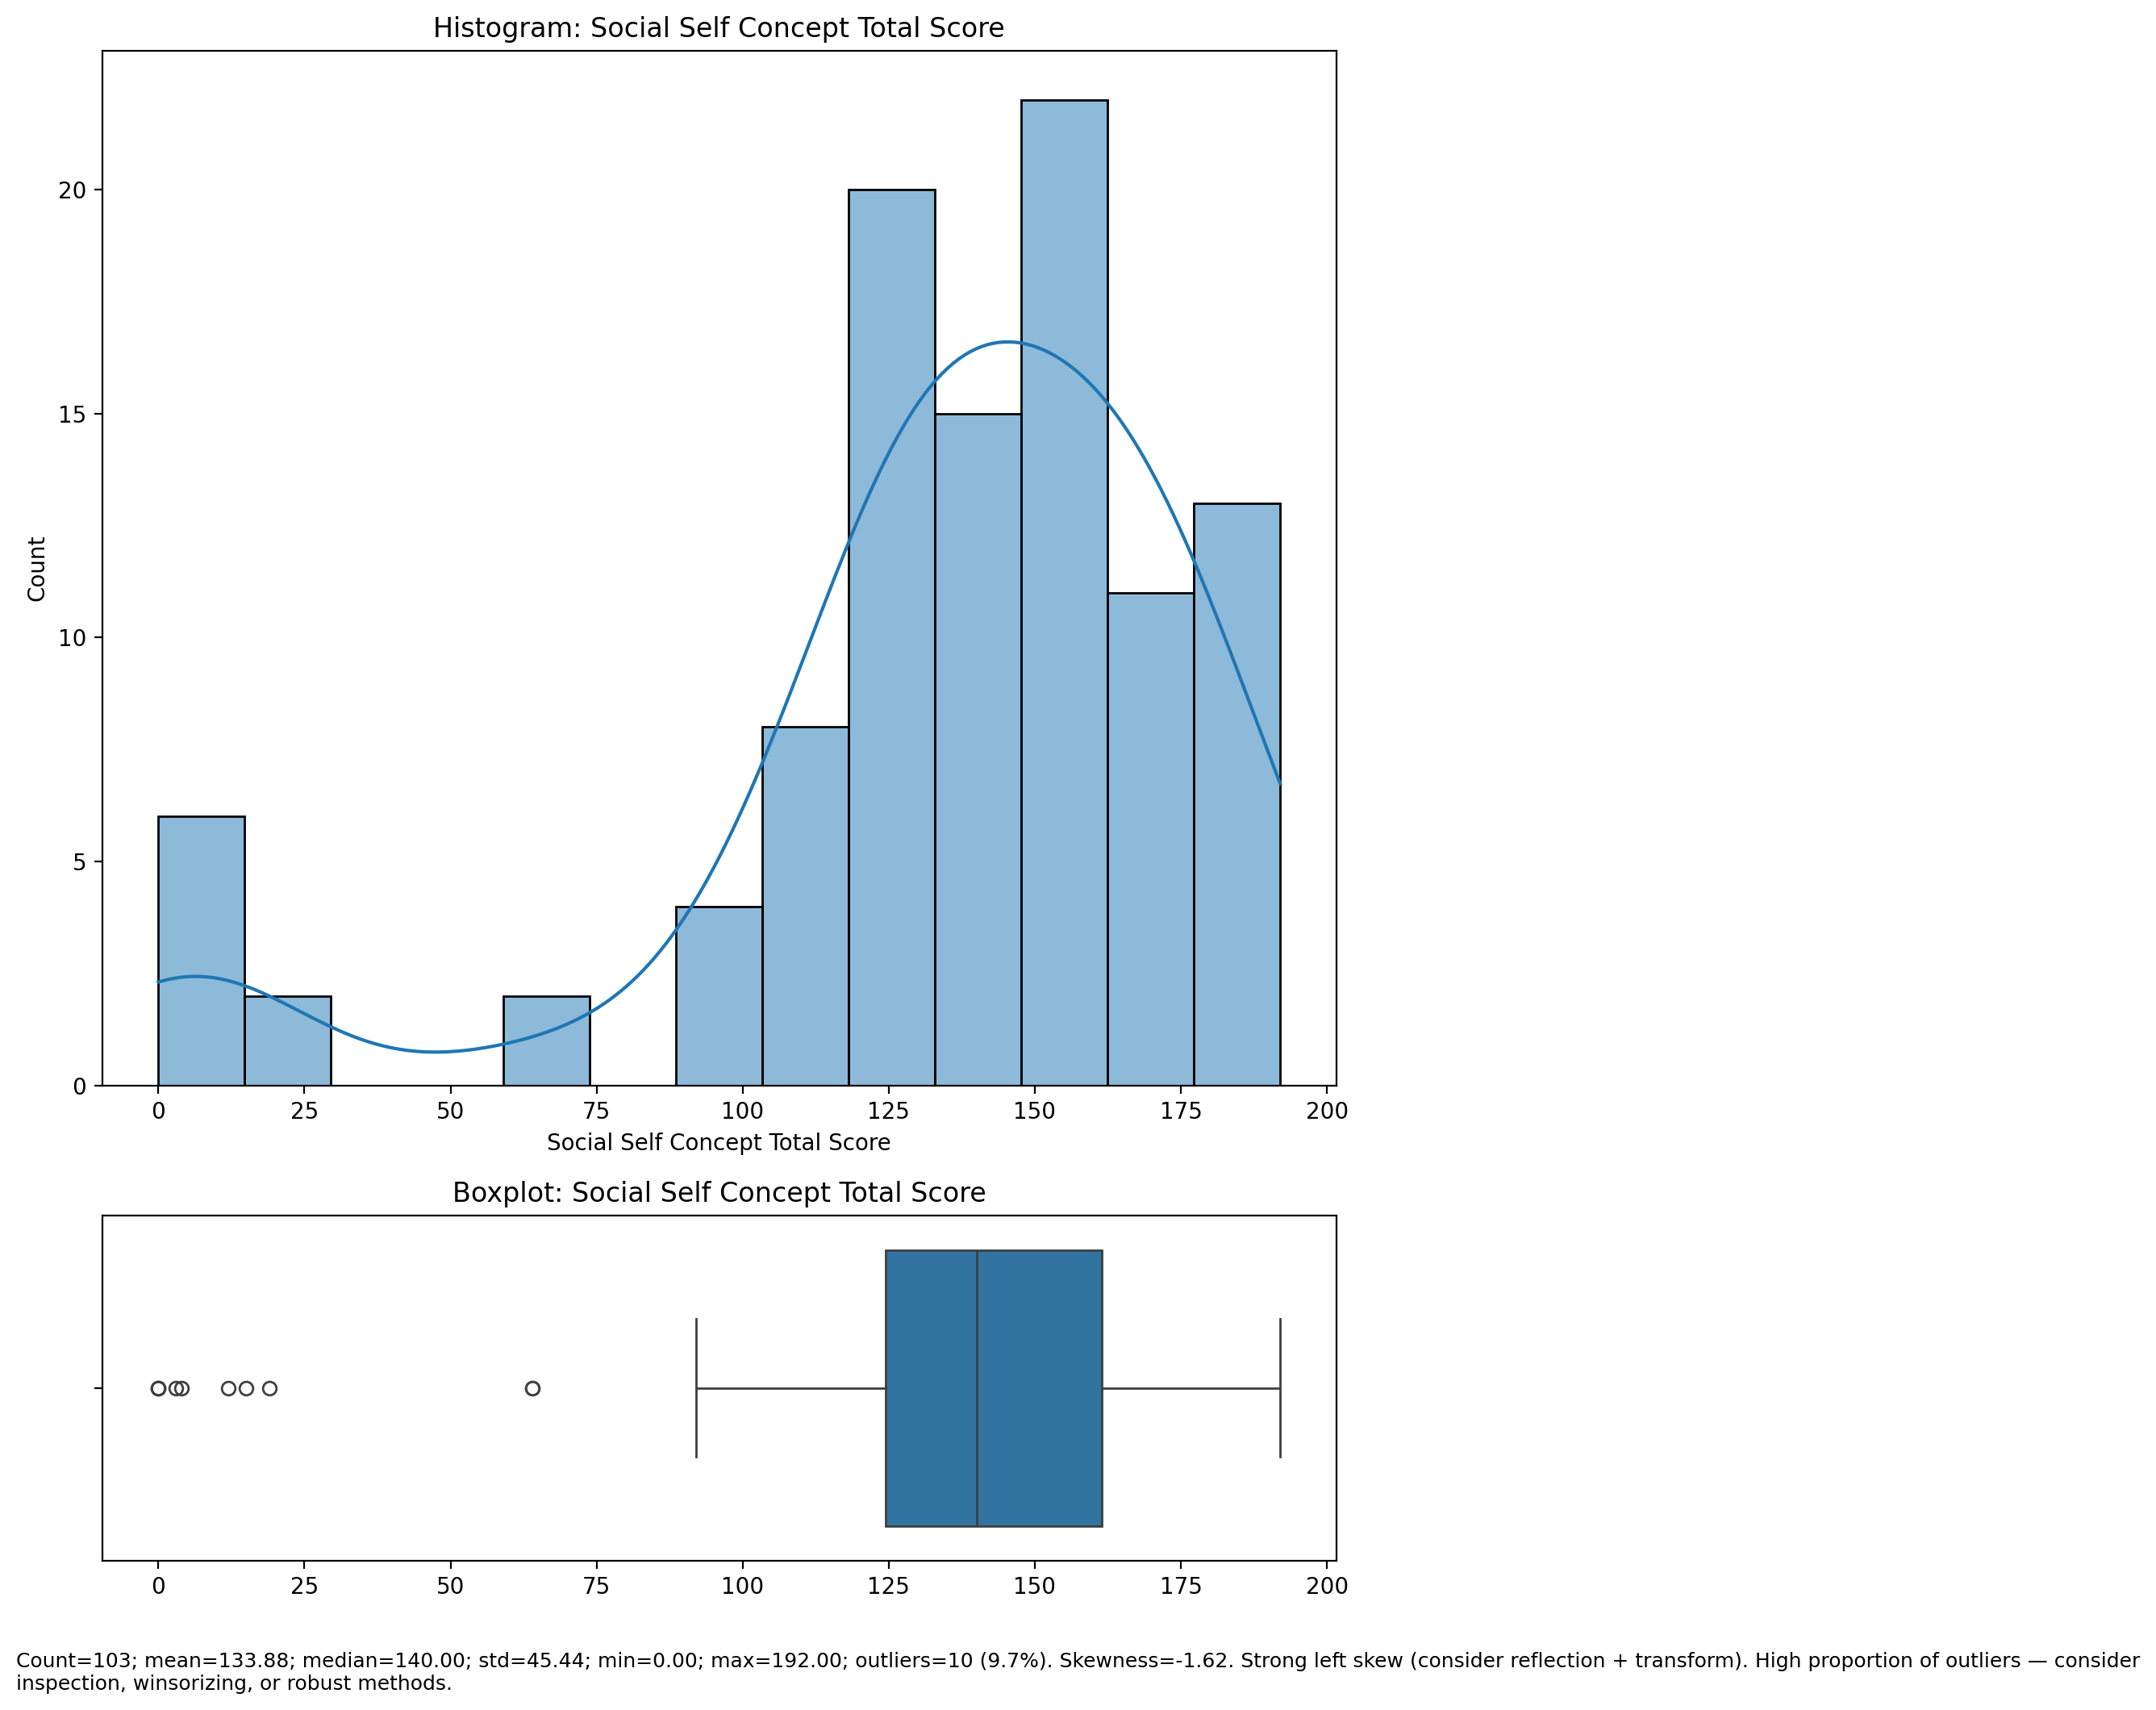

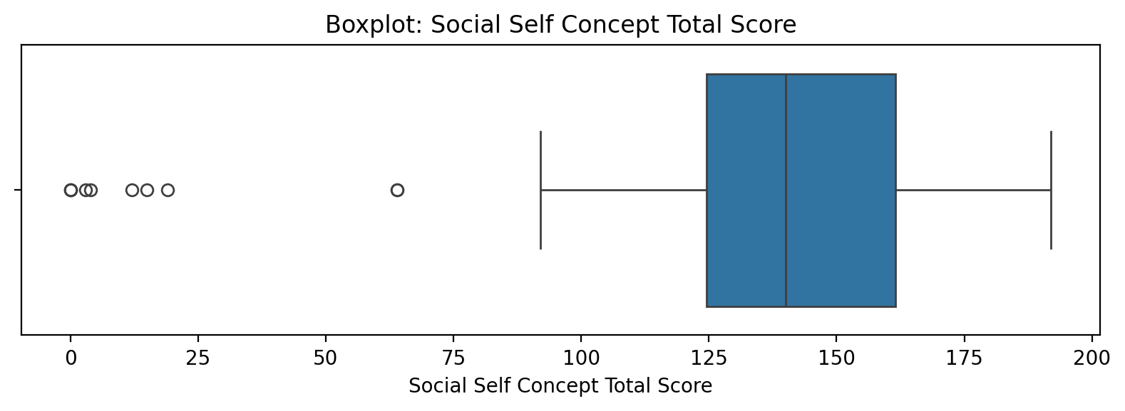

Count=103; mean=133.88; median=140.00; std=45.44; min=0.00; max=192.00; outliers=10 (9.7%). Skewness=-1.62.

## Real Self Concept Total Category

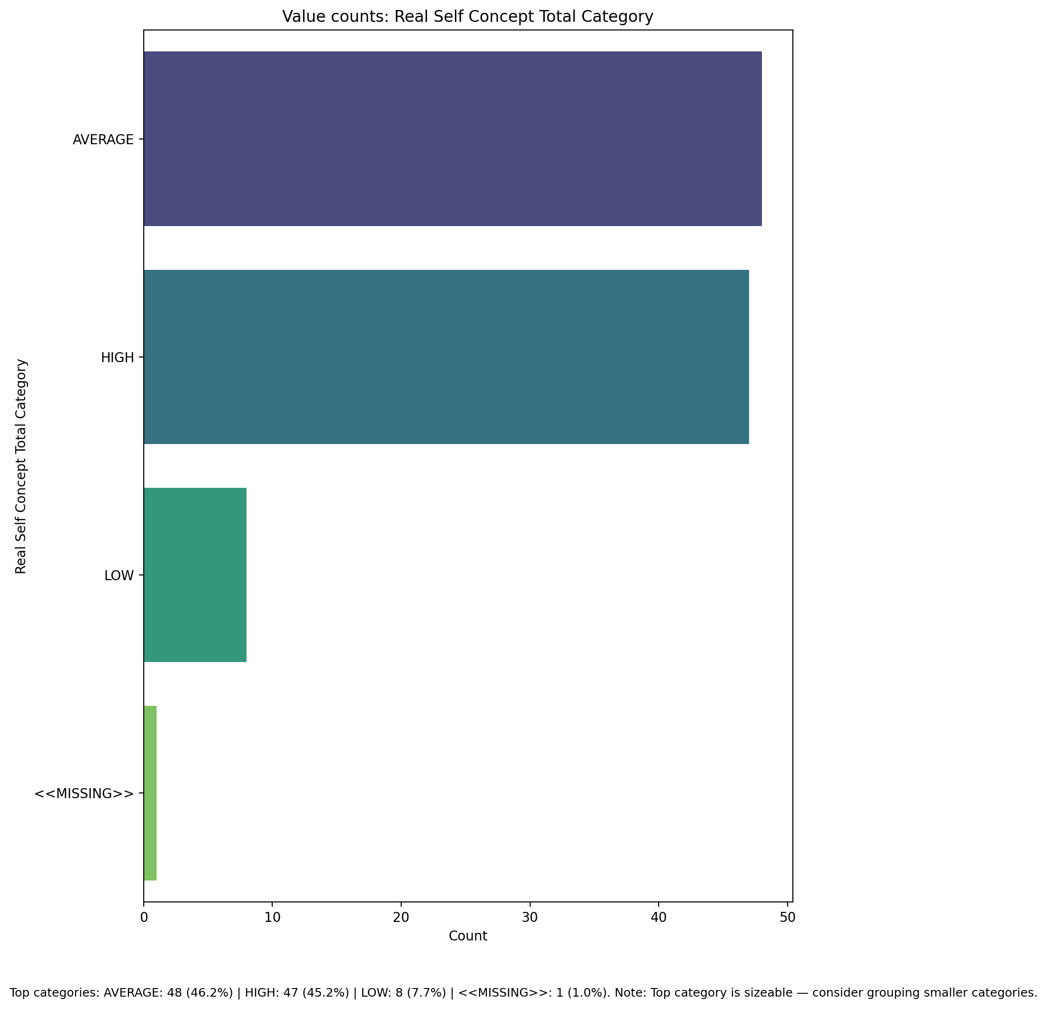

Top categories: AVERAGE: 48 (46.2%) | HIGH: 47 (45.2%) | LOW: 8 (7.7%) | <<MISSING>>: 1 (1.0%)

## Ideal Self Concept Total Category

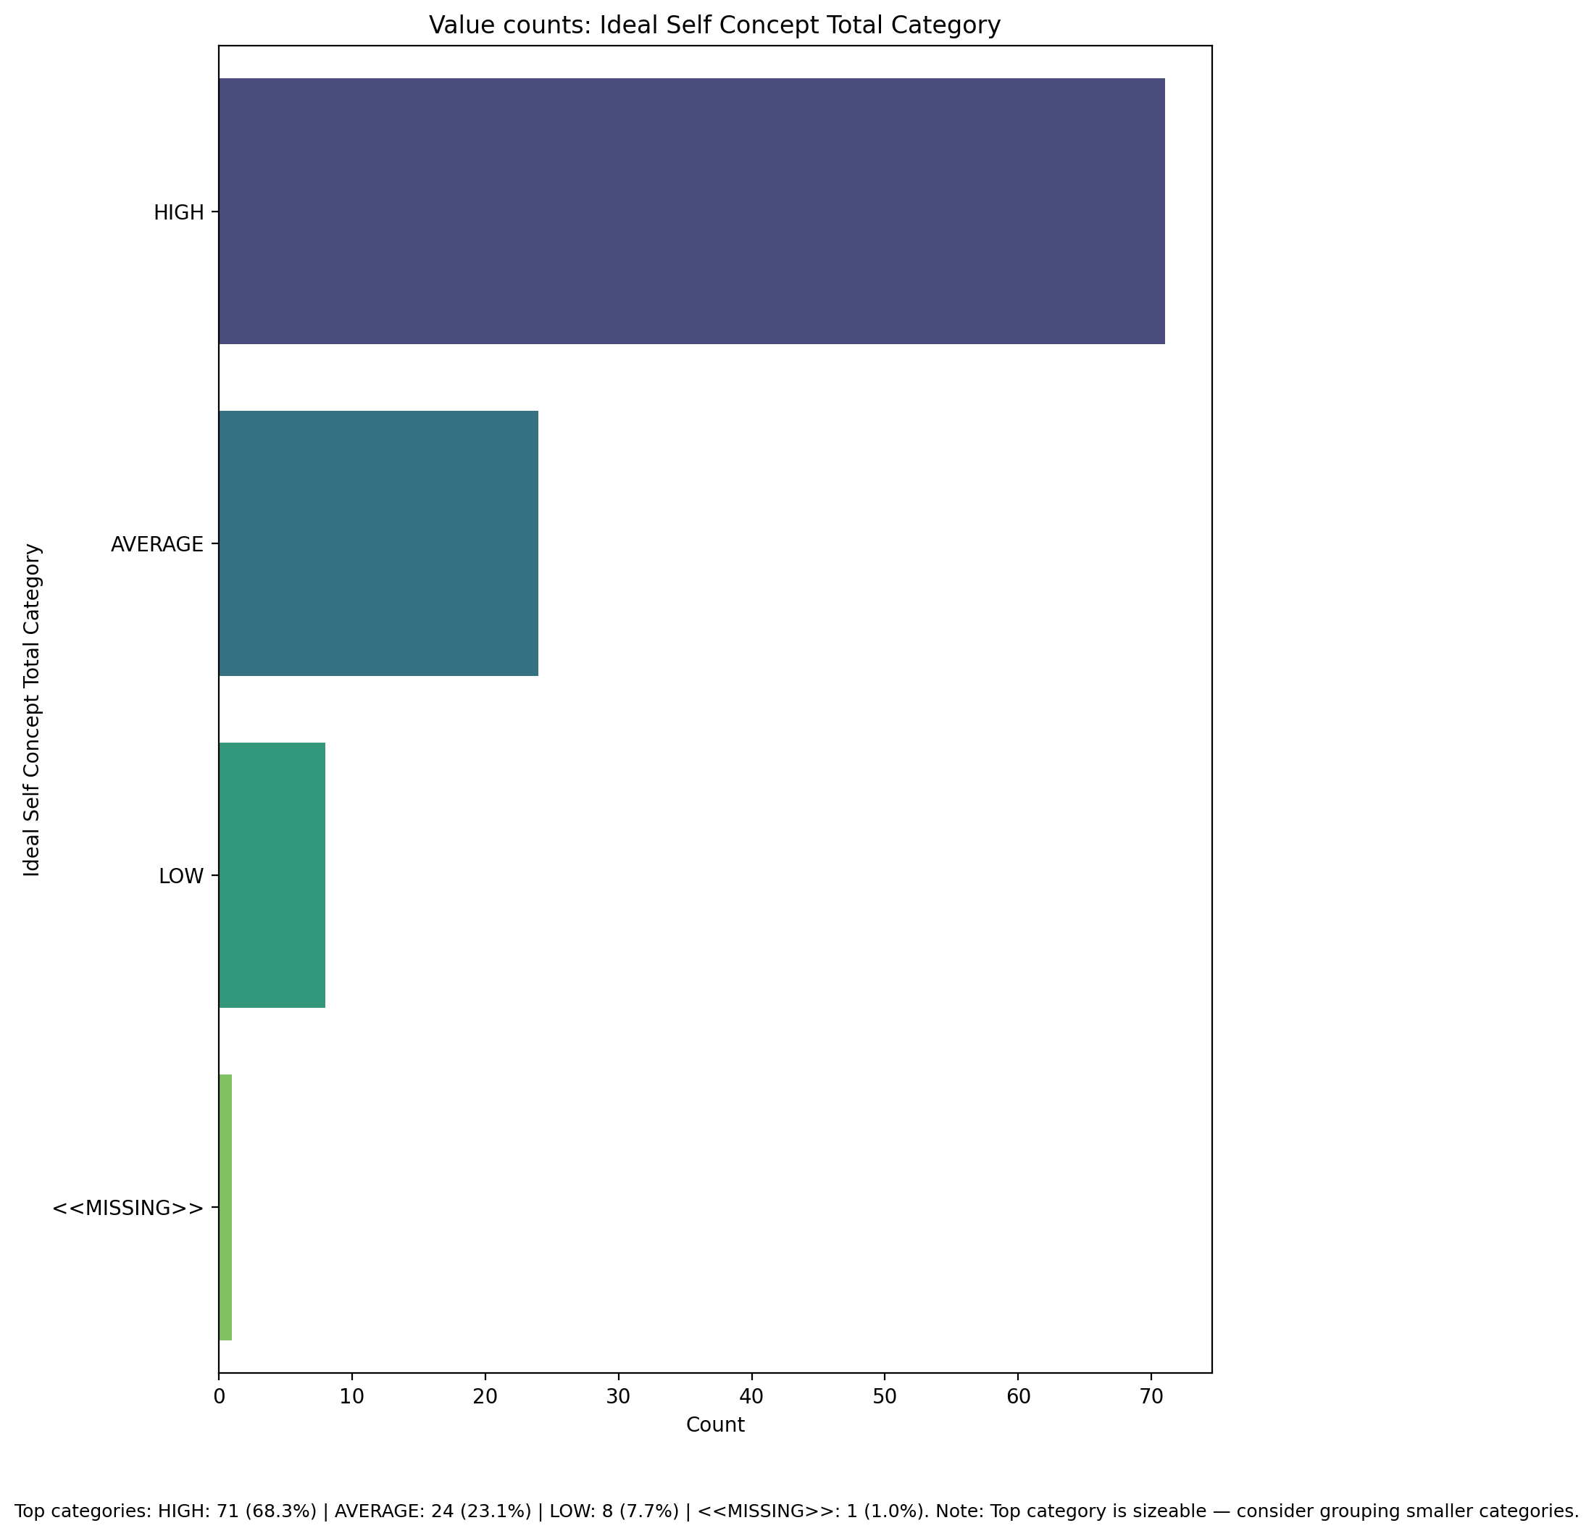

Top categories: HIGH: 71 (68.3%) | AVERAGE: 24 (23.1%) | LOW: 8 (7.7%) | <<MISSING>>: 1 (1.0%)

## Social Self Concept Total Category

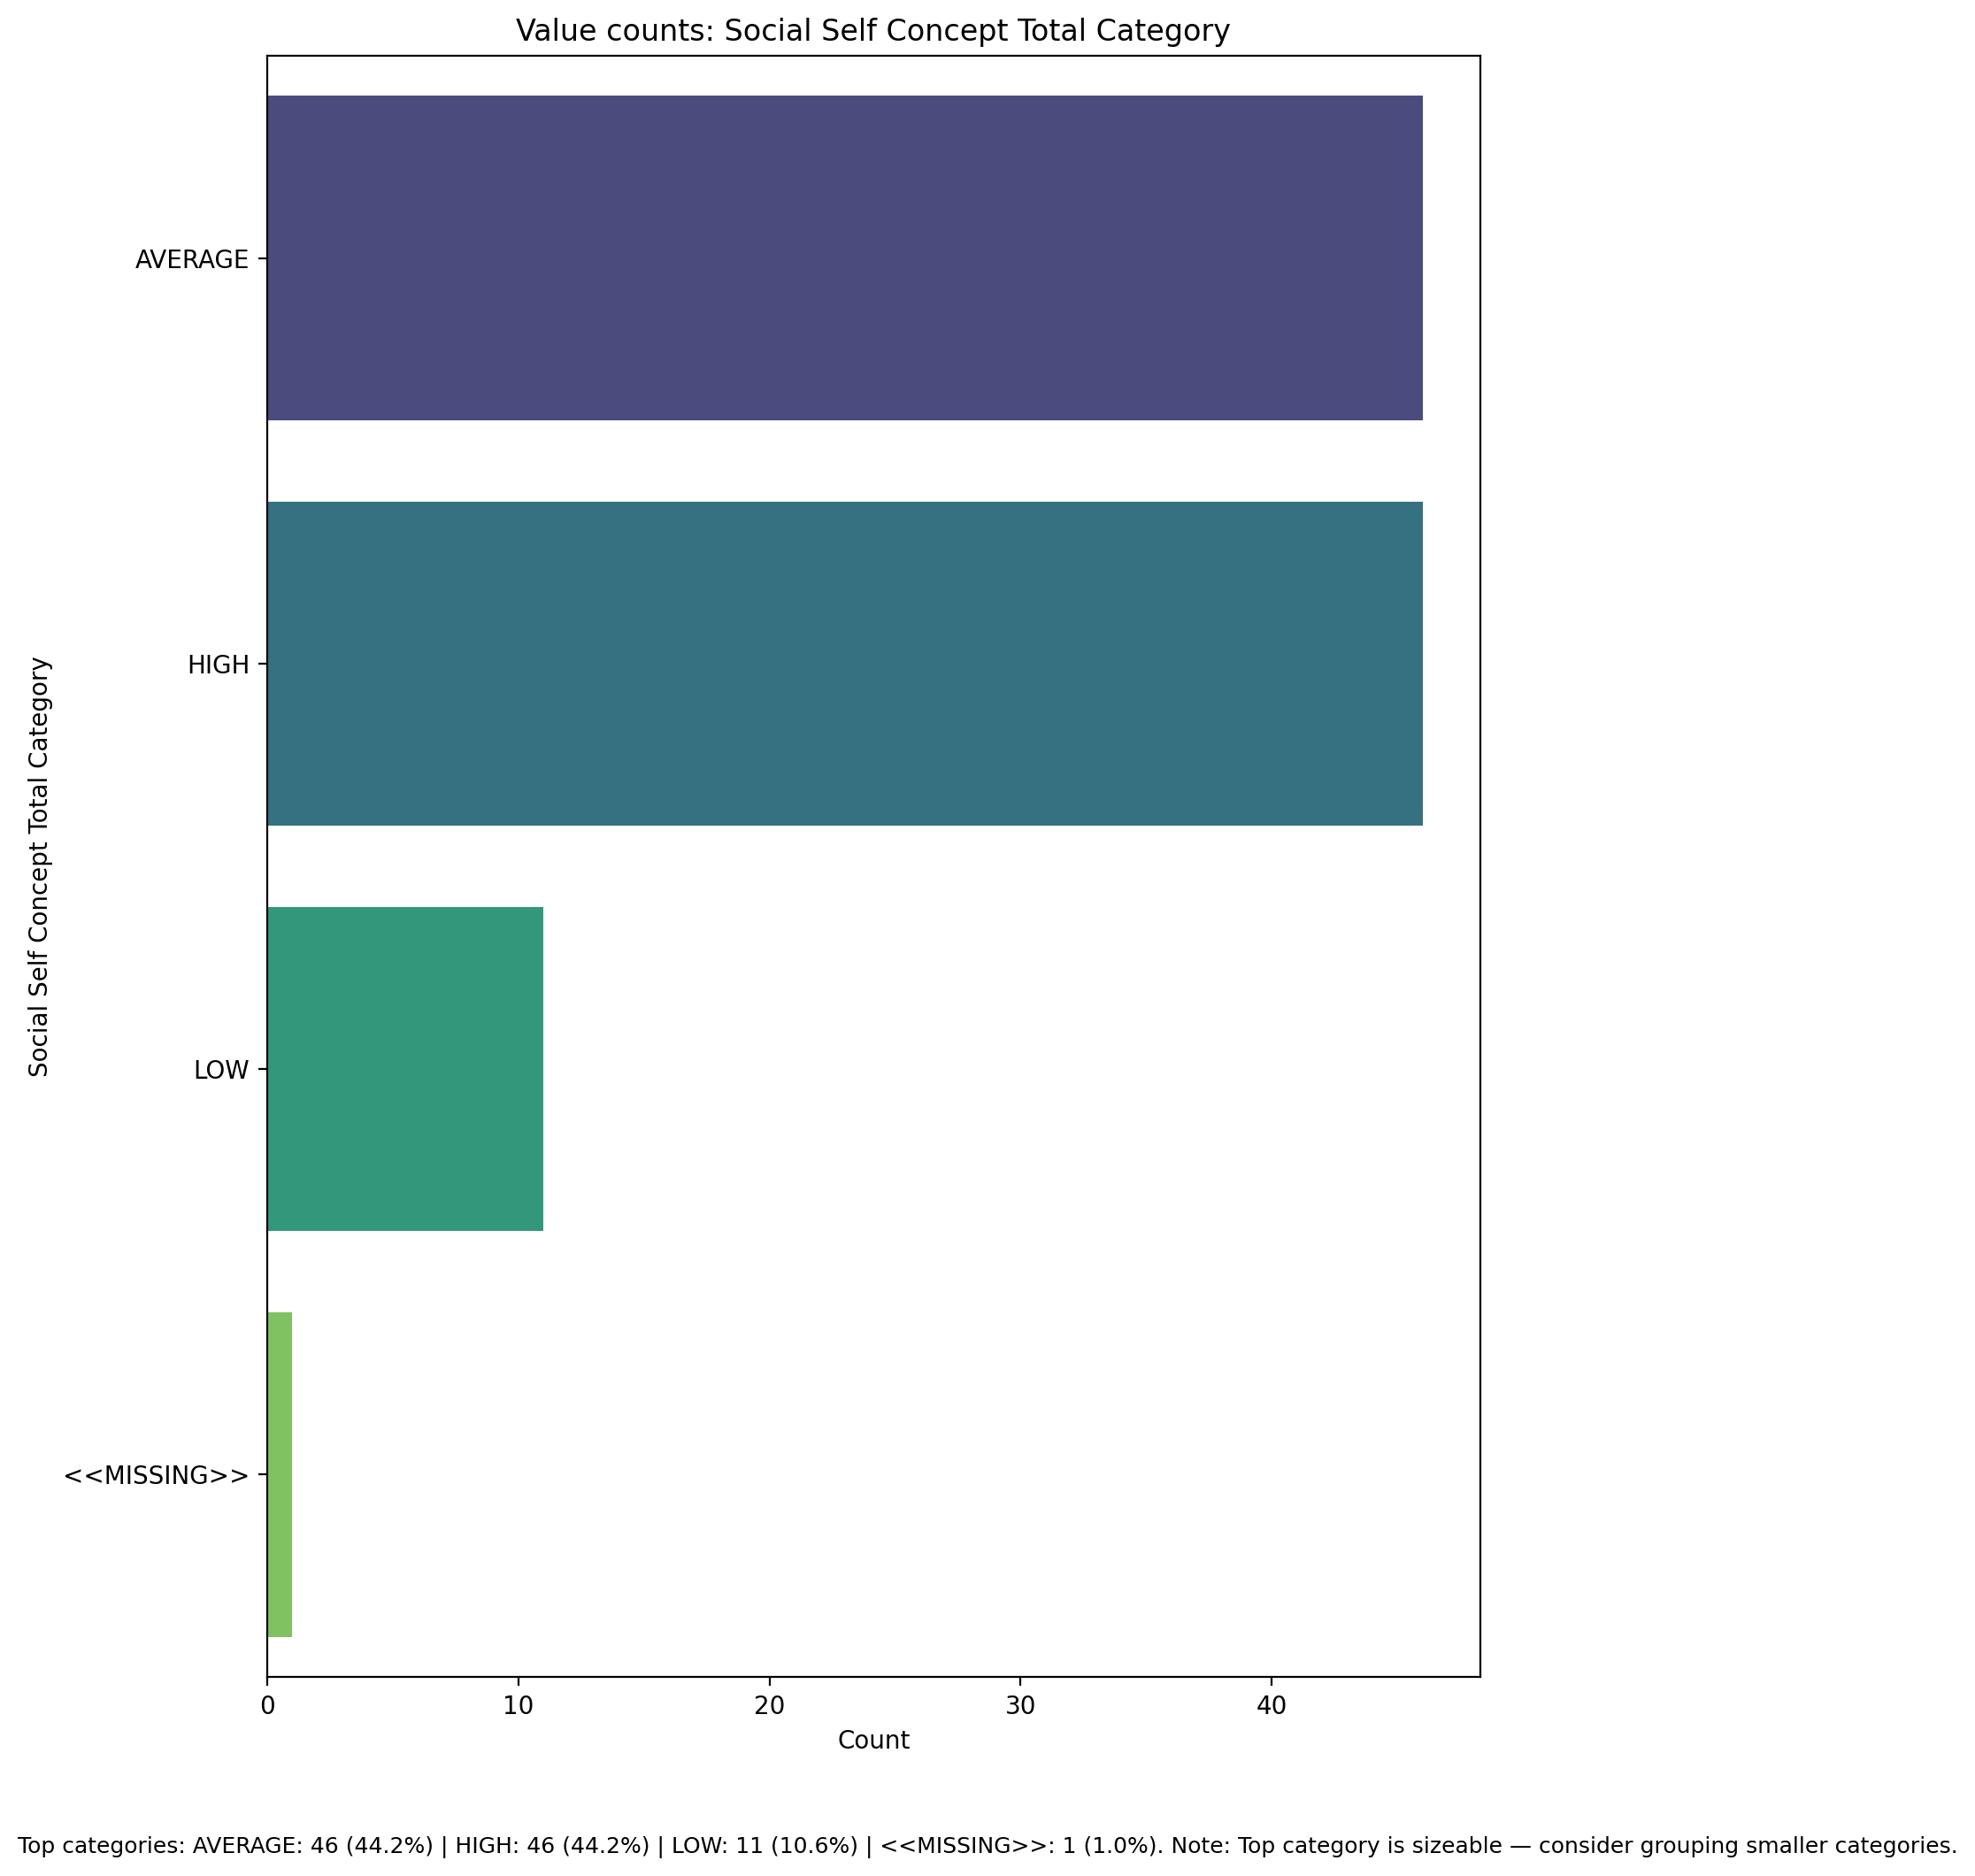

Top categories: AVERAGE: 46 (44.2%) | HIGH: 46 (44.2%) | LOW: 11 (10.6%) | <<MISSING>>: 1 (1.0%)

## Perceived Social Stress Score

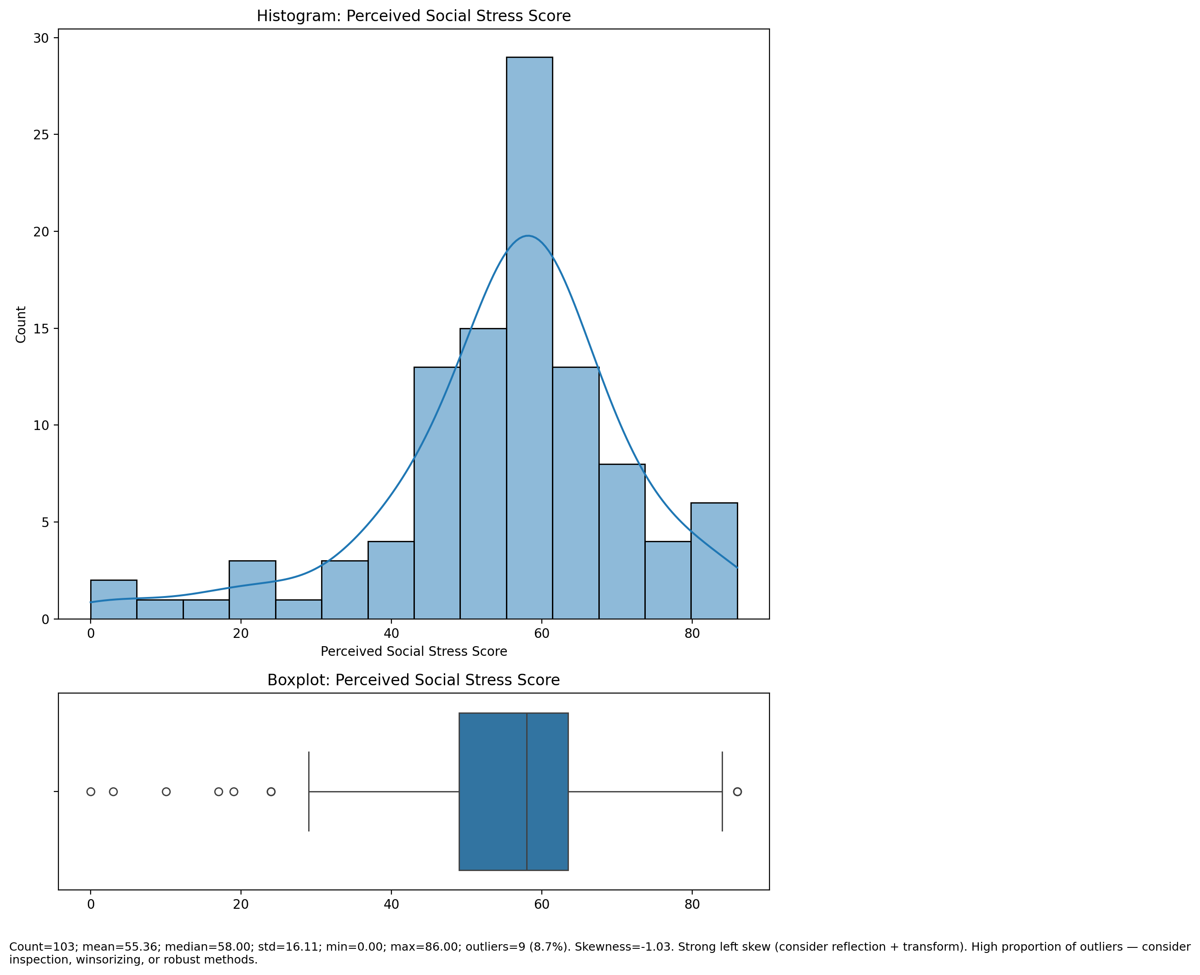

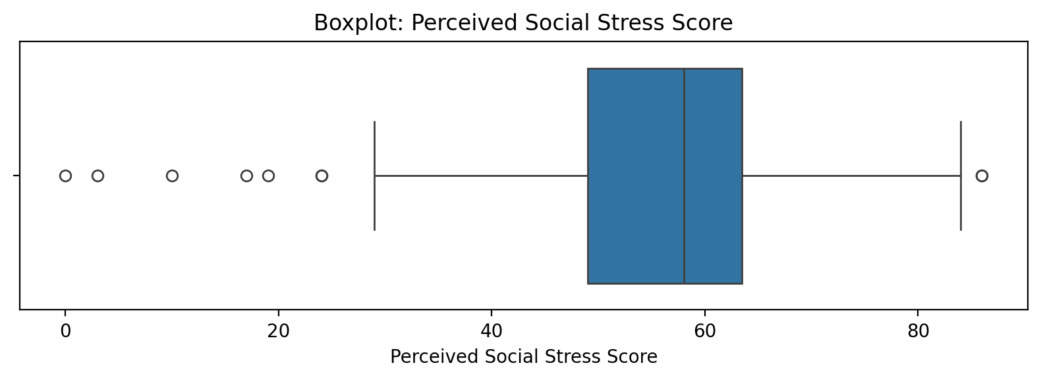

Count=103; mean=55.36; median=58.00; std=16.11; min=0.00; max=86.00; outliers=9 (8.7%). Skewness=-1.03.

## Perceived Social Stress Category

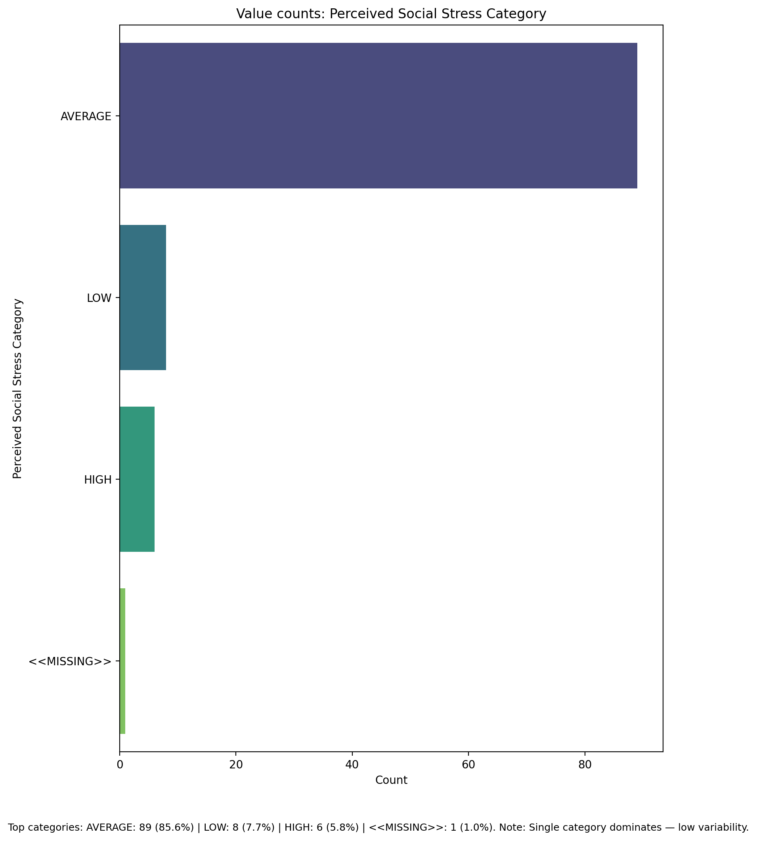

Top categories: AVERAGE: 89 (85.6%) | LOW: 8 (7.7%) | HIGH: 6 (5.8%) | <<MISSING>>: 1 (1.0%)

## Monthly household income_midpoint_INR

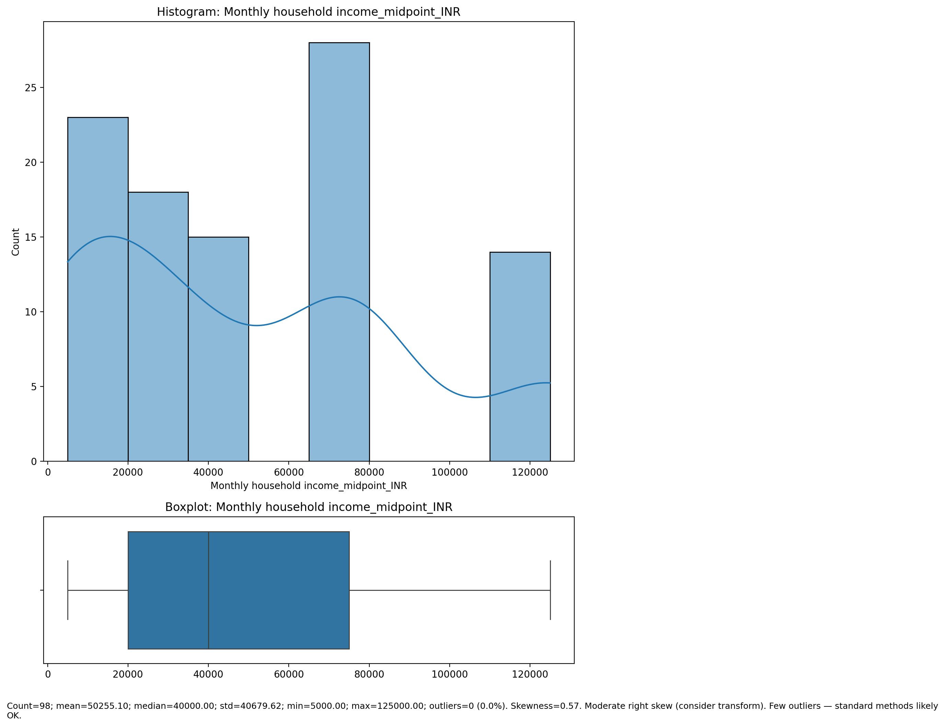

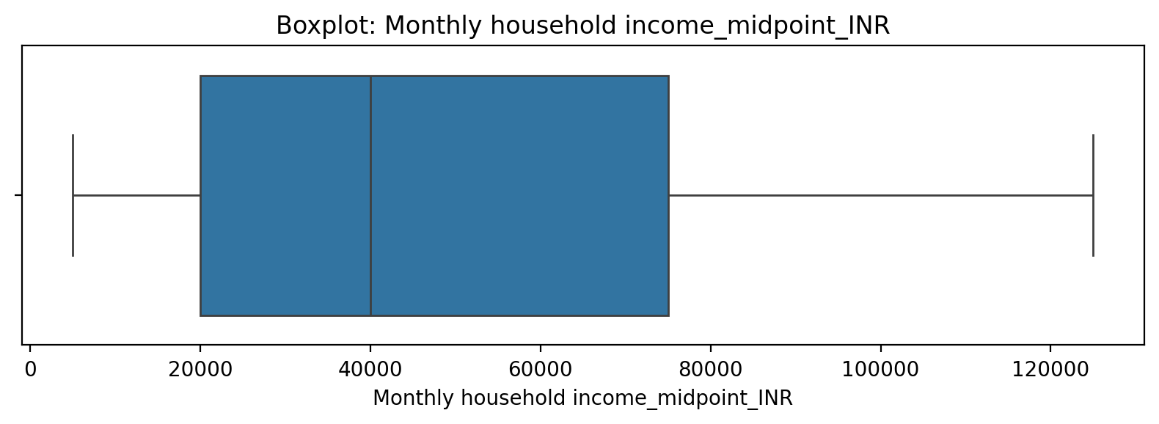

Count=98; mean=50255.10; median=40000.00; std=40679.62; min=5000.00; max=125000.00; outliers=0 (0.0%). Skewness=0.57.

## Monthly household income_cat

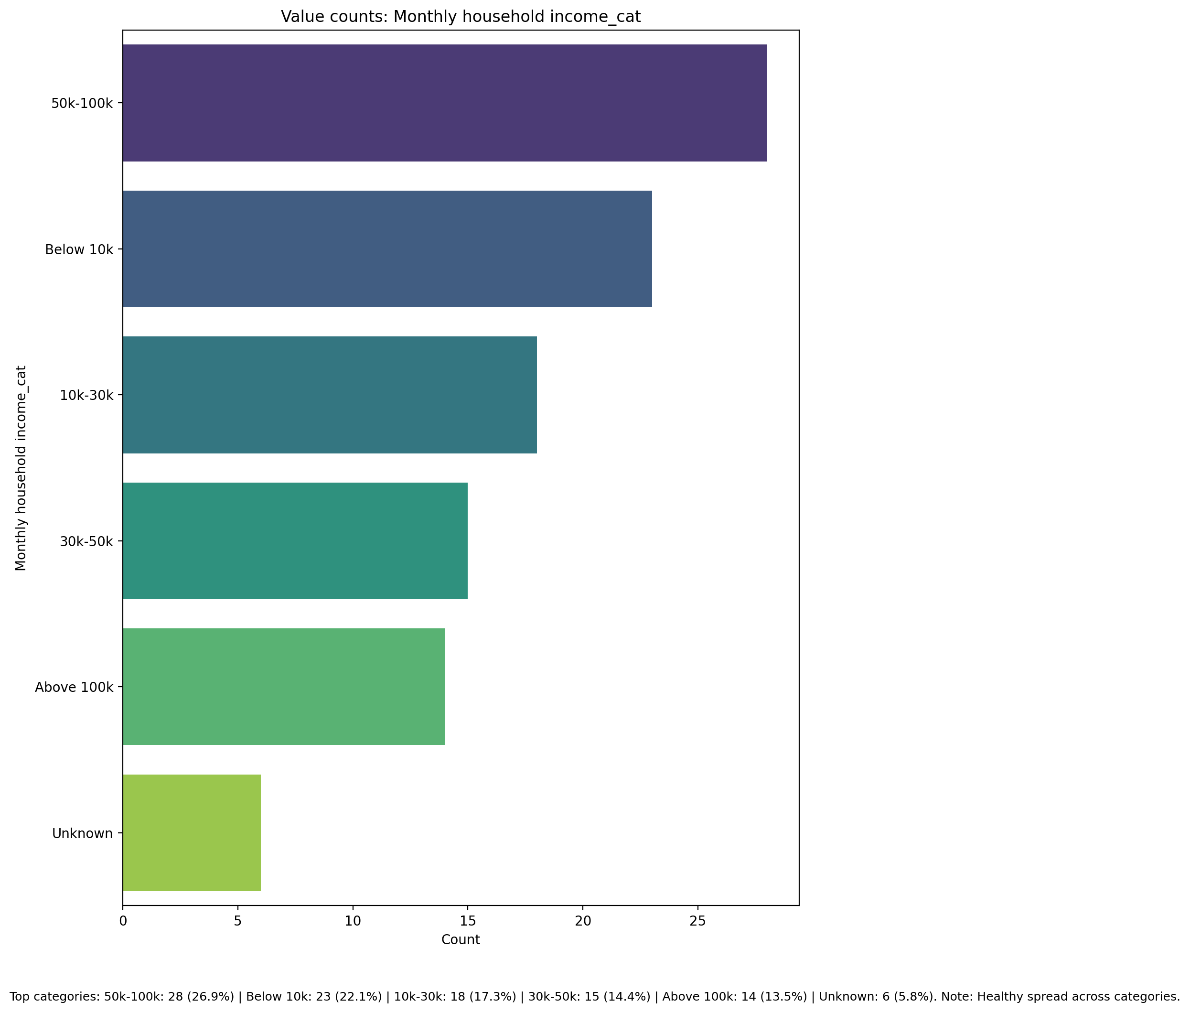

Top categories: 50k-100k: 28 (26.9%) | Below 10k: 23 (22.1%) | 10k-30k: 18 (17.3%) | 30k-50k: 15 (14.4%) | Above 100k: 14 (13.5%) | Unknown: 6 (5.8%)